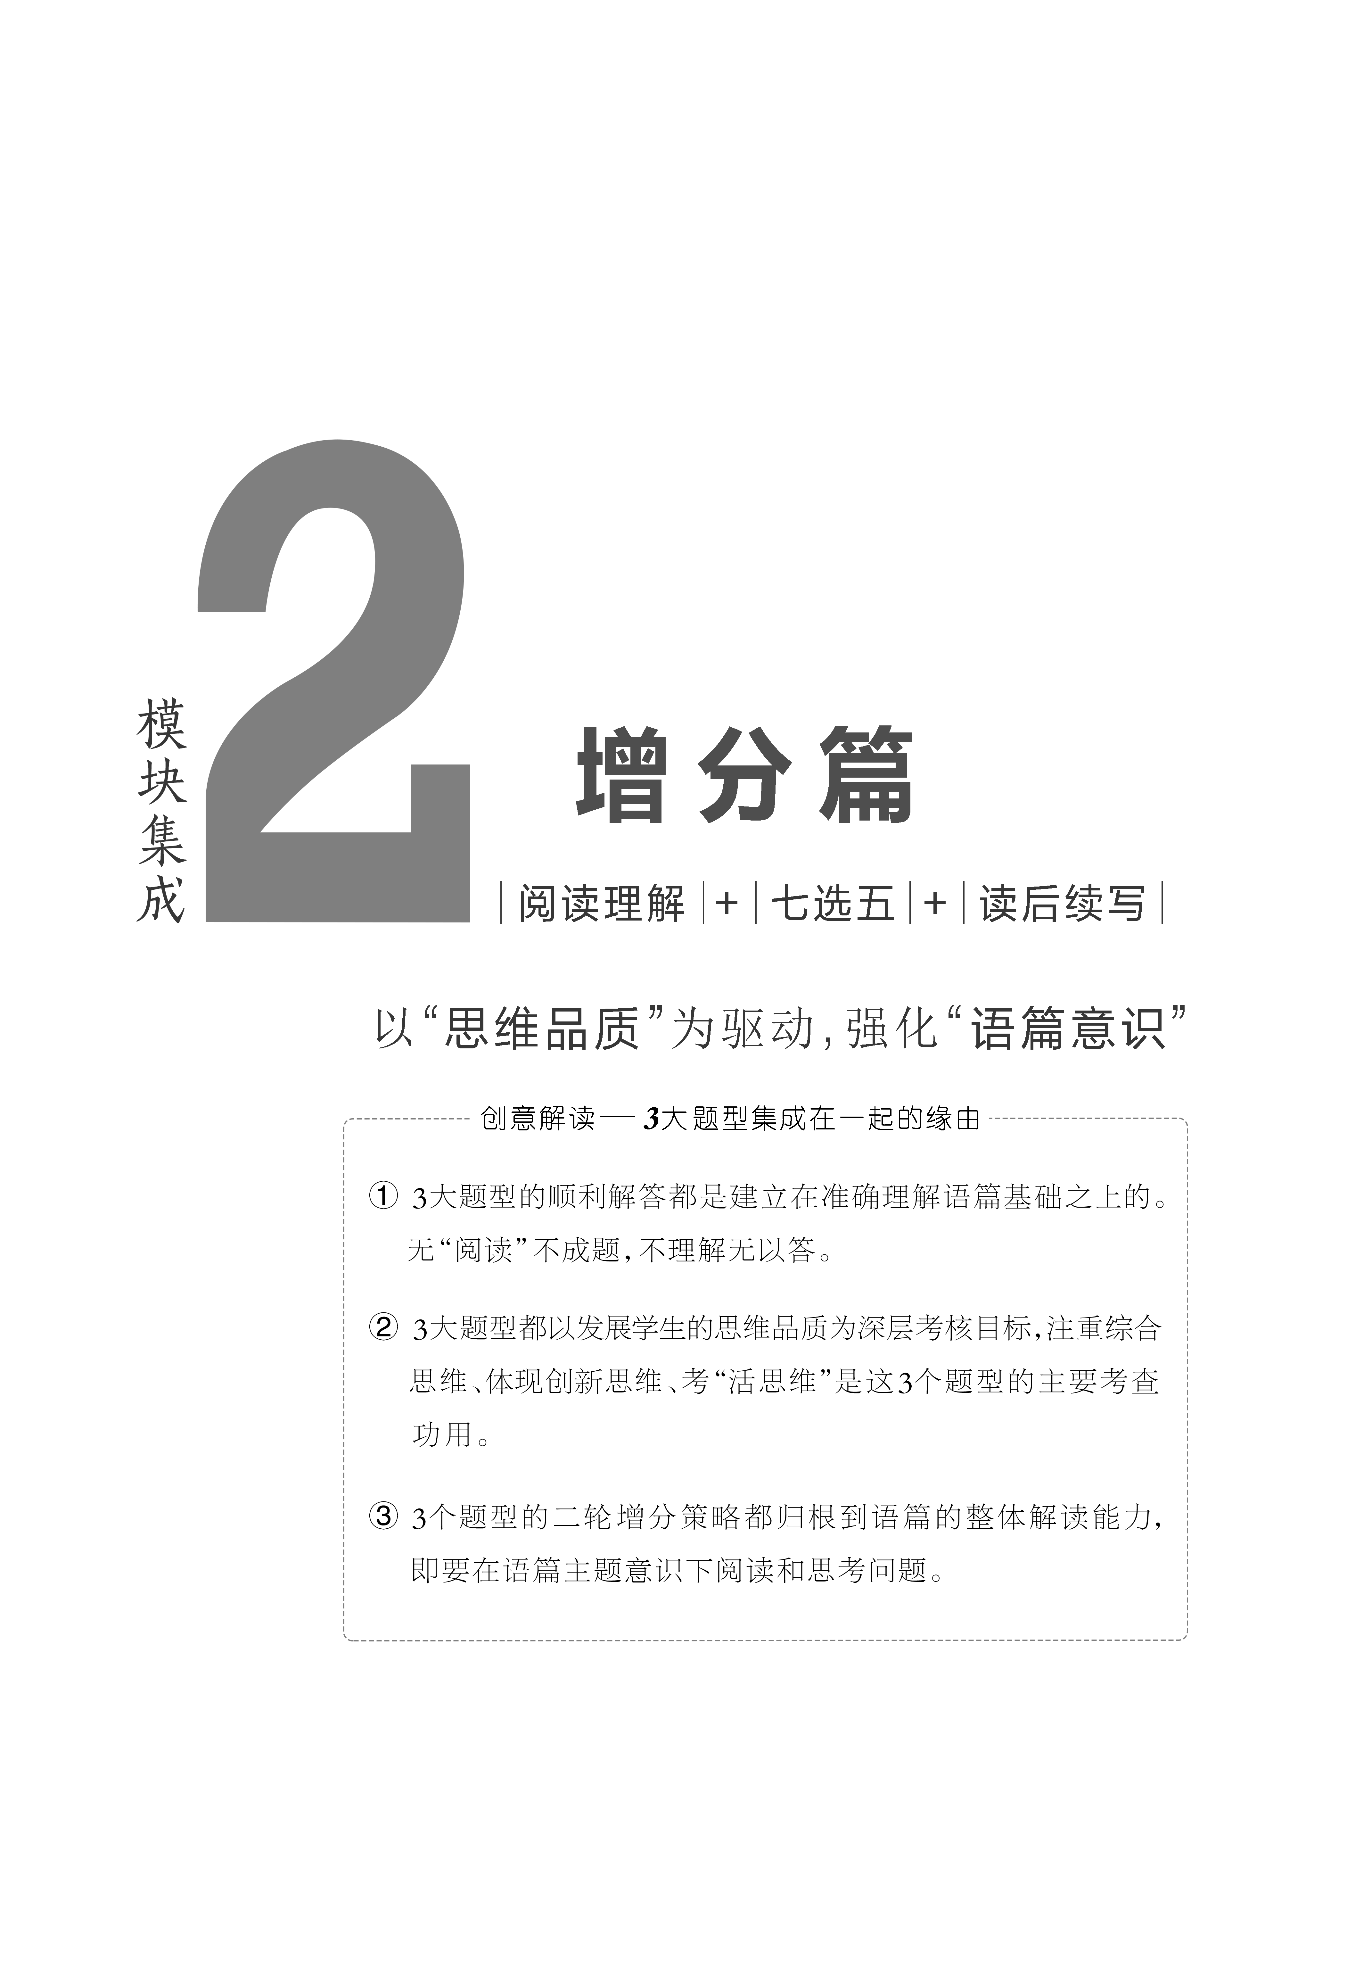
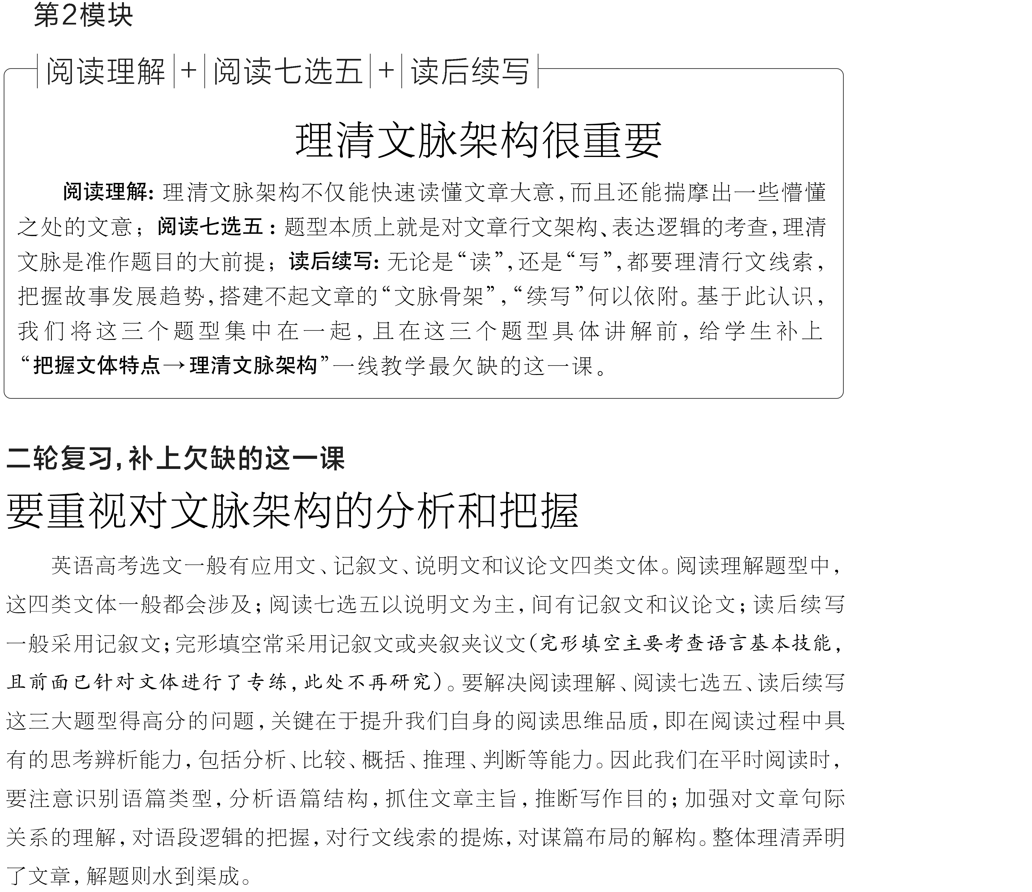

一、应用文的文体特点及读文技法
应用文是最贴近日常生活的文体，常见于阅读理解中，题材各异，措辞简洁明了，直截了当，其目的是向读者传输信息。文章一般采用“总—分”式或平行式两种行文方式。其命题主要考查考生提取信息和处理信息的能力，既注重特定细节的筛选、类比、综合，又注重推理判断能力，题目设置相对容易。读文时根据所提问题用寻读、跳读的方法可以达到事半功倍的效果。

[典例] (2023·新高考Ⅱ卷·阅读A篇)
Yellowstone National Park offers a variety of ranger programs throughout the park, and throughout the year. The following are descriptions of the ranger programs this summer.
Experiencing Wildlife in Yellowstone (May 26 to September 2)
Whether you're hiking a backcountry trail (小径), camping, or just enjoying the park's amazing wildlife from the road, this quick workshop is for you and your family. Learn where to look for animals and how to safely enjoy your wildlife watching experience. Meet at the Canyon Village Store.
Junior Ranger Wildlife Olympics (June 5 to August 21)
Kids can test their skills and compare their abilities to the animals of Yellowstone. Stay for as little or as long as your plans allow. Meet in front of the Visitor Education Center.
Canyon Talks at Artist Point (June 9 to September 2)
From a classic viewpoint, enjoy Lower Falls, the Yellowstone River, and the breathtaking colors of the canyon (峡谷) while learning about the area's natural and human history. Discover why artists and photographers continue to be drawn to this special place. Meet on the lower platform at Artist Point on the South Rim Drive for this short talk.
Photography Workshops (June 19 & July 10)
Enhance your photography skills — join Yellowstone's park photographer for a hands-on program to inspire new and creative ways of enjoying the beauty and wonder of Yellowstone.
6/19－Waterfalls & Wide Angles：meet at Artist Point.
7/10－Wildflowers & White Balance：meet at Washburn Trailhead in Chittenden parking area.

[架构分析]
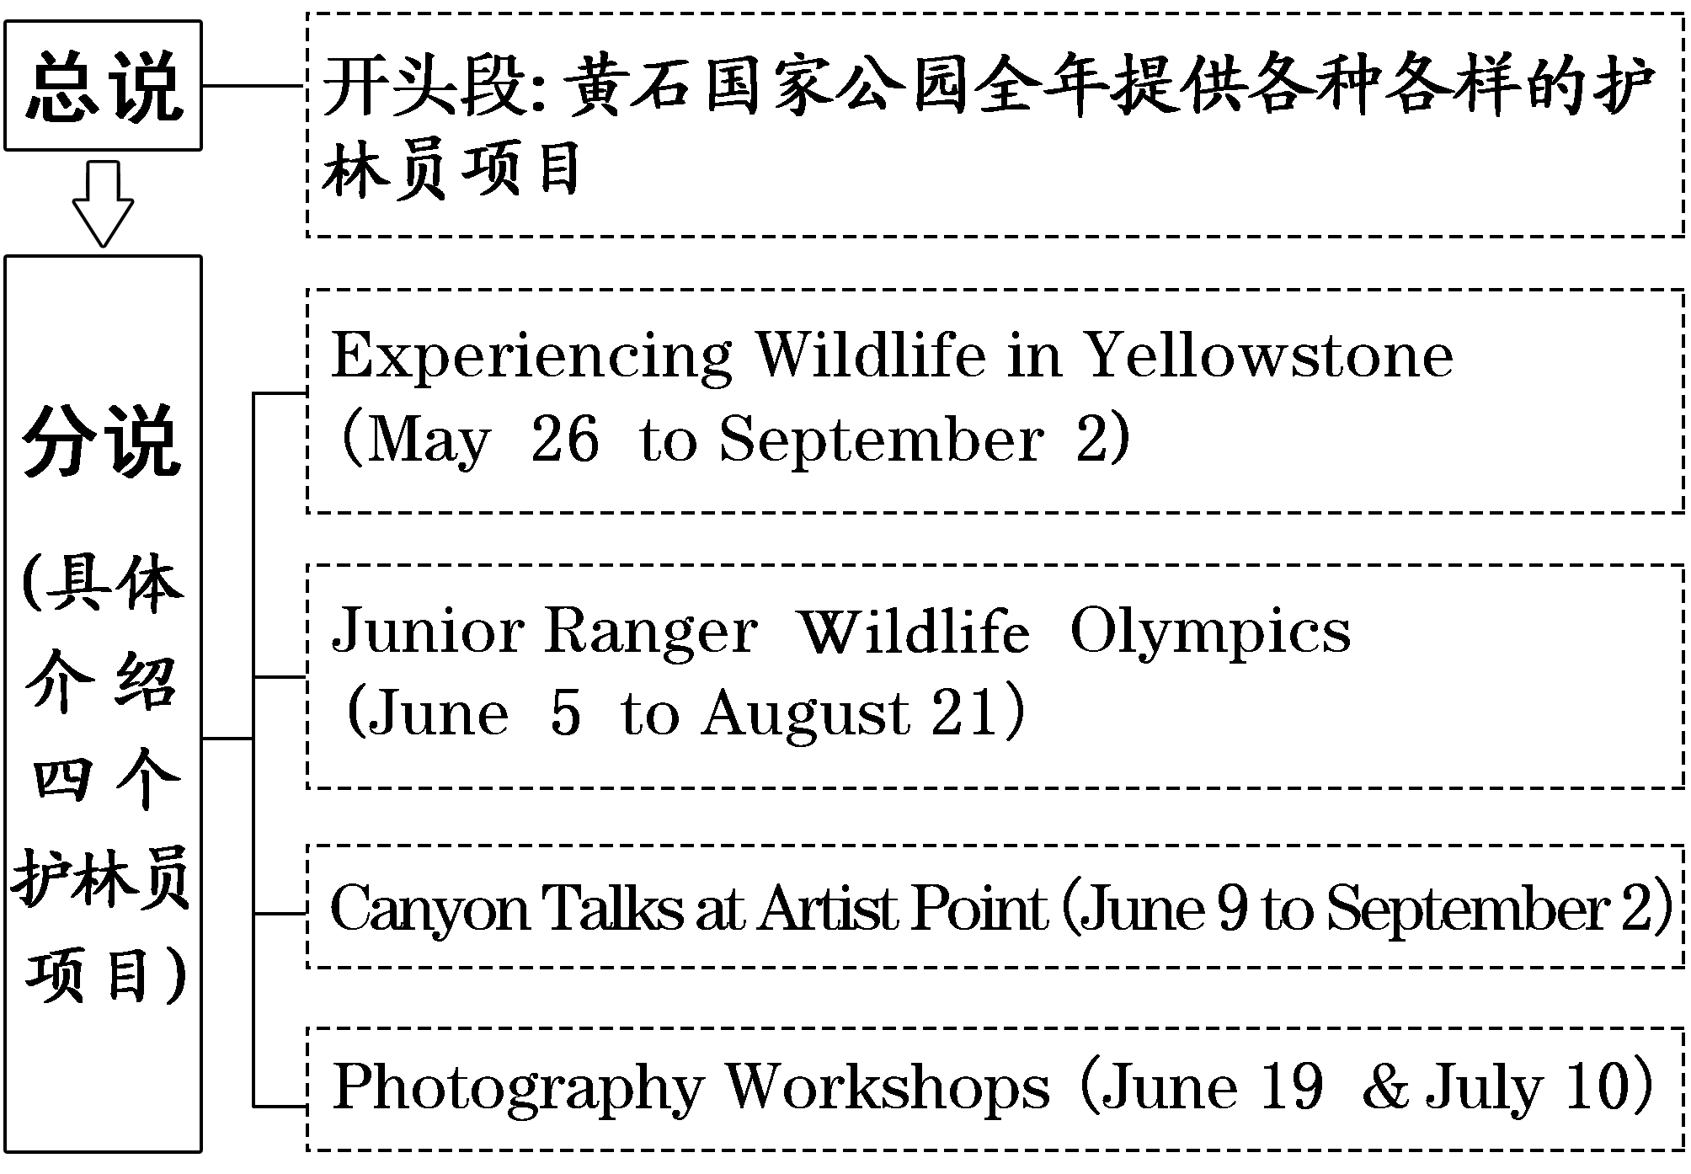
[触类旁通]
本文是一篇应用文，属于“人与自然”主题语境中的环境保护。文章采用了“总—分”的行文方式介绍了美国黄石国家公园的四个护林员项目。文章小标题醒目，重点突出，条理清晰，并用粗体字使文章结构更加鲜明。此类文章地方类名词较多，同时使用了缩略词、祈使句、省略句等，句子结构简单。阅读时，一定要先读题目及选项，后读文章，并按照题目顺序与段落顺序保持一致的原则快速查找信息，比对选项，进而得出答案。

二、记叙文的文体特点及读文技法
记叙文以写人、叙事、写景、状物为主，以人物的经历和事物发展变化为主要内容的一种文体形式。其特点是主题往往蕴含在字里行间，需要透过表面理解、领悟其深层含义，通过归纳概括来进行提炼。写作手法大多按时间或空间顺序展开。阅读时应采取略读和扫读的方法，快速抓住文中描写的主要内容，从整体上把握文章的脉络。文章一般具有“双线”，一方面要依据时空的顺序和故事的发展明确故事人物关系，理清故事主要事件以及它们之间的内在联系；另一方面，要根据人物的处境和描写、议论时所用的特定词语来准确把握人物的情感与态度，把握人物的情感线索，做到入情入境。
[阅读理解·例文]
(2023·全国乙卷·阅读B篇)Living in Iowa and trying to become a photographer specializing in landscape (风景) can be quite a challenge, mainly because the corn state lacks geographical variation.
Although landscapes in the Midwest tend to be quite similar, either farm fields or highways, sometimes I find distinctive character in the hills or lakes. To make some of my landscape shots, I have traveled up to four hours away to shoot within a 10-minute time frame. I tend to travel with a few of my friends to state parks or to the countryside to go on adventures and take photos along the way.
Being at the right place at the right time is decisive in any style of photography.I often leave early to seek the right destinations so I can set up early to avoid missing the moment I am attempting to photograph. I have missed plenty of beautiful sunsets/sunrises due to being on the spot only five minutes before the best moment.
One time my friends and I drove three hours to Devil's Lake, Wisconsin, to climb the purple quartz (石英) rock around the lake. After we found a crazy-looking road that hung over a bunch of rocks, we decided to photograph the scene at sunset. The position enabled us to look over the lake with the sunset in the background. We managed to leave this spot to climb higher because of the spare time until sunset. However, we did not mark the route (路线) so we ended up almost missing the sunset entirely. Once we found the place, it was stressful getting lights and cameras set up in the limited time. Still, looking back on the photos, they are some of my best shots though they could have been so much better if I would have been prepared and managed my time wisely.
[架构分析]
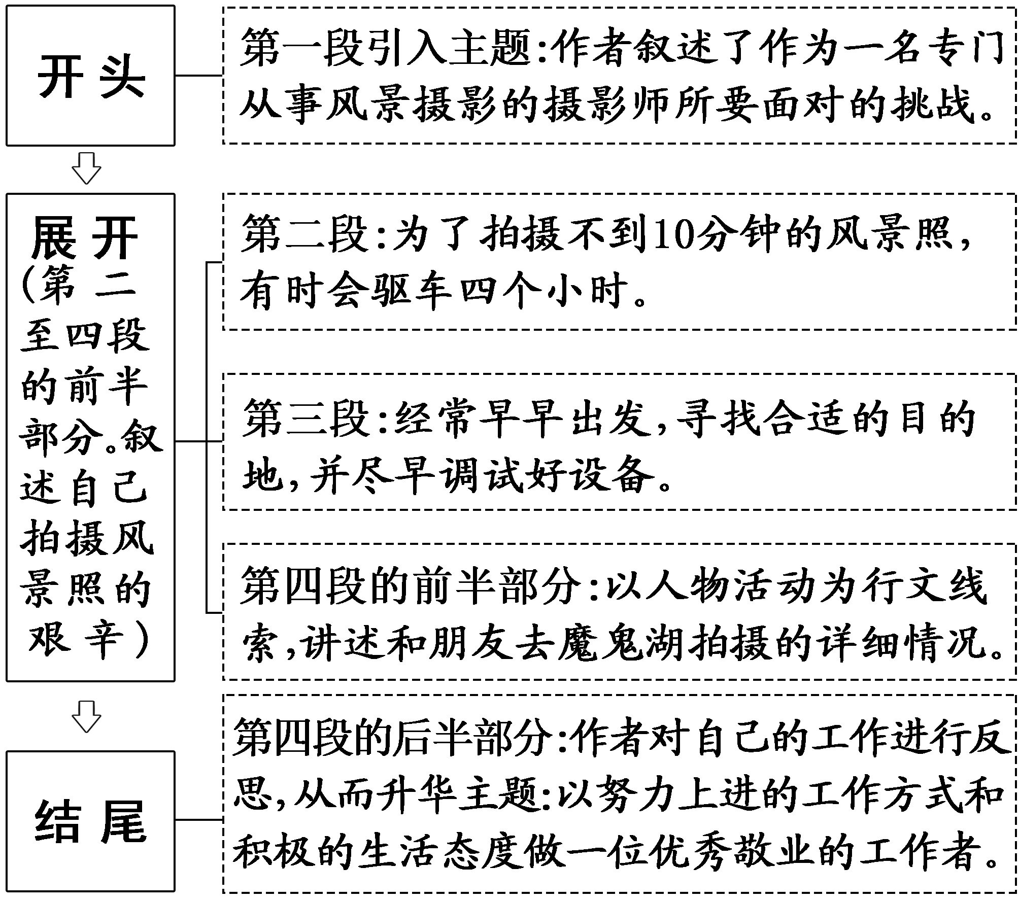
[触类旁通]
阅读故事叙述型文章时，应精读首尾段，总结文章的主旨；扫读中间部分，根据时间、地点线索查找细节信息；同时根据字里行间的描写把握主人公的情感态度。
[读后续写·例文]
(2023·新高考Ⅰ卷)When I was in middle school, my social studies teacher asked me to enter a writing contest. I said no without thinking. I did not love writing. My family came from Brazil, so English was only my second language. Writing was so difficult and painful for me that my teacher had allowed me to present my paper on the sinking of the Titanic by acting out a play, where I played all the parts.No one laughed harder than he did.
So, why did he suddenly force me to do something at which I was sure to fail? His reply: “Because I love your stories. If you're willing to apply yourself, I think you have a good shot at this.” Encouraged by his words, I agreed to give it a try.
I chose Paul Revere's horse as my subject. Paul Revere was a silversmith (银匠) in Boston who rode a horse at night on April 18,1775 to Lexington to warn people that British soldiers were coming. My story would come straight from the horse's mouth. Not a brilliant idea, but funny; and unlikely to be anyone else's choice.
What did the horse think, as he sped through the night? Did he get tired? Have doubts? Did he want to quit? I sympathized immediately. I got tired. I had doubts. I wanted to quit.But, like Revere's horse, I kept going. I worked hard. I checked my spelling. I asked my older sister to correct my grammar. I checked out a half-dozen books on Paul Revere from the library. I even read a few of them.
When I handed in the essay to my teacher, he read it, laughed out loud, and said, “Great. Now, write it again.” I wrote it again, and again and again. When I finally finished it, the thought of winning had given way to the enjoyment of writing. If I didn't win, I wouldn't care.

[架构分析]
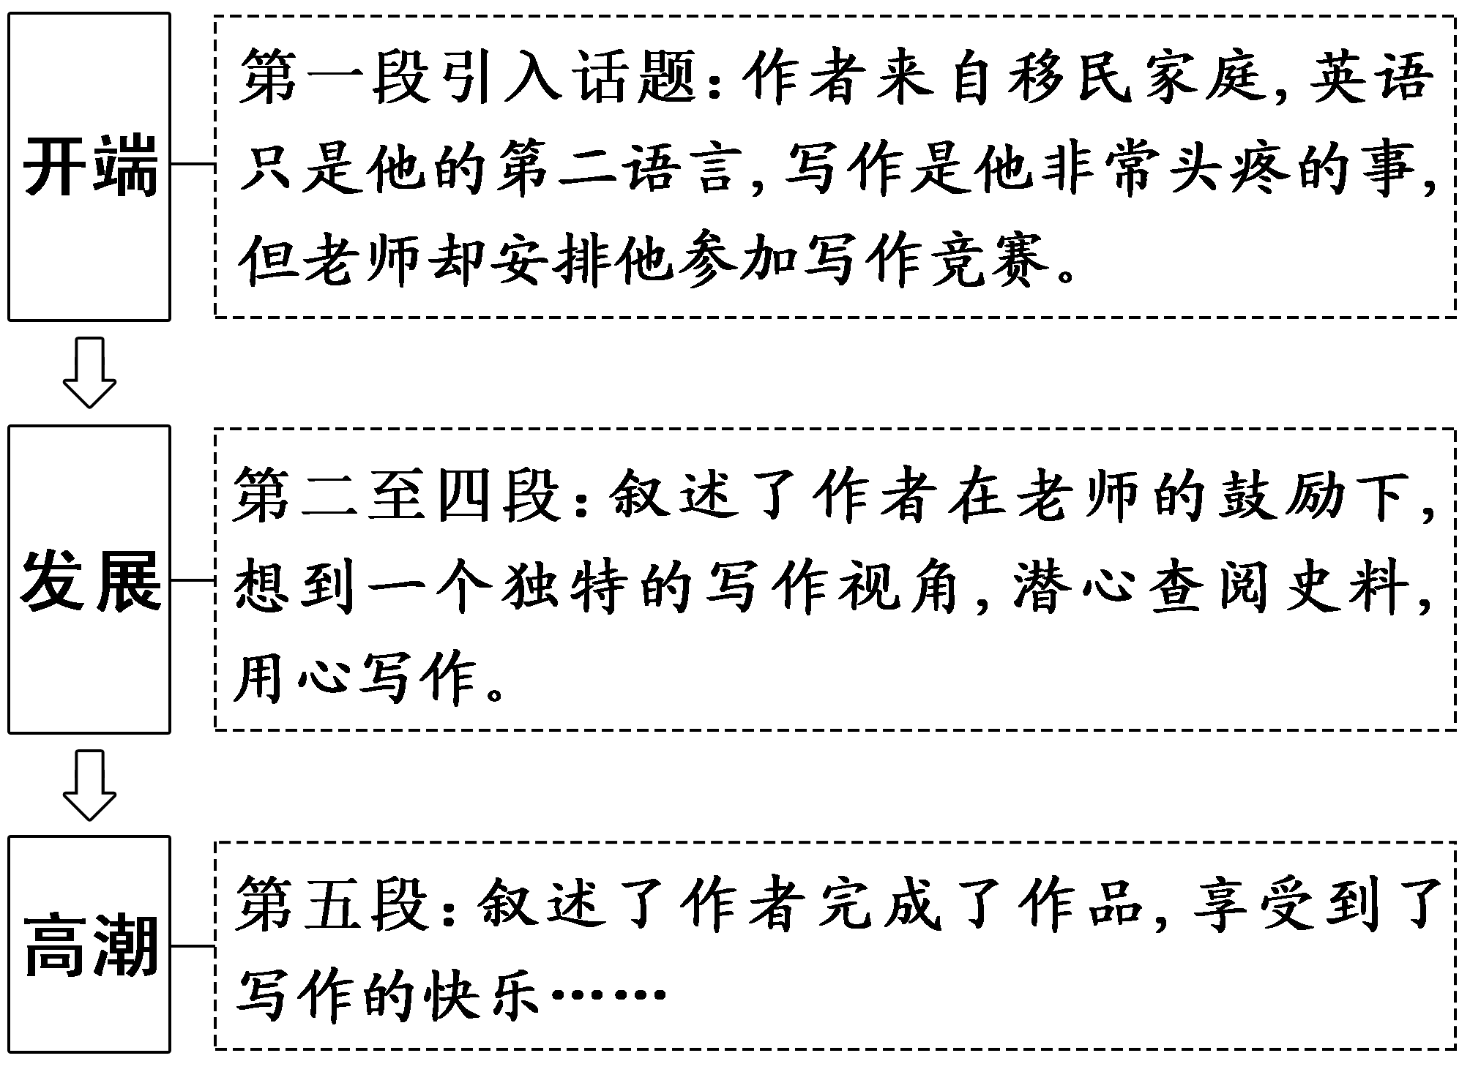

[触类旁通]
本文是一篇记叙文，属于“人与自我”主题语境中的生活与学习。文章讲述了一名英语为第二语言的中学生在老师的鼓励下参加写作比赛并通过努力取得优异成绩的故事。
记叙文常包含两条线，即故事线和情感线，通过梳理这两条线索，可以容易地把握整个故事的主旨。本文的故事线是“拒绝→同意尝试→尽力→喜欢写作”，情感线是“困惑的→坚定的→快乐的”，从而推出故事要表达的主旨是“努力会带来好结果”。续写时根据提供的开头语，在续写故事情节发展的同时，适时插入主人公的情感变化，确保故事情节的完美衔接，最后升华主题，讲述作者的感悟。

三、说明文的文体特点及读文技法
说明文通常通过举例子、作比较、分类别、析结果、列数字和作引用等手法，具体描述一项研究或者介绍一项新产品、新技术等，让读者了解信息。其行文方式一般有：总分式(“总—分”式、“总—分—总”式)、递进式(由浅入深、由表及里、由现象到本质，逐层递进，剖析事理)、并列式(文章各部分内容没有主次轻重之分)以及对照式(通过两个事物的对照和比较说明其异同)等。
[阅读理解·例文]
(2022·新高考Ⅰ卷·阅读C篇)The elderly residents (居民) in care homes in London are being given hens to look after to stop them feeling lonely.
The project was dreamed up by a local charity (慈善组织) to reduce loneliness and improve elderly people's wellbeing. It is also being used to help patients suffering dementia, a serious illness of the mind. Staff in care homes have reported a reduction in the use of medicine where hens are in use.
Among those taking part in the project is 80-year-old Ruth Xavier. She said：“I used to keep hens when I was younger and had to prepare their breakfast each morning before I went to school.
“I like the project a lot. I am down there in my wheelchair in the morning letting the hens out and down there again at night to see they've gone to bed.
“It's good to have a different focus. People have been bringing their children in to see the hens and residents come and sit outside to watch them. I'm enjoying the creative activities, and it feels great to have done something useful.”
There are now 700 elderly people looking after hens in 20 care homes in the North East, and the charity has been given financial support to roll it out countrywide.
Wendy Wilson, extra care manager at 60 Penfold Street, one of the first to embark_on the project, said：“Residents really welcome the idea of the project and the creative sessions. We are looking forward to the benefits and fun the project can bring to people here.”
Lynn Lewis, director of Notting Hill Pathways, said：“We are happy to be taking part in the project. It will really help connect our residents through a shared interest and creative activities.”

[架构分析]
本文属于现象解释性说明文，采用了递进式的行文方式。
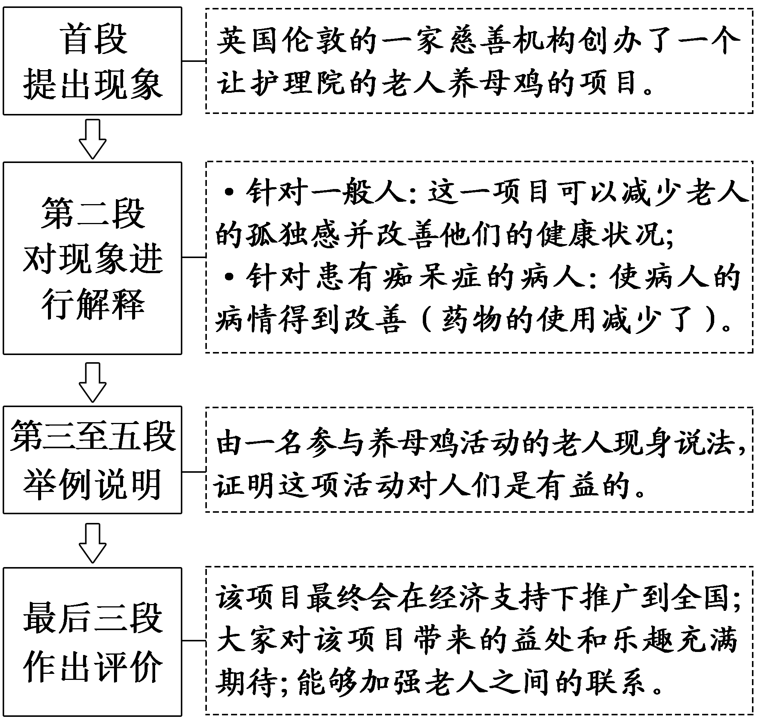

[触类旁通]
说明文大多向读者介绍新鲜的事物，这一文体特征就决定了文章内多有生僻词汇和复杂难懂句式，相比其他体裁的文章，阅读难度较大。阅读时，应把握文章结构，弄清作者所要说明的事物，尤其要重点阅读对现象的解释和评价，这是设题考查的重心所在。

[阅读七选五·例文]
(2023·全国乙卷)Indoor plants might look as if they just sit around not doing much, but in many ways they are the unsung heroes of the home. Not_only_do_they_look_beautiful,_but studies have shown that they can promote people's wellbeing by improving their mood (心情), reducing stress and helping their memory. What's more, indoor plants are easy to look after and are not very expensive.
What are indoor plants?
Indoor plants, also known as houseplants or pot plants, are plants that like to grow indoors. Many of these species (物种) are not ideally suited to growing outside in the UK, especially in the winter. Instead,_they_grow_better_inside,_where_it_is_warmer.
Why are indoor plants good for you?
Will Spoelstra, who works at the Royal Botanic Gardens，says, “There_are_many_benefits_to_growing_plants_indoors. I find during the winter months, plants around the house can really lift your mood.” Several studies have backed this up and found that indoor plants can improve creativity, focus and memory. There is also research showing that pot plants can clean the air around them by removing harmful gases, such as carbon dioxide. They also remove some harmful chemicals from paints or cooking. Plants_like_peace_lilies_and_devil's_ivy_are_among_the_best.
Which plants can you grow?
Aloe vera, peace lilies and spider plants are some of the species that are easy to grow indoors. You can buy plants from supermarkets, garden centres or online. Younger plants are often cheaper than fully grown ones, and you get to care for them as they mature — which is part of the joy of owning plants.“Learning_about_the_requirements_of_each_plant_can_be_very_rewarding，” Spoelstra says. “It can bring a new interest and focus into people's lives and help to make the link between home and nature.”

[架构分析]
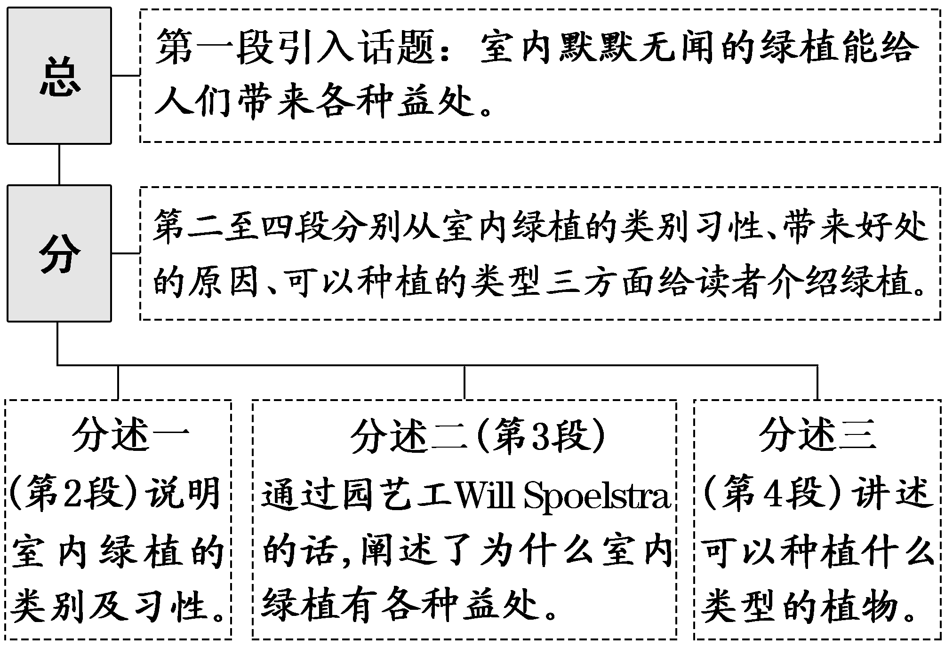
[触类旁通]
在做说明文体的阅读七选五时，要充分利用文章的小标题，它们是段落主旨，可以帮助考生更好地理解文章的逻辑结构。
四、议论文的文体特点及读文技法
议论文是一种剖析事物、论述事理、发表意见、提出主张的文体。作者通过摆事实、讲道理、辨是非等方法，直接阐述自己的观点，表明自己的态度。议论文的三要素是论点、论据和论证。论点是一篇文章的灵魂、统帅；论据是支撑论点的材料；论证是用论据来证明论点的方法和过程。文章大多以“提出问题—分析问题—解决问题”的结构行文。因此，在阅读议论文时，应该从结构和内容两方面同时入手，先通读原文，再区分事实和观点，明确论点、论据和论证，明晰作者最后得出的结论。

[典例](2023·新高考Ⅰ卷·阅读D篇)
On March 7, 1907, the English statistician Francis Galton published a paper which illustrated what has come to be known as the “wisdom of crowds” effect. The experiment of estimation he conducted showed that in some cases, the average of a large number of independent estimates could be quite accurate.
This effect capitalizes on the fact that when people make errors, those errors aren't always the same. Some people will tend to overestimate, and some to underestimate. When enough of these errors are averaged together, they cancel each other out, resulting in a more accurate estimate. If people are similar and tend to make the same errors, then their errors won't cancel each other out. In more technical terms, the wisdom of crowds requires that people's estimates be independent. If for whatever reasons, people's errors become correlated or dependent, the accuracy of the estimate will go down.
But a new study led by Joaquin Navajas offered an interesting twist (转折) on this classic phenomenon. The key finding of the study was that when crowds were further divided into smaller groups that were allowed to have a discussion, the averages from these groups were more accurate than those from an equal number of independent individuals. For instance, the average obtained from the estimates of four discussion groups of five was significantly more accurate than the average obtained from 20 independent individuals.
In a follow-up study with 100 university students, the researchers tried to get a better sense of what the group members actually did in their discussion. Did they tend to go with those most confident about their estimates? Did they follow those least willing to change their minds? This happened some of the time, but it wasn't the dominant response. Most frequently, the groups reported that they “shared arguments and reasoned together.” Somehow, these arguments and reasoning resulted in a global reduction in error.
Although the studies led by Navajas have limitations and many questions remain, the potential implications for group discussion and decision-making are enormous.

[架构分析]
本文是一篇议论文，属于“人与社会”主题语境中的社会服务与人际沟通。文章采用“提出观点—解释观点—评价观点”的行文模式。
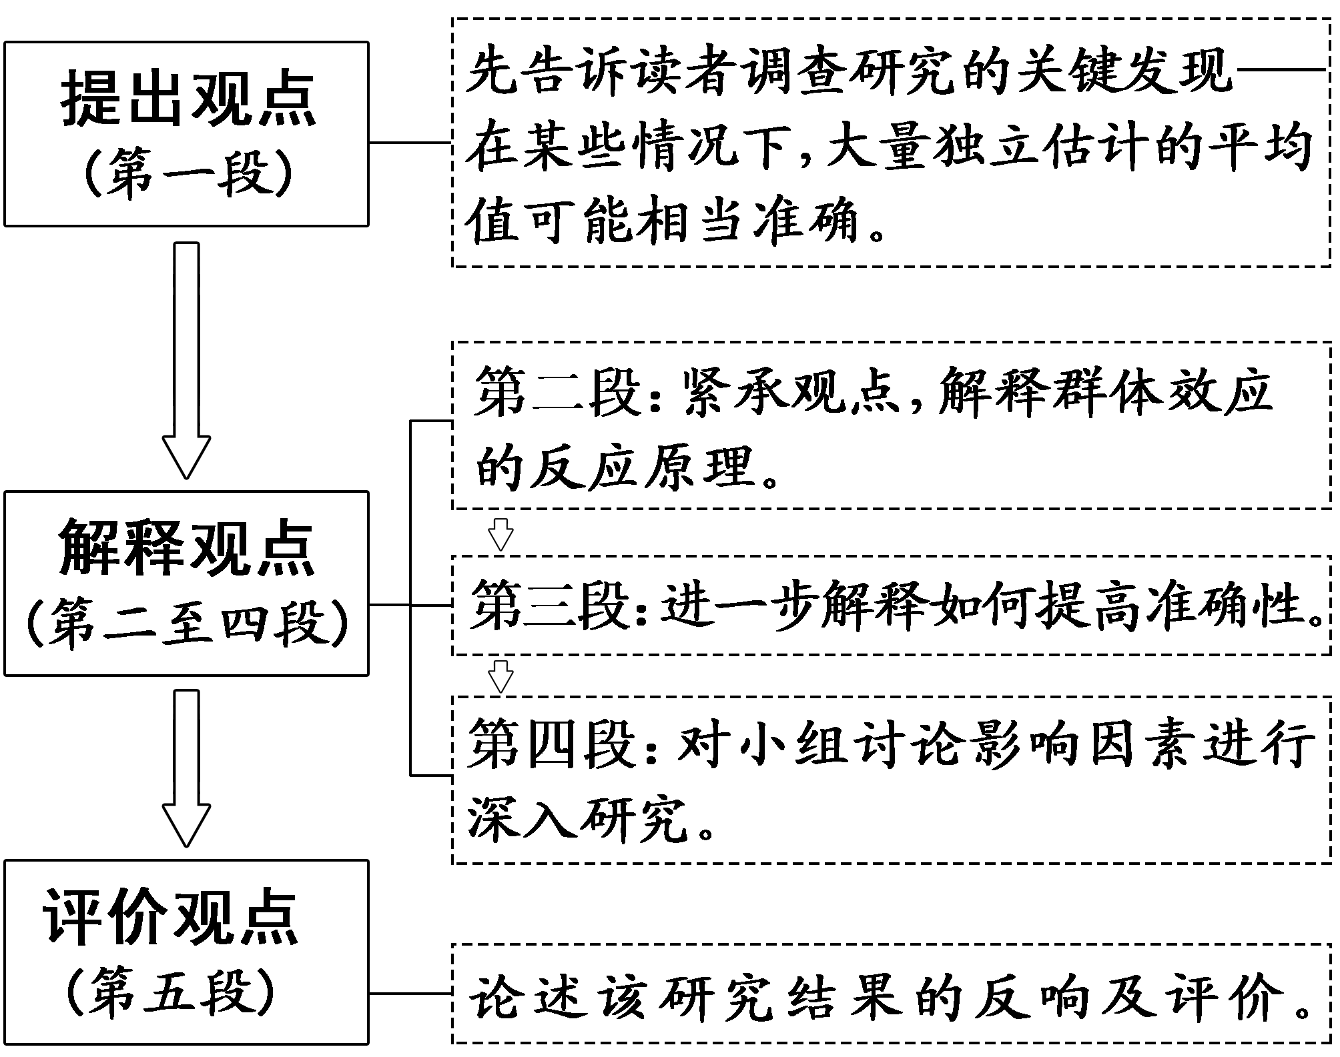
[触类旁通]
对于观点解释型文章，需要重点阅读观点和评价部分的内容，因为这些内容往往会成为命题着眼点。

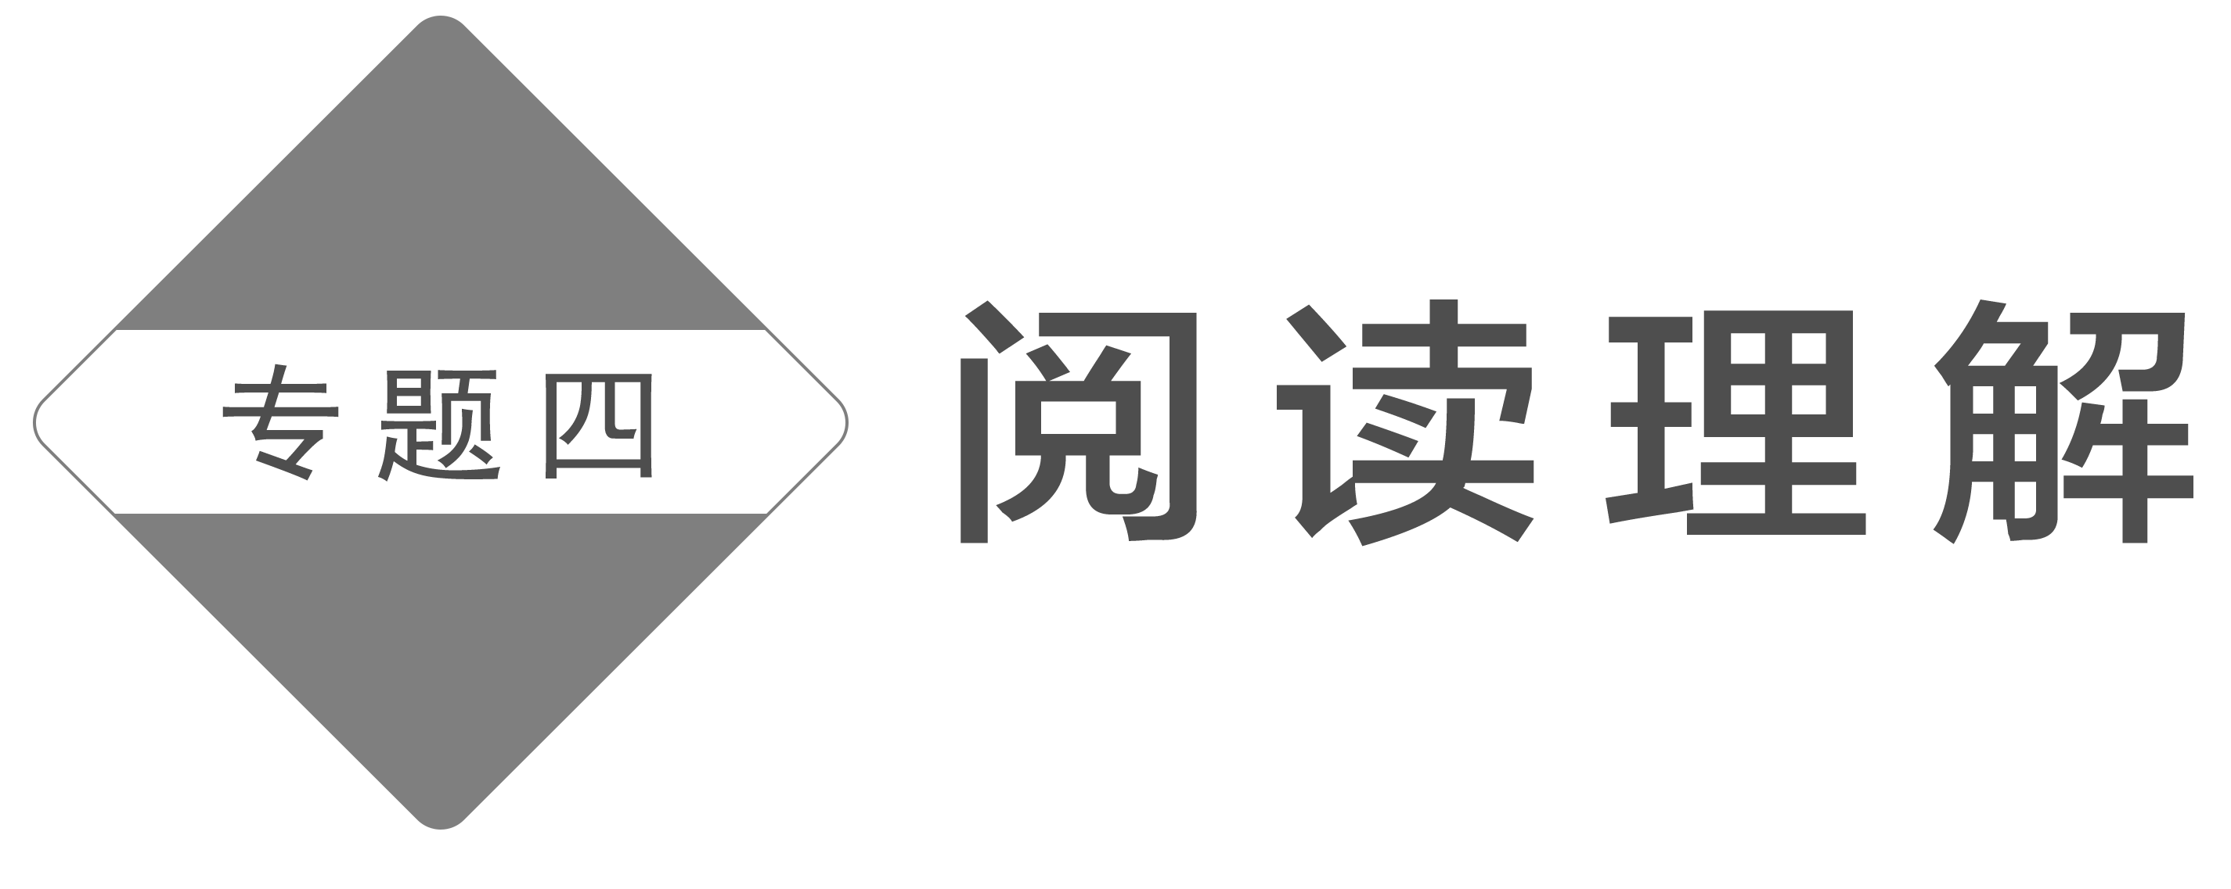

一、把握考情——3年新高考命题统计分析
年份 | 卷别 | 体裁(以A、B、C、D语篇为序) | 题型数量 |  |  |  | 题型特点
年份 | 卷别 | 体裁(以A、B、C、D语篇为序) | 细节理解 | 推理判断 | 词义猜测 | 主旨大意 | 题型特点
2023 | Ⅰ卷 | 应用文·记叙文  说明文·议论文 | 6 | 7 | 1 | 1 | 1.对标《课标》语境：选材紧紧围绕“人与自我”“人与社会”“人与自然”三大主题语境，内容越来越贴近生活。2023年高考题更加关注个体身心健康与成长，注入考生不熟悉的新理念，以增长考生的知识见识；考题凸显理性思维，思维含量明显增加，以发展考生的思维品质。  2.文章体裁多样：文章体裁包括应用文、记叙文、夹叙夹议文、说明文、议论文。  3.趋向深度理解：表现为事实理解从单句信息理解向段落综合信息理解发展，关键信息多维度、多次设项考查，对长句的理解频繁入题。2023年高考语篇及选项词汇量明显增加，加大了语篇阅读的难度。  4.渗透文化意识：文化意识的渗透性加强，凸显中国元素，具备世界视野。
2023 | Ⅱ卷 | 应用文·记叙文  说明文·说明文 | 8 | 5 | 1 | 1
2022 | Ⅰ卷 | 应用文·夹叙夹议文  说明文·说明文 | 8 | 5 | 1 | 1
2022 | Ⅱ卷 | 应用文·记叙文  说明文·说明文 | 8 | 4 | 2 | 1
2021 | Ⅰ卷 | 应用文·记叙文  说明文·说明文 | 6 | 6 | 1 | 2
2021 | Ⅱ卷 | 应用文·记叙文  说明文·说明文 | 9 | 4 | 1 | 1

二、读文指导(1)——如何破解生僻词汇
近几年高考越来越注重对考生阅读理解能力的考查，主要体现在在阅读文本中融入一些专有名词、熟词生义、合成词、派生词等，这些通常会给考生造成一定的理解障碍，无法准确理解文章内容及作者意图。正确处理阅读中遇到的生词，掌握一定的猜测生词词义的技巧，对于理解文章及答题都非常重要。对于生词(包括熟词僻义词汇)一般有下面几种策略：
1.无关紧要的词汇——跳过去
在阅读过程中，如果发现很多以大写字母开头的生词或者一连串的斜体单词，可以快速略过，只需判定生词是哪类事物即可，比如人名、地名、作品名(常用斜体)、报刊名(常用斜体)、物种名、机构组织名等，无需弄明白其具体所指。这些单词一般不会影响对文章大意的理解。
[典例] (2023·全国乙卷·阅读D篇)
The clearest example of this between literate and non-literate history is perhaps the first conflict, at Botany Bay, between Captain Cook's voyage and the Australian Aboriginals.
[分析] 对本段中出现的Botany Bay和Captain Cook这类首字母大写的单词，不要过多纠缠，尽管放心大胆地“跳过去”，它们是专有名词，不需要深究其含义，只需知道它们是地名和人名即可。
2.最熟悉的陌生词——细推敲
高考语篇中生词的数量是有限制的，但是高考对课标词汇的释义考查是没有限制的。很多单词本身有很多释义，考生所熟知的通常是教材中给出的最常用的释义，而命题人在设计试题时，所给单词的含义不会局限于考生熟悉的含义。有时基于命题的需要或者有意考查考生对词汇的掌握能力，命题者会在试题中给出一些熟悉的单词但其含义却是考生较为陌生的。有些单词的生义与熟义相近，考生根据单词的熟义和语境很容易就能推测出生义，但有些单词的生义与熟义大相径庭，需要考生结合语境仔细推敲来确定单词的含义。
[例1] (2023·新高考Ⅰ卷·阅读B篇)
When John Todd was a child, he loved to explore the woods around his house, observing how nature solved problems. A dirty stream, for example, often became clear after flowing through plants and along rocks where tiny creatures lived. When he got older, John started to wonder if this process could be used to clean up the messes people were making.
[分析] clear 熟义为“明白的，清楚的”。根据句中的stream (小溪)和flow (流动，流淌)可猜测这里表示的是“清澈的，透明的”。
[例2] (2023·新高考Ⅱ卷·阅读B篇)
And at first it is，says Abby Jaramillo, who with another teacher started Urban Sprouts, a school garden program at four low-income schools.
[分析] start熟义为“开始”。在这里用作动词，结合宾语“Urban Sprouts”可猜测这里表示“发起，创办”。
3.似曾相识的词汇——巧拆解
在阅读过程中，考生可以根据构词法猜测出某些长难单词的含义。构词法主要有三种：派生、合成和转化。派生是指一个词或词根加上前缀或后缀后构成另一个词；合成则是两个或更多的词合成一个新词；转化是由一种词性转化为另一种词性。掌握构词法有助于考生准确地猜测生词的意思，高效阅读。

类型1 顾名思义秒猜合成词
[例1] (2023·全国乙卷·阅读C篇)
It's thanks to these TV chefs rather than any advertising campaign that Britons are turning away from meat-and-two-veg and ready-made meals and becoming more adventurous in their cooking habits.
拆词解意：ready(准备好的)＋made(制作)→ready-made(现成的，做好的)
[例2] (2022·新高考Ⅰ卷·阅读D篇)
A ground-breaking, five-year study shows that diet-related changes in human bite led to new speech sounds that are now found in half the world's languages.
拆词解意：①ground(地)＋break(使破碎)＋-ing→ground-breaking(开辟新天地的，开拓性的)
②diet(日常饮食)＋related(相关的)→diet-related(与日常饮食相关的)

类型2 词缀辨义巧推派生词
[例3] (2023·浙江1月高考·阅读C篇)
Meaning emerges through a process of social interaction, not of computation, interaction that shapes the content of the symbols in our heads.
拆词解意：inter-(共同，互相，彼此)＋action (行为)→interaction(交流，互动)
[例4] (2021·全国乙卷·阅读C篇)
You've heard that plastic is polluting the oceans — between 4.8 and 12.7 million tonnes enter ocean ecosystems every year ... He builds massive sculptures out of plastic garbage, forcing viewers to re-examine their relationship to single-use plastic products.
At the beginning of the year, the artist built a piece called “Strawpocalypse，” a pair of 10-foot-tall plastic waves, frozen mid-crash.
拆词解意：①eco-(生态的)＋system(系统)→ecosystem(生态系统)
②mid-(当中)＋crash(碰撞)→mid-crash(在碰撞中)
[注意] 利用构词法猜测单词含义有时并不准确，例如前缀un- 通常表示“不，非，反”，但有些利用这个前缀构成的派生词并无否定含义(如unloose“松开”等)，所以考生在利用构词法猜测词义后，还要在语境中进行验证，切不可脱离语境。

4.生僻障碍词汇——看语境
阅读理解语篇中会出现一些生词，这些词不能通过构词法来猜测，它们往往是考生做题的拦路虎，需要考生利用上下文语境提供的线索猜测词义。(具体方法将在后面“第三讲”中详细阐述。)
三、读文指导(2)——如何破译复杂句式
学生读不懂文章，除了生僻词汇之外，另一个常见原因就是一些复杂长难句的存在影响了学生对文意的理解。下面就结合长难句的类型给予具体指导。
1．复杂简单句的破解 ——忽略不重要信息，留主干
考生在遇到这类长难句时，首先应迅速找出句子的主干(主谓宾结构)；其次找出主语、谓语和宾语各自的修饰语，如定语、状语等；最后，忽略它的修饰成分，即忽略不重要的信息，留主干和关键内容。这样，就能快速、准确地理解这类句子所表达的中心意思。
[典例] (2023·新高考Ⅰ卷·阅读C篇)
In these chapters, I examine issues such as the importance of solitude (独处) and the necessity of cultivating high-quality leisure to replace the time most now spent on mindless device use.
[分析] 这是个复杂的简单句。先忽略不重要的信息(介词短语In these chapters作状语；such as the importance of solitude and the necessity of cultivating high-quality leisure作定语；动词不定式短语to replace the time作目的状语；过去分词短语most now spent on mindless device use作后置定语)，留主干和关键部分(I examine issues)。这样就将长难句化解为简单的短句。
[句意] 在这些章节中，我研究了一些问题，比如独处的重要性，以及培养高质量休闲的必要性，以取代现在大部分花在无意识地使用电子设备上的时间。

2．含有多个简单句的并列句 ——找并列连词，意群阅读法
含有多个简单句的并列句是由并列连词(and, but, or等)或分号(；)把两个或两个以上的简单句连在一起构成的句子。意群阅读法是突破这类长难句非常有效的一种方法，即以意群而不是单词为最小阅读单位的一种快速阅读方法。考生首先找到并列连词，然后把全句分解为若干个意群。这样，化整为零，各个击破，就能轻松、准确地理解这类长难句。
[典例] (2023·全国乙卷·阅读D篇)
Ideally a history would bring together texts and objects, and some chapters of this book are able to do just that, but in many cases we simply can't.
[分析] 这是个含有三个简单句的并列句。首先找到连接两个简单句的并列连词：and和but，接着把这个含有三个简单句的并列句划分为3个意群，然后对每个简单句进行整体理解，各个击破。
[句意] 理想情况下，历史应该将文本和对象结合在一起，本书的某些章节能够做到这一点，但在许多情况下，我们根本做不到。
3．含有多个从句的复合句 ——寻关联，辨逻辑
含有多个从句的复合句其实是由主句与若干分句组成的复合句，可谓“句中套句”，逻辑层次多，结构错综复杂。在答题时间有限的情况下，如果考生没有扎实的语言基本功，就很难在短时间内理出头绪。
寻找主句与各种从句之间的关键词(分句的引导词或关联词)是破解含有多个从句的复合句的有效方法。阅读时，先找引导词或关联词，然后根据引导词或关联词分辨出句子之间的逻辑关系。抓住了引导词或关联词，就可以将长难句变为简单句，从而能够分别弄清主句和从句的意义。通过将句子化整为零的方法，各个击破，这类长难句也就容易理解了。
[典例] (2023·新高考Ⅱ卷·阅读D篇)
Naming each nature experience creates a usable language, which helps people recognize and take part in the activities that are most satisfying and meaningful to them.
[分析] 句子主干是Naming each nature experience creates a usable language; which引导定语从句，修饰先行词language。该定语从句中又包含另一个定语从句 that are most satisfying and meaningful to them，修饰先行词activities。
[句意] 给每种自然体验命名可以创造出一种可用的语言，它有助于帮助人们认识和参与对他们来说最令人满意和有意义的活动。

4．并列复合句的破解 ——找并列连词，寻关联逻辑
一些长句其实是由若干分句组成的并列复合句，而这些并列复合句之间需要一些关联词来连接。如果考生找准这些关联词，就能够弄清楚句与句之间的逻辑关系，进而弄清楚主句的意义和各从句的意义，这样长句就容易理解了。要掌握此方法必须对英语中常见的关联词熟记于心。
[典例] (2023·新高考Ⅱ卷·阅读D篇)
Past research has found health and wellness benefits of nature for humans, but a new study shows that wildness in urban areas is extremely important for human well-being.
[分析] 这是一个由转折连词but连接的并列复合句。but前第一个分句为“主谓宾状”结构的简单句，but后第二个分句为复合句，其中that引导宾语从句，作shows的宾语。
[句意] 过去的研究发现，自然对人类的健康有益，但一项新的研究表明，城市地区的野生环境对人类的福祉极其重要。

第一讲 细节理解题——细心就能做对
细节理解题主要考查考生对文中细节信息的理解。考生需要根据不同的设问角度阅读原文，以获取某些特定的信息或准确地寻找所需的细节。

一、细节理解题的设问方式与选项特征
1．常见设问方式
(1)特殊疑问句形式。以when，where，what，which, who, how much/many等疑问词引出问题。这是最常见的设问形式。
(2)以“According to ...”开头的提问形式。
(3)就文中数字、排序等提问。
(4)填空形式。如The biggest challenge for most mothers is from ____________.
2．正确选项特征
原文原词 | 利用原文原词作为正确选项
同义替换 | 指对原文句子中的关键词进行同义替换。如把lose one's job换成be out of work。有些细节理解题把原文中的一些词变换了词性，如把important变换成了of importance；改变原文中句子的语态，如主动语态与被动语态的转换
信息归纳 | 用精练的语言来概括原文中比较分散或复杂的信息，设置为正确答案
正话反说 | 把原文中的意思反过来表达而成为正确选项

3．干扰选项特征
张冠李戴 | 是原文信息，但不是题目要求的内容
无中生有 | 符合常识，但不是文章的内容
曲解文意 | 与原文的内容极其相似，只是在某个细节处有些变动
颠倒是非 | 在意思上与原文大相径庭甚至完全相反
正误参半 | 部分正确，部分错误

二、细节理解题的常见题型与解题技法
(一)直接信息题和数字计算题
1．直接信息题
直接信息题比较简单，一般能在文中直接找到明确的信息，往往只考查文章中的个别事实，通常只涉及原文一两句话的信息。
解此类试题常用“定位比对”法。解题流程如下：
第一步 | 在题干中标注定位词
第二步 | 在原文中查找与定位词或其近义词相关的信息句
第三步 | 比对选项与信息句，锁定答案

2．数字计算题
通常会涉及时间、年龄、价钱、数量、距离等的简单计算。一般来说，计算量都比较小，容易计算，但需要找出计算背后所隐含的信息。这些“暗”信息会涉及对某个复杂句的理解，从这个角度上讲，理解文中相应的复杂句是解这类题的关键。
解此类试题常用“整合推算”法。解题流程如下：
第一步 | 读题干，查找关键词寻读原文，标记数字、时间、年代等信息
第二步 | 分析题干询问数据与原文数据的逻辑关系
第三步 | 用加减乘除法进行推算，确定答案

[典例] (2023·新高考Ⅰ卷·阅读A篇)
Bike Rental & Guided Tours
Welcome to Amsterdam, welcome to MacBike. You see much more from the seat of a bike! Cycling is the most economical, sustainable and fun way to explore the city, with its beautiful canals, parks, squares and countless lights. You can also bike along lovely landscapes outside of Amsterdam.
Why MacBike
MacBike has been around for almost 30 years and is the biggest bicycle rental company in Amsterdam.With over 2,500 bikes stored in our five rental shops at strategic locations, we make sure there is always a bike available for you. We offer the newest bicycles in a wide variety, including basic bikes with foot brake (刹车), bikes with hand brake and gears (排挡), bikes with child seats, and children's bikes.
Prices
 | Hand Brake, Three Gears | Foot Brake, No Gears
1 hour | 7.50 | 5.00
3 hours | 11.00 | 7.50
1 day (24 hours) | 14.75 | 9.75
Each additional day | 8.00 | 6.00

Guided City Tours
The 2.5-hour tour covers the Gooyer Windmill, the Skinny Bridge, the Rijksmuseum, Heineken Brewery and much more. The tour departs from Dam Square every hour on the hour, starting at 1：00 pm every day. You can buy your ticket in a MacBike shop or book online.
21．What is an advantage of MacBike?
A．It gives children a discount.
B．It offers many types of bikes.
C．It organizes free cycle tours.
D．It has over 2,500 rental shops.
22．How much do you pay for renting a bike with hand brake and three gears for two days?
A.15.75. B.19.50.
C.22.75. D.29.50.
23．Where does the guided city tour start?
A．The Gooyer Windmill.
B．The Skinny Bridge.
C．Heineken Brewery.
D．Dam Square.

[解题示范]
第21题：直接信息题
一定 | 选定题干中的关键词advantage和MacBike。
二找 | 根据第二段尾句中including basic bikes with foot brake (刹车), bikes with hand brake and gears (排挡), bikes with child seats, and children's bikes可知，MacBike公司的一个优势是能提供各种款式的自行车，以满足各类人群的需求。
三比对 | A项：文章中并未提到，属于无中生有，主观臆断。
三比对 | B项：选项中的many types of bikes是对原文信息的归纳。故选B。
三比对 | C项：选项中的free意为“免费的”，明显与Prices部分不符，属于颠倒是非。
三比对 | D项：文章中尽管提到over 2,500，但那是自行车的数量，而不是租赁商店的数量，属于正误参半。

第22题：数字计算题
一定 | 根据题干中的关键词语How much和with hand brake and three gears for two days，确定是数字计算题。
二推 | 根据Prices部分所列表格的内容可知，带手刹的三挡自行车的日租金为14.75欧元，每超出一天按8欧元计算。
三计算 | 14.75＋8＝22.75，故租两天的费用为22.75欧元。故选C。

第23题：直接信息题
一定 | 选定题干中的关键词语guided city tour和start。
二找 | 根据尾段倒数第二句可知，有导游解说的城市游览从Dam Square出发。
三比对 | A项、B项和C项虽然在最后一段有所提及，但那不是旅程的出发地点，属于正误参半。故选D。

(二)间接信息题和综合信息题
1．间接信息题
此类试题相比直接信息题，命题的隐蔽性更强，正确选项一般都会在原文基础上进行改造。解答间接信息题时，要做到“两关注”“一防范”。“两关注”是指关注正确选项的两个特征：一是同义词替换或释义，即把文中的语言(词汇和结构)改头换面，来表达相同的意思；二是对文章信息的归纳。“一防范”是指防范干扰选项的逼真性，稍有不慎就会落入命题人设置的陷阱中。
解此类试题常用“同义转换”法。解题流程如下：
第一步 | 读题干，锁定关键词
第二步 | 扫原文，锁定信息区间
第三步 | 用5种正确选项特征定答案：  1.同义/近义/反义词复现；  2.同根词或原词复现；  3.简化原文复杂的表达；  4.正话反说；5.变换语态

2．综合信息题
综合信息题涉及一段内的多个信息或多段内容，且各个细节信息都能在文章中找到，因此考生要综合细节信息，认真分析、概括和归纳得出正确答案。
解此类试题常用“概括归纳”法。解题流程如下：
第一步：分析题干 | 分析题干找出关键词，根据关键词在文中找到信息源
第二步：提炼信息 | 对散落在文章中不同的信息源，一一分析提炼，弄清楚各信息源的主要内容
第三步：综合概括 | 对各个信息源综合概括归纳，确定答案

[典例] (2022·全国乙卷·阅读C篇)
Can a small group of drones (无人机) guarantee the safety and reliability of railways and, at the same time, help railway operators save billions of euros each year? That is the very likely future of applying today's “eyes in the sky” technology to making sure that the millions of kilometres of rail tracks and infrastructure (基础设施) worldwide are safe for trains on a 24/7 basis.
Drones are already being used to examine high-tension electrical lines. They could do precisely the same thing to inspect railway lines and other vital aspects of rail infrastructure such as the correct position of railway tracks and switching points. The more regularly they can be inspected, the more railway safety, reliability and on-time performance will be improved. Costs would be cut and operations would be more efficient (高效) across the board.
That includes huge savings in maintenance costs and better protection of railway personnel safety. It is calculated that European railways alone spend approximately 20 billion euros a year on maintenance, including sending maintenance staff, often at night, to inspect and repair the rail infrastructure. That can be dangerous work that could be avoided with drones assisting the crews' efforts.
By using the latest technologies, drones could also start providing higher-value services for railways, detecting faults in the rail or switches, before they can cause any safety problems. To perform these tasks, drones for rail don't need to be flying overhead. Engineers are now working on a new concept: the rail drones of the future. They will be moving on the track ahead of the train, and programmed to run autonomously. Very small drones with advanced sensors and AI and travelling ahead of the train could guide it like a co-pilot. With their ability to see ahead, they could signal any problem, so that fast-moving trains would be able to react in time.
28．What makes the application of drones to rail lines possible?
A．The use of drones in checking on power lines.
B．Drones' ability to work at high altitudes.
C．The reduction of cost in designing drones.
D．Drones' reliable performance in remote areas.
30．What function is expected of the rail drones?
A．To provide early warning.
B．To make trains run automatically.
C．To earn profits for the crews.
D．To accelerate transportation.
[解题示范]
第28题：间接信息题
一定 | 读题干，锁定关键词rail lines。
二找 | 扫原文，锁定信息区间。根据第二段中的“Drones are already being used to examine high-tension electrical lines ... other vital aspects of rail infrastructure ... ”可知，无人机已经被用于检查高压电线，这使得无人机在铁路线上的应用成为可能。
三转换 | examine与check on为同义词，electrical lines与power lines为同义词，故选A。

第30题：综合信息题
一分析 | 题干问的是铁路无人机有望具有什么功能，关键词为function，锁定最后一段。
二提炼 | 根据最后一段第一句“By using the latest technologies ... detecting faults in the rail or switches, before they can cause any safety problems.”和最后一句“With their ability to see ahead ... would be able to react in time.”可提炼信息为人们期待未来的无人机的功能是提前看到问题，并给火车发出警示。
三概括 | 对提炼的信息综合概括，确定答案为A。
考生要想在细节理解题上拿高分并不难，这需要细心和耐心，重点识别干扰项陷阱和理解细节信息。有些干扰选项要对原文中提供的信息进行简单的思维加工后才可排除，因此要认真分析句子，读懂后再答题；对一些模棱两可、无把握的选项，可用排除法辅助答题。


A
(2023·湖南师大附中三模)
Explore Scenic Train Journeys
The four most scenic train journeys provide not only beautiful sceneries at destination cities, but also charming views outside the trains' windows on the way.
Route 1: Xining to Lhasa
Length: around 1,900km
Duration: 22 hours
This train route is the longest high altitude train trip in the world — named as the way to the sky. Most of this route is over 4,000 meters and it goes above 5,000 meters several times. After the train has left Xining Railway Station for about an hour, you can see the boundless lake — Qinghai Lake.
Route 2: Lhasa to Rikaze
Length: around 250km
Duration: 2.5 hours
This railway has an average high altitude of above 3,600 meters. It makes Tibet travel more convenient for travelers, especially those who want to see Mount Qomolangma. Along the railway line, you can see local farmers and yaks (牦牛). And most of the time, you can appreciate a plateau (高原) landscape of mountains and meadows.
Route 3: Chengdu to Kunming
Length: around 1,100km
Duration：6 hours (high-speed train)
From Chengdu's plains area, with an altitude of about 400 meters, the train goes up to altitudes of about 2,000 meters, traveling through tunnels and across mountains. The complex geography along the railway line gives this route the name of Geological Museum.
Route 4: Beijing to Shanghai
Length: around 1,300km
Duration: 5.5 hours
Beijing and Shanghai are two of the most popular cities for foreign travelers who come to China for the first time. It is a trip that combines some of China's main urban landscapes with cultivated countryside scenery and mountains in between. The new and modern facilities on the train ensure you have a comfortable journey.
语篇解读：本文是一篇应用文，介绍了四条风景最优美的火车之旅。
1．Which route takes the least time?
A．Lhasa to Rikaze. B．Chengdu to Kunming.
C．Xining to Lhasa. D．Beijing to Shanghai.
解析：选A 细节理解题。从每段旅程的“Duration”中可知，Route 1: Xining to Lhasa需22小时，Route 2: Lhasa to Rikaze需2.5小时，Route 3: Chengdu to Kunming需6小时，Route 4: Beijing to Shanghai需5.5小时。所以Route 2: Lhasa to Rikaze所需的时间是最少的。
2．What makes Route 3 special?
A．Its convenience for travelers.
B．Its wide popularity among foreigners.
C．Its complicated geography along the route.
D．Its new and modern facilities on the train.
解析：选C 细节理解题。根据小标题Route 3: Chengdu to Kunming下的内容可知，这条铁路线的特别之处是沿线地形复杂，被称为“地质博物馆”。
3．What do the four routes have in common?
A．Travelers can experience high altitude train trips.
B．Travelers can witness a plateau view and some yaks.
C．Travelers can appreciate the scenery of Qinghai Lake.
D．Travelers can admire beautiful views from the train windows.
解析：选D 细节理解题。根据第一段的内容可知，旅客们在这四条铁路线上都可以欣赏到窗外美丽的风景。
B
(2023·日照三模)Most of us take the task of buying a cup of coffee for granted, as it seems simple enough. However, we have no idea just how stressful tasks like this can be for people who suffer from disabilities. That's why it's so heart-warming to see a story like this in which a barista (咖啡师) does something small to make life a little easier for someone who is deaf.
Ibby Piracha lost his hearing when he was only two years old, and he now goes to his local cafe in Leesburg, Virginia to order a cup of coffee at least three times a week. Though all the baristas who work there have his order memorized, Ibby always write his order on his phone and shows it to the barista.
One day, however, one of the baristas did something that changed everything! After Ibby ordered his coffee, he was amazed when barista Krystal Payne handed him a note in response. “I've been learning sign language just so you can have the same experience as everyone else，” the note read. Krystal then asked Ibby in sign language what he would like to order.
Ibby was touched that she would learn sign language just to help him feel welcome. “I was just so moved that she actually wanted to learn sign language. It is really a totally different language and it was something that she wanted to do because of me. Because I was a deaf customer. I was very, very impressed，” Ibby said.
Krystal had spent hours watching teaching videos so that she could learn enough sign language to give Ibby the best customer service that she could! “My job is to make sure people have the experience they expect and that's what I gave him，” Krystal says.
Ibby posted a photo of Krystal's note online, and it quickly went viral, getting hundreds of likes and comments that praised Krystal for her kind action.
语篇解读：本文是一篇记叙文。文章主要讲述了聋哑人Ibby在买咖啡的时候遇到了一位服务员，她学习手语，希望能够让Ibby拥有和其他人同样的购物体验。
4．What can we learn about Ibby Piracha from Paragraph 2?
A．He was born deaf.
B．He lives a hard life.
C．He loves to order take-out food.
D．He visits the cafe regularly.
解析：选D 细节理解题。根据第二段中的“Ibby Piracha lost his hearing ... three times a week.”可知，Ibby Piracha经常去这家咖啡馆。
5．Why did Krystal learn sign language?
A．To serve Ibby better.
B．To attract more customers.
C．To give Ibby a big surprise.
D．To make herself more popular.
解析：选A 细节理解题。根据第三段中的“After Ibby ordered his coffee ... as everyone else”可知，Krystal学习手语是为了更好地为Ibby服务，让他能和其他人有同样的体验。
[易错诊断]
本题易误选C项。部分考生根据文中第三段中的“he was amazed when barista Krystal Payne handed him a note in response”认为Krystal之所以学习手语是为了给他一个惊喜。虽然同义转换是解答此类题目的关键所在，但含有同义转换的选项并不都是正确答案，应该根据文章信息进行综合理解。
6．Which of the following can best describe Krystal?
A．Kind and considerate.
B．Honest and responsible.
C．Sociable and humorous.
D．Ambitious and sensitive.
解析：选A 推理判断题。根据第三段中的“After Ibby ordered his coffee ... like to order.” 可知，Krystal之所以学习手语是为了让Ibby能和其他人有同样的购物体验，可推测Krystal是个心地善良且又善解人意的人。
7．What message does the author want to convey in the text?
A．Two heads are better than one.
B．A small act makes a difference.
C．One good turn deserves another.
D．Actions speak louder than words.
解析：选B 推理判断题。通读全文，尤其是根据第四段“Ibby was touched ... Ibby said.”可知，文章主要想表达的是一个小举动却让Ibby印象深刻，并让他心里充满温暖。

第二讲 推理判断题——重在合情合理
推理判断题是指在理解原文字面意义的基础上，通过对语篇逻辑关系的分析和细节的暗示，做出合情的推理和符合文意的判断。根据近几年高考来看，推断隐含意义、写作意图、观点态度为高频考点，而推断下段内容、文章出处、读者对象等为低频考点。推理判断题的解题基本原则是：合文意、合情理，不可妄加推断、过度推断。

一、把握推理判断题的命题特点
1．常见设问方式
(1)What can we infer from the text?
(2)What can be inferred from the last paragraph?
(3)What is the author's main purpose in writing the text?
(4)What is the purpose of this text?
(5)What's the author's attitude towards ...?
(6)Where does this passage probably come from?
(7)Where can the text be found?
(8)Which of the following can best describe ...?
2．正确选项特征
(1)“立足原文，只推一步”，即根据原文内容，一步即可推断出结果。
(2)选项中一般不可以出现表示绝对概念的词，如only, never, all和absolutely等；正确答案的表述一般会用一些相对能够留下一些余地的词，如often, usually, sometimes, some, may, might, can, could, possibly和probably等。
3．干扰选项特征
背离主题 | 选项背离了文章的主题思想
事实复述 | 选项仅仅是对原文事实进行简化复述，而非推断出来的
主观臆断 | 没有基于原文进行推断，而是根据常识推断
过度推断 | 有时作者只是客观地叙述事实，并未做出评论，而一些选项却主观地进行推断。如提到一样东西贵，并不意味着买不起
以偏概全 | 一些选项仅对某一句话进行推断，而忽略了其他信息，造成以偏概全错误
偷换概念 | 某些干扰项的内容与原文句子结构及词汇几乎完全一样，只是在不起眼的地方略微改动某个词或表达方法，造成干扰项与短文内容发生细微的变化；或者利用原文中的词来伪造选项或断章取义，干扰性极强
逻辑颠倒 | 某些选项与原文不符，出现逻辑颠倒，如因果倒置、手段与目的倒置等

二、熟悉推理判断题的三种常考题型
题型(一) 细节推理判断题
细节推理判断题要求考生根据语篇内容，推断具体细节，如时间、地点、人物关系、人物身份、事件等。一般可根据短文提供的信息，或者借助生活常识进行推理判断。考生只有正确把握文章的内在联系，理解文章的真正含义，才可能做出准确的推断。注意题干中常用的六个动词：infer (推断), indicate (象征，暗示), imply (暗示), suggest (表明), conclude (得出结论)和assume (假定，设想)。
[例1] (2023·全国甲卷·阅读D篇节选)
Obviously, if precautions (预防) aren't taken, grizzlies can become troublesome, sometimes killing farm animals or walking through yards in search of food. If people remove food and attractants from their yards and campsites, grizzlies will typically pass by without trouble. Putting electric fencing around chicken houses and other farm animal quarters is also highly effective at getting grizzlies away. “Our hope is to have a clean, attractant-free place where bears can pass through without learning bad habits，” says James Jonkel, longtime biologist who manages bears in and around Missoula.
35．What can be inferred from the last paragraph?
A．Food should be provided for grizzlies.
B．People can live in harmony with grizzlies.
C．A special path should be built for grizzlies.
D．Technology can be introduced to protect grizzlies.
分析：这是一道细节推理判断题。根据节选段中的“If people remove food and attractants ... is also highly effective at getting grizzlies away.”可知，如果人们把食物和引诱剂从他们的院子和露营地移走，灰熊通常会安然通过。在鸡舍和其他农场动物生活区周围设置电动围栏也能有效地赶走灰熊。由此可以推断，人类可以和灰熊和谐共处。故选B。
题型(二) 观点、态度推理判断题
1．文章的观点或结论推理判断题
此类试题问的不一定是全文的中心思想或作者的全文观点，可能只是文章中的某一片段的观点。但要推测文中某一观点，仍离不开对全文中心思想的把握，因为它们在语义上是紧密相连的，次要的观点是支撑说明全文主要观点的。所以理解全文的主要观点或中心思想对正确解答此类试题至关重要。
2．作者态度、语气推理判断题
此类试题往往通过作者在文章里的措辞、感情色彩表现出来，并常常用一些词汇进行表述。因此考生必须透过字里行间察其端倪，以此作为前提进行推理。
[例2] (2023·浙江1月高考·阅读B篇节选)
Zero waste was a radical lifestyle movement a few years back.I remember showing my parents a video of Bea Johnson, sharing how cool I thought it would be to buy groceries with jars, and have so little trash！A few days later, I came back with my first jars of zero waste groceries, and my dad commented on how silly it was for me to carry jars everywhere. It came off as a bit discouraging.
25．What was the attitude of the author's father toward buying groceries with jars?
A．He disapproved of it.
B．He was sympathetic to it.
C．He was tolerant of it.
D．He didn't care about it.
分析：此题考查对观点态度的判断。根据节选段中的 “my dad commented on how silly ...jars everywhere” 可知，作者的父亲说作者到哪里都拿着罐子是愚蠢的，这令作者感到沮丧。由silly这一暗示情感态度的表达可以判断，父亲对作者在“零浪费”生活方式上做的尝试并不赞同。故选A。
题型(三) 写作意图推理判断题
写作意图推理判断题要求考生根据文章的论述，揣测作者的写作意图及运用某种写作手法的目的。作者一般不直接陈述自己的意图，而是通过文章所提供的事实，客观地使读者信服某种想法或观点。这类题型不但要求考生能理解文章的大意，同时还要具备对作者阐述问题的方法进行分析和归纳总结的能力。
[例3] (2023·浙江1月高考·阅读C篇)
A machine can now not only beat you at chess, it can also outperform you in debate. Last week, in a public debate in San Francisco, a software program called Project Debater beat its human opponents, including Noa Ovadia, Israel's former national debating champion.
Brilliant though it is，Project Debater has some weaknesses. It takes sentences from its library of documents and prebuilt arguments and strings them together.This can lead to the kinds of errors no human would make. Such wrinkles will no doubt be ironed out, yet they also point to a fundamental problem. As Kristian Hammond, professor of electrical engineering and computer science at Northwestern University, put it: “There's never a stage at which the system knows what it's talking about.”
What Hammond is referring to is the question of meaning, and meaning is central to what distinguishes the least intelligent of humans from the most intelligent of machines. A computer works with symbols. Its program specifies a set of rules to transform one string of symbols into another. But it does not specify what those symbols mean. Indeed, to a computer，meaning is irrelevant.Humans，in thinking, talking, reading and writing, also work with symbols. But for humans, meaning is everything. When we communicate, we communicate meaning. What matters is not just the outside of a string of symbols, but the inside too, not just how they are arranged but what they mean.
Meaning emerges through a process of social interaction, not of computation, interaction that shapes the content of the symbols in our heads. The rules that assign meaning lie not just inside our heads, but also outside, in society, in social memory, social conventions and social relations. It is this that distinguishes humans from machines. And that's why, however astonishing Project Debater may seem, the tradition that began with Socrates and Confucius will not end with artificial intelligence.
28．Why does the author mention Noa Ovadia in the first paragraph?
A．To explain the use of a software program.
B．To show the cleverness of Project Debater.
C．To introduce the designer of Project Debater.
D．To emphasize the fairness of the competition.
分析：此题考查考生对写作意图的推理判断能力。文章第一段提到一个击败以色列前国家辩论冠军Noa Ovadia的软件程序，再结合第二段提到它无法理解意义的缺陷以及最后的结论只有社会互动才是理解意义的关键可判断，提到Noa Ovadia是为了说明 Project Debater在辩论方面很出色，故选B。

三、灵活运用6大解题技法
推理判断题的题型多样，考查内容灵活，在解题时可依据设问角度灵活运用以下6类解题技法。
技法(一) 根据特定信息，运用逆向思维进行推断
有些推理判断题，可根据题干提供的信息，到原文中去抓关键信息，然后进行分析、推理、判断，利用逆向思维，从而得出正确的结论。
[例1] (2023·全国乙卷·阅读B篇节选)
One time my friends and I drove three hours to Devil's Lake, Wisconsin, to climb the purple quartz (石英) rock around the lake. After we found a crazy-looking road that hung over a bunch of rocks, we decided to photograph the scene at sunset. The position enabled us to look over the lake with the sunset in the background. We managed to leave this spot to climb higher because of the spare time until sunset. However, we did not mark the route (路线) so we ended up almost missing the sunset entirely. Once we found the place, it was stressful getting lights and cameras set up in the limited time. Still, looking back on the photos, they are some of my best shots though they could have been so much better if I would have been prepared and managed my time wisely.
26．What can we infer from the author's trip with friends to Devil's Lake?
A．They went crazy with the purple quartz rock.
B．They felt stressed while waiting for the sunset.
C．They reached the shooting spot later than expected.
D．They had problems with their equipment.
分析：根据题干中的“Devil's Lake”定位到节选段。根据所给段落中的“However, we did not mark the route ... it was stressful getting lights and cameras set up in the limited time.”可知，文中描述的是作者和朋友几乎完全错过了日落，之后安置拍摄设备的时间就非常有限了，由此可逆向推断出他们比预想的到达时间晚。故选C。
技法(二) 整合全文(段)信息进行推断
有些推理判断题，很难从某一句话或某几句话中推断出其含义，这时就需要在理解全文(段)意思的基础上，整合与题目相关的有用信息，综合起来去推理判断，从而确定最佳结论。
[例2] (2023·新高考Ⅰ卷·阅读C篇)
The goal of this book is to make the case for digital minimalism, including a detailed exploration of what it asks and why it works, and then to teach you how to adopt this philosophy if you decide it's right for you.
To do so, I divided the book into two parts. In part one, I describe the philosophical foundations of digital minimalism, starting with an examination of the forces that are making so many people's digital lives increasingly intolerable, before moving on to a detailed discussion of the digital minimalism philosophy.
Part one concludes by introducing my suggested method for adopting this philosophy：the digital declutter. This process requires you to step away from optional online activities for thirty days. At the end of the thirty days, you will then add back a small number of carefully chosen online activities that you believe will provide massive benefits to the things you value.
In the final chapter of part one, I'll guide you through carrying out your own digital declutter. In doing so, I'll draw on an experiment I ran in 2018 in which over 1,600 people agreed to perform a digital declutter. You'll hear these participants' stories and learn what strategies worked well for them, and what traps they encountered that you should avoid.
The second part of this book takes a closer look at some ideas that will help you cultivate (培养) a sustainable digital minimalism lifestyle. In these chapters, I examine issues such as the importance of solitude (独处) and the necessity of cultivating high-quality leisure to replace the time most now spent on mindless device use. Each chapter concludes with a collection of practices, which are designed to help you act on the big ideas of the chapter. You can view these practices as a toolbox meant to aid your efforts to build a minimalist lifestyle that works for your particular circumstances.
28．What is the book aimed at?
A．Teaching critical thinking skills.
B．Advocating a simple digital lifestyle.
C．Solving philosophical problems.
D．Promoting the use of a digital device.
分析：本题需结合全文的内容进行整合推理判断。根据第一段中的“The goal of this book is to make the case for digital minimalism”、第二段中的“digital lives”和最后一段中的“a sustainable digital minimalism lifestyle”可知，本书旨在倡导一种简单的数字生活方式。故选B。
技法(三) 根据语境的褒贬性进行推断
文章是作者抒发感情、表达观点的一种方式。因此，很多文章，尤其是记叙文和议论文，其语境都有一定的褒贬性，这种褒贬性反映了主人公的特定心理和情绪状态以及作者的写作意图。利用好文章的语境褒贬性就能在把握主旨的基础上对文章进行准确地逻辑判断。找出反映语境褒贬性及变化的标志性词汇或句子，对掌握文章主旨大意、了解主人公的心理特点及情感变化，从而正确地进行逻辑推断很有用处。
[例3] (2019·全国卷Ⅰ·阅读D篇节选)
During the rosy years of elementary school (小学), I enjoyed sharing my dolls and jokes, which allowed me to keep my high social status.I was the queen of the playground.Then came my tweens and teens, and mean girls and cool kids.They rose in the ranks not by being friendly but by smoking cigarettes, breaking rules and playing jokes on others, among whom I soon found myself.
32．What sort of girl was the author in her early years of elementary school?
A．Unkind. B．Lonely.
C．Generous. D．Cool.
分析：观察四个选项可以看出，C项是褒义词，A、B、D三项是贬义词。因此要注意文章里面所表现的褒贬色彩。根据节选段第一句“During the rosy years of elementary school (小学), I enjoyed sharing my dolls and jokes”可知，作者在小学时乐于与他人分享，是个慷慨大方的女孩。故选C。
技法(四) 根据作者的思想倾向和感情色彩，推断观点态度
此方法适用于推断作者及文中人物的观点、态度、情感等。观点和态度一般分为三类：支持或反对、乐观或悲观、主观或客观。作者的这种思想倾向和感情色彩往往隐含在文章的字里行间。解答此类题目应多注意行文中的措辞，特别是具有感情色彩的形容词或副词。

解此类试题常用“忠于措辞”法。
忠于措辞法 | 关注首段首尾句，推断文章主题，确定作者或某个人物的观点
忠于措辞法 | 关注but后表示观点态度的语句，推断作者或文中人物的观点
忠于措辞法 | 关注作者所举的例子或所引用的话语，推测作者或文中人物的态度倾向
忠于措辞法 | 关注文章语言的褒贬，推测作者的态度
忠于措辞法 | 不要用自己的态度代替作者的态度

把握感情色彩，推断观点态度，要注意文中的一些表达情感态度的倾向词。
支持、肯定 | favorable 赞同的 positive 肯定的  approving 赞成的 reasonable 合理的
反对、否定 | critical 批评的 negative 否定的  disapproving 不赞成的 impractical 不实际的  radical 激进的 prejudiced 有成见的
中立、客观 | objective 客观的 neutral 中立的  indifferent/unconcerned漠不关心的

[例4] (2021·新高考Ⅰ卷·阅读D篇节选)
Although popular beliefs regarding emotional intelligence run far ahead of what research can reasonably support, the overall effects of the publicity have been more beneficial than harmful. The most positive aspect of this popularization is a new and much needed emphasis (重视) on emotion by employers, educators and others interested in promoting social well-being. The popularization of emotional intelligence has helped both the public and researchers re-evaluate the functionality of emotions and how they serve people adaptively in everyday life.
34．What is the author's attitude to the popularization of emotional intelligence?
A．Favorable. B．Intolerant.
C．Doubtful. D．Unclear.
分析：这是一道观点态度题，可依据“忠于措辞法”解题。本段含有more beneficial than harmful, positive aspect, helped等褒义措辞，由此可推知，作者对情商普及化是支持的。故选A。
技法(五) 根据通篇大意，把握写作意图
做推断写作意图题时，考生应对整篇文章有完整、准确的理解，从总体上把握文章的主题，善于抓住文中的关键词或关键句。对文章的引申含义进行分析，整合与题目相关的信息，综合起来去把握写作意图，确定最佳结论。
[例5] (2023·新高考Ⅰ卷·阅读B篇节选)
He was amazed at the results. The plants and animals in the eco-machine took the sludge as food and began to eat it! Within weeks, it had all been digested, and all that was left was pure water.
Over the years, John has taken on many big jobs. He developed a greenhouse-like facility that treated sewage (污水) from 1,600 homes in South Burlington. He also designed an eco-machine to clean canal water in Fuzhou, a city in southeast China.
26．What is the author's purpose in mentioning Fuzhou?
A．To review John's research plans.
B．To show an application of John's idea.
C．To compare John's different jobs.
D．To erase doubts about John's invention.
分析：本文是记叙文。节选部分的第一段讲到了John的发明取得成功。根据节选部分第二段的中心句“Over the years, John has taken on many big jobs.”可知，多年来，John做了很多重大的工作。由此可推知，下文提到净化福州的运河水是为了举例说明John的发明及其理念在实践中的应用。故选B。
技法(六) 根据文章体裁和内容推断文章出处
文章出处题要求考生具备一定的常识，能够根据文章的体裁和内容来推断文章的出处或类别。
依内容判出处 | 文章前面有日期、地点或通讯社名称→newspaper
依内容判出处 | 推销介绍新产品→advertisement
依内容判出处 | 文章中有click here等网络用语→website
依内容判出处 | 旅游胜地方面的介绍→travel guide
依内容判出处 | 时尚、名人或娱乐方面的介绍→magazine/journal/entertainment section
依内容判出处 | 科普知识→science report
依内容判出处 | 文化教育类文章→education section

[例6] (2023·新高考Ⅱ卷·阅读C篇)
Reading Art: Art for Book Lovers is a celebration of an everyday object — the book, represented here in almost three hundred artworks from museums around the world. The image of the reader appears throughout history, in art made long before books as we now know them came into being. In artists' representations of books and reading, we see moments of shared humanity that go beyond culture and time.
In this “book of books，” artworks are selected and arranged in a way that emphasizes these connections between different eras and cultures. We see scenes of children learning to read at home or at school, with the book as a focus for relations between the generations. Adults are portrayed (描绘) alone in many settings and poses — absorbed in a volume, deep in thought or lost in a moment of leisure. These scenes may have been painted hundreds of years ago, but they record moments we can all relate_to.
Books themselves may be used symbolically in paintings to demonstrate the intellect (才智), wealth or faith of the subject. Before the wide use of the printing press, books were treasured objects and could be works of art in their own right. More recently, as books have become inexpensive or even throwaway，artists have used them as the raw material for artworks — transforming covers, pages or even complete volumes into paintings and sculptures.
Continued developments in communication technologies were once believed to make the printed page outdated. From a 21st-century point of view, the printed book is certainly ancient, but it remains as interactive as any battery-powered e-reader. To serve its function, a book must be activated by a user：the cover opened, the pages parted, the contents reviewed, perhaps notes written down or words underlined. And in contrast to our increasingly networked lives where the information we consume is monitored and tracked, a printed book still offers the chance of a wholly private，“off-line” activity.
28．Where is the text most probably taken from?
A．An introduction to a book.
B．An essay on the art of writing.
C．A guidebook to a museum.
D．A review of modern paintings.
分析：根据第一段的第一句中的“Reading Art：Art for Book Lovers is a celebration of an everyday object — the book ...”可知，文章的主题是书；再由第一句中的“...the book, represented here in almost three hundred artworks from museums around the world.”以及第二段的第一句“In this ‘book of books，’ artworks are selected and arranged in a way that emphasizes these connections between different eras and cultures.”等内容可知，本文介绍了收录近三百件来自世界各地博物馆的收藏品的一本书——《阅读艺术：书籍爱好者的艺术》。故可以推知，本文最有可能摘自书的序言。故选A。
[特别注意]
推理判断题需要根据文章提供的事实和线索进行逻辑推理。考生在解题时应注意：
1．直接陈述文章内容的选项一般不能选，要选择根据文章推理出来的选项(但要以正确为前提)；
2．推理不是凭空猜测，而是立足已知推断未知，因此正确选项一定能在文中找到依据或理由；
3．不能以自己的观点代替作者的想法，脱离原文的主观臆断都是错误的。

A
(2023·镇江模拟)Budha Magar, a double above-the-knee amputee (被截肢者), is working with an all-Nepali team to attempt to conquer the world's highest mountain in May. Though he will be kitted out (装备) with special climbing legs, he will essentially be crawling up Everest using his hands.
He estimates it will take him three times longer than able-bodied climbers to reach the summit (顶峰), though he is confident he will be faster than average on the ladder sections because of his superior upper body strength. Two climbers with below-knee amputations have reached Everest's summit before. But making the climb without knees is significantly harder. “In Nepali we say that being disabled is ‘like a burden of the earth’，” he explains. Magar hopes that he can raise awareness of just what is possible for a disabled person in the country of his birth, and hopefully inspire others further afield.
He was born in a village of Nepal, and he left there at the age of 19. In April 2021, he had an accident. Suddenly legless, he spent at least 18 months depressed before a charity offered him the chance to go skydiving. “That was a big turning point for me, especially for my confidence. And when we landed on the ground, I realized that even without legs we are able to do lots of things，” he says.
He began doing sports — golf, rock climbing, table tennis — before setting his sights on mountaineering. Before long, a childhood dream to climb Everest resurfaced, and he began training in earnest to make the climb in 2018.
Now living in Canterbury, Budha Magar has raised more than ￡200,000 towards his attempt. If he can find another ￡100,000 of sponsorship, he will travel to Nepal in spring with his expedition leader Krishna Thapa. Success on the world's highest mountain can never be guaranteed, but his expedition credo (信条) illustrates his mindset: no legs, no limits.
语篇解读：本文是一篇新闻报道。文章介绍了Budha Magar身患残疾，但意志坚定，充满冒险精神，正在筹集资金尝试在5月份征服世界最高峰。
1．What may enable Magar to perform better than average on the ladder sections?
A．His optimism.
B．Unique equipment.
C．His stronger upper body.
D．Help from an all-Nepali team.
解析：选C 细节理解题。根据第二段中“He estimates it will take him three times longer than ... because of his superior upper body strength.”可知，Magar有力的上肢使他在梯段的表现比普通人要好。
2．What can we learn about Magar from Paragraph 3?
A．He lived in his birth place all the time.
B．He recovered from the accident in 2021.
C．He was a member of a charity.
D．He gained confidence through skydiving.
解析：选D 细节理解题。根据第三段中Magar的话“That was a big turning point for me, especially for my confidence. And when we landed on the ground, I realized that even without legs we are able to do lots of things”可知，通过跳伞Magar获得了自信。
3．What can we infer about Magar from the last paragraph?
A．He hasn't raised enough money for the summit attempt.
B．He needs a new expedition leader.
C．He can ensure the success of reaching the summit.
D．He will go to Canterbury in spring.
解析：选A 推理判断题。根据最后一段中“Now living in Canterbury ... his expedition leader Krishna Thapa.”可知，Magar已为登顶尝试筹集了20多万英镑，还差10万英镑才能顺利启动该尝试。由此可知，他还没有为登顶筹集到足够的资金。
4．Which of the following best describes Magar?
A．Caring and courageous.
B．Determined and adventurous.
C．Hard-working and cooperative.
D．Enthusiastic and intelligent.
解析：选B 推理判断题。根据第一段中“Budha Magar, a double ... in May.”可知，Magar身体残疾但是想要征服世界最高峰，可见他是富有冒险精神的。根据最后一段中“Success on the world's ... no legs, no limits.”可知，面对巨大的未知，Magar有着坚定的信念。由此可知，Magar意志坚定且富有冒险精神。
B
(2023·淄博三模)There is no universally accepted age that is considered old among or within societies. Often disagreements exist as to what age a society may consider old and what members in that society of that age and older may consider old. Moreover, biologists are not in agreement about the existence of an internal biological cause for aging.
In general the social status of an age group is related to its effective influence in its society, which is associated with that group's function in productivity. In agricultural societies the elderly have a status of respectability. Their life experiences and knowledge are regarded as valuable, especially in preliterate (尚无文字的) societies where knowledge is orally transmitted. The range of activities in these societies allows the elderly to continue to be productive members of their communities.
In industrialized nations, although in certain fields old age is still considered significant, particularly in the political field, older people are increasingly being forced into retirement before their productive years are over, causing problems in their psychological adaptations to old age. Retirement is not regarded unfavorably in all instances, but its economic limitations tend to further remove older people from the range of influence and raise problems in the extended use of leisure time and housing. As a consequence, financial preparation for retirement has become an increased concern for individuals and society.
Familial relationships tend to be the focus of the elderly's attention. However, the tendency for young people in industrialized countries to be highly mobile has forced older people to decide whether to move to keep up with their families or to remain in neighborhoods which also change, altering their familiar patterns of activity. Although most older people do live within an hour from their closest child, industrialized societies are faced with formulating programs to accommodate increasing numbers of older people who function independently of their families. Adult education programs are beginning to close the generation gap; however, as each successive generation reaches old age, bringing with it its particular tendencies and preferences, new problems arise requiring new social accommodations.
语篇解读：本文是一篇议论文。文章认为老年人的社会地位与其社会影响力有关。农业社会中老年人凭借其生产力价值赢得尊重，但是工业化社会中很多老年人被迫退休，在心理和财政上都受到影响，随之而来的家庭生活问题亟待社会的解决方案。
5．What counts for the elderly in agricultural societies?
A．Their status of respectability.
B．Their value in productivity.
C．Their rich knowledge in education.
D．Their extraordinary ability to work.
解析：选B 推理判断题。根据第二段中“In agricultural societies the elderly have a status of respectability. Their life experiences and knowledge are regarded as valuable ... productive members of their communities.”可知，在农业社会老年人的生活经验和知识使他们依旧具有生产力价值，从而获得尊敬。由此可知，生产力上的价值对于农业社会的老年人很重要。
[易错诊断]
题干意为“什么对于农业社会的老年人很重要？”部分考生仅根据“In agricultural societies the elderly have a status of respectability.”而不假思索就错选A，忽略了其他信息。A项错误属于以偏概全。
6．What can we learn about the elderly's retirement from Paragraph 3?
A．It has faded the elderly's worries.
B．It means the end of productive ability.
C．It is considered beneficial in all distances.
D．It influences the elderly psychologically and financially.
解析：选D 推理判断题。根据第三段中“... older people are increasingly being forced ... increased concern for individuals and society”可知，退休问题会引起老年人的心理适应问题，并在经济上限制老年人的活动和影响力，使其不得不做好财务准备。因此，退休在心理和财政两方面都影响着老年人。
7．What does the underlined word “formulating” in Paragraph 4 mean?
A．Planning. B．Changing.
C．Extending. D．Canceling.
解析：选A 词义猜测题。根据第四段中画线词所在句可知，此处前后有转折，虽然大多数老年人的生活范围离子女很近，但是越来越多的老年人独立生活，这种情况需要社会制定计划去解决。由此推知，formulating意思是“制定”，与planning意思一致。
8．Where is this text probably taken from?
A．A personal journal.
B．A science research.
C．A social issue review.
D．A community brochure.
解析：选C 文章出处题。通读全文可知，文章从对老年人的定义的各种分歧引入话题，然后介绍了老年人的社会地位与其社会影响力有关，农业社会中老年人凭借其生产力价值赢得尊重，但是工业化社会中很多老年人被迫退休，在心理和财政上都受到影响，随之而来的家庭生活问题亟待社会的解决方案。因此，文章聚焦的是社会问题和现象，应该出自社会问题评论。

第三讲 词句猜测题——抓住“暗示”破题
猜测词句类题目是高考阅读理解的常考题型，这类题型针对语篇中一些关键性的单词、短语或句子进行设问，要求考生猜测其含义。这些需要猜测的单词、短语或句子往往与上下文有紧密的逻辑关系，文章中往往会提供和这些词句相关的定义解释、提示词或者句子结构等，考生做题时要善于寻找并捕捉这些隐性提示，并关联上下文意进行猜测。这类题型分为词义猜测题、代词指代题和句意猜测题。 | 常见设问方式有：  ·What does “...” underlined in Paragraph 3 refer to？  ·Which is closest in meaning to “...” in Paragraph 1？  ·What do the underlined words “...” mean in Paragraph 3？  ·Which of the following best explains “...” underlined in Paragraph 2？  ·Which of the following can replace the underlined word “...” in Paragraph 2？  ·Which of the following words can take the place of the underlined word “...”？

一、词义猜测题——灵活运用“5大技法”
技法(一) 根据上下文语境猜测词义
上下文语境是猜测画线部分含义的重要依据之一。在解题时，考生需要“瞻前顾后”，全面考虑词汇在文章中所要表达的含义。
[例1] (2023·新高考Ⅰ卷·阅读C篇节选)
Part one concludes by introducing my suggested method for adopting this philosophy：the digital declutter. This process requires you to step away from optional online activities for thirty days. At the end of the thirty days, you will then add back a small number of carefully chosen online activities that you believe will provide massive benefits to the things you value.
29．What does the underlined word “declutter” in paragraph 3 mean?
A．Clear-up. B．Add-on.
C．Check-in. D．Take-over.
分析：根据画线词后面“This process requires you to step away from optional online activities for thirty days.”可知，the digital declutter要求人们远离一些线上活动，即对自己的线上活动进行清理。故选A。
技法(二) 根据同(近)义词/反义词复现猜测词义
在同一句、同一段或同一篇文章中，作者为了避免语言的单调、重复，有时会使用意思相同、相近或相反的词。因此，考生只要读懂上下文，知道其中一个词的意思，就能猜出另外一个词的意思。
[例2] (2023·浙江1月高考·阅读C篇节选)
Brilliant though it is, Project Debater has some weaknesses. It takes sentences from its library of documents and prebuilt arguments and strings them together. This can lead to the kinds of errors no human would make. Such wrinkles will no doubt be ironed out, yet they also point to a fundamental problem. As Kristian Hammond, professor of electrical engineering and computer science at Northwestern University, put it: “There's never a stage at which the system knows what it's talking about.”
29．What does the underlined word “wrinkles” in paragraph 2 refer to?
A．Arguments. B．Doubts.
C．Errors. D．Differences.
分析：根据画线词的前一句“This can lead to the kinds of errors no human would make.”可知，尽管“辩论者计划”非常出色，但它也有一些弱点，这可能导致人类不会犯的错误。下文提到这些______无疑会被解决，但它们也指出了一个根本问题。由前面Such可判断wrinkles与上文中的errors为同义词。故选C。
技法(三) 根据语法关系猜测词义
在做阅读理解题目时，利用语法关系猜测词义是一种快速有效的方法。常见的语法关系主要有：
下定义 | be, mean, refer to, be called/named, namely, that is, be considered等词语后面的内容是对前面的注解性说明，相当于对前面的词语下定义。
同位语(从句) | 同位语(从句)是对其前内容的解释说明，也可以帮助猜测词义。
定语从句 | 尤其注意which/who后的非限制性定语从句。
举例 | for example, for instance, such as, include, like, including等后的内容也有助于猜测词义。
标点符号 | 注意破折号、冒号、分号后的内容；注意引号或括号中的内容。

[例3] (2023·全国甲卷·阅读B篇节选)
Terri Bolton is a_dab_hand when it comes to DIY (do-it-yourself). Skilled at putting up shelves and piecing together furniture, she never pays someone else to do a job she can do herself.
24．Which is closest in meaning to “a dab hand” in paragraph 1?
A．An artist. B．A winner.
C．A specialist. D．A pioneer.
分析：根据该段的第二句所举的例子可知，泰瑞·博尔顿擅长搭架子和拼装家具，她自己能做的工作从不付钱让别人做。据此可知，她是自我动手方面的专家，故画线部分意为“专家”。故选C。
[例4] (2021·浙江6月高考·阅读B篇节选)
In the past few years, an increasing number of people and organizations have begun coming up with plans to counter this trend.A couple of years ago, film-maker David Bond realized that his children, then aged five and three, were attached to screens to the point where he was able to say “chocolate” into his three-year-old son's ear without getting a response.He realized that something needed to change, and, being a London media type, appointed himself “marketing director for Nature”．He documented his journey as he set about treating nature a brand to be marketed to young people.The result was Project Wild Thing, a film which charts the birth of the Wild Network，a group of organizations with the common goal of petting children out into nature.
26．Which of the following can replace the underlined word “charts” in paragraph 2?
A．records B．predicts
C．delays D．confirms
分析：画线词所在的句子是一个定语从句，所修饰的先行词film又作Project Wild Thing的同位语，对其起到解释说明的作用。分析画线词前面的句子，再结合画线词后面的“the birth of the Wild Network”可知，他的纪录片记录了一个组织的诞生。charts应表示“记录”，与“records”意思一致。故选A。

技法(四) 根据逻辑关系猜测词义
语篇是按照一定的逻辑关系展开的，根据逻辑关系可以推断出生词词义。常见的逻辑关系主要有：
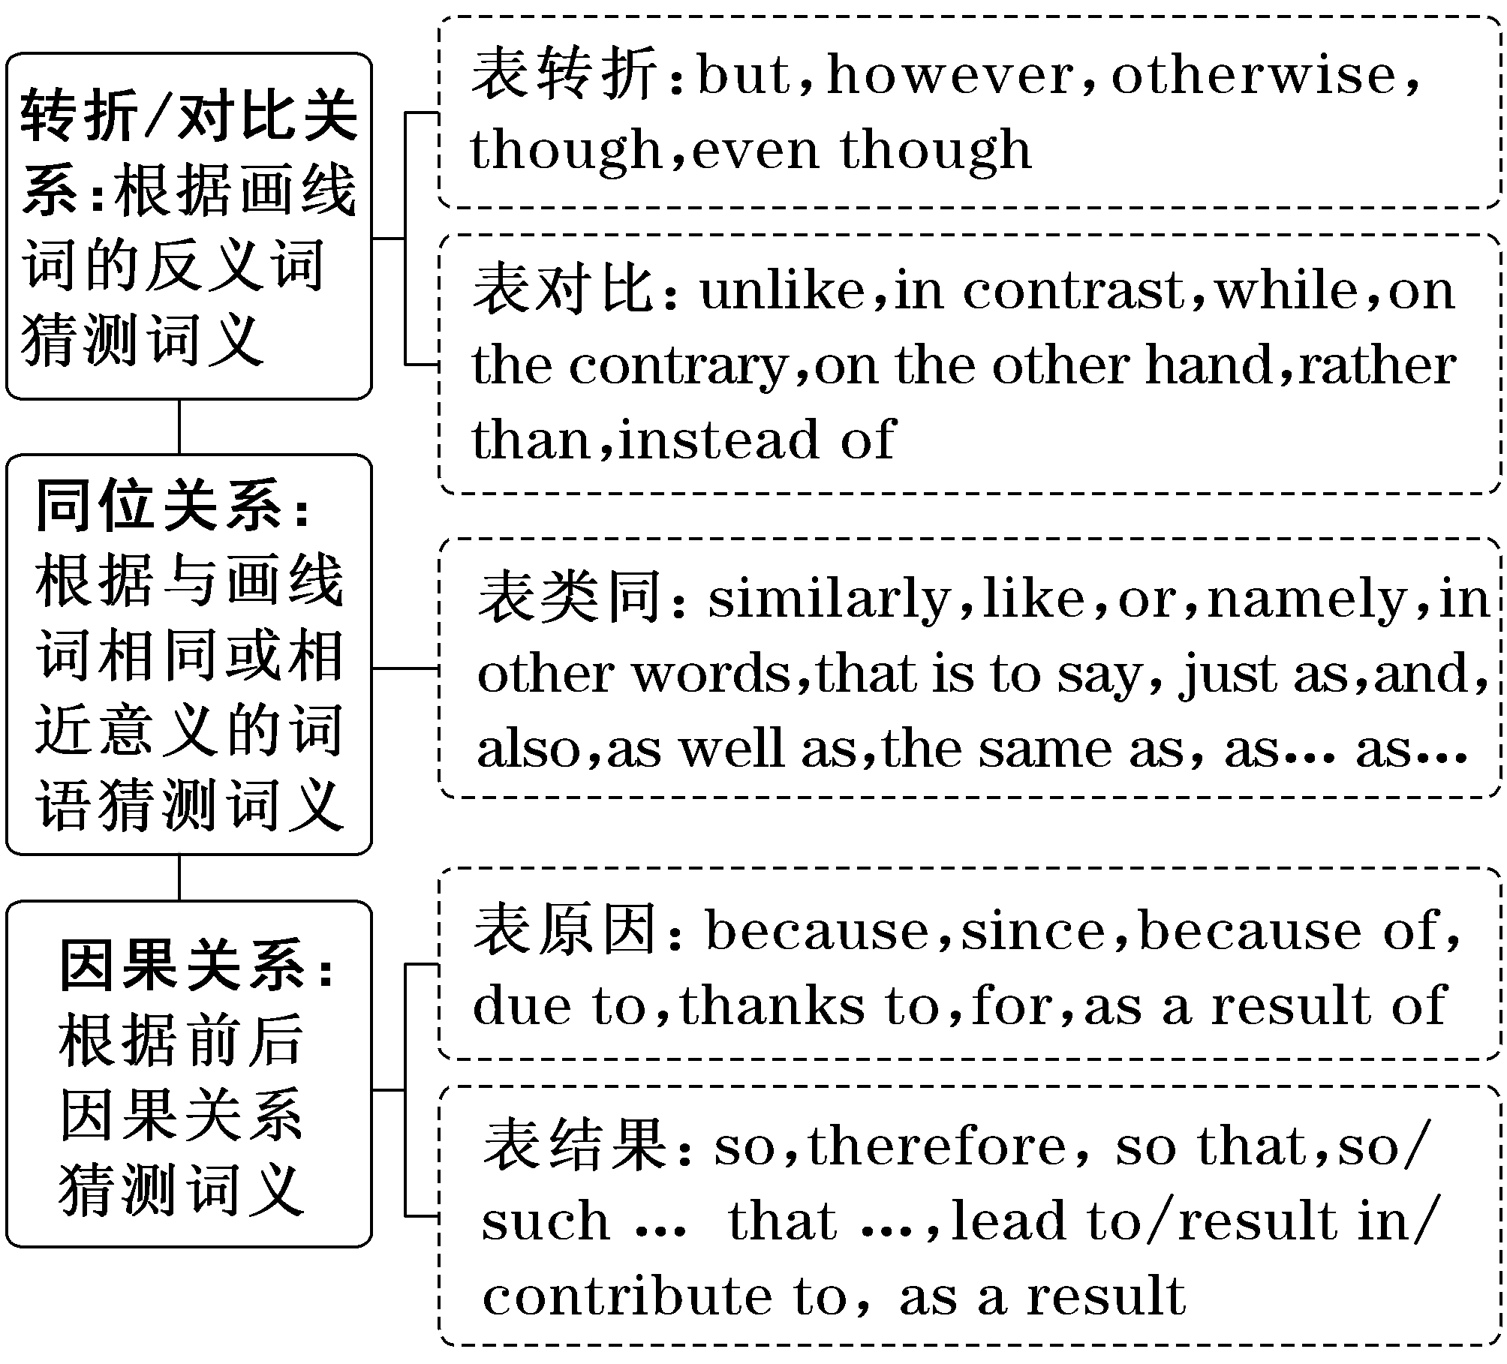
[例5] (2023·新高考Ⅱ卷·阅读 C篇节选)
In this “book of books，” artworks are selected and arranged in a way that emphasizes these connections between different eras and cultures. We see scenes of children learning to read at home or at school, with the book as a focus for relations between the generations. Adults are portrayed (描绘) alone in many settings and poses — absorbed in a volume, deep in thought or lost in a moment of leisure. These scenes may have been painted hundreds of years ago, but they record moments we can all relate_to.
30．What do the underlined words “relate to” in paragraph 2 mean?
A．Understand. B．Paint.
C．Seize. D．Transform.
分析：根据本段尾句“These scenes may have been painted hundreds of years ago, but they record moments we can all relate to.”中的转折连词but表达的语境可知，这些场景可能是数百年前绘制的，但它们记录了我们都能理解的时刻。画线词意为“理解”。故选A。

阅读理解的语篇常涉及生活常识和背景知识方面的内容，因此运用常识或背景知识猜测词义也是一种有效的方法。
[例6] (2021·全国甲卷·阅读C篇节选)
Southbank, at an eastern bend in the Thames, is the center of British skateboarding, where the continuous crashing of skateboards left your head ringing.I loved it.I soon made friends with the local skaters.We spoke our own language.And my favorite: Safe.Safe meant cool.It meant hello.It meant don't worry about it.Once, when trying a certain trick on the beam (横杆)，I fell onto the stones, damaging a nerve in my hand, and Toby came over, helping me up: Safe, man.Safe.A few minutes later, when I landed the trick, my friends beat their boards loud, shouting：“Safe!_Safe!_Safe！” And that's what mattered — landing tricks, being a good skater.
29．What do the underlined words “Safe! Safe! Safe！” probably mean?
A．Be careful! B．Well done!
C．No way! D．Don't worry!
分析：“Safe！”是作者滑滑板时最喜欢的语言，也是整篇文章的题眼。画线词所在句子的上文描述了“safe”的安慰作用，即“don't worry about it”。而本句则描述了自己一次完美的落地，结合本句 “when I landed the trick, my friends beat their boards loud, shouting ...”所提供的情景，再结合生活常识可知，当作者成功掌握了落地技巧的时候，朋友们会夸赞他动作完成得很棒。故选B。

二、代词指代题——“就近原则”找指代
代词指代题旨在考查考生根据上下文猜测代词的指代意义的能力。代词多是“it, that, he, him, those”等，可以指代上文提到的人或物，it和that还可以指代一件事。有时代词指代的对象相隔较远，要认真查找；有时需要对前面提到的内容进行总结，才能得出代词所指代的内容。
[技法图解]
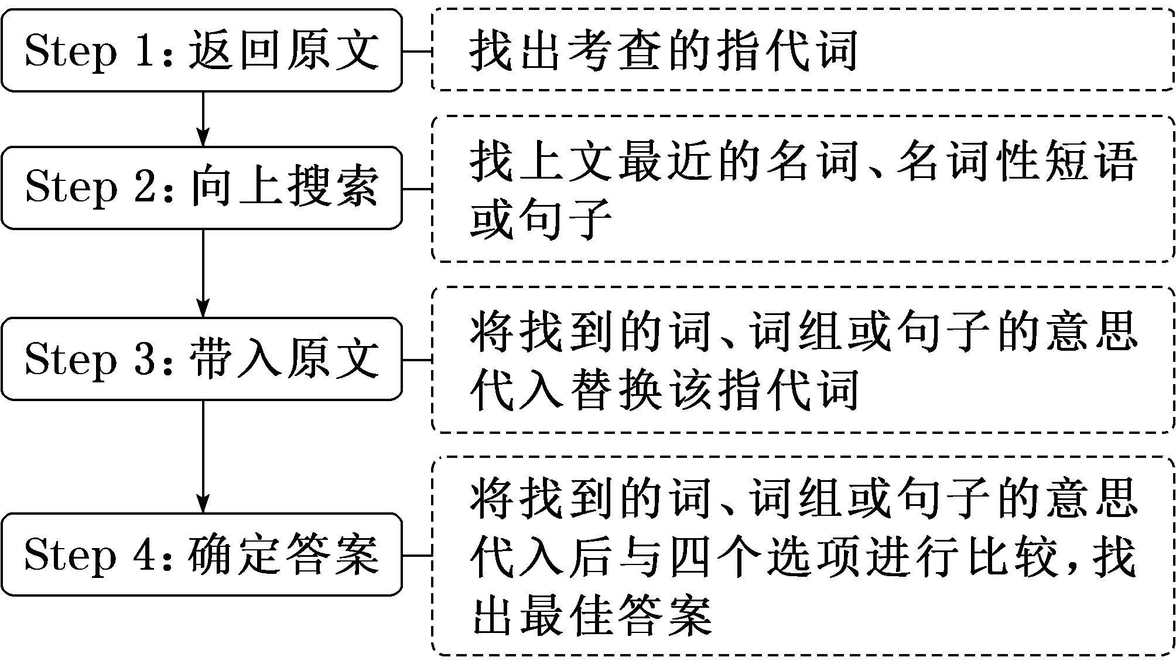
[例7] (2020·新高考全国卷Ⅰ·阅读C篇节选)
In the mid-1990s, Tom Bissell taught English as a volunteer in Uzbekistan. He left after seven months, physically broken and having lost his mind. A few years later, still attracted to the country, he returned to Uzbekistan to write an article about the disappearance of the Aral Sea.
His visit, however, ended up involving a lot more than that. Hence this book, Chasing the Sea: Lost Among the Ghosts of Empire in Central Asia, which talks about a road trip from Tashkent to Karakalpakstan, where millions of lives have been destroyed by the slow drying up of the sea. It is the story of an American travelling to a strange land, and of the people he meets on his way: Rustam, his translator, a lovely 24-year-old who picked up his colorful English in California, Oleg and Natasha, his hosts in Tashkent, and a string of foreign aid workers.
9．What does the underlined word “that” in paragraph 2 refer to?
A．Developing a serious mental disease.
B．Taking a guided tour in Central Asia.
C．Working as a volunteer in Uzbekistan.
D．Writing an article about the Aral Sea.
分析：画线词位于第二段首句，that用来指代上文提到的事情，因此推断that指代第一段的内容。把第一段最后一句“A few years later, still attracted to the country, he returned to Uzbekistan to write an article about the disappearance of the Aral Sea.(几年后，仍然被这个国家所吸引，他回到乌兹别克斯坦写了一篇关于咸海消失的文章)”代入并与四个选项进行比较可知，that指代他写了一篇关于咸海消失的文章这件事，故选D项。

三、句意猜测题——“意义吻合”定句意
句意猜测题通常需要考生猜测一个具有概括性的句子的意思，要求考生通过分析上下文语境，理解句子表达的含义。考生可以在原文中找到该句，进行语法和逻辑关系分析，首先要理解句子前后的语境，然后将句子的意思与语境相结合进行推断，做出选择。
[技法图解] “意义吻合”定句意
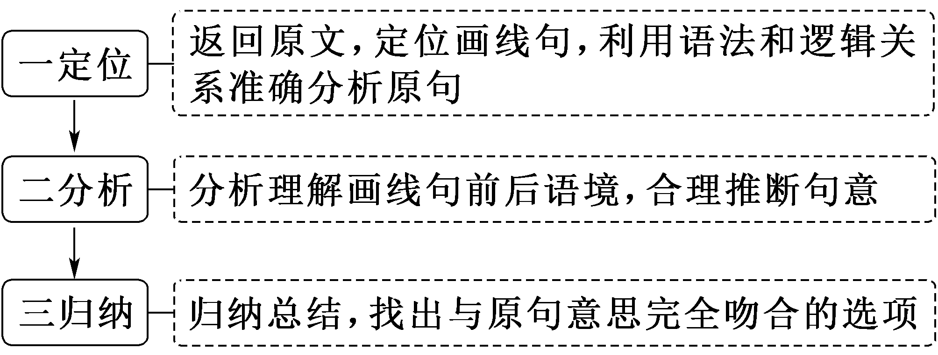
[例8] (2019·浙江高考·阅读B篇节选)
Money_with_no_strings_attached. It's not something you see every day.But at Union Station in Los Angeles last month, a board went up with dollar bills attached to it with pins and a sign that read，“Give What You Can, Take What You Need.”
24．What does the expression “Money with no strings attached” in paragraph 1 mean?
A．Money spent without hesitation.
B．Money not legally made.
C．Money offered without conditions.
D．Money not tied together.
分析：根据下文的内容并结合木板上写的“Give What You Can，Take What You Need.”可知，钉在木板上的钱是可以随意取走的，并不附带任何条件。故选C。

A
(2023·抚顺一模)Artificial intelligence helps teachers identify which of their students have learning difficulties, according to a new study.
Teachers make more accurate assessments of learning difficulties among their students if they are given AI-generated feedback (反馈) rather than an “expert solution” written by a qualified professional. Researchers believe that because the AI analyzed the teacher's own work, it's easier for the teacher to understand than a “model answer” prepared beforehand.
“Teachers play a critical role in recognizing the signs of disorders and learning difficulties in pupils and referring them to specialists，” said Riikka Hofmann. “Unfortunately, many of them feel that they have not had sufficient opportunity to practice these skills. AI could provide an extra level of individualized feedback to help them develop these essential competences.”
Trainee teachers were asked to assess fictionalized students for potential learning difficulties, based on evidence including examples of their work, school behavior records and written texts of conversations with parents. Half of the trainees received the “expert solution”， typical of the material given to trainee teachers, while the other half received AI-generated feedback on their approach, highlighting where they could improve. The trainees then completed similar follow-up assessments, and were graded both on the accuracy of their diagnoses (诊断) and on how well they had used the evidence. Trainees who received the AI feedback scored significantly higher than those who worked with the pre-written expert solutions.
While the researchers said this does not mean AI is preferable to one-to-one feedback from a skilled expert, this is not always available for trainee teachers. “We are not arguing that AI should replace teacher-educators: new teachers still need expert guidance on how to recognize learning difficulties in the first place，” said Dr Michael Sailer. “It does seem, however, that AI-generated feedback helped these trainees to focus on what they really needed to learn. When personal feedback is not readily available, it could be an effective substitute (代替物)．”
语篇解读：本文是一篇说明文。文章主要介绍了人工智能可以帮助老师对学生的学习困难等问题有更好的了解。
1．What does the underlined word “them” in Paragraph 3 refer to?
A．Pupils. B．Teachers.
C．Specialists. D．Researchers.
解析：选B 代词指代题。 根据第三段中的“Teachers play a critical role in recognizing the signs of disorders and learning difficulties in pupils and referring them to specialists”可知，them指的是老师。
2．What did AI help trainee teachers know in the study?
A．How well they had used the evidence.
B．Whether the expert solution was accurate.
C．Where their approach needs improvement.
D．What follow-up assessments they completed.
解析：选C 细节理解题。根据第四段中的“Half of the trainees ... where they could improve.”可知，人工智能在研究中帮助实习教师了解他们的方法需要改进的地方。
3．What does Dr Michael think of AI?
A．It will take the place of skilled experts.
B．It acts as an expert guide to trainee teachers.
C．It is only suitable for new teachers to use.
D．It can be a useful teaching training aid.
解析：选D 推理判断题。根据最后一段中的“We are not arguing that AI should ... could be an effective substitute (代替物)．”可知，人工智能对于老师来说是一个有用的教学培训辅助。
4．Which of the following is a suitable title for the text?
A．AI locates learning difficulties for the students
B．AI becomes an effective teaching tool in school
C．AI helps teachers spot students with learning difficulties
D．AI trains teachers in judging the learning of the students
解析：选C 标题归纳题。根据第一段以及全文内容可知，文章主要讲人工智能可以让老师对学生的学习困难等问题有更好的了解，C项“人工智能帮助教师发现有学习困难的学生”符合文意。
B
(2023·陕西商洛三模)When I started researching the science of happiness a decade ago, I believed negative emotions had no place in it. It turned out that I was wrong.
Firstly, you need the full experience of human emotions, both the positive and the negative. Feeling all kinds of emotions shows that you are fully alive and that you care about what is going on. Secondly, the more you try to deny the negative emotions you feel, the more power you will give to them. Thirdly, all emotions help you to survive and develop. Positive emotions tell you when things are right. Negative emotions help guide you to feel right again in your next steps. Hence, negative emotions play an important role in your life. But that doesn't mean they should play so loudly that they overpower the positive ones. Here is how to avoid them from happening and to get the most out of your negative emotions：
When you notice a negative emotion, become aware of it. Pay attention to it without any judgment. Simply pay attention to it for what it is. You may call it stress, fear, anxiety, sadness, or whatever it is that you are feeling. Don't spend more time thinking about this.
Say “I feel X．” rather than “I am X．” For example, “I feel anxious.” or “I feel upset.” Make sure to say “I feel upset.” rather than “I am upset.” You stress that the emotion you are feeling is fleeting but not permanent. This way of processing negative emotions reminds you that you are simply feeling it, giving it less power and making it easier to overcome.
Ask yourself, “What is making me feel this way？” Exploring the reason behind the negative emotion will make it easier for you to manage it. When did this negative emotion come about? What made it start? Allowing yourself to ask these questions and explore your negative emotion will help you to make peace with it. You will also feel more confident about your ability to handle it.
Remind yourself that happiness isn't the absence of negative emotions but your ability to deal with them.
语篇解读：本文是一篇说明文。文章介绍了作者认为幸福感中不是没有负面情绪，主要是你要有处理负面情绪的能力。
5．What does the author want to tell us in Paragraph 2?
A．The effect of feeling positive emotions.
B．The important role of negative emotions.
C．The difference between the two emotions.
D．The result of denying negative emotions.
解析：选B 段落大意题。根据第二段中的“Negative emotions help guide you to feel right again in your next steps. Hence, negative emotions play an important role in your life.”及本段其他内容可知，作者想告诉我们负面情绪的重要作用。
6．What is one solution if you meet with a negative emotion?
A．To ignore it. B．To explain it.
C．To research it. D．To notice it.
解析：选D 细节理解题。根据第三段中的“When you notice a negative emotion, become aware of it. Pay attention to it without any judgment. Simply pay attention to it for what it is. ”可知，如果遇到消极情绪时，你要去注意它。
7．What does the underlined word “fleeting” in Paragraph 4 mean?
A．Brief. B．Reliable.
C．Constant. D．Unavoidable.
解析：选A 词义猜测题。第四段画线单词后“but not permanent”中的but表示转折关系，说明fleeting和permanent“永久的”互为反义词，故画线单词和A项brief意思相近，意为“短暂的”。
8．What is the most important to happiness according to the author?
A．The strong belief to become successful.
B．The courage to face various challenges.
C．The ability to manage negative emotions.
D．The opportunity to have positive emotions.
解析：选C 推理判断题。根据最后一段内容推知，作者认为对幸福最重要的是处理负面情绪的能力。

第四讲 主旨大意题——不被“浮云”遮眼
主旨大意题是阅读理解中考生失分最多的题目，因为该类试题不仅考查考生略读文章、领会大意的能力，也对考生的归纳、概括能力提出了较高的要求。此题型在文章中没有明显的解题依据，需要考生从文章中抽取、提炼一些关键词、主题句进行加工概括，才能归纳出文章的主旨。所以，遇到主旨大意题时切勿草率作答，一定要读完、读通文章后再做判定，建议考生把此类题目放到最后来做。此类题型可分为三大类，即标题归纳题、文章大意题和段落大意题。其选项具有以下特点：
1．正确选项特征
涵盖性强，覆盖全文或全段
确定的范围恰当，既不太大，也不太小
精确性强，不会改变语言表意的程度及色彩

2．干扰选项特征
过于笼统，不知所云 | 所给选项内容概括的范围过大，超出全文或全段所述内容
以偏概全，主次不分 | 所给选项只阐述了文章的一部分内容，或以文章中的细节信息或个别词作为选项的设置内容，或以次要的事实或细节充当全文的主要观点
移花接木，偷换概念 | 所给选项被命题者有意识地把本属于A的内容放在B上，若不留神，极易选错答案
无中生有，生搬硬套 | 所给选项的关键词语虽然在文章中提到了，但经过仔细阅读分析之后，发现选项的内容与文章的内容毫无联系

题型(一) 标题归纳题——高度概括
1．常见设问方式
·Which of the following is the best title of the passage?
·What would/could be the best title for the passage?
·Which of the following is a suitable title for the text?
2．最佳标题的3大特点
概括性 | 准确而又简短
针对性 | 标题外延正好与文章内容相符
醒目性 | 能引发读者的阅读兴趣

3．活用4大方法解题
关键词法 | 多次出现的词语或观点是体现主旨的关键词
主题句法 | 依主题句定中心词
穿珠串联法 | 从文章细节中找共同点，如同穿珠般，串联细节共同点，确定标题
逆向思维法 | 考虑四个选项的可能内容，对照原文，最相似者为最佳标题

[例1] (2023·新高考Ⅱ卷·阅读B篇)
Turning soil, pulling weeds, and harvesting cabbage sound like tough work for middle and high school kids. And at first it is, says Abby Jaramillo, who with another teacher started Urban Sprouts, a school garden program at four low-income schools. The program aims to help students develop science skills, environmental awareness, and healthy lifestyles.
Jaramillo's students live in neighborhoods where fresh food and green space are not easy to find and fast food restaurants outnumber grocery stores. “The kids literally come to school with bags of snacks and large bottles of soft drinks，” she says. “They come to us thinking vegetables are awful, dirt is awful, insects are awful.” Though some are initially scared of the insects and turned off by the dirt, most are eager to try something new.
Urban Sprouts' classes, at two middle schools and two high schools, include hands-on experiments such as soil testing, flower-and-seed dissection, tastings of fresh or dried produce，and work in the garden. Several times a year, students cook the vegetables they grow, and they occasionally make salads for their entire schools.
Program evaluations show that kids eat more vegetables as a result of the classes.“We have students who say they went home and talked to their parents and now they're eating differently，” Jaramillo says.
She adds that the program's benefits go beyond nutrition. Some students get so interested in gardening that they bring home seeds to start their own vegetable gardens. Besides, working in the garden seems to have a calming effect on Jaramillo's special education students, many of whom have emotional control issues. “They get outside，” she says，“and they feel successful.”
27．What can be a suitable title for the text?
A．Rescuing School Gardens
B．Experiencing Country Life
C．Growing Vegetable Lovers
D．Changing Local Landscape
[解题示范]
第一步：读文章，理清结构
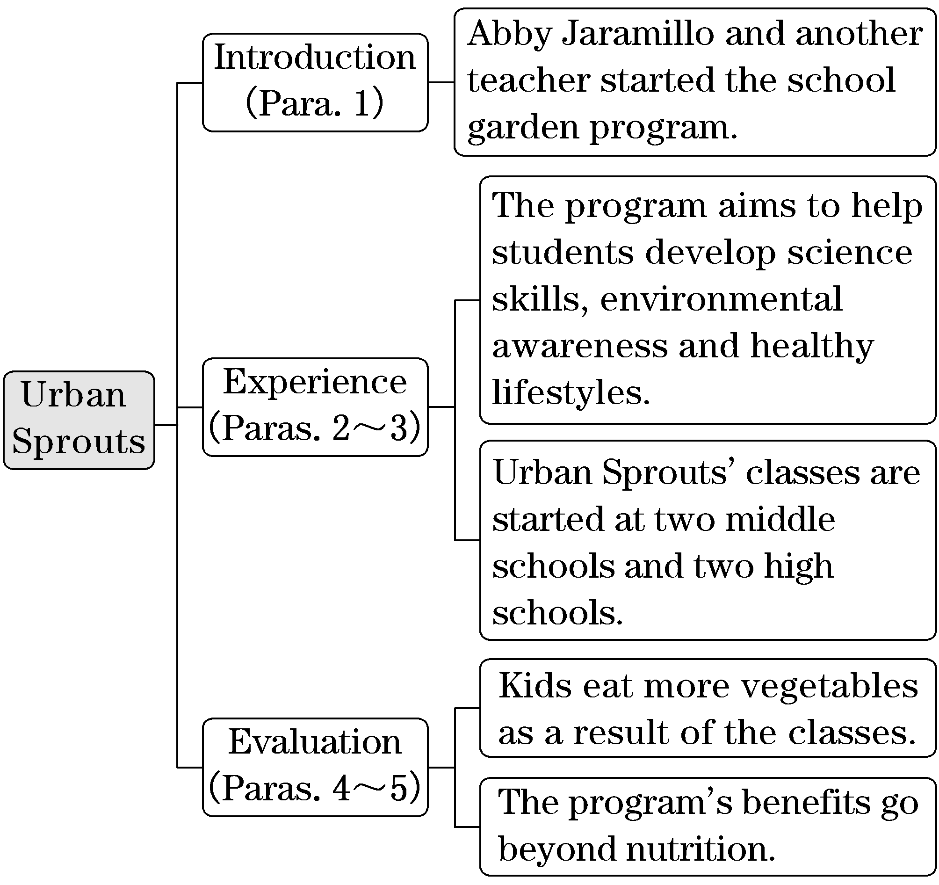

第二步：细揣摩，概括文意
本文是一篇记叙文。文章首先介绍了Jaramillo和另外一位老师发起的学校园艺项目Urban Sprouts及其创办目的，然后介绍了一些学生从最初不喜欢蔬菜种植，到开始喜欢园艺，并在各方面有了积极的影响。本篇文章都是围绕Urban Sprouts这一主题展开的。文章中虽然没有明确的主题句，但是可以从文中找到关键词：Urban Sprouts以及前后的故事发展，通过以上分析可以概括文章的主要内容。
第三步：析选项，斟酌判断
A | 拯救学校花园Abby Jaramillo和另一位老师在四所低收入学校启动了学校园艺项目，而不是拯救花园。 | 无中生有，生搬硬套
B | 体验乡村生活  该项目旨在帮助学生培养科学技能、环保意识和健康的生活方式，而不是体验乡村生活。 | 移花接木，偷换概念
C | 蔬菜种植爱好者  本文主要讲述了Abby Jaramillo和另一位老师发起Urban Sprouts项目，带领学生种植蔬菜的故事，学生们开始对园艺感兴趣。 | 涵盖性强，覆盖全文  (选项为正确答案)
D | 不断变化的本地景观  “local landscape”范围过大。 | 过于笼统，不知所云

题型(二) 文章大意题——主题句定位
1．常见设问方式
·What's the main idea/point of the passage?
·What is the text mainly about?
·Which of the following best states the main idea of the passage?
·Which of the following statements best expresses the main idea/theme of the passage?
2．掌握寻找主题句的4个小窍门，快速确定文章大意
找出每段的主题句。各段的主题句常在该段的首句或尾句，各段主题句的整体归纳便是文章的中心思想。有的文章无明显的主题句，主题句隐含在段意之中，这就需要进一步加工概括，理清全文的结构安排，理解文章的“重心”和支撑性细节。
用浏览法(skimming)，即快速阅读文首、文尾，或每段的首句和尾句等搜索主题线索和主题信息的方法可以快速找到主题句。以下是找主题句的四个小窍门：
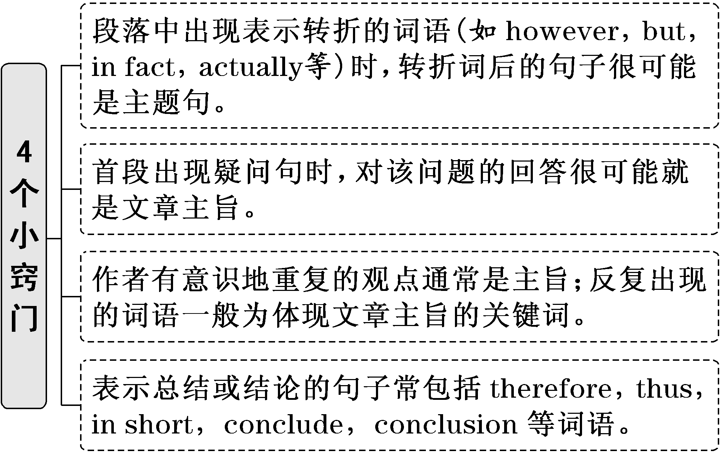
3．解题技巧
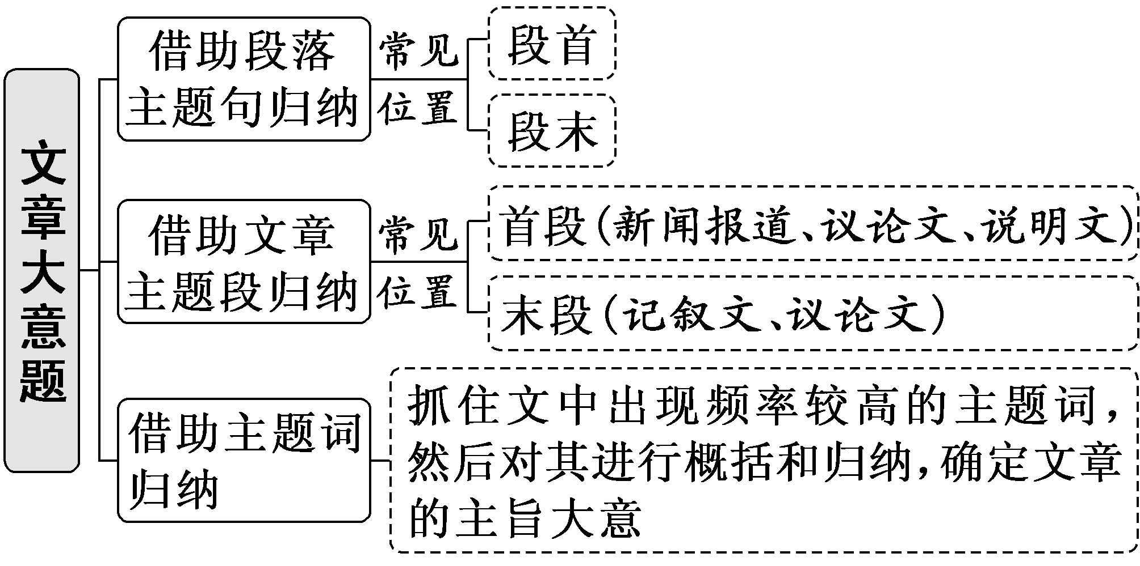

[例2] (2023·浙江1月高考·阅读B篇)
Live with roommates？Have friends and family around you？Chances are that if you're looking to live a more sustainable lifestyle, not everyone around you will be ready to jump_on_that_bandwagon.
I experienced this when I started switching to a zero waste lifestyle five years ago, as I was living with my parents, and I continue to experience this with my husband, as he is not completely zero waste like me. I've learned a few things along the way though, which I hope you'll find encouraging if you're doing your best to figure out how you can make the change in a not-always-supportive household.
Zero waste was a radical lifestyle movement a few years back.I remember showing my parents a video of Bea Johnson, sharing how cool I thought it would be to buy groceries with jars, and have so little trash！A few days later, I came back with my first jars of zero waste groceries, and my dad commented on how silly it was for me to carry jars everywhere. It came off as a bit discouraging.
Yet as the months of reducing waste continued, I did what I could that was within my own reach.I had my own bedroom, so I worked on removing things I didn't need.Since I had my own toiletries (洗漱用品), I was able to start personalising my routine to be more sustainable.I also offered to cook every so often, so I portioned out a bit of the cupboard for my own zero waste groceries.Perhaps your household won't entirely make the switch, but you may have some control over your own personal spaces to make the changes you desire.
As you make your lifestyle changes, you may find yourself wanting to speak up for yourself if others comment on what you're doing, which can turn itself into a whole household debate.If you have individuals who are not on board, your words probably won't do much and can often leave you feeling more discouraged.
So here is my advice：Lead by action.
27．What is the text mainly about?
A．How to get on well with other family members.
B．How to have one's own personal space at home.
C．How to live a zero waste lifestyle in a household.
D．How to control the budget when buying groceries.
[解题示范]
第一步：读文章，理清结构
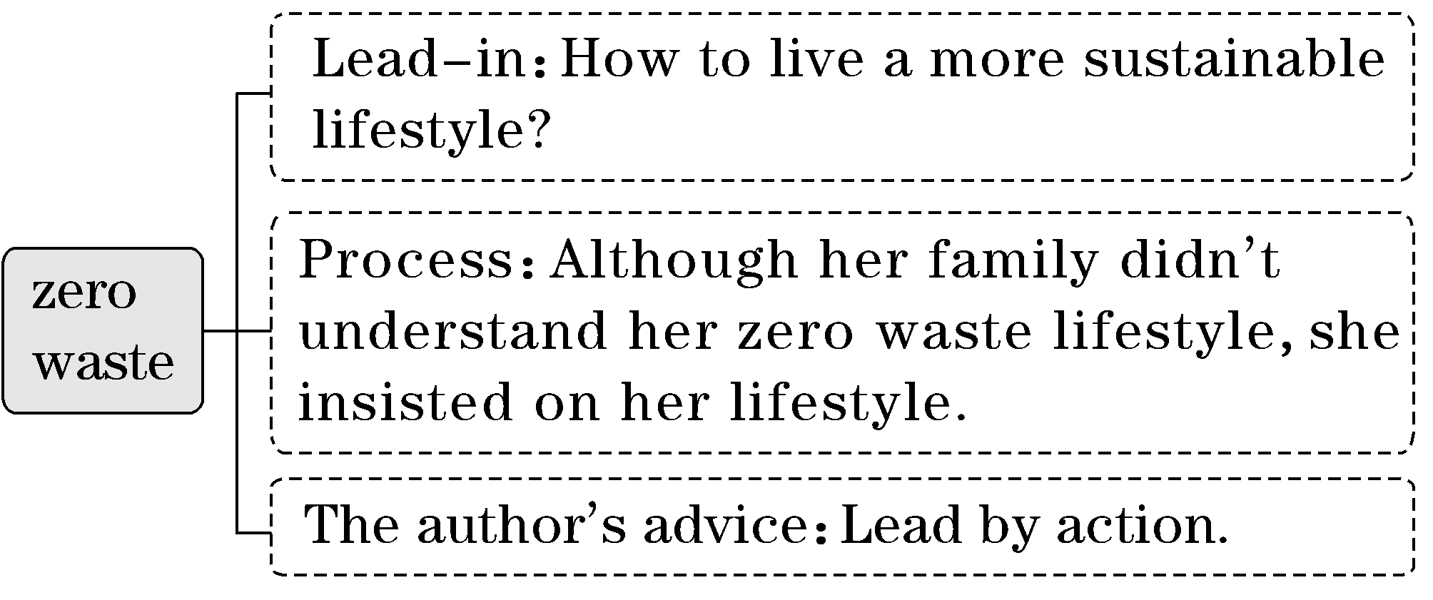
第二步：细揣摩，概括文意
段落大意 |  | 概括文意
第1－2段 | 在家庭生活中实行“零浪费”的生活方式可能遭到反对 | 本文是一篇记叙文，讲述了作者践行“零浪费”的生活方式，不被家人理解，但她坚持自己的生活方式，从而阐释了在群体生活中得不到理解和支持时，“用行动说话”是最好的办法
第3－4段 | 作者自身如何通过行动在家庭中改变生活方式
第5段 | 当你改变生活方式时，你可能遭遇的情况
第6段 | 作者给读者的建议

第三步：析选项，斟酌判断
A | 如何与其他家庭成员和睦相处。文章讲述了作者“零浪费”的生活方式遭到家人的不理解，但没有谈及和家庭成员和睦相处的问题。 | 无中生有,生搬硬套
B | 如何在家里拥有自己的私人空间。  这种说法过于宽泛。 | 过于笼统，不知所云
C | 如何在家庭中过上“零浪费”的生活方式。  文章讲述了作者践行“零浪费”的生活方式，不被家人理解，但她坚持自己的生活方式。 | 涵盖性强，覆盖全文  (选项为正确答案)
D | 如何在购买杂货时控制预算。  文中提到了购买杂货，并没有提及控制预算。 | 以偏概全，主次不分

题型(三) 段落大意题——首尾兼顾
1．常见设问方式
·What does the author tell us in Paragraph ...?
·What is the first paragraph mainly about?
·Which of the following can best summarize Paragraph 1?
2．两方法破解段落大意题
方法(1)：概括段落大意
要准确概括某段的大意，务必要知道该段的逻辑结构。
总分式  (总分/总分总) | 段落首句为主题句，段落其他各句是例子或论证
分总式 | 段落开头是举例子或层层推进的论述，段尾才是段落主题句
分总分式 | 段落开头列举具体事例，通过事例得出结论，这个结论就是段落主题句，后面的内容继续或拓展该结论
对比式 | 事物的共同点或不同点就是该段大意

方法(2)：揣摩段落大意
有时，作者可能不直接给出主题句，而是通过各种方法暗示给读者，这就需要读者充分发挥想象力与判断力，揣摩段落大意。
[例3] (2023·新高考Ⅰ卷·阅读D篇节选)
This effect capitalizes on the fact that when people make errors, those errors aren't always the same. Some people will tend to overestimate, and some to underestimate. When enough of these errors are averaged together, they cancel each other out, resulting in a more accurate estimate. If people are similar and tend to make the same errors, then their errors won't cancel each other out. In more technical terms, the wisdom of crowds requires that people's estimates be independent. If for whatever reasons, people's errors become correlated or dependent, the accuracy of the estimate will go down.
32．What is paragraph 2 of the text mainly about?
A．The methods of estimation.
B．The underlying logic of the effect.
C．The causes of people's errors.
D．The design of Galton's experiment.
[解题示范]
第一步：细揣摩，概括段意
作者在此段中没有给出主题句，需要我们揣摩其段意。此段主要解释了为什么大量独立估算的平均值在某些情况下可以相当准确，这是由于人们估算的误差并不总是相同的，当这些误差足够多，并被平均开来时，它们会互相抵消，从而得出更准确的估算值，这就是群体智慧效应的基本逻辑。
第二步：析选项，斟酌判断
A | 估算的方法。本段没有提到估算的方法。 | 无中生有，生搬硬套
B | 效果的潜在逻辑。  对本段内容的精练总结和概括。 | 涵盖性强，覆盖全段  (选项为正确答案)
C | 人们犯错的原因。  本段说明如果由于某种原因，人们的错误变得相关或依赖，估算的准确性就会下降。不是犯错的原因。 | 移花接木，偷换概念
D | 高尔顿实验的设计。本段没有提到该实验的设计。 | 无中生有，生搬硬套

A
(2023·天门三模)Reading is a complex and crucial skill that impacts the youth's ability to perform as students. Therefore, it's important to develop reading skills during childhood. A team of researchers focused on the effect of whole-body learning in instruction, known as embodied learning.
The research included 149 children, aged 5 to 6, who had just started school. They were divided into three groups: one that stood up and used their whole bodies to shape letter sounds; a seated group that shaped letter sounds with their hands and arms; and a control group that received traditional, seated instruction during which they wrote letters by hand.
“Our research showed that children who used their whole bodies to shape the sounds of letters became twice as proficient (熟练的) at letter sounds that are more difficult to learn as those who received traditional instruction，” says PhD student Linn Damsgaard of UCPH's Department of Nutrition, Exercise and Sports.
With regard to difficult letter sounds, she adds, “There are many difficult letter sounds in Danish. These sounds are particularly important because once children become proficient at them, they will be better readers.”
Associate professor Jacob Wienecke, who led the study, explains, “The primary goal is to learn more about which methods can be used to give beginner readers a good start. The idea is that if, through play and movement, we can learn where their strengths truly lie, we'll create a form of learning that combines reading with play, and that's truly positive.”
Previously, the researchers showed that the children felt more motivated by teaching methods which included physical movement. Jacob Wienecke hopes this will provide an opportunity to inspire teachers and school managers to prioritize movement across subjects.
The study also investigated whether a direct effect of embodied learning could be found on children's reading of individual words. This was not possible, which might be due to the fact that the children were at such an early stage of their literacy development that they could not yet use their knowledge of letter sounds to read words.
语篇解读：本文是一篇说明文。文章主要介绍了全身学习，又称为体验式学习，有助于培养孩子阅读技能。
1．What were the participants required to do in the study?
A．To pick out difficult letter sounds in Danish.
B．To learn new letters through repeated writing.
C．To learn letter sounds using different approaches.
D．To memorize some letter sounds as soon as possible.
解析：选C 细节理解题。根据第二段中的“They were divided into three groups: one that stood up ... seated instruction during which they wrote letters by hand.”可知，参与者在研究中被要求用不同的方法学习字母的读音。
2．How can embodied learning get children actively involved?
A．By combining learning with games.
B．By offering them chances to cooperate.
C．By inspiring them to overcome difficulties.
D．By explaining instructions to them patiently.
解析：选A 细节理解题。根据第五段中的“The idea is that if, through play and movement ... and that's truly positive.”可知，体验式学习通过将学习与游戏相结合让孩子积极参与。
3．What does Jacob expect of the research finding?
A．Promoting harmonious teacher-student relationships.
B．Urging schools to pay attention to physical exercise.
C．Enabling researchers to carry out further studies.
D．Encouraging educators to apply it to teaching.
解析：选D 细节理解题。根据倒数第二段中的“Jacob Wienecke hopes this will provide an opportunity to inspire teachers and school managers to prioritize movement across subjects.”可知，Jacob期望研究发现可以鼓励教育工作者将其应用于教学。
4．What could be the best title for the text?
A．Whole-body learning — a good start to children's reading
B．Embodied learning — a booster for children's reading speed
C．Children's reading skills matter a lot in their literacy development
D．Children's literacy development depends on the flexibility of their bodies
解析：选A 标题归纳题。通读全文，尤其第一段可知，文章主要介绍了全身学习有助于培养孩子阅读技能。故A项“全身学习——儿童阅读的良好开端”符合文意。
[易错诊断]
本题易误选B项。文章主要说明了全身学习有助于培养孩子阅读技能，但没有提及阅读速度，B项错误属于无中生有，生搬硬套。
B
(2023·龙岩二模)Music is good for the health. And drumming may be best of all. As well as being physically demanding, it requires people to synchronise their limbs and to react to outside stimuli, such as what the rest of the band is up to. It is particularly helpful for children who have emotional and behavioural difficulties.
Researchers at the Clem Burke Drumming Project — an organisation named after Blondie's drummer, who was one of its founders — have shown that teaching such children to drum helps them to control their reactions more generally, to focus more effectively on tasks they are given, and to communicate better with other people.
The project's latest work, published in the Proceedings of the National Academy of Sciences by a team led by Marie-Stephanie Cahart of King's College, London, goes a step further. It looks at the neurological (神经系统的) changes which accompany these shifts. Ms Cahart and her colleagues recruited 36 autistic (自闭的) teenagers and split them into two groups. One lot had drum lessons twice a week for eight weeks. The others did not. At the beginning and end of the project everyone was asked to stay still for 45 minutes in a functional magnetic-resonance imaging (fmri) machine, to see how the activity of their brains had changed. Their behaviour, as reported by their guardians, was also recorded.
As expected, most of the drumming group showed positive behavioural changes. And these were indeed reflected in their brains. The fmri scans showed that several clusters of connectivity between parts of those brains had strengthened during the experiment. In particular, two regions involved in attention control, the right dorsolateral prefrontal cortex (背外侧前额叶皮层) and the right inferior frontal gyrus (额下回), formed strong links, respectively, with places associated with reflection and with areas involved in interpreting facial expressions. These changes in the brain's “wetware” thus nicely match the changes in behaviour which learning to drum causes.
Not a surprise, perhaps. But an encouraging confirmation of drumming's power to heal.
语篇解读：本文是一篇说明文。文章介绍了打鼓可以帮助孩子解决情绪和行为上的困难，有助于他们控制自己的反应，更好地集中注意力和沟通。
5．What does the underlined word “synchronise” in Paragraph 1 probably mean?
A．Order. B．Show.
C．Strengthen. D．Adjust.
解析：选D 词义猜测题。结合常识和画线词所在句“it requires people to synchronise their limbs and to react to outside stimuli”中的“react to outside stimuli”可知，打鼓的时候四肢参与，要对外界刺激做出反应就需要不断去“调整”四肢的动作与状态，所以画线词与adjust同义，意为“调整”。
6．Why was the teenagers' behaviour recorded?
A．To observe the positive stimuli.
B．To see its relation with brain changes.
C．To show behavioural differences.
D．To demonstrate their facial connection.
解析：选B 推理判断题。根据第三段中的“At the beginning and end of the project ... was also recorded.”可知，记录青少年的行为的目的是看它与大脑变化的关系。
7．What can we learn about drumming?
A．It cures mental illnesses.
B．It arouses interest in music.
C．It shapes better behaviour.
D．It balances minds and behaviour.
解析：选C 细节理解题。根据第四段中的“As expected, most of the drumming group showed positive behavioural changes.”可知，打鼓塑造了更好的行为。
8．What is the text mainly about?
A．Drumming benefits health.
B．How to tackle people less focused.
C．A research on emotion and behaviour.
D．The links between drumming and brain.
解析：选A 主旨大意题。通读全文并结合第一段可知，本文主要介绍打鼓可以帮助孩子解决情绪和行为上的困难，有助于他们控制自己的反应，更好地集中注意力和沟通。所以A项“Drumming benefits health.(击鼓有益于健康)”符合文意。

第五讲 集释5大错因，提高阅读理解的正答率
得阅读者得高分：指的是阅读理解在英语试卷中的份量。近年来随着高考命题理念的转变，阅读理解题越来越重视对考生思维品质的考查。一些反规律、反套路化的命题，往往让一些考生落入惯性思维的陷阱。为提高阅读理解的正答率，本讲从命题人常采用的设误手段、考生常犯的答题错误等方面给予揭示、指正。“知错”方能“改错”。明白了题目从何处来，才能知道解题往何处去。
易错点1 混淆事实与观点，答非所问
混淆事实与观点是阅读理解常见的干扰项的特征。干扰项的内容和原文的表述是一致的，或者干扰项的表述是客观事实，因此迷惑性很强，考生很容易错选。 破解这类题的办法是从题干出发，忠于原文，根据题干关键词锁定原文中的信息句，然后和选项进行认真比对。
[例1] (2023·新高考Ⅱ卷·阅读C篇节选)
Continued developments in communication technologies were once believed to make the printed page outdated. From a 21st-century point of view, the printed book is certainly ancient, but it remains as interactive as any battery-powered e-reader. To serve its function, a book must be activated by a user：the cover opened, the pages parted, the contents reviewed, perhaps notes written down or words underlined. And in contrast to our increasingly networked lives where the information we consume is monitored and tracked, a printed book still offers the chance of a wholly private, “off-line” activity.
31．What does the author want to say by mentioning the e-reader?
A．The printed book is not totally out of date.
B．Technology has changed the way we read.
C．Our lives in the 21st century are networked.
D．People now rarely have the patience to read.
错因： 本题易误选C项。文章中提及in contrast to our increasingly networked lives，这是事实而不是作者的观点。
分析：根据本段尾句可知，在我们日益网络化的生活中，我们所消费的信息被监控和跟踪，与之相反，印刷书仍然提供了一个完全私人的、“离线”活动的机会。该句强调了印刷书的价值。据此可知，作者提及电子书旨在说明印刷书并未完全过时。故选A。
易错点2 被干扰项中的“偷换概念、曲解文意”带节奏
偷换概念一般指在阅读理解题的选项中，干扰项的表达与原文信息句吻合程度较高，仅有部分词汇原文中没有体现或者和原文不一致，这容易给考生造成一种错觉，从而误选。这种干扰项常常偷换了动作的发出者、动作的承受者、动作本身或积极、消极语义等。曲解文意也是干扰项设置中的常见方法，有些选项来自文章中的某一句或某几句话，看似表达文章的意思，其实是对原句意思的曲解。
针对此类选项，考生在解题时要根据题干中的关键词回原文定位，认真分析原文相关语句，字斟句酌，准确理解原文表达的意思，避免误选。

[例2] (2022·全国甲卷·阅读D篇节选)
Andrew Reynolds, a cheerful fellow in his early 30s, pilots Sydney ferryboats for a living.I spent the whole morning shuttling back and forth across the harbor. After our third run Andrew shut down the engine, and we went our separate ways — he for a lunch break, I to explore the city.
“I'll miss these old boats，” he said as we parted.
“How do you mean？” I asked.
“Oh, they're replacing them with catamarans. Catamarans are faster, but they're not so elegant, and they're not fun to pilot. But that's progress, I guess.”
33．What can we learn about Andrew Reynolds?
A．He goes to work by boat.
B．He looks forward to a new life.
C．He pilots catamarans well.
D．He is attached to the old ferries.
错因：本题易误选C。文中虽然提到Andrew Reynolds通过开“渡船”来谋生，但这并不能说明他开“双体船”开得好。选项C属于偷换概念。
分析：根据节选部分第二段中的“I'll miss these old boats”以及最后一段中的“Oh, they're replacing them with catamarans. Catamarans are faster, but they're not so elegant, and they're not fun to pilot.”可以推断，Andrew Reynolds很喜欢这些旧渡船。故选D。
易错点3 被干扰项中的“以偏概全、扩缩范围”蒙慧眼
以偏概全、扩大或缩小概括范围的干扰项常出现在需要归纳概括的主旨大意类题目中。对该类题目可以通过以下方法避免干扰：(1)要站在文章主旨意图的高度审视每个段落，分析每个段落是从哪一角度服务主旨意图的；(2)用“逆向推理”法，反推文章的写作方向，看与原文是否相符，不一致的则排除。

[例3] (2021·新高考Ⅰ卷·阅读C篇)
When the explorers first set foot upon the continent of North America, the skies and lands were alive with an astonishing variety of wildlife. Native Americans had taken care of these precious natural resources wisely. Unfortunately, it took the explorers and the settlers who followed only a few decades to decimate a large part of these resources. Millions of waterfowl (水禽) were killed at the hands of market hunters and a handful of overly ambitious sportsmen. Millions of acres of wetlands were dried to feed and house the ever-increasing populations, greatly reducing waterfowl habitat (栖息地)．
In 1934, with the passage of the Migratory Bird Hunting Stamp Act (Act), an increasingly concerned nation took firm action to stop the destruction of migratory (迁徙的) waterfowl and the wetlands so vital to their survival. Under this Act, all waterfowl hunters 16 years of age and over must annually purchase and carry a Federal Duck Stamp. The very first Federal Duck Stamp was designed by J．N. “Ding” Darling, a political cartoonist from Des Moines, Iowa, who at that time was appointed by President Franklin Roosevelt as Director of the Bureau of Biological Survey. Hunters willingly pay the stamp price to ensure the survival of our natural resources.
About 98 cents of every duck stamp dollar goes directly into the Migratory Bird Conservation Fund to purchase wetlands and wildlife habitat for inclusion into the National Wildlife Refuge System — a fact that ensures this land will be protected and available for all generations to come. Since 1934, better than half a billion dollars has gone into that Fund to purchase more than 5 million acres of habitat. Little wonder the Federal Duck Stamp Program has been called one of the most successful conservation programs ever initiated.
31．Which of the following is a suitable title for the text?
A．The Federal Duck Stamp Story
B．The National Wildlife Refuge System
C．The Benefits of Saving Waterfowl
D．The History of Migratory Bird Hunting
错因：本题易错选 D。部分考生根据第一段中“When the explorers first set foot upon the continent of North America”“Millions of waterfowl (水禽) were killed at the hands of market hunters and a handful of overly ambitious sportsmen.”等信息而误选。虽然原文第一段中提到了hunting，但它只是文章的一个小细节，不足以概括文章的主要大意。
分析：本篇说明文一共分三段：第一段介绍水禽丧失赖以生存的湿地的历史背景；第二段介绍了解决问题的措施：发行联邦鸭票；第三段说明这一措施的影响。纵观全文，本文是在介绍联邦鸭票的故事。故选A。
易错点4 忽视语境逻辑，过度推断
有时作者仅简单、客观地叙述事实，并未作出评论，而部分选项却扩大作者的叙述范围，进行过度推断。

[例4] (2021·天津3月高考·阅读D篇节选)
Things are connected. Let your expertise in one field fuel your passions in all related areas. Some of your interests may not appear to be connected but, once you explore their depths, you discover that they are. My editor Toni, who is also a writer, has edited several history books. She has decided to study Chinese history. Fascinated by the structural beauty of the Forbidden City as a painter, she is equally interested to learn more about Chinese philosophy. “I don't know where it will lead, but I'm excited I'm on this pursuit.”
54．What does the author intend to show with the example of Toni?
A．Passion alone does not ensure a person's success.
B．In-depth exploration makes discoveries possible.
C．Everyone has a chance to succeed in their pursuit.
D．Seemingly unrelated interests are in a way connected.
错因：本题易误选C项。选项C说每个人都有成功的机会，而原文中只提到Toni 正在追求自己的兴趣，并未评价是否成功，更不能推断出所有人都有希望成功，C项属于过度推断。
分析：根据本段中“Some of your interests ... that they are”可知，作者引用Toni的例子旨在说明看似没有关系的兴趣实际上存在联系。故选D。
易错点5 主观臆断取代作者观点
在推断作者观点态度的试题中，考生由于思维定式，或受到文中某些非关键信息的干扰很容易凭主观臆断做出错误的选择。做该类题目时，如果文中没有直接表明作者观点态度的词句，考生要根据作者在文中的措辞，尤其是表达情感色彩的词，以及作者所举的事例，读懂弦外之音，来正确推断其观点态度。

[例5] (2023·全国乙卷·阅读D篇节选)
Ideally a history would bring together texts and objects, and some chapters of this book are able to do just that, but in many cases we simply can't. The clearest example of this between literate and non-literate history is perhaps the first conflict, at Botany Bay, between Captain Cook's voyage and the Australian Aboriginals.From the English side, we have scientific reports and the captain's record of that terrible day. From the Australian side, we have only a wooden shield (盾) dropped by a man in flight after his first experience of gunshot. If we want to reconstruct what was actually going on that day, the shield must be questioned and interpreted as deeply and strictly as the written reports.
33．What does the author indicate by mentioning Captain Cook in paragraph 2?
A．His report was scientific.
B．He represented the local people.
C．He ruled over Botany Bay.
D．His record was one-sided.
错因：本题易误选A项。部分考生仅根据“From the English side, we have scientific reports and the captain's record of that terrible day.”就主观臆断做出错误的判断。
分析：根据节选段首句以及最后一句可知，作者认为历史应该是文字和实物相结合的产物，但是很多情况下，我们做不到这一点。下文通过举例说明库克船长的记录是片面的。故选D。

第六讲 从立意高度审视题目，对接“价值引领”妙杀题目
高考将“立德树人、服务选才、引导教学”的核心功能融入命题选材中，围绕人与自我、人与社会和人与自然三大主题语境选材，命题关注社会、聚焦时代，渗透“五育”教育，培育全面发展的时代新人。我们在阅读文章、解答题目时，一定要准确把握命题人的选材意图和考查目的，从素养立意的高度上无限接近命题人，占领思维高地。那些体现文章核心观点的、积极的、正能量的选项往往是正确选项。
一、人与自我类
高考文章多从“个人生活”“健康的生活方式”“学校生活”“语言学习”“做人做事”等方面选材。文章内容通常是引导考生养成健康的生活方式、积极的生活态度，形成优秀品行、正确的人生观和价值观等。“人与自我”中的人物故事是高考新课标中的重要话题，高考命题人选材青睐于催人奋进的感人故事或是富有哲理的、令人深思的故事。因此，考生要多从积极的、正能量的方向去获取文章大意和写作意图。
[典例] (2022·全国甲卷·阅读C篇)
As Ginni Bazlinton reached Antarctica, she found herself greeted by a group of little Gentoo penguins (企鹅) longing to say hello.These gentle, lovely gatekeepers welcomed her and kick-started what was to be a trip Ginni would never forget.
Ever since her childhood, Ginni, now 71, has had a deep love for travel.Throughout her career (职业) as a professional dancer, she toured in the UK, but always longed to explore further. When she retired from dancing and her sons eventually flew the nest, she decided it was time to take_the_plunge.
After taking a degree at Chichester University in Related Arts, Ginni began to travel the world, eventually getting work teaching English in Japan and Chile.And it was in Chile she discovered she could get last-minute cheap deals on ships going to Antarctica from the islands off Tierra del Fuego, the southernmost tip of the South American mainland. “I just decided I wanted to go，” she says.“I had no idea about what I'd find there and I wasn't nervous. I just wanted to do it.And I wanted to do it alone as I always prefer it that way.”
In March 2008, Ginni boarded a ship with 48 passengers she'd never met before, to begin the journey towards Antarctica.“From seeing the wildlife to witnessing sunrises, the whole experience was amazing.Antarctica left an impression on me that no other place has，” Ginni says.“I remember the first time I saw a humpback whale; it just rose out of the water like some prehistoric creature and I thought it was smiling at us.You could still hear the operatic sounds it was making underwater.”
The realization that this is a precious land, to be respected by humans, was one of the biggest things that hit home to Ginni.
(一)命题立意——高度把握
本文是一篇记叙文，选材属于“人与自我”范畴。文章主要介绍了71岁的Ginni Bazlinton从小就对旅行有着深深的爱，渴望探险，在她不再跳舞，且孩子们都成家立业之后，她开始周游世界，并在2008年开始了前往南极洲的旅程。语篇中所描述的人物故事积极向上，充满正能量，在思想和行动上为考生树立了榜样。命题人选择此文的目的是引导考生在真实的生活体验中感受梦想的伟大，鼓励考生树立高远志向，认同只要有梦想就要努力去追寻，具有积极乐观、不断追求更好的自我的人生态度。因而，考生在做题的时候，一定要多从这个方面去考虑正确答案。
(二)思量价值——妙杀题目
28．Which of the following best explains “take the plunge” underlined in paragraph 2?
A．Try challenging things.
B．Take a degree.
C．Bring back lost memories.
D．Stick to a promise.
分析：词义猜测题。根据第二段“Throughout her career (职业) as a professional dancer ... she decided it was time to take the plunge.”可知，在她的舞蹈演员职业生涯中，她曾在英国巡演，但一直渴望进一步探索。在她不再跳舞且她的儿子们最终成家立业后，她决定是时候冒险了。据此可以判断，take the plunge意为“尝试具有挑战性的事情”。故选A。
29．What made Ginni decide on the trip to Antarctica?
A．Lovely penguins.
B．Beautiful scenery.
C．A discount fare.
D．A friend's invitation.
分析：细节理解题。根据第三段中的“And it was in Chile she discovered ... the southernmost tip of the South American mainland.”可知，打折的船票使她决定到南极洲旅行。故选C。
30．What does Ginni think about Antarctica after the journey?
A．It could be a home for her.
B．It should be easily accessible.
C．It should be well preserved.
D．It needs to be fully introduced.
分析：推理判断题。根据最后一段可知，意识到这是一块宝贵的土地，应该受到人类的尊重，这是Ginni最深刻的感受之一。据此可推断，Ginni认为南极洲应该受到很好的保护。故选C。
31．What is the text mainly about?
A．A childhood dream.
B．An unforgettable experience.
C．Sailing around the world.
D．Meeting animals in Antarctica.
分析：主旨大意题。通读全文可知，文章主要讲述了Ginni Bazlinton去南极洲旅行的经历；再根据倒数第二段中Ginni Bazlinton 对南极洲之旅的评价： the whole experience was amazing.Antarctica left an impression on me that no other place has可知，去南极洲旅行让她非常难忘。故选B。
二、人与社会类
高考文章多从“社会交往”“人际关系”“体育活动”“志愿服务”“文化渊源”“科技发展”等方面选材。这些文章的内容通常是引导考生建立良好的人际关系与社会交往；热衷于公益事业与志愿服务；正确理解中外文化交流和差异，具有跨文化意识；能够以尊重文化多样性的方式调适交际策略；领悟世界文化的多样性和丰富性，具有人类命运共同体意识；分析、鉴别文化现象所反映的价值取向，自觉坚定文化自信；汲取优秀文化，具有正确的价值观、健康的审美情趣和道德情感；了解科技发展现状，培养热爱科学的意识。
[典例] (2022·新高考Ⅰ卷·阅读C篇)
The elderly residents (居民) in care homes in London are being given hens to look after to stop them feeling lonely.
The project was dreamed up by a local charity (慈善组织) to reduce loneliness and improve elderly people's wellbeing. It is also being used to help patients suffering dementia, a serious illness of the mind. Staff in care homes have reported a reduction in the use of medicine where hens are in use.
Among those taking part in the project is 80-year-old Ruth Xavier. She said：“I used to keep hens when I was younger and had to prepare their breakfast each morning before I went to school.
“I like the project a lot. I am down there in my wheelchair in the morning letting the hens out and down there again at night to see they've gone to bed.
“It's good to have a different focus. People have been bringing their children in to see the hens and residents come and sit outside to watch them. I'm enjoying the creative activities, and it feels great to have done something useful.”
There are now 700 elderly people looking after hens in 20 care homes in the North East, and the charity has been given financial support to roll it out countrywide.
Wendy Wilson, extra care manager at 60 Penfold Street, one of the first to embark_on the project, said：“Residents really welcome the idea of the project and the creative sessions. We are looking forward to the benefits and fun the project can bring to people here.”
Lynn Lewis, director of Notting Hill Pathways, said：“We are happy to be taking part in the project. It will really help connect our residents through a shared interest and creative activities.”
(一)命题立意——高度把握
本文是一篇说明文，选材属于“人与社会”范畴。文章主要介绍了伦敦的一家慈善机构推出的一个独特的项目——养母鸡。该项目通过让护理院的老人养母鸡，来减少他们的孤独感并以此来提高他们的幸福感。本文的主题非常符合我们所弘扬的尊老爱幼的中华传统美德，语篇向考生展示了中外文化的交融。命题人选择此文的目的是培养考生的跨文化意识，从而引导考生正确理解我国优秀传统文化，坚定文化自信，形成文化自觉。考生在解答题目时，需要从文章内容出发，了解英国伦敦这家慈善机构推出的这个独特的“养母鸡”项目的目的和人们对它的评价。
(二)思量价值——妙杀题目
28．What is the purpose of the project?
A．To ensure harmony in care homes.
B．To provide part-time jobs for the aged.
C．To raise money for medical research.
D．To promote the elderly people's welfare.
分析：细节理解题。本题意在考查学生理解具体信息的能力。根据第二段中的“The project was dreamed up by a local charity (慈善组织) to reduce loneliness and improve elderly people's wellbeing.”可知，该项目的目的是减少老人的孤独感并提高老人的幸福感。故选D。
29．How has the project affected Ruth Xavier?
A．She has learned new life skills.
B．She has gained a sense of achievement.
C．She has recovered her memory.
D．She has developed a strong personality.
分析：细节理解题。本题意在考查学生理解具体信息的能力。根据第五段中的“I'm enjoying the creative activities, and it feels great to have done something useful.”可知，这个项目让Ruth Xavier觉得她自己做了有用的事情，并获得了成就感。故选B。
30．What do the underlined words “embark on” mean in paragraph 7?
A．Improve. B．Oppose.
C．Begin. D．Evaluate.
分析：词义猜测题。根据画线短语所在的句子“Wendy Wilson, extra care manager at 60 Penfold Street ... said：‘Residents really welcome ... to people here.’”可知，Wendy Wilson是第一批开始做这个项目的人之一，所以画线短语意为“开始”。故选C。
31．What can we learn about the project from the last two paragraphs?
A．It is well received.
B．It needs to be more creative.
C．It is highly profitable.
D．It takes ages to see the results.
分析：推理判断题。本题意在考查学生简单推理的能力。倒数第二段中的“Residents really welcome the idea of the project and the creative sessions.”提到，居民们非常欢迎这个项目和创意会议的想法；最后一段中的“It will really help connect our residents through a shared interest and creative activities.”提到了该项目的好处，由此可推知，这个项目获得的反响很好。故选A。
三、人与自然类
高考文章多从“人与环境”“人与动植物”等方面选材。这些文章的内容通常是引导考生关注生态、保护环境，提高人与自然共处的意识。文章一般是说明文，先提出一种自然现象，接着分析形成这种现象的原因，最后提出解决方法。因而，考生在解答此类问题时，要多从自然环境保护、自然遗产保护、人与环境和谐相处、人与动植物和谐共存等方面去考虑正确答案。

[典例] (2023·新高考Ⅰ卷·阅读B篇)
When John Todd was a child, he loved to explore the woods around his house, observing how nature solved problems. A dirty stream, for example, often became clear after flowing through plants and along rocks where tiny creatures lived.When he got older, John started to wonder if this process could be used to clean up the messes people were making.
After studying agriculture, medicine, and fisheries in college, John went back to observing nature and asking questions. Why can certain plants trap harmful bacteria (细菌)? Which kinds of fish can eat cancer-causing chemicals? With the right combination of animals and plants, he figured, maybe he could clean up waste the way nature did. He decided to build what he would later call an eco-machine.
The task John set for himself was to remove harmful substances from some sludge (污泥). First, he constructed a series of clear fiberglass tanks connected to each other. Then he went around to local ponds and streams and brought back some plants and animals. He placed them in the tanks and waited. Little by little, these different kinds of life got used to one another and formed their own ecosystem. After a few weeks, John added the sludge.
He was amazed at the results. The plants and animals in the eco-machine took the sludge as food and began to eat it! Within weeks, it had all been digested, and all that was left was pure water.
Over the years, John has taken on many big jobs. He developed a greenhouse-like facility that treated sewage (污水) from 1,600 homes in South Burlington. He also designed an eco-machine to clean canal water in Fuzhou, a city in southeast China.
“Ecological design” is the name John gives to what he does. “Life on Earth is kind of a box of spare parts for the inventor，” he says. “You put organisms in new relationships and observe what's happening. Then you let these new systems develop their own ways to self-repair.”
(一)命题立意——高度把握
本文是一篇记叙文，选材属于“人与自然”范畴。John Todd从小就喜欢观察大自然，并被自然的修复能力折服。大学时期经过专业的学习之后，John通过实验找到了合适的生态组合，发明出了“生态机器”，并解决了很多实际的污水净化问题。语篇向考生呈现了人与自然之间的共存关系。本文在选材上积极引导考生关注人类社会所面临的热点问题——环境问题，培养考生与自然和谐共生、保护自然环境的意识，使考生能够增强责任感、紧迫感和使命感。考生在解答题目时，需要从文章主题出发，站在人与自然和谐共生的角度，围绕文章立意辩证地思考问题。

(二)思量价值——妙杀题目
24．What can we learn about John from the first two paragraphs?
A．He was fond of traveling.
B．He enjoyed being alone.
C．He had an inquiring mind.
D．He longed to be a doctor.
分析：细节理解题。根据第一段中的“observing how nature solved problems” “When he got older ... the messes people were making.”和第二段中的“John went back to observing nature and asking questions”以及第二段中的两个问题可以看出，John拥有研究事物的好奇心，善于思考。故选C。
25．Why did John put the sludge into the tanks?
A．To feed the animals.
B．To build an ecosystem.
C．To protect the plants.
D．To test the eco-machine.
分析：推理判断题。根据第三段中的“The task John ... placed them in the tanks”及第四段中的“all that was left was pure water”可以推断，John在水箱里放入污泥是为了检验他的生态机器的处理效果。故选D。
26．What is the author's purpose in mentioning Fuzhou?
A．To review John's research plans.
B．To show an application of John's idea.
C．To compare John's different jobs.
D．To erase doubts about John's invention.
分析：推理判断题。上文讲到了John的发明成功了。根据第五段的中心句“Over the years, John has taken on many big jobs.”可知，多年来，John做了很多重大的工作。下文提到净化福州的运河水是为了举例说明John的发明及其理念在实践中的应用。故选B。
27．What is the basis for John's work?
A．Nature can repair itself.
B．Organisms need water to survive.
C．Life on Earth is diverse.
D．Most tiny creatures live in groups.
分析：推理判断题。本文主要围绕John的疑问“A dirty stream, for example ... people were making.”展开，正是在这个疑问的指引下，John发明了“生态机器”，因此，John发明的根源就在于自然的自我修复能力。故选A。
总之，阅读理解类文章的选材不但注重广泛性，以增长考生的知识见识，还非常注重时代性、真实性和思想性，以体现立德树人、以文化人的育人方向。在解答推理判断题、主旨大意题等文章深层理解类题目时，考生务必要深刻把握文章主旨内涵，洞察命题人的考查意图，这样，才不会仅仅停留在文章表意，而未深刻理解文章主题深意，误入命题人故意设置的陷阱而错答。

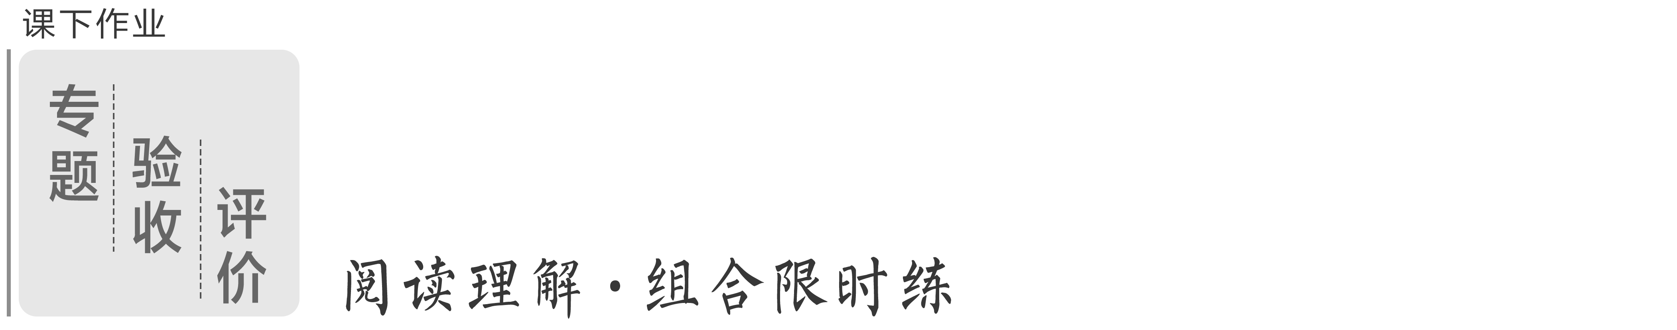
阅读理解·组合限时练(一)
(限时30分钟)
说明：语篇中的加黑词汇为高级表达词汇，用黑体给予凸显，旨在让考生在阅读的同时，潜移默化地提升表达素养，且这些词汇在后面给予集中归纳，供考生自主积累并应用。

A
(2023·常德一模)It's hard to imagine a visual record of the 20th century without Picasso.The Spanish artist captured everything from the horrors of war to the boundless possibilities of the human form.Even those unfamiliar with the modern art history can likely identify a few of his best-known paintings.
The Old Guitarist
Completed: Late 1903 to early 1904
Where to see it: Art Institute of Chicago
The Old Guitarist has to be one of the most sorrowful paintings to ever capture the art world's imagination.The figure depicted (描绘) thin and cross-legged appears exhausted as he sits over his brown guitar.
Garcon a la Pipe
Completed: 1905
Where to see it: Private collection
With Garcon a la Pipe (Boy With a Pipe), we move from Picasso's blue period to the more lively rose period.And while the figure in the oil-on-canvas portrait is clothed in blue, the background features happier shades of ochre and pink.
Girl Before a Mirror
Completed: 1932
Where to see it: Museum of Modern Art (New York)
If there's a single painting that screams Picasso, this might be the one.Girl Before a Mirror is alive with color, pathos and charming shapes that take cubism to its extremes.Picasso said he preferred this painting to any of the others, according to MOMA's founding director, Alfred H．Barr Jr.
Guernica
Completed: 1937
Where to see it: Museo Reina Sofia (Madrid)
Guernica is Picasso's best-known work.Its depiction of an aerial bombing attack on the Basque town of Guernica in April 1937, during the Spanish Civil War, was a visual prelude (序曲) to coming violent act of World War Ⅱ.The muted tones of gray further emphasize the shapes of humans, their arms outstretched in extreme pain.Guernica has become one of the most recognizable anti-war paintings in history.
语篇解读：本文是一篇应用文，主要介绍了毕加索最著名的几幅画。
1．Where can we see The Old Guitarist?
A．In Paris. B．In Chicago.
C．In New York. D．In Madrid.
解析：选B 细节理解题。根据The Old Guitarist部分中的“Where to see it: Art Institute of Chicago”可知，我们在芝加哥可以看到《老吉他手》。
2．Which painting is Picasso's favorite?
A．The Old Guitarist. B．Garcon a la Pipe.
C．Girl Before a Mirror. D．Guernica.
解析：选C 细节理解题。根据Girl Before a Mirror部分中的“Picasso said he preferred this painting to any of the others”可知，《镜子前的女孩》是毕加索的最爱。
3．What does Picasso describe in Guernica?
A．The greed of human.
B．The cruelty of the war.
C．The misfortune of women.
D．The suffering of the poor.
解析：选B 细节理解题。根据Guernica部分中的“Its depiction of an aerial bombing attack on the Basque town of Guernica ... coming violent act of World War Ⅱ.”可知，毕加索在《格尔尼卡》中描述了战争的残酷。
B
(2023·江苏苏锡常镇二模)“To repair ancient books, we have a lot to do，” says Song Jing, 34, who has been working in the restoration division for ancient books at the National Library of China in Beijing for eight years.Before starting a restoration project, Song and her colleagues have to evaluate the subject to consider what problems can be solved through restoration and those that cannot.Fearing the chemicals in commercially produced pastes (胶水) might harm the books, they have to make the glues they need by themselves, starting from removing starch (淀粉) from flour.
“The restoration also requires high levels of control in brushing the paper.If the pressure is not properly controlled during the brushing process, the paper may tear, but if the touch is too light, the paper won't stick，” Song explains.
Song was determined to join the field from an early age.As a child, she was attracted by documentaries about the world's cultural relics (遗物) and became deeply interested in the art of artifact restoration.
In senior middle school, those earlier experiences helped her to set her sights on becoming a master restorer of ancient books.
There were not many schools offering cultural-relic restoration courses back then, and her dream destination, Peking University, only offered openings every other year.
As Song looked into undergraduate curricula (本科课程) arrangement for that particular field of study, she found it was mostly related to chemistry.Therefore, she chose to start a chemistry degree at Fudan University in Shanghai in 2008.In her spare time, she continued to read up on cultural relics and study how museums operate.
“I got to learn how certain aspects of chemistry are going a long way in restoring cultural relics，” she says.
After graduating from Fudan, she was accepted as a master's candidate to the cultural heritage preservation program at Peking University.From then on, she has been on a mission to make her dreams a reality.
语篇解读：本文是一篇新闻报道。文章主要讲述了宋静在北京中国国家图书馆古籍修复处工作和努力成为古籍修复师的故事。
4．What will ruin a restoration work?
A．Brushing the paper.
B．Man-made glue.
C．Removing starch.
D．Incorrect assessment.
解析：选D 细节理解题。根据第一段中的“Before starting a restoration project ... those that cannot.”可知，错误的评估可能会破坏修复工作。
5．Which of the following can best describe Song's job?
A．Demanding and Boring.
B．Complex and challenging.
C．Complicated and Dangerous.
D．Entertaining and profitable.
解析：选B 推理判断题。根据第一段中的“Fearing the chemicals ... removing starch (淀粉) from flour.”和第二段中的“The restoration also requires high levels of control in brushing the paper ... the paper won't stick”可知，古籍修复工作复杂且具有挑战性。
6．Why did Song study chemistry at Fudan University in 2008?
A．She didn't reach the requirement of Peking University.
B．Only Fudan University offered her favorite course.
C．She wanted to be better prepared for her dream occupation.
D．Her interest had shifted from book restoration to chemistry.
解析：选C 细节理解题。根据第六段中的“As Song looked into undergraduate curricula (本科课程) arrangement ... at Fudan University in Shanghai in 2008.”和第七段“‘I got to learn how certain aspects of chemistry are going a long way in restoring cultural relics，’ she says.”可知，宋静去上海复旦大学攻读化学学位是因为她发现研究该特定研究领域的本科生课程安排主要与化学有关，所以她去学习化学是为自己梦想中的职业做更好的准备。
[谨防最易错的那一个]
错因：本题易误选D。部分考生根据第六段中的“Therefore, she chose to start a chemistry degree at Fudan University in Shanghai in 2008.”未加分析就作出错误的选择。
分析：选项D属于曲解文意，错项故意更换个别关键字词或说法，如将“她去学化学是为梦想中的职业做准备”改成了“她兴趣的转移”， 造成说法相异，从而背离原文意思，歪曲作者的观点。要判断“曲解文意”干扰项，一定要仔细比对原文，充分理解文意。要特别注意揣摩事物与事物之间的关系，看选项是否有意混淆了逻辑关系。
7．What can we learn from Song's story?
A．History mirrors future.
B．Courage is the key to achievements.
C．Education breaks down barriers.
D．Commitment and hard work pay off.
解析：选D 推理判断题。根据第三段“Song was determined to join the field from an early age.As a child, she ... became deeply interested in the art of artifact restoration.”以及最后一段“After graduating from Fudan, she was accepted ... at Peking University ... to make her dreams a reality.”可知，宋静的故事告诉我们，只要付出和努力就会有回报。
C
(2023·晋中三模)To adapt to climate change, some flowers are darkening their color to protect themselves from the sun's radiation, new research shows.
The study suggests that over the past 75 years, the ultraviolet (UV) pigments (紫外线色素) in flowers have increased in response to rising temperatures and a thinning ozone layer (臭氧层)．The flowers won't look any different to humans, but insects consider the higher levels of UV pigments as a darker color, which could be confusing when they try to find out colorful flowers to land on.
The UV-absorbing pigments in flowers work like sunscreen and protect sensitive cells from harmful radiation, Matthew Koski, a plant ecologist at Clemson University, says.He and his team hoped to determine if changes in pigments were a result of environmental change — and if so, what are the plants responding to?
The team collected dried, pressed plants across North America, Australia, and Europe.In total, they studied 1,238 samples from 42 different species dating back to 1941.Then, using a UV-sensitive camera, they photographed flower petals from each species to see how the pigment level changed over time.Next, they paired the photographs with historic local temperature and ozone level data from the time the plant was picked.
The researchers found that the changes in pigments differ by species, a result of the flower's structure.Flowers with open, exposed pollen (花粉) had more UV-absorbing pigments when ozone levels were low and radiation was high.But flowers with pollen surrounded by the petal responded to temperature, not ozone levels.
As climate change continues to intensify, these changes in flowers' color can affect plant-insect interactions.When the whole flowers get darker, insects might miss the flowers entirely.“This has a negative influence on plant reproduction.” Koski says.
语篇解读：本文是一篇说明文。最新研究表明，为了适应气候变化，一些花的颜色正在变深。
8．What is the cause of flowers' color changing according to the research?
A．The impact of climate crisis.
B．The loss of natural habitats.
C．The harm of nuclear radiation.
D．The thickening of ozone layer.
解析：选A 细节理解题。根据第二段中的“The study suggests that over the past 75 years ... and a thinning ozone layer (臭氧层)．”可知，花朵中的紫外线色素随着温度升高和臭氧层变薄而增加，这是花朵应对气候变化的策略。
9．What are Koski's findings based on?
A．Photographs of flowers from different species.
B．Analysis of how levels of UV pigments change over time.
C．Collection of abundant samples from various species.
D．Historic local temperature and ozone level database.
解析：选B 推理判断题。根据第四段中的“Next, they paired the photographs with historic local temperature and ozone level data from the time the plant was picked.”可知，该研究团队将紫外线敏感相机拍摄的花瓣照片与植物被采摘时的当地历史温度和臭氧水平数据配对，分析紫外线色素的水平如何随时间变化，从而得出研究结果。
10．What can we learn about the change in pigments?
A．It exists in flowers with exposed pollen only.
B．It responds to temperature and sea levels.
C．It remains the same regardless of species.
D．It varies depending on the flower's structure.
解析：选D 细节理解题。根据第五段中的“The researchers found that the changes in pigments differ by species, a result of the flower's structure.”可知，色素沉着的变化因花的结构而异。
11．What is Koski's attitude towards the change in flowers' color?
A．Concerned. B．Indifferent.
C．Unclear. D．Optimistic.
解析：选A 推理判断题。根据最后一段中的“When the whole flowers get darker ... Koski says.”可知，当整朵花变暗时，昆虫可能会完全错过花朵，这对植物的繁衍有消极的影响，说明Koski对此现象是担忧的。
D
(2023·义乌三模)Erin Alexander was having a hard day.A waitress working at Starbucks was too.Erin ordered an iced green tea and told the waitress to cheer up.After picking up the order, she noticed a message on the cup: “Erin, your soul is golden.” Erin Alexander recalled the incident, “Of course, I was still really sad, but that little thing made the rest of my day.”
New findings, published in the Journal of Experimental Psychology in August, prove just how powerful experiences like Erin's can be.Researchers found that people who perform a random act of kindness tend to underestimate how much the recipient will appreciate it.And they believe that miscalculation could hold many of us back from doing nice things for others more often.
A recent experiment recruited 84 participants at an ice skating rink in Chicago, where they were given a hot chocolate and asked to keep it or give it to a stranger as an act of kindness.The 75 participants who gave away their hot chocolate were asked to predict how the recipient would feel on a scale from 0(very small) to 10(very large), and the recipients were then asked to report their actual feelings on the same scales.
In that experiment, the people doing the kind thing consistently underestimated the appreciation they receive, according to Amit Kumar, a psychology professor at the University of Texas.“People tend to think that what they are giving is kind of little, maybe it's relatively inconsequential，” Dr.Kumar said.“But recipients are less likely to think along those lines.They consider the gesture to be significantly more meaningful because they are also thinking about the fact that someone did something nice for them.” Dr.Kumar continued, “With an experiment like this, I hope it will inspire more people to actually commit random acts of kindness.”
语篇解读：本文是一篇说明文。研究人员发现，随意做善事的人往往会低估接受者的感激程度，误判可能会阻碍我们中的许多人更频繁地为他人做好事，希望这个结果可以鼓舞人们更多地做好事。
12．What's the function of Paragraph 1?
A．To present a fact.
B．To introduce the topic.
C．To describe a scene.
D．To explain an opinion.
解析：选B 推理判断题。结合文章的主题可知，第一段讲述了一个小的善意让双方都感到快乐的小故事是为了引出话题。
[谨防最易错的那一个]
错因：本题易误选C。部分考生只读完第一段的Erin ordered an iced green tea and told the waitress to cheer up.After picking up the order, she noticed a message on the cup：“Erin, your soul is golden.”就误认为这是描述一个场景。
分析：解答本题时，要从写作手法角度考虑，有些说明文采用“故事法”引入主题，先讲一个较短的故事来引发读者的兴趣，从而引出文章的主题。以本文为例，文章主要讲述研究人员发现，随意做善事的人往往会低估接受者的感激程度，误判可能会阻碍我们中的许多人更频繁地为他人做好事，结合第二段讲述文章的主题可推断，第一段的功能是引出话题。
13．What can we learn about the experiment?
A．All participants give away their hot chocolate.
B．Recipients received kind gestures from their friends.
C．Recipients showed more appreciation than givers think.
D．Participants reported their feelings on a scale from 0 to 10.
解析：选C 细节理解题。根据最后一段中的“People tend to think that what ... the fact that someone did something nice for them.”可知，接受人比给予者所想到的表现出更多的感激。
14．What does the underlined word “inconsequential” in Paragraph 4 mean?
A．Insignificant. B．Substantial.
C．Beneficial. D．Unbelievable.
解析：选A 词义猜测题。根据前文“People tend to think that what they are giving is kind of little”和后文“But recipients are less likely to think along those lines ... did something nice for them.”以及But表示转折关系可知，人们倾向于认为自己做得很少，微不足道，画线词与A项“不重要的”意思相近。
15．Which can be a suitable title for the text?
A．The Power of Small Acts of Kindness
B．The Magic of Receivers' Appreciation
C．The Importance of Appreciating Kindness
D．The Impact of a Simple Message on a Cup
解析：选A 标题归纳题。根据第二段“New findings, published ... from doing nice things for others more often.”以及全文内容可知，文章讲述了一个实验结果，随意做善事的人往往会低估接受者的感激程度。研究者希望通过这个结果能鼓舞更多的人做好事，因此推断A项“小善意的力量”为最佳标题。

加练区|读写结合促写作
(一)由语篇积表达词汇
1．capture vt. 捕获
2．identify vt. 发现
3．sorrowful adj. 悲伤的，悲痛的
4．evaluate vt. 评估
5．determined adj. 坚定的
6．in response to 作为回应
7．sensitive adj. 敏感的
8．pick up 拿起
9．kind of 有点，稍微
10．random adj. 任意的，随机的
(二)用好词写优美片段
1．看到衣服散落在各处，Lucy开始动手收拾。请根据以上背景及提示词尝试续写Lucy看到衣服散落各处后的动作描写。 (pick up)
Seeing the clothes scattered here and there, she_murmured,_“How_come_my_room_is_so_messy？”_She_picked_up_the_clothes_and_hung_them_in_the_cupboard_as_Mom_usually_does.
2．在寒冷的冬夜，凯特和妈妈发现她们家的猫不见了，于是外出寻找。请根据以上背景及提示词尝试续写找到猫之后的场景描写和心理描写。 (identify, kind of, sorrowful, determined)
Several minutes later, they_identified_the_poor_cat_under_the_car.It_curled_into_a_tiny_ball_and_kept_shaking.Kate_felt_kind_of_sorrowful.They_were_determined_to_take_it_to_go_to_the_animal_hospital_at_once.

阅读理解·组合限时练(二)
(限时30分钟)
A
(2023·邯郸三模)A bunch of flowers, a box of chocolates and a bottle of wine are the classic moves when it comes to buying the best Mother's Day gifts.If you want something a little different this year, we've prepared a guide to fine gifts for your mother, grandmother or mother-in-law.
Personalized Chopping Board (切菜板)
From ￡40, Etsy
Quickest delivery: 5－7 days, free
A good chopping board will stay with you for life.This wooden board is handmade in a Yorkshire workshop, and can be personalized on one or both sides.Sizes vary from small to extra large.
Bloom & Wild Flower Subscription
￡104 for six months, Bloom & Wild
Give the gift of fresh flowers once a month, for six months with this well priced Bloom & Wild gift subscription.It works out at ￡17.33 per bunch.That's a pretty good deal considering the average bunch at Bloom & Wild costs nearer ￡25.
The Body Shop Rose Quartz Gua Sha Stone
￡15, The Body Shop
Quickest delivery: next day if you order before 11 am, ￡4.99
The practice of gua sha is rooted in ancient Chinese medicine but became the number one western beauty trend in 2020 after influencers and beauty editors alike were crazy about how it made their faces appear more attractive.It involves combing a gua sha along your cheeks, jawline, chin and around your mouth in delicate dragging motions to de-puff (消肿)．
Fitbit Inspire 2
￡44.99, John Lewis
Quickest delivery: next day from ￡7.50
It's a common misconception that you have to break the bank to buy a fitness watch, but this Fitbit watch suggests otherwise.For less than ￡50, she gets a tracker of activity, heart-rate and sleep, as well as a battery that lasts up to 10 days.
语篇解读：本文是一篇应用文。文章主要介绍了一些适合母亲节的礼物。
1．How much may yearly subscribed flowers cost at Bloom & Wild?
A．￡100. B．￡104.
C．￡208. D．￡300.
解析：选C 细节理解题。根据Bloom & Wild Flower Subscription部分中的“￡104 for six months, Bloom & Wild”可知，Bloom & Wild花店订阅六个月是104英镑，故订阅一年是208英镑。
2．What made gua sha popular in 2020?
A．Its beautifying effect.
B．Its easy-to-use feature.
C．Its body weight control.
D．Its Chinese medicine origin.
解析：选A 细节理解题。根据The Body Shop Rose Quartz Gua Sha Stone部分中的“The practice of gua sha ... became the number one western beauty trend in 2020 ... appear more attractive.”可知，刮痧由于其美容功效在2020年变得流行。
3．What is special about Fitbit Inspire 2?
A．It is water-proof.
B．It is reasonably priced.
C．It has a long battery life.
D．It can track users' activity.
解析：选B 细节理解题。根据Fitbit Inspire 2部分“It's a common misconception that you have to break the bank to buy a fitness watch, but this Fitbit watch suggests otherwise.For less than ￡50 ...”可知，Fitbit Inspire 2的特殊之处在于它价格合理。
B
(2023·大连二模)One day Hilary Krieger was sitting in her parents' home when her friend accidentally squirted (喷，射) himself with an orange slice.“I said，‘Oh, the orange just orbisculated，’” she recalls.“And he said，‘It did what？’” The two made a $5 bet, and Hilary confidently grabbed the family dictionary.But “orbisculate” is somehow not in the dictionary!
Hilary burst into her dad's study and told him the shocking news.He looked kind of embarrassed, and said he had made up this word in college and defined it as “When you dig your spoon into a grapefruit and it squirts juice directly into your eye.” He had just been using it all the time.She was mad at his words but quickly came to see her dad's made-up word as a gift, one that showed his creativity and inventive spirit.
Two decades later, Hilary found herself telling that funny story again and again.Her father, Neil Krieger, passed away in April 2020 at age 78.Then Hilary began to think that “orbisculate” is such a great word; it should be in the dictionary!
Getting a word into the dictionary isn't easy.Merriam-Webster adds only about 1,000 new words to its master database every year.Only words with a large and broad readership in publications can enter the dictionary.
Then Hilary,44, hatched a plan.She built a website called orbisculate.com and encouraged people to use the word publicly enough.Many friends and strangers are inspired.Some wear T-shirts with the word printed on them.Some use the word in an online crossword puzzle.Some even put a homemade orbisculation warning sign in a grocery store.
It has been three years since Neil's death.Even if the word doesn't make it into the dictionary, Hilary feels her effort to get her father's word into the dictionary has helped her recapture a little of the joy that has been missing from their lives.
语篇解读：本文是一篇记叙文。文章介绍了希拉里的父亲创造了一个全新的词汇。希拉里在父亲去世后努力使这个词汇被纳入《韦氏词典》的故事。
4．What can we know about the word “orbisculate”？
A．It was widely acknowledged.
B．It was made up to trick others.
C．It was of practical use.
D．It was wrongly used by Hilary.
解析：选C 推理判断题。根据第二段中的“He looked kind of embarrassed ... had just been using it all the time.”可知，这个词可以解释果汁喷到眼睛里的具体场景，而且父亲一直在用orbisculate这个词，说明这个词很实用。
5．What's the function of Paragraph 4?
A．Presenting some evidence.
B．Adding some background.
C．Introducing a new topic.
D．Making a comparison.
解析：选B 推理判断题。根据第四段“Getting a word into the dictionary isn't easy ... 1,000 new words ... Only words with a large and broad readership in publications can enter the dictionary.”可知，本段讲述了如何才能把一个新词添加到《韦氏词典》中，即讲述了希拉里想把父亲创造的词纳入《韦氏词典》这件事的背景。
6．Why did Hilary build a website?
A．To make a profit.
B．To appreciate friends and strangers.
C．To memorize her father.
D．To get the word officially recognized.
解析：选D 推理判断题。根据第五段中的“She built a website called orbisculate.com and encouraged people to use the word publicly enough.”可知，希拉里建立网站是为了让人们多使用这个词汇，因为上文提到只有足够多的使用量才能使这个词被官方认可，由此推断出希拉里建立网站的最终目的是使这个词汇获得官方认可。
7．What's the best title of the text?
A．Warning：This Fruit May Orbisculate
B．Love：A Daughter Recalls Her Father
C．Wonder：A Word Went Into Dictionary
D．Memory：A Creative and Inventive Father
解析：选A 标题归纳题。根据第一段“One day ... ‘Oh, the orange just orbisculated，’ she recalls.”并结合全文可知，全文围绕着希拉里和父亲经常使用orbisculate这个他独创的词汇及她在父亲去世后为了使orbisculate这个词被纳入《韦氏词典》而做出的努力，由此推断出全文是围绕orbisculate这个词展开的，A项“警告：这种水果汁会喷入你的眼睛里”，可作为本文的标题。
[谨防最易错的那一个]
错因：本题易误选C。部分考生根据第三段中的“Then Hilary began to think that ‘orbisculate’ is such a great word; it should be in the dictionary！”以及下文希拉里作出的种种努力而误选C项。
分析：选项C属于主题扩大，即概括的范围过大，超过文章实际讨论的内容。根据全文内容可知，文章是围绕主题词“orbisculate”展开的，A项与文章主题契合，适合作标题。
C
(2023·潍坊二模)As winter arrives, the problem of fogged-up car windscreens becomes more pressing for drivers.Anti-misting sprays (喷雾剂) are one way to deal with such fogging.But they need frequent reapplication.Another approach is to fix within the thing to be demisted a set of electrically powered heating wires.But because of the visual distraction (分心) created, that doesn't work for a car's front windscreen.
Iran Hachler and Dimos Poulikakos of the Swiss Federal Institute of Technology in Zurich have, however, come up with another way of warming something up to stop fog forming.Their new material is a coating ten nanometres (纳米) thick.It is flexible, easily made using existing processes, and can be applied as a coating to glass or plastic, or inset inside such materials.Its demisting properties are powered by sunlight.
In effect, it is a gold sandwich.The “bread” of this sandwich is a pair of layers (层), top and bottom, of a chemical material, each three nanometres thick.The filling is a four-nanometre deep golden material.The whole structure lets visible light pass unlimited, while absorbing invisible lights and transforming them into heat.It is the filling that warms the glass.Gold acts as a medium in the heating process.The network will now absorb heat if left in the sunshine.The top and bottom layers boost that absorption.
Glass coated with Mr Hachler's and Dr Poulikakos's invention is, they claim, four times more effective at preventing fog than an uncoated surface.It absorbs around 30% of solar radiation incident upon it — which, on a sunny day, increases the temperature of what it is applied to by around 8℃.On a cloudy day, that temperature rise is closer to 3－4℃.But in either case the enhancement is sufficient both to remove any fog that has formed and to prevent new fog forming.
The next step, Mr Hachler says, is to find the product's best market.Even though gold is used, the cost of adding this extra one is low.For the two inventors, though, the idea might prove a gold mine.
语篇解读：本文是一篇说明文。随着冬天的到来，汽车挡风玻璃被雾遮住的问题对司机来说变得更加紧迫。针对此问题文章介绍了一种新的解决方法。
8．What is the disadvantage of anti-misting sprays?
A．They have no lasting effect.
B．They damage the windscreens.
C．They turn the drivers' attention away.
D．They are constantly powered by electricity.
解析：选A 细节理解题。根据第一段中“As winter arrives ... Anti-misting sprays (喷雾剂) ... need frequent reapplication.”可知，防雾喷雾剂的缺点是它们没有持久的效果。
9．What is the function of the center layer?
A．To save up heat.
B．To protect the gold.
C．To produce electricity.
D．To heat the windscreens.
解析：选D 细节理解题。根据第三段中的“The whole structure lets visible light pass unlimited ... It is the filling that warms the glass.Gold acts as a medium in the heating process.”可知，中间层的作用是为了加热挡风玻璃。
[谨防最易错的那一个]
错因：本题易误选A。部分考生根据第三段中的 “... absorbing invisible lights and transforming them into heat”就误认为这是保存热量。
分析：选项A属于“以偏概全”。命题者设计选项时故意增删、改动文中表示范围限制或表示程度轻重的词语干扰考生，主要以部分代整体(或相反)、以个别代一般(或相反)、以特殊代普遍(或相反)等，从而使考生做出错误的判断。要判断“以偏概全”干扰项，在阅读文章时，一要特别注意词语前边的修饰与限制词，看选项与原文中的指代内容是否存在范围、程度上的差异；二要注意原文表述是涵盖全部还是有所针对。本题结合下句“It is the filling that warms the glass”就可判断出中间层的作用是为了加热挡风玻璃。
10．What can be inferred about the invention from Paragraph 4?
A．It is useless on cloudy days.
B．It is unable to work at night.
C．Coated glass absorbs the visible lights.
D．Uncoated glass lowers the temperature by 8℃.
解析：选B 推理判断题。根据第四段中的“on a sunny day ... On a cloudy day, that temperature rise is closer to 3－4℃.But in either case the enhancement is sufficient both to remove any fog that has formed and to prevent new fog forming.”可推断出这项发明不能在晚上工作。
11．What does the author think of the new invention?
A．It is very costly.
B．It hits the market well.
C．It is highly profitable.
D．It needs further improvement.
解析：选C 观点态度题。根据最后一段“The next step, Mr Hachler says, is to find the product's best market ... though, the idea might prove a gold mine.”可知，作者认为这项新发明是高利润的。
D
(2023·汕头二模)“Mona Lisa's” famous smile is routinely described as ambiguous.But is it really that hard to read? Apparently not.In an unusual trial, close to 100 percent of people described her expression as “happy”．
The “Mona Lisa” is often held up as a symbol of emotional mystery.Kornmeier, the German scientist, and a team used it in a study of factors that influence how humans judge visual clues such as facial expressions.Using a copy of the masterpiece by Leonardo da Vinci, the team moved the model's mouth corners slightly up and down to create eight altered images.They created four “happier” and four “sadder”“Mona Lisas”．
A block of nine images were shown to 12 trial participants 30 times.In every showing the pictures were randomly rearranged.Then participants had to describe each of the nine images as happy or sad.
“Given the descriptions from art and art history, we thought that the original would be the most ambiguous，”Kornmeier said.Instead, “We found that da Vinci's original was perceived as happy in 97 percent of cases.”
The second experiment involved the original “Mona Lisa” with eight “sadder” versions.These were given even more subtle (微妙的) differences in the lip tilt (倾斜)．In this test, the original was still described as happy.However, participants' reading of the other images changed.“They were perceived a little sadder than in the first experiment，” said Kornmeier.
The findings confirm that “we don't have an absolute fixed scale of happiness and sadness in our brain” — and that a lot depends on context, the researcher explained.Understanding this process may be useful in the study of psychiatric (精神病学的) disorders.As for the masterpiece itself, the team believe their work has finally settled a centuries-old question.
语篇解读：本文是一篇说明文，主要介绍了德国科学家Kornmeier和他的团队用《蒙娜丽莎》来研究影响人类如何判断面部表情等视觉线索的因素。
12．What does the underlined word “ambiguous” mean in the first paragraph?
A．Strange. B．Happy.
C．Sad. D．Unclear.
解析：选D 词义猜测题。根据第一段中的“But is it really that hard to read？”可知，很多人觉得蒙娜丽莎的微笑是难解读的，也就是搞不清楚蒙娜丽莎的微笑，因此画线词ambiguous的意思是“不明朗的”，和unclear意思相近。
13．What is the purpose of the study led by Kornmeier?
A．To create copies of altered images.
B．To answer a centuries-old question.
C．To analyze what affect humans' visual judgement.
D．To describe the ambiguous smile of the masterpiece.
解析：选C 推理判断题。根据第二段中的“Kornmeier, the German scientist, and a team used it in a study of factors that influence how humans judge visual clues such as facial expressions.”可知，Kornmeier领导的这项研究的目的是分析影响人类视觉判断的因素。
14．What can we learn from the first experiment?
A．The experiment was randomly arranged.
B．The result proved the original assumption.
C．The copies differed in “Mona Lisa's” mouth corner.
D．Altogether 30 different images were shown to the participants.
解析：选C 细节理解题。根据第二段中的“Using a copy of the masterpiece ... four ‘sadder’‘Mona Lisas’．”可知，我们能从第一个实验中了解到复制品的不同之处在于蒙娜丽莎的嘴角。
15．What will Kornmeier agree according to the findings?
A．Humans' visual judgement will change with context.
B．Humans are better at recognizing happiness than sadness.
C．“Mona Lisa's” smile is related with psychiatric disorders.
D．The study result can be used to treat patients with mental disorders.
解析：选A 细节理解题。根据最后一段中的“The findings confirm that ‘we don't have an absolute fixed scale of happiness and sadness in our brain’ — and that a lot depends on context, the researcher explained.”可知，Kornmeier会同意的是人类的视觉判断会随着环境的变化而变化。

加练区|读写结合促写作
(一)由语篇积表达词汇
1．considering prep. 考虑到，鉴于
2．drag vt. 拖，拽
3．recall v. 记起，回想起
4．grab vt. 抓住
5．burst into 突然闯入；突然……起来
6．in effect 实际上
7．sufficient adj. 足够的
8．apparently adv. 显然
9．given prep. 考虑到
10．confirm vt. 证实
11．absolute adj. 绝对的
12．as for 至于；关于
(二)用好词写优美片段
1．听到杰克受伤了，他的爸爸妈妈急忙赶到医院。请根据以上背景及提示词尝试续写他们看到杰克时的场景描写。 (burst into)
When they got to the hospital, they_saw_Jack_was_sitting_on_the_chair_alone_with_his_arm_bound_to_bandages.Mom_burst_into_tears,_asking_“How?_You_didn't_tell_me？”
2．保罗看到一位妇女溺水，想起了电影中救生员营救溺水者的场景。请根据以上背景及提示词尝试续写保罗救人的场景描写和动作描写。 (recall, grab, drag, apparently)
As Paul got closer, he could tell that the woman seemed to be in the most trouble._Her_head_was_then_below_the_surface_of_the_water.She_was_drowning.He_recalled_a_movie_in_which_a_lifeguard_grabbed_a_drowning_victim,_pulling_the_person_ashore_while_swimming_on_his_back.Paul_tried_this,_but_the_woman's_clothing_made_her_so_heavy;_he_kept_being_dragged_under,_too.Apparently,_he_needed_a_new_plan.

阅读理解·组合限时练(三)
(限时30分钟)
A
(2023·大庆二模)Northern Ireland's capital and largest city — Belfast — has become a top tourist destination.Here are a few of the attractions that bring in guests from around the globe.
Botanic Gardens
Belfast Botanic Gardens started out as a private park in 1828 but opened to the public in 1895.Construction on the garden's famous Palm House, a building of glass and iron, started in the 1830s.A wide variety of plants can be found there, including one that is over 400 years old!
Open: 9：00 am－4：30 pm.(Closed from Nov.15th to Feb.15th next year.)
Admission: Individual：$9 (adult), $5 (kid under 14)
Family: $21 (Parents & up to 3 kids)
Belfast City Hall
Belfast City Hall, located in the center of the city, is a good place to begin touring.The grand building, which opened in 1906, houses exhibits that are related to Belfast's politics and government.Outside, the gardens are full of impressive statues and memorials.
Open: 8：00 am－5：30 pm.(Closed on Dec.23rd－25th & Jan.1st－3rd.)
Admission: Individual: $10 (adult), $6 (kid under 14)
Family: $24 (Parents & up to 3 kids)
Ulster Museum
The largest museum in Northern Ireland is Belfast's splendid Ulster Museum.It has been called Northern Ireland's treasure house of the past and present.From mummies to moon rocks, the museum possesses impressive art, natural science and history collections.
Open: Weekdays: 8：00 am－5：30 pm.Weekends: 10：00 am－3：30 pm.
Admission: Individual：$8 (adult), $4 (kid under 14)
Family: $19 (Parents & up to 3 kids)
St.George's Market
Award-winning St.George's Market was built in the 1890s and is Belfast's last remaining market housed in a Victorian building.Visitors will find approximately 200 stands selling food, clothes, antiques, crafts and more.Go early for the market's famous breakfast, and try a specialty coffee or tea while listening to live music.
Open: Weekends: 5：30 am－3：30 pm.
Admission: FREE
语篇解读：本文是一篇应用文。文章主要介绍了北爱尔兰的首都——贝尔法斯特的一些吸引人的景点。
1．At what time can Botanic Gardens be visited?
A．8：30 am, Mar.24th.
B．9：30 am, May 7th.
C．12：15 pm, Nov.30th.
D．5：00 pm, July 17th.
解析：选B 细节理解题。根据Botanic Gardens部分下的“Open: 9：00 am－4：30 pm.(Closed from Nov.15th to Feb.15th next year.)”并结合选项时间可知，在5月7日的上午九点半可以参观Botanic Gardens。
2．How much would a couple with two children under 14 pay for admission to Belfast City Hall at least?
A．$16. B．$22.
C．$24. D．$32.
解析：选C 细节理解题。根据Belfast City Hall部分下的“Admission: Individual: $10 (adult), $6 (kid under 14) Family: $24 (Parents & up to 3 kids)”可知，一对夫妇和两个14岁以下的孩子参观Belfast City Hall，按家庭组团付费最省，即需要支付入场费24美元。
3．Where may you observe items from space?
A．Ulster Museum.
B．Botanic Gardens.
C．Belfast City Hall.
D．St.George's Market.
解析：选A 细节理解题。根据Ulster Museum部分下的“From mummies to moon rocks, the museum possesses impressive art, natural science and history collections.”可知，在Ulster Museum，游客可以看到来自太空的东西。
B
(2023·三明三模)Lin Xi, a 26-year-old lady engaged in electronic disassembly (拆卸) art, has proved with her experience that no effort is in vain.
Lin's work is to tear apart used electronic products and then present the components in an artistic way.“After being put back together, the one dusty items will become exhibition pieces that remind the owners of their childhood experience, a period of hard work or a deep-rooted memory, ” she says.Initially, Lin has to contact her customers to learn the stories behind each one and the type of presentation they prefer.Then comes the disassembly.The components, after being carefully cleaned, will be laid out on a piece of white paper in the desired order.The final step is to use graphics software to draw and print a base plate.
Lin gained her popularity on short-video platform.However, it was not luck that brought Lin her current success.She first tried her hand at livestreaming in 2017 as a performer singing popular songs.At the time she was a senior at Beijing Foreign Studies University.After graduation, she went to the UK for further study.During her one-year stay abroad, Lin visited many museums and appreciated exhibitions on different subjects, varying from insects to dolls.She was so fascinated by an exhibit of used light bulbs, which gave her the inspiration to disassemble electronics and present the components like a decorative painting.She returned to China in 2019 and taught herself how to use digital design software.
Before officially starting her business, Lin surveyed her followers to see whether they would be interested in buying electronic disassembly art.It is important to know who your target audience is when running social media accounts, she explains.Speaking of the future, she notes that there are no big plans, but she will keep focusing on her daily work.
语篇解读：本文是一篇记叙文。文章主要讲述了从事电子拆卸艺术的26岁女子林曦用她的经验证明，只要付出就有回报。
4．What is the first step of Lin's work?
A．Tearing apart electronic products.
B．Communicating with the customers.
C．Cleaning the components carefully.
D．Presenting the components artistically.
解析：选B 细节理解题。根据第二段中的“Initially, Lin has to contact her customers to learn the stories behind each one and the type of presentation they prefer.”可知，林的工作第一步是与客户沟通。
5．What made Lin Xi start her business?
A．Graphics software. B．Internet platform.
C．An exhibition. D．A painting.
解析：选C 细节理解题。根据第三段中的“She was so fascinated by an exhibit of used light bulbs ... taught herself how to use digital design software.”可知，是一个展览会促使林曦创业的。
[谨防最易错的那一个]
错因：本题易误选B。部分考生根据第三段中的“Lin gained her popularity on short-video platform.”就认为是网络平台促使她创业的。
分析：解答阅读理解时，务必精准定位信息句，才能避免误判。仔细阅读第三段就可以发现信息句在本段最后两句，由此可知是一个展览会促使林曦创业的。
6．Why did Lin Xi conduct a survey?
A．To satisfy her own curiosity.
B．To locate her target audience.
C．To make her followers interested.
D．To promote her social media account.
解析：选B 细节理解题。根据最后一段中的“Lin surveyed her followers ... to know who your target audience is when running social media accounts, she explains.”可知，林进行调查的原因是找到她的目标受众。
7．What can best describe Lin Xi?
A．Brilliant and caring.
B．Careful and ambitious.
C．Generous and determined.
D．Creative and organized.
解析：选D 推理判断题。根据第二段中“Initially, Lin has to contact her customers to learn ... Then comes the disassembly ...The final step is to use graphics software to draw and print a base plate.”可知，林曦很有条理；根据第三段中“She was so fascinated by an exhibit of used light bulbs ... present the components ... taught herself how to use digital design software.”可知，她很有创意。
C
(2023·泉州二模)In a strawberry field surrounded by strawberry fields on the outskirts of Santa Maria, a pair of robots have been picking berries all summer.
Each robot, made by a Colorado company called Tortuga AgTech, rolls in the field on wheels, then stops in front of a plant.A mechanical arm operates its sensor among the leaves; machine vision software scans the sensor data in search of ripe berries.If an unripe berry is in the way, the robot repositions for a better angle.As nipper-grabber (夹爪) mounted in the middle of the sensors stretches to cut the berry's stem (茎), then cautiously places it in awaiting plastic container at the robot's base.
Tortuga's robots are designed to pick strawberries from plants grown on hydroponic (水培的) tabletops, not the ground shadberries.The tabletop system enables Tortuga's strawberry robots to work by making berms cower to be poked up with robotic arms and protecting the robots from direct exposure to the elements.
Since hitting this field last spring, the robots are on their way to picking nearly as many berries as human pickers, and with 95% accuracy, according to Tortuga.Unlike a human, the Tortuga robots don't need breaks, can't get sick, are always ready to work and can pick all day and into the night.With wages making up so much of a grower's expense, the allure of a robot increased reliability and potential to become more cost-efficient over time is hard to resist.
“I do think the best humans are going to be able to outperform robots at these judgment-driven tasks，” said Eric Adamson, Tortuga's cofounder and chief executive.“But that's OK.It doesn't have to be better than every human; it just has to be better than enough people.”
Meanwhile, the team behind Tortuga sees agricultural robots as more than labor-saving devices.They see them as the only way that an industry facing climate change, land use and chemical regulation can adapt and survive.
语篇解读：本文是一篇说明文，主要介绍了采摘草莓的机器人以及它的前景。
8．How can the robot detect ripe strawberries?
A．By analyzing the sensor data.
B．By observing their positions.
C．By monitoring their stems.
D．By testing them in containers.
解析：选A 细节理解题。根据第二段中的“A mechanical arm operates its sensor among the leaves; machine vision software scans the sensor data in search of ripe berries.”可知，机器人通过对传感器数据的分析检测成熟的草莓。
9．What does the author intend to do in Paragraph 3?
A．Add some relevant information.
B．Provide some advice for growers.
C．Summarize the previous paragraphs.
D．Introduce a new topic for discussion.
解析：选A 推理判断题。根据第三段内容可知，作者在第三段打算添加一些关于这种机器人的相关信息。
10．What does the underlined word “allure” in Paragraph 4 probably mean?
A．Pressure. B．Appeal.
C．Impact. D．Expansion.
解析：选B 词义猜测题。根据倒数第三段中的“a robot increased reliability and potential to become more cost-efficient”可知，机器人更可靠，可以节约成本，所以这种吸引力是难以抗拒的，画线词allure的意思是“吸引力”，和appeal意思相近。
11．What is the text mainly about?
A．Robots replacing human labor.
B．Urgent need for agricultural robots.
C．Robots shaping the future of strawberry.
D．Great challenges of future robots.
解析：选C 主旨大意题。通读全文，尤其是根据最后一段的“Meanwhile, the team behind Tortuga sees ... adapt and survive.”可知，农业机器人不仅仅是节省劳动力的设备，也是一个面临气候变化、土地使用和化学品监管的行业适应和生存的唯一途径。由此可知，本文主要介绍了采摘草莓的机器人以及它的前景。
D
(2023·石家庄三模)While the rest of us are sleeping, freshwater turtles (龟) from Central America to Asia are getting out of the water and basking at night.There have been reports of this behavior before, but now a new study is the first to document the widespread occurrence.The findings suggest this may be a common and almost entirely overlooked aspect of many species' ecology.
Dr.Donald McKnight, one of the researchers, said he and a colleague first observed freshwater turtles night basking at the Ross River in Townsville, Australia.“We think it's related to temperature.The water is staying so warm at night that it's actually warmer than the turtles like to be and they can cool down by coming out of the water，” says McKnight.
For the study, researchers put cameras to watch the night activity of as many freshwater turtle species as possible.The cameras were set up in 25 locations.They were programmed to take a photo every two minutes.They collected data on 29 species of freshwater turtles.
It would be lovely to think the turtles are just enjoying some leisure time when things are quiet.But the researchers note that in most cases, the turtles got out of water when the water was too warm and the air was cooler.Given the warming planet, that's admittedly a bit depressing.However, not all of the nighttime baskers were escaping too-warm water.According to the study, turtles in India exhibited more basking on cooler nights, rather than warmer nights, and those in Africa spent more time basking at night in winter than in summer.The reasons for these differences are unclear.It may be that at some sites or seasons, turtles are escaping unfavourably warm water temperatures, while at others, they are taking advantage of the warm air to increase their body temperature and escape unfavourably cold water.
Regardless of the “why” behind different species' reasons for midnight basking, it's a fascinating look at behaviors not previously documented by scientists.And it is at least encouraging to know that turtles are figuring out important behaviors tied to climate change.
语篇解读：本文是一篇说明文。文章主要介绍了一项研究发现淡水龟进行月光浴是因为水温变化。
12．Why do the freshwater turtles from Australia get out of water at night?
A．To search for extra food.
B．To avoid natural enemies.
C．To cool themselves down.
D．To enjoy the quietness outside.
解析：选C 细节理解题。根据第二段中的“‘We think it's related to temperature ... the turtles ... can cool down by coming out of the water，’ says McKnight.”可知，澳大利亚的淡水龟晚上从水中出来是为了给自己降温。
13．What is Paragraph 3 mainly about?
A．How the study was conducted.
B．What the study brought about.
C．Why the study was carried out.
D．Where the study was made.
解析：选A 段落大意题。根据第三段“For the study, researchers put cameras to watch ... collected data on 29 species of freshwater turtles.”可知，在这项研究中，研究人员安装了摄像机，以观察尽可能多的淡水龟物种的夜间活动。摄像机设置在25个地点。它们被设定为每两分钟拍一张照片。他们收集了29种淡水龟的数据，由此可知本段主要介绍了研究是如何进行的。
14．Which of the following are the researchers certain about?
A．Turtles in Africa flee water often on summer nights.
B．The water is unfavorable for turtles to survive in India.
C．The reasons for turtles' different behaviors are obvious.
D．Night basking is caused by the change of water temperature.
解析：选D 细节理解题。根据倒数第二段中的“But the researchers note ... and the air was cooler.”以及下文内容可知，研究人员能够确定的是月光浴由水温的变化引起。
[谨防最易错的那一个]
错因：本题易误选C。部分考生根据“But the researchers note that in most cases, the turtles got out of water when the water was too warm and the air was cooler.”，认为淡水龟出水的原因已经确定，从而误选。
分析：选项C 属于“颠倒是非”，在意思上与原文大相径庭，甚至完全相反。由下文“However, not all of the nighttime baskers were escaping too-warm water ... The reasons for these differences are unclear.”可知，并非所有的月光浴都是为了逃离过于温暖的水温，造成这些差异的原因尚不清楚，可知C项错误。本题需要综合倒数第二段的信息才能得出正确答案。
15．How does the author feel about the finding?
A．Skeptical. B．Positive.
C．Surprised. D．Desperate.
解析：选B 推理判断题。根据最后一段内容可知，研究至少是令人鼓舞的，说明作者对研究的发现持积极态度。

加练区|读写结合促写作
(一)由语篇积表达词汇
1．a wide variety of 各种各样的
2．be related to 与……有关
3．impressive adj. 给人印象深刻的
4．possess vt. 拥有
5．stand n. 摊位
6．(be) engaged in 从事，参与
7．in vain 徒劳的
8．fascinated adj. 入迷的
9．inspiration n. 灵感；鼓舞人心的人(或事物)
10．cautiously adv. 慎重地，谨慎地
11．await vt. 等待
12．adapt v. 适应
13．overlook vt. 忽视；俯瞰
14．depressing adj. 令人沮丧的
15．take advantage of 利用
(二)用好词写优美片段
1．Dora小心地打开珠宝盒，发现是珍珠项链。请根据以上背景及提示词尝试续写Dora看到项链后的动作描写和情感描写。 (cautiously)
Dora opened the jewel box carefully and a lovely pearl necklace appeared._She_couldn't_believe_her_eyes.She_took_the_pearl_necklace_out_and_cautiously_put_it_on,_tears_of_happiness_beginning_to_blur_her_vision.
2．盲人大卫意志相当坚强。尽管他面临着种种挑战，他仍然登上舞台，而且表演非常成功。请根据以上背景及提示词尝试续写“我”在看到大卫表演后的感想。 (impressive, inspiration)
Blind David had a very strong will.What_David_performed_was_impressive.He_would_always_be_an_inspiration_to_me.Through_him,_I_learned_having_an_unflagging_spirit_could_overcome_challenges_and_David_truly_had_that.

阅读理解·组合限时练(四)
(限时30分钟)
A
(2023·阜阳一模)From the Karakoram Mountain to the Indus River plain, Pakistan is home to many breathtaking landscapes.
Kaghan Valley
Kaghan Valley is a place of fairytales.According to one version of a local legend, a prince of Persia fell in love with a fairy princess in the valley.But a giant (巨人) was also in love with the princess.One day, she escaped with the prince. In his anger, the giant flooded the valley and created lakes with his tears.Today, visitors from around the world travel to Kaghan Valley for its beautiful lakes, mountain scenery, and clear night skies.
Baltoro Glacier
Baltoro Glacier is one of the world's largest glacier valleys.Though difficult to access, it is one of the most highly visited regions in Pakistan because of mountain climbing destination like K2, Broad Peak, and the Gasherbrum peaks in this area.Baltoro Glacier is not only known for its scenery, but as a life source — a large percentage of northern Pakistan's population depends on the water from the Karakoram glaciers.
Deosai National Park
Known as “Land of the Giants”， the park is swept by wildflowers and rare butterflies each spring.This biodiversity hot spot is home to the Tibetan wolf, Himalayan ibex, Tibetan red fox and the critically endangered Himalayan brown bear.The park was granted (授予) World Heritage status in 2016.
Hingol National Park
Hingol National Park is the largest national park in Pakistan.While it is well-known for its diverse wildlife, it is perhaps best known for its active mud volcanoes.One of the most famous mud volcanoes is Chandragup, a sacred site for Hindus.Every spring, more than 40,000 people went there to honor the goddess Sati.Before they pay their respect to the goddess at a nearby temple, they have to clean their bodies with the mud.
语篇解读：本文是一篇应用文。文章介绍了从喀喇昆仑山脉到印度河平原，巴基斯坦拥有许多令人惊叹的风景。
1．What can tourists do in Kaghan Valley?
A．See active mud volcanoes.
B．Pay respect to the goddess Sati.
C．Enjoy its beautiful scenery.
D．Climb the world's highest mountain.
解析：选C 细节理解题。根据第二段中的“Today, visitors from around the world travel to Kaghan Valley for its beautiful lakes, mountain scenery, and clear night skies.”可知，在卡汉山谷，游客可以欣赏美丽的风景。
2．Which is the main water source for northern Pakistan?
A．Baltoro Glacier.
B．Hingol National Park.
C．Kaghan Valley.
D．Deosai National Park.
解析：选A 细节理解题。根据第三段中的“Baltoro Glacier is not only known for its scenery ... depends on the water from the Karakoram glaciers.”可知，巴基斯坦北部的主要水源是巴尔托罗冰川。
3．What do the last two parks have in common?
A．They are sacred sites for Hindus.
B．They are known for diverse wildlife.
C．They are famous volcanic parks.
D．They are granted World Heritage status.
解析：选B 细节理解题。根据倒数第二段中的“This biodiversity hot spot is home to the Tibetan wolf, Himalayan ibex, Tibetan red fox and the critically endangered Himalayan brown bear.”以及末段中的“While it is well-known for its diverse wildlife, it is perhaps best known for its active mud volcanoes.”可知，这两个公园的共同之处是它们以各种野生动物而闻名。
B
(2023·沧州一模)Tammy Ruggles always wanted to be a photographer.In her First Person Vox narrative, she writes, “I'd always loved taking pictures.Ever since I was a little girl, taking photos of my family and pets with the Kodak camera has been my favorite hobby.”
But like her driver's license and social work career, Ruggles accepted that photography was something she would have to give up due to Retinitis Pigmentosa (RP), a progressive blinding disease that worsens the retinas (视网膜) over time.Ruggles is legally blind, only capable of making out unclear shapes.How could she practice an art form that is only dependent on vision, if she had none?
That's when Ruggles heard of point-and-shoot digital cameras which didn't necessitate a dark room, exact precision, or changing manual (手动) settings.Ruggles went to her backyard, pressing the shutter at shapes as an experiment.After transferring the images to black and white on her 47-inch monitor (she sees best in contrast), she noticed little things she had never seen even prior to losing her vision — blueberries in some brush, wild pumpkins at the edge of the woods, individual leaves on a tree.And with that her camera became her eyes, capturing things she herself couldn't see and had never seen.
Ruggles now considers her vision problem a plus to her photography.Unlike most photographers who visualize what they want their photo to look like, Ruggles approaches her art with zero preconceived (预想的) ideas about what she hopes to capture.With her loss of vision, Ruggles gained another pair of eyes — ones that can see the hidden beauty of the world around her.
语篇解读：本文是一篇记叙文。文章叙述了Tammy Ruggles一直想成为摄影师，虽患有视网膜色素变性，但她没有放弃梦想，而是借助相机来看世界。
4．What do we know about Ruggles?
A．She was born blind.
B．She is fond of photography.
C．She has got her driver's license.
D．She's still taking pictures with the Kodak camera.
解析：选B 细节理解题。根据第一段“Tammy Ruggles always wanted to be a photographer.In her First Person Vox narrative, she writes, ‘I'd always loved taking pictures ...’”可知，Ruggles喜欢摄影。
5．Which of the following can best describe Ruggles?
A．Brave and ambitious.
B．Confident and optimistic.
C．Generous and gifted.
D．Helpful and sincere.
解析：选B 推理判断题。根据第一段中的“Tammy Ruggles always wanted to be a photographer.”以及下文内容可知，她一直想成为摄影师，相信自己能实现自己的梦想；根据第三段中的“And with that her camera became her eyes, capturing things she herself couldn't see and had never seen.”可知，即使她失明了，也没有很悲观，而是学习用相机来帮她捕捉看不到的东西，这说明她很乐观。
6．What can we infer from the last paragraph?
A．Ruggles will give up shooting due to her loss of vision.
B．Ruggles imagines the photos in her mind before shooting.
C．Ruggles views her vision issue as a strength to her photography.
D．Ruggles has achieved great success because she can see the hidden beauty.
解析：选C 推理判断题。根据最后一段中的“Ruggles now considers her vision problem a plus to her photography.”可推知，Ruggles认为她的视觉问题是她摄影的一个优势。
7．What is the author's purpose of writing the text?
A．To call on people to protect eyes.
B．To help people be a good photographer.
C．To promote point-and-shoot digital cameras.
D．To praise the photographer's bravery and perseverance.
解析：选D 推理判断题。文章叙述了Tammy Ruggles一直想成为摄影师，但是她患有视网膜色素变性，导致眼睛看不见，但她没有放弃自己的梦想，而是借助相机来看世界。由此可推知，作者的写作目的是赞美这位摄影师的勇气和毅力。
C
(2023·龙岩二模)A new study shows that rising levels of planet-warming gasses may reduce important nutrients in food crops.
Other studies have shown that higher temperatures from climate change and weather extremes will reduce food production.But scientists are finding that rising levels of carbon dioxide and other planet-warming gasses threaten food quality.
Researchers studied the effects of one such gas — carbon dioxide — on rice.They grew 18 kinds of rice in fields in China and Japan in a controlled environment.They set carbon dioxide levels to what scientists are predicting for our planet by the end of the century.They found that the resulting rice crops had lower than normal levels of vitamins, minerals and protein.
Rice grown under high carbon dioxide conditions had, on average, 13 to 30 percent lower levels of four B vitamins and 10 percent less protein.The crops also had 8 percent less iron and 5 percent less zinc (锌) than rice grown under normal conditions.
The researchers said the effects of planet-warming gasses would be most severe for the poorest citizens in some of the least developed countries.These people generally eat the most rice and have the least complex diets, they noted.Scientists estimated that almost 150 million people might be at risk of having too little protein or zinc in their diet by 2050.
One scientist, Sam Myers of Harvard University of Massachusetts, US, said that findings like this are an example of the surprises climate change creates.“My concern is, there are many more surprises to come，” he said.
Myers noted that pollution, loss of some species, destruction of forests, and other human activities are likely to produce unexpected problems.He said that you cannot completely change all the natural systems that living organisms have grown to depend on over millions of years without having effects come back to affect our own health.
The new study suggests a way to lower the nutritional harm of climate change — to grow different forms of rice that have shown to be more resistant to higher carbon dioxide levels.
语篇解读：本文是一篇说明文，主要介绍的是一项研究表明，不断增加的温室气体可能会减少粮食作物的重要营养成分，对人们的身体健康造成影响，并提出了一种降低气候变化对营养减少的方法——种植不同形式的水稻。
8．According to the new study, how do planet-warming gasses affect crops?
A．They remove the nutrition.
B．They worsen the quality.
C．They lower the production.
D．They decrease the species.
解析：选B 细节理解题。根据第一段内容和第二段中的“But scientists are finding that rising levels of carbon dioxide and other planet-warming gasses threaten food quality.”可知，温室气体会让作物的质量变差。
9．What can be inferred from the text?
A．Asian crops contain more nutrients.
B．Rice is grown in restricted conditions.
C．Crops grown with lower CO₂ are healthier.
D．Poor people suffer a lot from food shortage.
解析：选C 推理判断题。根据第四段“Rice grown ... than rice grown under normal conditions.”可知，在高二氧化碳下生长的水稻，其营养元素都有所降低，由此可知，在低二氧化碳条件下生长的水稻更健康。
[谨防最易错的那一个]
错因：本题易误选B。部分考生虽然找到了信息句“Rice grown under high carbon dioxide ... than rice grown under normal conditions.”但并没有作出合理的概括，从而误选。
分析：阅读理解的正确选项往往是对原文内容的同义转述或简短概括。要仔细对原文信息句进行分析。根据在高二氧化碳下生长的水稻，其营养元素都有所降低可推断出，在低二氧化碳条件下生长的水稻更健康。
10．What does Sam Myers agree with?
A．Natural systems damage our health.
B．The nutritional harm should be lowered.
C．More effects are caused by climate changes.
D．Human activities result in health problems.
解析：选C 细节理解题。根据倒数第三段“One scientist, Sam Myers of Harvard University of ...‘My concern is, there are many more surprises to come，’ he said.”可知，Sam Myers认为这只是气候变化带来的震惊之一，他担心的是会有更多的震惊，由此可知，气候变化会带来更多的影响。
11．What does the writer intend to do?
A．To introduce a study.
B．To clarify a fact.
C．To make a suggestion.
D．To show a concern.
解析：选A 推理判断题。根据首段内容以及尾段“The new study suggests a way ... to be more resistant to higher carbon dioxide levels.”并结合文中对该研究的介绍和分析，同时新研究提出的相应的解决方案可知，本文作者是在介绍一项气候变暖针对作物质量影响的新研究。
D
(2023·泰安二模)For more than 25 years, search engines have been the Internet's front door.AltaVista, the first site to allow searches of the full text of the web, was swiftly replaced by Google, which has dominated the field ever since.Google's search engine, still the heart of its business, has made its parent, Alphabet, one of the world's most valuable companies.
But nothing lasts forever, particularly in technology.Just ask IBM, which once ruled business computing, or Nokia, once the leader in mobile phones.Both were defeated because they missed big technological transitions (革新)．Now tech firms are excited about an innovation that might bring a similar shift and a similar opportunity.Chatbots (聊天机器人) powered by artificial intelligence (AI) let users gather information via typed conversations.Leading the field is ChatGPT, made by OpenAI, a startup.By the end of January, two months after its launch, ChatGPT was being used by more than 100m people, making it the fastest-growing consumer application in history, according to UBS, a bank.
AI is already used behind the scenes in many products, but ChatGPT has put it center stage, by letting people chat with an AI directly.ChatGPT can write essays in various styles, explain complex concepts, summarize text and answer various questions.It can even pass legal and medical exams.And it can synthesise knowledge from the web: for example, listing holiday spots that match certain criteria, or suggesting menus.If asked, it can explain its reasoning and provide detail.Many things that people use search engines for today, in short, can be done better with chatbots.
On February 7th, Microsoft, which has invested more than $11bn in OpenAI, revealed a new version of Bing, its search engine, which includes ChatGPT.Satya Nadella, Microsoft' s boss, sees this as his chance to challenge Google.For its part, Google has announced Bard, its own chatbot, as a companion to its search engine.The share price of Baidu, known as the Google of China, jumped when it said it would release its chatbot, called Ernie, in March.
But can chatbots be trusted? Can tech firms make money from this? Only time will tell.
语篇解读：本文是一篇说明文。文章主要介绍了一种人工智能ChatGPT，并讨论了其是否能取代Google。
12．Why does the author mention IBM and Nokia in the second paragraph?
A．To prove his idea.
B．To show their popularity.
C．To introduce them to readers.
D．To emphasize the value of them.
解析：选A 推理判断题。根据第二段中的“But nothing lasts forever, particularly in technology. ... Both were defeated because they missed big technological transitions (革新)．”可知，作者在第二段提到IBM和诺基亚的目的是证明自己的观点。
13．What does the underlined word “synthesise” mean in Paragraph 3?
A．Spread. B．Combine.
C．Stress. D．Advance.
解析：选B 词义猜测题。根据第三段中的“for example, listing holiday spots that match certain criteria, or suggesting menus”可知，此处是指可以综合网上的信息，所以synthesise意为“结合，综合”。
[谨防最易错的那一个]
错因：本题易误选A。部分考生根据“It can even pass legal and medical exams.”，认为画线词所在句的含义为它可以在网上传播知识，从而误选。
分析：本题可以根据文中所举的例子进行适当归纳，从一般到具体猜出画线词的含义。举例的标志词有for instance/for example/such as/like/including ...。本题根据后面的for example可判断出画线词的含义。
14．What is ChatGPT unable to do according to the text?
A．Comprehend meaning. B．Write essays.
C．Replace doctors. D．Chat with people.
解析：选C 细节理解题。根据第三段“AI is already used behind the scenes in many products, but ChatGPT has put it center stage, by letting people chat with an AI directly.”可知，ChatGPT可以和人聊天，排除选项D；根据“ChatGPT can write essays in various styles, explain complex concepts, summarize text and answer various questions.”可知，ChatGPT可以理解含义、写文章，排除选项A和B。
15．Which of the following is the best title for the text?
A．Will ChatGPT be popular?
B．Will AI replace human beings?
C．Will Microsoft defeat Google?
D．Will ChatGPT eat Google's lunch?
解析：选D 标题归纳题。通读全文，尤其是根据第一段可知，文章主要介绍了一种人工智能ChatGPT，并讨论了其是否能取代Google。

加练区|读写结合促写作
(一)由语篇积表达词汇
1．breathtaking adj. 激动人心的；令人惊叹的
2．anger n. 愤怒，怒火
3．tear n. 眼泪，泪水
4．capable adj. 有能力的
5．make out 看清楚，辨认出
6．approach vt. 靠近；处理，对付
7．severe adj. 十分严重的
8．concern n. 关心，担心
9．resistant adj. 抵制的，有抵抗力的
10．reveal vt. 揭示，透露，展示
11．announce vt. 宣布
12．companion n. 伙伴
(二)用好词写优美片段
1．作者得知心爱的猫咪去了邻居家，感到很生气。请根据以上背景及提示词尝试续写在邻居家发现猫咪受到良好照顾后的情感变化。(anger, companion)
Seeing my cat well taken care of, I_realized_I_had_misunderstood_my_caring_neighbor.Now_my_anger_gave_way_to_gratitude.I_thanked_her_again_and_again_before_I_took_my_companion_to_my_home.
2．似乎过了一个世纪，爸爸的生日终于到来了。Tim和Lily决定送给爸爸他们写的《龙的故事》。请根据以上背景及提示词尝试续写兄妹两个送给爸爸礼物时的动作描写以及爸爸的情感描写。 (approach, announce, tear)
After what seemed to be a century, Dad's birthday finally came.They_approached_their_father.“This_is_a_present_from_both_of_us!_A_dragon_story_written_by_us！”_Lily_announced_and_she_could_feel_Dad_was_in_surprise.When_it_was_Tim's_turn_to_read_the_story,_he_turned_to_the_first_page,_reading_slowly.Having_finished,_he_caught_sight_of_Dad_wiping_tears_off_his_eyes.

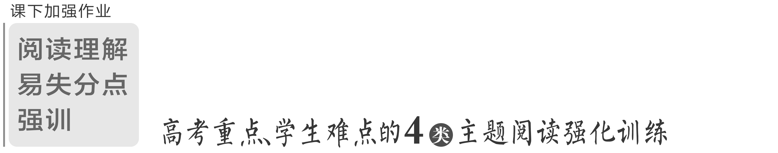

热考主题强化训练(一) 创新引领
(限时30分钟)
A
(2023·张家口一模)Blynn Shideler arrived at Stanford with an award-winning health device.The device addresses a need in the cerebral palsy community.Often, kids with cerebral palsy — a group of disorders that affect movement, balance, and posture — need daily sessions with a physical therapist (治疗专家) to build strength and improve motor skills.
Studying bioengineering at Columbia University, Shideler thought there must be a better way.He worked with other students to design a device that would make it easier for these kids to perform their therapy exercises at home, or anywhere.The result was BUDI — the Biofeedback Upper-limb Device for Impairment — a bracelet (手环) with sensors that tracked motion and provided feedback on how the users could adjust their movements.
BUDI was named “Most Outstanding Design Project from Columbia Biomedical Engineering”．A teenager in Ohio reached out and said, “I have CP, saw your product and would love to see if it works on me.” But Shideler had no bracelets to give him.His team had only built two samples.So, inspired by that message from someone he didn't know living across the country，Shideler set out to produce BUDI on a larger scale (规模)．
In 2021, Shideler got involved in Stanford School of Medicine and planned to start a program that would give children with cerebral palsy the opportunity to try technologies for improving mobility.He got a permission from the FDA's Pediatric Device Consortium to develop wearable devices.Shideler also attended an introductory session for CardinalKit, an open-sourced platform designed by Stanford researchers for coding digital health research projects.
“I learned about building an app and what we can do with the sensors on smartwatches and phones，” he said.“Maybe BUDI could be designed as software on a smartwatch rather than building bracelets.” If kids anywhere could download BUDI in the app store, Shideler thought, they could have physical therapy on demand on their wrists.It would give them some autonomy, help tackle problems created by a shortage in physical therapists, and reduce the stress on their families.
语篇解读：本文是一篇说明文。文章主要介绍了布林·希德勒发明的一种为脑瘫患者治疗练习用的可穿戴设备。
1．What's Shideler's purpose of inventing BUDI?
A．To make a fortune.
B．To help with therapists' job.
C．To get admitted to Stanford.
D．To make treatment easier for some patients.
解析：选D 细节理解题。 根据第二段中的“Shideler thought there must be a better way.He worked ... make it easier for these kids to perform their therapy exercises at home, or anywhere.”可知，希德勒发明BUDI的目的是让一些病人更容易接受治疗。
2．What can be inferred about the teenager in Ohio?
A．He wanted to try BUDI.
B．He thought highly of BUDI.
C．He visited Shideler in person.
D．He joined Shideler's research team.
解析：选A 推理判断题。根据第三段中的“A teenager in Ohio reached out and said, ‘I have CP, saw your product and would love to see if it works on me.’”可知，他想试试BUDI。
3．What is Paragraph 4 mainly about?
A．The popularity of BUDI.
B．BUDI's influence on Shideler.
C．Shideler's efforts to produce more BUDIs.
D．Shideler's achievement in the medical field.
解析：选C 段落大意题。根据第四段内容可知，第四段主要讲述了希德勒为生产更多BUDI所做的努力。
4．What's Shideler's expectation for BUDI in the future?
A．It will have more functions.
B．It can be more available for users.
C．It can help families prevent cerebral palsy.
D．It can be recognized by physical therapists.
解析：选B 推理判断题。根据最后一段中的“If kids anywhere could download BUDI in the app store ... and reduce the stress on their families.”可知，希德勒对BUDI未来的期望是它可以让更多的用户能使用它。
[谨防最易错的那一个]
错因：本题易误选A。部分考生根据“Maybe BUDI could be designed as software on a smartwatch rather than building bracelets.”而误认为Shideler的期望是BUDI将会有更多的功能。
分析：选项A属于“片面推断”。根据最后一段可判断BUDI将会有更多的功能，这是毋庸置疑的，但这不是Shideler的期望。本题需要综合最后一段的信息进行推断，应该是让更多的用户受益。对文章信息进行推断时要全面分析所有相关信息，作出合理适度的推断，切忌片面思考或过度推断。
B
(2023·济南一模)There is nothing quite like enjoying the sights, sounds and culture of a city while tasting a cup of coffee outdoors.But it is not that enjoyable when heat waves sweep the city.An outdoor cooling system produced by Kinonko, an Israeli (以色列的) company, began to be tested in Tel Aviv.The sweltering city is a perfect place to try the new technology.
With global warming heating up the temperature, it will soon be too hot to sit outside in cafes.While outdoor cooling systems have existed for a while, most of them use some sort of water or misting system to cool the air around them, consuming too much water and power.After two years of development, the perfect solution to the problem was found.“We have invented a new generation of air conditioner, ” Kinonko CEO Leizer said.
As Leizer introduced, the energy is from the pressure created between liquid nitrogen (氮) and gas nitrogen.When liquid nitrogen at －196 degrees turns into gas, it produces a very strong pressure and the pressure is used to run a mechanical engine.It is that mechanical engine that slowly releases freezing nitrogen gas to cool down the air around it.
The technology is unique and amazing.Beyond the coolness of the concept, it also has other advantages.The work unit doesn't need to be power-driven, and doesn't blow out harmful warm air as it works.As for the potential price, it will probably be no more expensive than any other air conditioner.In addition, the liquid nitrogen container will need to be replaced every seven to ten days, depending on usage.This makes it an affordable option for all sorts of businesses.The cooling system is expected to be on the market in 2024.
语篇解读：本文是一篇说明文。文章介绍了开始进入测试阶段的一种室外冷却系统。这项新技术有望在2024年投入市场，使人们在炎热的天气下，能够重享在室外喝咖啡的快乐。
5．What does the underlined word “sweltering” mean in Paragraph 1?
A．Warm. B．Dry.
C．Hot. D．Freezing.
解析：选C 词义猜测题。根据第一段中的“But it is not that enjoyable when heat waves sweep the city.”可知，这座城市是非常闷热的。由此可知，“The sweltering city”指的是这座闷热的城市，画线词sweltering意为“闷热的”。
6．What problem does the existing outdoor cooling systems have?
A．They are wasteful.
B．They overheat easily.
C．They often break down.
D．They are slow to cool the air.
解析：选A 细节理解题。根据第二段中的“While outdoor cooling systems have existed ... consuming too much water and power.”可知，现在的室外冷却系统消耗过多的水和电力，是比较浪费的。
7．What does Paragraph 3 mainly explain?
A．What powers the engine.
B．What turns liquid into gas.
C．How the pressure is formed.
D．How the new system works.
解析：选D 段落大意题。根据第三段“When liquid nitrogen ... the pressure is used to run a mechanical engine.”可知，该段主要描述了这种新的冷却系统是如何工作的。
8．What is the purpose of this text?
A．To promote a company.
B．To settle an energy crisis.
C．To introduce a technology.
D．To market a misting system.
解析：选C 推理判断题。通读全文，尤其是根据第一段中的“An outdoor cooling system produced by Kinonko, an Israeli (以色列的) company, began to be tested in Tel Aviv.”可知，本文的主要目的是向人们介绍一种新的室外冷却技术。
C
(2023·泰安一模)How can people speak their mind without saying anything? This is a question that scientists have aimed to answer for a long time.Researchers recently brought an upgraded device that can translate users' brain waves into daily speech.
Previously, the team led by Edward Chang at the University of California, San Francisco, developed an AI-based system that can identify up to 50 commonly used words based on the participant's brain waves.The participant was a paralyzed (瘫痪的) man who had been implanted with 16 electrodes (电极) under his skull.
According to their paper published in November, the team upgraded the system which can now translate thoughts into complete sentences on a computer screen.
Their tests showed that the device could decode silently spoken letters from a 1,152-word vocabulary at a speed of about 29 characters per minute.The accuracy was up to 94 percent.“It shows strong promise for restoring communication by tapping into the brain's natural speech machinery，” Chang said to the university's news website.
However, this method can still be problematic since users still need to undergo surgery.Scientists at the University of Texas, US, have tried to translate people's thoughts without even touching their heads, reported Live Science.
The new technique is called fMRI, or functional magnetic resonance imaging (功能性磁共振成像)．It's a safer way of “reading” brain activity.Active brain cells have more oxygen.By tracking these cells, scientists can translate brain activity.
The team asked participants to listen to 16 hours of radio shows while scanning their brains.Then they used a computer algorithm (算法) to create a story based on the fMRI recording.It matched the radio shows pretty well.
Also, the algorithm could basically explain the story of a silent movie that the participants watched.The team aims to develop this technology so that it can be used in brain-computer interfaces (脑机接口) designed for people who cannot speak or type.
语篇解读：本文是一篇说明文。文章主要介绍了一款基于人工智能系统的升级设备，研究人员用该设备可以将人类脑电波转换成日常语言。
9．What do we know about the device mentioned in Paragraph 2?
A．It was implanted into a man's heart.
B．It can help restore patients' lost memory.
C．It was developed through cooperation.
D．It can identify about 50 rarely used words.
解析：选C 细节理解题。根据第二段内容可知，该设备是由Edward Chang领导的团队开发出来的，是通过合作发展起来的。
10．How does fMRI “read” people's minds?
A．By tracking their active brain cells.
B．By putting electrodes into their brains.
C．By recording their reaction to radio shows.
D．By matching their brain activity with their habits.
解析：选A 细节理解题。根据第六段中的“Active brain cells have more oxygen.By tracking these cells, scientists can translate brain activity.”可知，fMRI是通过追踪活跃的脑细胞去读懂人们的思想的。
11．Why is fMRI chosen compared to the first device mentioned in the story?
A．It's cheaper. B．It's more accurate.
C．It's smaller in size. D．It's safer.
解析：选D 细节理解题。根据第六段中的“The new technique is called fMRI ... a safer way of ‘reading’ brain activity.”可知，该设备比之前的设备更加安全。
12．What can be concluded about fMRI from the last two paragraphs?
A．It can only read what participants hear.
B．It can be used in brain-computer interfaces.
C．It can read every detail of participants' minds.
D．It cannot work out what people imagine in their heads.
解析：选B 推理判断题。根据最后两段内容可知，它可以用于脑机接口。
D
(2023·杭州二模)ChatGPT, designed by OpenAI to carry on conversations just like humans, has become a viral excitement.The AI-powered tool went from zero to a million users in just five days! Its ability to provide in-depth answers to users' questions has even drawn the attention of distinguished technology companies.
The intelligent robot understands what the user says or types and then responds in a way that makes sense.Its vast body of knowledge has been gathered from the Internet and archived books.It is further trained by humans.This makes ChatGPT a useful tool for researching almost any topic.
“We have a lot of information on the Internet, but you normally have to Google it, then read it and then do something with it，” says Ricardo, chief science officer and co-founder of AI company, Erudit.“Now you'll have this resource that can process the whole Internet and all of the information it contains for you to answer your question.”
ChatGPT cannot think on its own.It depends on the information that it has been trained on.As a result, the AI tool works well for things that have accurate data available.However, when unsure, ChatGPT can get creative and flow out incorrect responses.OpenAI cautions users to check the information no matter how logical it sounds.Also, ChatGPT has only been trained with information.Hence, it cannot be relied upon for anything that happened after that.
Experts believe ChatGPT has limitless potential to solve real-world problems.It can translate long texts into different languages, create content on almost any topic, and even summarize books.
However, ChatGPT has received mixed reactions from educators.Some believe it could serve as a valuable tool to help build literacy skills in the classroom.It could also be used to teach students difficult science or math concepts.But other educators think ChatGPT will encourage students to cheat.They fear this will prevent them from building critical thinking and problem-solving skills.As a result, many districts are starting to ban its use in schools.
语篇解读：本文是一篇说明文。文章主要介绍了人工智能ChatGPT，包括其特点、存在的问题以及人们对ChatGPT的看法。
13．What is the unique feature of ChatGPT?
A．It has artificial intelligence.
B．It can answer users' questions.
C．It has the largest number of users.
D．It can engage in meaningful conversations.
解析：选D 细节理解题。根据第一段最后一句以及第二段中的“The intelligent robot understands what the user says or types and then responds in a way that makes sense.”可知，ChatGPT的独特之处是它可以参与有意义的对话。
[谨防最易错的那一个]
错因：本题易误选B。部分考生根据第一段中的“Its ability to provide in-depth answers to users' questions has even drawn the attention of distinguished technology companies.”就误认为它的独特之处是能够回答用户的问题。
分析：解答阅读理解时要避免以偏概全，才能作出正确选择。结合第二段中的第一句，就可知道ChatGPT的独特之处是它可以参与有意义的对话。
14．What makes ChatGPT helpful to research various topics?
A．Its capability of information processing.
B．Its accurate information.
C．Its availability of up-to-date data.
D．Its vast body of questions.
解析：选A 细节理解题。根据第二段“The intelligent robot understands ... This makes ChatGPT a useful tool for researching almost any topic.”可知，信息处理能力使ChatGPT有助于研究各种主题。
15．Why do ChatGPT users have to be cautious when using it?
A．ChatGPT is unable to think itself.
B．ChatGPT lacks creativity.
C．ChatGPT offers illogical information.
D．ChatGPT is not properly trained.
解析：选A 细节理解题。根据第四段中的“ChatGPT cannot think on its own.It depends on the information ... has only been trained with information.”可知，ChatGPT用户在使用时必须谨慎，因为ChatGPT本身无法思考。
16．What is the author's attitude towards ChatGPT?
A．Favorable. B．Disapproving.
C．Objective. D．Intolerant.
解析：选C 推理判断题。根据第四段中的“ChatGPT cannot think on its own.”；第五段中的“Experts believe ChatGPT has limitless potential to solve real-world problems.”以及最后一段中的“However, ChatGPT has received mixed reactions from educators.”可推知，作者主要列举了其他人对ChatGPT的看法，没有提到自己对ChatGPT的态度，故作者对ChatGPT的态度是客观的。

加练区|读写结合促写作
(一)由语篇积表达词汇
1．address vt. 满足(需求)
n. 地址
2．adjust vt. 调整
3．rather than 而不是
4．on demand 一经要求
5．tackle vt. 解决
6．consume vt. 消耗
7．undergo vt. 经历，经受
8．track vt. 追踪
9．chief adj. 首席的
10．potential n. 潜力；可能性
11．mixed reactions 反应不一
12．fear vt. 害怕
13．ban vt. 禁止
(二)用好词写优美片段
1．越野比赛中，作者在离终点线400米的地方体力不支时，回想了自己跑步的经历。跑步是父亲和自己共同的梦想，父亲一直支持着自己。请根据以上背景及提示词尝试续写之后比赛的情况和比赛结果。 (mixed reactions, fear, adjust)
All of a sudden, the world became still.Observing_the_mixed_reactions_of_the_audience_around_me,_I_couldn't_help_but_fear_whether_I_could_realize_our_dream._Remembering_my_father's_encouragement_to_me,_I_adjusted_my_running_shoes_and_began_to_run,_eventually_winning_the_second_place.
2．作者一家人外出吃早餐时，丢失了手机，作者的弟弟Lemon通过发短信得知手机在格林太太那里。请根据以上背景及提示词尝试续写他们寻找手机的过程和开车去取手机的动作描写。 (tackle, address)
I found out I lost my phone. In_order_to_tackle_the_problem,_Lemon_tried_to_send_a_text_message_to_the_lost_phone_saying,_“We_will_pay_money_to_get_our_phone_back,_and_please_tell_us_where_you_are.”_This_idea_worked_out_well.Soon_we_got_a_reply_message_saying,_“119_Ocean_Parkway,_Mrs.Green.”_In_no_time,_we_all_got_into_our_car_and_headed_for_the_address.When_we_got_there,_Lemon_messaged_again,_telling_the_lady_we_had_arrived.

热考主题强化训练(二) 科普知识
(限时30分钟)
A
(2023·淮北二模)As 3D printing technology improves, people keep finding new uses for it.And the latest is pretty sweet: cheesecake.Researchers with the department of mechanical engineering at Columbia University created a seven-ingredient slice of cake using a 3D printer, and they say printing foods could be a new cooking option with several benefits.
Such printers have been used to make organs before, and similar technologies already exist in the food space — like pizza and bread robots, pasta printers and automatic cake decorators, the researchers say in the study, published in the NPJ Science and Food journal.
The researchers defined printed food as“the controlled deposition (沉淀), of an ingredient; as such, any ingredient that was pushed into paste (酱)，” and they say many existing processed foods can be considered “printed” by this definition.So, in order to make the 3D-printed peanut butter-banana cheesecake with a cherry coat, all the ingredients had to be converted into paste-like substances.All seven ingredients were put in to the 3D printer and then printed out in layers into the shape of a piece of cheesecake.
The researchers say 3D printing food could allow cooks to control the nutrient content in a meal and also offer the ability to make more customized meals.It also reduces human contact with food, which could prevent the spread of food-borne illnesses and diseases.
They also see sustainability benefits to printing food, because ingredients can be locally sourced, plant-based meals can be created and the shelf life of the foods could be extended.
Printing food could also help people with swallowing and other digestive disorders，by providing new food options, rather than the bland foods they may be restricted to.
While some processed foods could have better taste, texture, cleanliness and shelf lives, processing foods can also degrade their nutrients.However, the researchers hope developing the 3D printing technology can help prevent nutrient degradation while processing foods.
语篇解读：本文是一篇科普说明文，介绍了3D 食品打印技术的好处。
1．What does the author intend to tell us in Paragraph 2?
A．Printing food is not as strange as it sounds.
B．Such printers were only used in medical before.
C．Printing pizza is similar to printing bread robots.
D．This technology gets the approval of many scientists.
解析：选A 推理判断题。根据第二段中的“Such printers have been used to make organs before, and similar technologies already exist in the food space”可知，作者在第二段中告诉我们打印食物并不像听起来那么奇怪。
2．How did the researchers make the ingredients printable?
A．By squeezing them into paste.
B．By cutting them into pieces.
C．By shaping them into layers.
D．By putting them into different printers.
解析：选A 细节理解题。根据第三段中的“So, in order to make the 3D-printed peanut ... converted into paste-like substances.”可知，研究人员必须把它们挤成糊状才能将这些成分打印出来。
3．What is the benefit of printing cooking?
A．Increasing human contact with food.
B．Making meals become more nutritious.
C．Promoting the spread of food-borne diseases.
D．Treating the disorders associated with food.
解析：选D 细节理解题。根据第六段“Printing food could also help people ... rather than the bland foods they may be restricted to.”可知，打印烹饪的好处是治疗与食物有关的疾病。
4．Where is the text probably taken from?
A．A diet dairy. B．A cookbook.
C．A medical magazine. D．A science journal.
解析：选D 推理判断题。本文是一篇科普说明文，介绍了3D 食品打印技术的好处，由此可知文章可能选自科学期刊。
B
(2023·鞍山一模)The earth has many mysteries for people to explore and we live on the earth for protection.Did you know that the earth has two North Poles? There's the geographic North Pole, which never changes.And there's the magnetic North Pole, which is always on the move.Over the past 150 years, the magnetic North Pole has casually wandered 685 miles across northern Canada.But right now it's racing 25 miles a year to the northwest.This could be a sign that we're about to experience something humans have never seen before: a magnetic polar flip.And when this happens, it could affect much more than just your compass.
Right now on the surface of the planet, it looks like it's just a bar magnet.Our compasses are just pointing to one pole at a time because there's mainly a two-pole system.But sometimes, the earth doesn't just have a single magnetic North and South Pole.Evidence suggests that, for hundreds to thousands of years at a time, our planet has had four, six, and even eight poles.This is what has happened when the magnetic poles flipped in the past.And when it happens again, it won't be good news for humans.
Now you might think, eight poles must be better than two.But the reality is that multiple magnetic fields would fight each other.This could weaken the earth's protective magnetic field by up to 90% during a polar flip.
The earth's magnetic field is what protects us from harmful space radiation which can damage cells and cause cancer.With a weaker field in place, some scientists think this could expose planes to higher levels of radiation, making flights less safe.
This could also disrupt the internal sense of direction in many animals that use the magnetic field for navigation.Even worse, it could make certain places on the planet too dangerous to live in.But what exactly will take place on the surface is less clear than what will undoubtedly happen in space.
Satellites and space missions will need extra shelter that we'll have to provide ourselves.Without it, intense universal and solar radiation will fry circuit boards and increase the risk of cancer in astronauts.
语篇解读：本文是一篇说明文。文章主要说明了地球的磁场对人类的作用，以及磁极翻转会给地球上的生命所带来的影响。
5．What can we learn from the text?
A．Astronauts are more likely to suffer from cancer.
B．The magnetic North Pole is moving faster than before.
C．There are always more than two magnetic poles on the earth at a time.
D．Flights aren't allowed to travel as usual when the magnetic poles flip.
解析：选B 细节理解题。根据第一段中“Over the past 150 years, the magnetic North Pole ... 25 miles a year to the northwest.”可知，磁北极比以前移动得更快。
6．Which of the following can best describe the earth's magnetic field?
A．The protective umbrella of humans.
B．The navigation of satellites.
C．The center of the universe.
D．The focus of scientific research.
解析：选A 推理判断题。根据倒数第三段中的“The earth's magnetic field is what protects us from harmful space radiation which can damage cells and cause cancer.”可推知，地球磁场是人类的保护伞。
7．What will some animals be faced with when the magnetic poles flip?
A．Being unable to find directions exactly.
B．Bearing very loud noise day and night.
C．Losing the ability to hunt for food.
D．Being unable to protect themselves from danger.
解析：选A 细节理解题。根据倒数第二段中的“This could also disrupt the internal sense of direction in many animals that use the magnetic field for navigation.”可知，当磁极翻转时，一些动物将找不到确切的方向。
8．What may be the best title for the text?
A．How and when will the poles flip?
B．The reasons why scientists research poles
C．What will happen when the poles flip?
D．The ways that scientists research poles
解析：选C 标题归纳题。根据第一段中的“This could be a sign ... affect much more than just your compass.”并结合全文可知，本文主要说明了地球的磁场对人类的作用，以及磁极翻转会给地球上的生命带来的影响。C选项“当两极翻转时会发生什么？”最符合文章标题。
C
(2023·聊城二模)Researchers have recently discovered that gut bacteria (肠道细菌) that grow within our body help the brain build important social skills.
According to a paper published in PLOS Biology in November, zebra fish were used as research subjects to test how a lack of bacteria could affect social skills.Zebra fish are social animals as even 2-week-old fish start to hang out in groups of four to twelve.
The experiment started with making a group of fish “bacteria-free” through their diet.The other group were injected with a healthy mix of gut bacteria after they were hatched.About 15 days later, the second group began swimming in groups while the “bacteria-free” group “shockingly, didn't，” Judith Eisen, a co-author of the new research, said to Quanta Magazine.
The team then examined the fish's brains, discovering obvious differences between the two groups.The ones who lacked the gut bacteria had more interconnections among the neurons (神经元) in their brains in charge of social behavior, and social neurons were seen to have overgrown.This made the fish more cautious in social situations.
Scientists said that the bacteria might release a special chemical that crosses the blood-brain barrier to reach the brain directly.Although the experiments were only on fish, the findings cantheoretically be applied to humans.The team wishes to explore how gut bacteria affect the human brain in the future, which may lead to solutions to mental health problems.
Perhaps many people who claim that they have “social phobia (社交恐惧症)” can blame their guts.However, social phobia, or social anxiety disorder, can be a serious illness if overlooked.According to the National Health Service in the UK it is more than shyness but instead a constant fear of social situations.Patients may experience panic attacks which are an overwhelming fear and anxiety that last for a few minutes.
语篇解读：本文是一篇说明文。文章主要介绍了研究人员最近发现，在我们体内生长的肠道细菌有助于大脑建立重要的社交技能。
9．What does the research focus on?
A．The growth of gut bacteria.
B．The way zebra fish build social skills.
C．The influencing factors of social behavior.
D．The link between gut bacteria and social behavior.
解析：选D 细节理解题。根据第二段中的“According to a paper published ... how a lack of bacteria could affect social skills.”可知，这项研究的重点是肠道细菌和社交行为之间的联系。
10．What was found in the experiment?
A．The two groups of zebra fish became different in size.
B．The bacteria-free zebra fish swam in groups.
C．The zebra fish injected with gut bacteria were quieter.
D．The zebra fish with gut bacteria swam in groups.
解析：选D 细节理解题。根据第三段中的“About, 15 days later, the second group ... groups while the ‘bacteria-free’ group ‘shockingly, didn't’”可知，带有肠道细菌的斑马鱼成群游动。
11．How do scientists feel about their findings?
A．Positive. B．Disappointed.
C．Doubtful. D．Concerned.
解析：选A 推理判断题。根据倒数第二段中的“Although the experiments were only on fish, the findings can theoretically be applied to humans ... health problems.”可知，科学家们对这项研究的发现是持积极态度的。
12．Which is TRUE about “social phobia” according to the last paragraph?
A．It will result in gut problems.
B．It is a severe illness.
C．It may cause panic.
D．It is all about shyness.
解析：选C 细节理解题。根据最后一段中的“Patients may experience panic attacks which are an overwhelming fear and anxiety that last for a few minutes.”可知，“社交恐惧症”可能会引起患者惊慌。
D
(2023·晋中一模)Mindfulness meditation (冥想) is a practice used to achieve mental quiet and a sense of calm.It is a series of steps used to encourage reflection and deep breathing and to increase self-awareness.
A mindfulness meditation course may be as effective at reducing anxiety as a common medication (药物), according to a new study.The research, published on November 9 in JAMA Psychiatry, involved a group of 276 adults with untreated anxiety disorders.Half of the patients were randomly selected to take 10 to 20mg of escitalopram, the generic form of Lexapro, a common medication used to treat anxiety and depression.The other half were assigned to an eight-week course in mindfulness-based stress reduction.The results were stunning: Both groups experienced about a 20% reduction in their anxiety symptoms over the eight-week period.
The patients assigned to the meditation group were asked to attend a mindfulness meditation group class in-person once a week.Each class was around two-and-a-half hours long and held at a local clinic.They were also asked to meditate on their own for around 40 minutes per day.Hoge, the lead author on the study, compared the time commitment to “taking an exercise class or an art class”．
But according to Joseph Arpaia, an Oregon-based psychiatrist specializing in mindfulness and meditation, the daily time commitment is likely too much for many patients dealing with anxiety.
Arpaia says that he has worked to find less time-intensive mindfulness methods to help patients manage their anxiety.One technique he teaches is called a “one-breath reset” that helps patients calm themselves over the course of a single breath.
But despite his reservations, “It's always interesting to see meditation work, and it works as well as medication，” he said.“My hope would be that people realize that there are things other than medication that can work.”
“My other hope would be that they realize that if sitting and following your breath makes you feel relaxed, great, but it doesn't make everyone feel relaxed.Find something that does.Read a book, go for a walk, and spend time gardening，” he said.
语篇解读：本文是一篇说明文。文章主要介绍了有关“冥想减压”的一项新研究以及专业人士对此研究的评价。
13．What's the main feature of mindfulness meditation?
A．It works in removing anxiety.
B．It makes people's mind empty.
C．It drives people to keep calm.
D．It focuses on thoughts and awareness.
解析：选D 细节理解题。根据第一段中的“It is a series of steps used to encourage reflection and deep breathing and to increase self-awareness.”可知，正念冥想不是让思想处于空无状态，而是更注重思想和意识。
14．What can we know about the new study?
A．Its result is hard to understand.
B．Its participants should attend courses face to face.
C．Its function is like an exercise class or an art class.
D．Its participants are divided into two equal groups freely.
解析：选D 细节理解题。根据第二段中的“Half of the patients were randomly selected ... an eight-week course in mindfulness-based stress reduction.”可知，该实验的参加者被任意分成人数均等的两个小组。
15．Which word can best describe the author's attitude to the new study's result?
A．Objective. B．Skeptical.
C．Conservative. D．Approving.
解析：选A 推理判断题。本文作者主要介绍了关于“冥想减压”的一项新研究的过程与结果以及Joseph Arpaia对该项研究的评价，因此作者对该项新研究的结果持客观态度。
[谨防最易错的那一个]
错因：本题易误选D。部分考生只读完第二段中的“as effective at reducing anxiety as a common medication”就误认为作者会赞成研究结果。
分析：解答阅读理解时要避免受到某些词汇的影响，凭主观臆断做出错误的选择。推断观点态度时，要根据作者在文中的措辞以及所举的事例读懂弦外之音，来正确推断其观点态度。根据第二段中的“The results were stunning: Both groups experienced about a 20% reduction in their anxiety symptoms over the eight-week period.”以及Joseph Arpaia对该项研究的评价可以看出作者只是客观陈述，因此A项才是最佳选择。
16．How does Joseph Arpaia expect people to reduce anxiety?
A．They learn more about meditation.
B．They can bring a “one-breath reset” into focus.
C．They choose a proper way to relax besides meditation.
D．They can read books to develop mind instead of medication.
解析：选C 推理判断题。根据倒数第二段中Joseph Arpaia所说的话“My hope would be that people realize that there are things other than medication that can work.”以及最后一段中的“My other hope would be that ... Find something that does.”可知，Joseph Arpaia希望人们认识到减少焦虑的方式不仅仅只有药物治疗，同时还希望人们可以尝试一下“正念冥想减压法”，当然也可以尝试其他的适合自己的减压方式。

加练区|读写结合促写作
(一)由语篇积表达词汇
1．convert vt. 转变
2．contact n. 联系，联络
3．benefit n. 好处，益处
4．extend vt. 延长
5．swallow vt. 吞咽
6．race vt. (使)快速移动
7．expose vt. 暴露
8．undoubtedly adv. 无疑，肯定
9．hang out 闲逛
10．shockingly adv. 令人吃惊地
11．in charge of 负责
12．cautious adj. 谨慎的，小心的
13．claim vt. 声称
14．anxiety n. 焦虑，忧虑
15．panic n. 恐慌，惊慌
(二)用好词写优美片段
1．Tamika告诉全班同学，她今年夏天去了伦敦郊区度假，而同学Jeremy则说这根本算不上旅行，Tamika感到很尴尬。放学后，Jeremy遇到了Tamika。请根据以上背景及提示词尝试续写Jeremy看到Tamika之后的内心活动以及动作描写。(swallow, cautiously)
At this moment, Jeremy was walking by and saw Tamika. Noticing_Tamika's_teary_eyes,_Jeremy_swallowed_what_he'd_intended_to_say._A_sense_of_guilt_seized_him_and_he_stood_there,_frozen.He_apologized_to_her_very_cautiously_and_said，“I_didn't_mean_to_embarrass_you_with_those_words.”
2．作者开车回家的路上，发现了一个受伤很重的男孩。请根据以上背景及提示词尝试续写作者营救小男孩的动作描写。 (undoubtedly, race)
I was driving home when I found a severely injured boy. Undoubtedly_he_could_die_any_minute,_so_I_stopped_my_car,_rushed_to_him,_and_carefully_examined_his_breath.With_the_help_of_some_passers-by,_I_lifted_the_unconscious_boy_into_the_car_and_raced_to_the_hospital.

热考主题强化训练(三) 生态环保
(限时30分钟)
A
(2023·潍坊三模)Researcher Ruijia Hu said wildlife habitat in crowded places like south went Ohio is becoming increasingly fragmented (分散) as forests give way to new construction. Eventually, this could make trouble to an animal with specific habitat needs like Ohio'n pileated (红冠) woodpecker.
Pileated woodpeckers have the nickname carpenter birds for their never-ending natural woodworking. They peck out holes in trees for their nests every year, creating lots of valuable homes for animals like fox squirrels and owls. “They make new nests every year. They won't reuse old ones，” Hu said. “Other animals depend on them.”
Pileated woodpeckers are private birds that are more often heard than seen. Studying them can be especially difficult. So Hu turned to citizen science for help. To identify where woodpeckers have been seen, she used eight years of sightings collected by birders and logged into the website eBird, a free online tool and app that anyone can use to record their observations and locations. She overlaid these sightings with remote sensing data and found that corridors along rivers and creeks with abundant mature trees and deadwood helped the birds adjust to their increasingly fragmented urban landscape.
“With fragmented forests, many habitats that were once suitable for wildlife are broken up，” Hu said. “Wildlife is unable to find habitat big enough to meet their survival needs. And even if there are suitable habitats, the distance between them can be too great. Wildlife corridors link up these habitat patches. Since wildlife can travel and migrate from one patch to another, the probability of finding food and shelter is higher.”
“There are so many species in urban areas that we don't pay attention to, especially when they're not considered vulnerable，” Hu said. “With development chipping away at more forest in this crowded county, the tipping point (临界点) could come quickly and unexpectedly. You can't fix it overnight. It's not just about planting more trees. The birds need mature forest, so it could take 30 to 50 years to replace their habitat. At least we can protect these riverside forest corridors and see that existing trees reach maturity.”
语篇解读：本文是一篇说明文，介绍了随着森林被新的建筑所取代，野生动物的栖息地正变得越来越分散，最终，这可能会给有特定栖息地需求的动物带来麻烦，比如俄亥俄州的红冠啄木鸟。
1．What can we infer from the second paragraph?
A．The magpie's nest is occupied by the dove.
B．Birds abandon the old for the new easily.
C．Friendship really exists among animals.
D．One's trash is another treasure.
解析：选D 推理判断题。根据第二段中的“They peck out holes in trees ... Other animals depend on them.”可知，红冠啄木鸟每年都在树上啄洞筑巢，但它们不会重复使用旧的，这些旧巢可以被其他动物利用。
2．What is the main idea of the third paragraph?
A．The effect of Hu's study on birds.
B．The process of Hu's research.
C．The difficulty Hu had in her study.
D．The application of technology.
解析：选B 段落大意题。根据第三段内容可知，本段主要讲述了胡的研究过程。
3．What role do wildlife corridors play for birds?
A．Helping them survive in the fragmented landscape.
B．Making them adjust to deadwood quickly.
C．Providing them with enough food for survival.
D．Ensuring them a stable and safe habitat.
解析：选A 推理判断题。根据倒数第二段中的“Wildlife is unable to find habitat big enough to meet their survival needs ... finding food and shelter is higher.”可知，野生动物走廊帮助动物在支离破碎的环境中生存。
4．What does Hu imply in the last paragraph?
A．One tree doesn't make a forest.
B．Be wise after the event.
C．Prepare for a rainy day.
D．Take things as they come.
解析：选C 推理判断题。根据最后一段内容可知，此段中胡暗示：我们不能等问题出现了才去采取行动，那样就太晚了，我们需要未雨绸缪。
[谨防最易错的那一个]
错因：本题易误A。部分考生不了解谚语的含义，而只是根据最后一段Hu讲的话是关于森林砍伐之类的话题而误认为应该选取与forest相关的选项。
分析：解答这种题目，平时要注意常用谚语的积累。如本题A项表示“独木不成林”；B项表示“事后诸葛亮”；C项表示“未雨绸缪”；D项表示“顺其自然”。结合最后一段Hu说的话可判断应该是“未雨绸缪”。
B
(2023·枣庄二模)A volunteer team in South Africa is rescuing pangolins from illegal trade as the animals face growing threats of extinction.
Pangolins, or scaly ant-eaters as they are otherwise known, are unique species found in Asia and Africa.They are covered in hard scales (鳞甲)．When they feel threatened, they roll up into a tight ball with only their scales exposed.
Pangolins are little studied and little understood species.However, they are poached and illegally traded in Asia and Africa.Their meat is considered a delicacy in many Asian countries and the scales are used in expensive clothing and handbags.But much of the illegal trade in pangolins involves their scales, which are thought to fight illnesses.High demand for their scales has resulted in poaching and illegal trade despite the fact that the species is protected.
The African Pangolin Working Group in Johannesburg is a volunteer team of veterinarians (兽医) and wildlife experts.They take care of their wounds, feed them and bring them back to health.Nicci Wright heads the group.
“When we receive those pangolins, they are all very weak, whether they have been with the poachers for a few days or up to two weeks，” Wright said. “They have got wounds and injuries, and it is very pitiful and very difficult to emotionally deal with that kind of suffering and abuse.”
The group is not just treating pangolins.They also help police to identify and catch poachers and traders, often in undercover operations.They also work on anti-trafficking measures.The latest program is to train dogs to sniff out pangolins being hidden and transported.
It is reported that 97 tons of pangolin scales were seized from smugglers who tried to take them out of Africa last year.This amounts to about 150,000 poached animals.However, it's only about 20 percent of the total number, because the rest escaped with the poachers.“If this trend continues, there is a very likely extinction event for all species of the pangolin，” Wright noted.
语篇解读：本文是一篇说明文，介绍了一个拯救穿山甲的组织以及他们的工作。
5．Why are pangolins considered unique mammals?
A．Their meat makes delicious food.
B．They have scales to protect themselves.
C．They are in danger of dying out.
D．They are little understood species.
解析：选B 细节理解题。根据第二段内容可知，穿山甲之所以独特，是因为在遇到威胁时它们可用鳞甲保护自己。
6．What pushes the poaching and illegal trade of pangolins?
A．Food shortages in Africa.
B．Health benefits of their meat.
C．Medicinal value of their scales.
D．The demand of fashion industry.
解析：选C 细节理解题。根据第三段中的“But much of the illegal trade in pangolins involves their scales, which are thought to fight illnesses.”可知，之所以有大量穿山甲非法贸易，主要是由于其鳞片的药用价值。
7．What do the volunteer team's efforts focus on?
A．Catching the poachers and illegal traders.
B．Training dogs to find the hidden pangolins.
C．Reporting any illegal trade or poaching.
D．Treating and tending the rescued pangolins.
解析：选D 细节理解题。根据第四段中的“They take care of their wounds, feed them and bring them back to health.”以及第六段中的“The group is not just treating pangolins.”可知，该组织主要工作是照顾穿山甲的伤口，喂养它们，让它们恢复健康，除此之外，也做一些别的工作。
8．What is Nicci Wright's major concern according to the last paragraph?
A．Pangolins' suffering and abuse.
B．Extinction of all pangolin species.
C．A decline in pangolin populations.
D．The research on pangolin's behavior.
解析：选B 细节理解题。根据最后一段中的“‘If this trend continues, there is a very likely extinction event for all species of the pangolin，’ Wright noted.”可知，Wright主要担忧的就是穿山甲的灭绝。
C
(2023·茂名二模)Growing up in the Philippines, construction worker Johnny Manlugay combs the beaches each night for the eggs of sea turtles.He knows exactly what to look for, as he was trained as a child by his grandfather on how to locate the animals and their eggs.Back then, his family traded or ate them.It wasn't about getting rich as much as it was just a part of life.
Manlugay has since turned over a new leaf.Instead, he uses his tracking skills to protect the sea turtles that visit the beaches he lives by.
“I've learned to love this work，”Manlugay acknowledged in an interview.“We didn't know poaching (偷猎) was illegal and that we should not eat turtle eggs and meat.”
Manlugay delicately transferred each egg into a bucket he brought with him, as well as some sand from the turtle nests, to be handed over to Coastal Underwater Resource Management Actions (CURMA), the group leading the conservation program on the beaches.
Established in 2009，the CURMA conservation effort has gradually transformed sea turtle poachers into valuable allies (盟友). They manage this by offering training to ultimately save thousands of turtles and keep their eggs from ending up everywhere but their nests.
“We talked to the poachers, and it turned out poaching was just another means for them to earn a living，”explained Carlos Tamayo, the director of operations.“They had no choice.”
On average, sea turtles lay 100 eggs in a nest.The number of nests in the area ranges between 35 and 40 each season, which runs from October to February.Tamayo noted that the figures had doubled during 2020.“Last season alone, for example, we had 75 nests and we released close to 9,000 hatching，”he shared.
Once collected, the eggs are then transferred to CURMA’s hatchery (孵化场) to be reburied in protected areas.Another former poacher, Jessie Cabagbag, grew up eating turtle meat and eggs like many people there.“I stopped poaching when we underwent training and were taught that what we have been doing was illegal and that these species of turtles are endangered，”he explained.Now, he admits，“I am truly proud.I am happy that I get to contribute to the conservation of the turtles.”
语篇解读：本文是一篇新闻报道。文章报道了菲律宾前海龟蛋偷猎者成为保护者的故事。
9．Why did Johnny Manlugay hunt turtles as a child?
A．To make a living. B．To make a fortune.
C．To protect them. D．To locate them.
解析：选A 细节理解题。根据第一段中的“Back then, his family traded or ate them.It wasn't about getting rich as much as it was just a part of life.”可知，约翰尼·曼卢盖小时候猎杀海龟的原因是谋生。
10．How does Johnny Manlugay deal with the turtle eggs nowadays?
A．To sell them.
B．To hatch them.
C．To hand them over to a conservation organization.
D．To bury them under some sand near the turtle nests.
解析：选C 细节理解题。根据第四段内容可知，曼卢盖现在把海龟蛋交给一个保护组织。
11．On average, how many sea turtle eggs are laid in the area seasonally?
A．About 7,500.
B．Close to 9,000.
C．From 3,500 to 4,000.
D．Between 3,500 and 10,000.
解析：选C 细节理解题。根据倒数第二段中的“On average，sea turtles lay 100 eggs in a nest.The number of nests in the area ranges between 35 and 40 each season，which runs from October to February.”可知，平均来说，一个季节在这个地区会产下3 500到4 000海龟蛋。
12．What's the best title for this passage?
A．Sea Turtles are Well Protected in the Philippines
B．Local People in the Philippines Search the Beaches for Sea Turtle Eggs
C．The Conservation Program Aims to Save Endangered Turtles
D．Former Turtle Egg Poachers in the Philippines Turn Protectors
解析：选D 标题归纳题。通读全文，尤其是根据第一、二段可知，短文报道了菲律宾前海龟蛋偷猎者成为保护者的故事。
[谨防最易错的那一个]
错因：本题易误选C。部分考生未能把握住文章体裁的特点，只是根据“Established in 2009，the CURMA conservation effort has gradually transformed sea turtle poachers into valuable allies(盟友)．”，认为文章的大意是介绍这个组织旨在帮助濒危的海龟，从而误选。
分析：文章的标题或主旨需要根据文章的体裁而定。本文是新闻报道，一般在开头的导语部分概括交代报道的主题。文章的第一段介绍了Johnny Manlugay过去搜寻海龟蛋是为了谋生，第二段介绍了现在搜寻海龟蛋是为了保护海龟，再结合全文可判断答案。
D
(2023·江门一模)A city in Denmark is about to become the first in the world to provide most of its citizens with fresh water using only the energy created from household wastewater.
The Marselisborg Wastewater Treatment Plant (MWTP) in Aarhus has undergone improvements that mean it can now produce more than 150 percent of the electricity needed to run the plant.The extra power can be used to pump drinking water around the city.As well as regularly powering the entire water system of 200, 000 people living in the inner city area, any unwanted electricity could be sold into the local power network.
The plant produces energy from the biogas which creates out of household wastewater.Carbon is removed from the wastewater and pumped into digesters (沼气池) kept at 38℃ filled with bacteria.These produce biogas — mostly methane — that is then burned to make heat and electricity.
Upgrading the facilities in Marselisborg required nearly 3 million, but Aarhus Water expects that to be recovered in just five years.Other cities in Denmark, including Copenhagen, have been trying to copy the example of Aarhus.
When talking about copying Denmark's experience, Molly Walton, energy analyst at International Energy Agency, says scientists and engineers would firstly have to improve energy efficiency; and it requires an enormous amount of money that could considerably increase the price of the water.Moreover, to work, the wastewater plant needs to be big enough to produce enough biogas, and even the wastewater has to be the right-mix.If it's watered down by much storm or groundwater, it will be almost impossible to recover energy, Walton says.
With rising global temperatures, more energy will be needed to provide fresh water from other sources such as seawater.The city's action may not solve the problems, but it is a big step in the right direction.
语篇解读：本文是一篇新闻报道。文章主要介绍了丹麦奥胡斯的马塞利堡污水处理厂将废水转化为能源的事情。
13．What can we learn about the city Aarhus?
A．Aarhus can sell green energy to Denmark.
B．The plant in Aarhus can produce extra power.
C．The plant in Aarhus makes good use of carbon.
D．Aarhus is the first city to benefit from household wastewater.
解析：选B 细节理解题。根据第二段中的“The Marselisborg Wastewater Treatment Plant (MWTP) in Aarhus has undergone improvements ... pump drinking water around the city.”可知，奥胡斯的污水处理厂可以产生额外的电力。
14．Why is it difficult to practise the way of MWTP?
A．The global temperature is rising.
B．Energy efficiency needs improving.
C．The plant is too big to produce biogas.
D．MWTP requires demanding conditions.
解析：选D 细节理解题。根据第五段内容可知，马塞利堡污水处理厂的经验很难复制是因为它需要苛刻的条件。
15．What is Molly Walton's attitude towards copying Denmark's example?
A．Doubtful. B．Negative.
C．Uninterested. D．Positive.
解析：选A 推理判断题。根据第五段内容可知，莫莉·沃尔顿认为要复制丹麦的做法很困难，对其持怀疑的态度。
16．What does the passage mainly tell us?
A．Copying the example of Aarhus cost a lot.
B．MWTP has improved the processing of biogas.
C．A plant in Aarhus turns wastewater into energy.
D．The water service in Aarhus needs more energy.
解析：选C 主旨大意题。通读全文，尤其是根据第一段可知，这篇文章主要介绍了丹麦奥胡斯的马塞利堡污水处理厂将废水转化为能源的事情。

加练区|读写结合促写作
(一)由语篇积表达词汇
1．increasingly adv. 越来越多地，不断增加地
2．depend on 依靠
3．identify v. 识别；确认
4．observation n. 观察
5．probability n. 可能性
6．threat n. 威胁
7．seize vt. 扣押
8．amount to 总计，等于
9．acknowledge vt. 承认
10．contribute to 有助于，促成
11．recover vt. 恢复
12．enormous adj. 巨大的
(二)用好词写优美片段
1．三个孩子因为想去参加夏令营，在路边摆摊卖柠檬水赚报名费。随着柠檬越来越少，他们打起了歪主意：往柠檬汁里兑水并提价。后来，Morty的家人开心地来照顾生意。他的爸爸喝出了柠檬水的问题。请根据以上背景及提示词尝试续写孩子们承认了错误以及Morty的父亲的情感描写。 (acknowledge)
A moment later, they_acknowledged_what_they_had_done.Although_Morty's_father_was_disappointed,_he_said,_“You_still_have_time_to_correct_your_wrongdoings.”_Hearing_this,_they_nodded_immediately.
2．作者遇到了Lung老师，老师给作者补课，作者后来获奖了，可是作者和老师失去了联系。请根据以上背景及提示词尝试续写作者最终联系上老师时的情感描写以及电话告知老师的内容。 (increasingly, depend on)
When I finally got the chance to hear Mrs Lung's voice, tears_welled_up_in_my_eyes_increasingly._I_told_her_that_I_depended_on_her_so_much_that_I_won_the_prize_，and_that_I_thought_of_her_all_the_time.

热考主题强化训练(四) 社会现象
(限时30分钟)
A
(2023·福州二模)WHEN KIM JI-UN lived in Seoul, she worried about finding a good job.Now, she is worried that drought may ruin her crop.The 23-year-old started a farm last year.Her first harvest was a success; she was surprised that her black beans did better than her strawberries.
Ms Kim is part of a phenomenon called kwichon, or returning to rural life.Coined a millennium ago, the term crops up during periods of economic hardship.This time, many new farmers have never lived in the countryside before.By planting young farmers in rural areas, the government hopes to enjoy big rewards in future.
The plan is working.In 2021 nearly 380,000 people moved to the countryside.Comfort with digital technology gives young farmers a_leg_up,_says Cho Kyung-ik, the director of the Beginning Farmer's Centre, an institution educating those who wish to kwichon at its downtown offices.They sell fresh produce on Naver, South Korea's largest search engine.
The centre teaches techniques like how to use a tractor (拖拉机) or select the best crops.It arranges a trial period during which ambitious farmers work under the guidance of an old hand, learning what it means to do back-breaking labour from dawn to dusk.
The most important lesson is how to get on with the locals.The villagers are also offered tips on how to act towards the newcomers.That part is not yet a total success.Ms Kim says her neighbours have a bad temper.“The old people come in here and give me unwanted advice, or say that I will never be able to grow anything, ”she says.Her black beans beg to differ.She and the South Korean government will be hoping that her crops put the argument to rest for good.
语篇解读：本文是一篇说明文。文章介绍了韩国越来越多的年轻人远离城市喧嚣、回归田园生活的现象。
1．Why does the writer tell Ms Kim's story?
A．To start a discussion.
B．To introduce a topic.
C．To explain a solution.
D．To make a comparison.
解析：选B 推理判断题。第一段中的“WHEN KIM JI-UN lived in Seoul, she worried about finding a good job.Now, she is worried that drought may ruin her crop.”提到Kim女士从城市回归农村，下文讲述了韩国出现的“回归农村生活”的现象，故第一段提到Kim女士是为了引入本文话题。
2．What does the underlined phrase “a leg up” in Paragraph 3 mean?
A．A new identity. B．A helping hand.
C．A big reward. D．A different idea.
解析：选B 词义猜测题。根据第三段中的“They sell fresh produce on Naver, South Korea's largest search engine.”可知，年轻农民可以在数字技术的帮助下在线上销售农产品，由此可推知，画线短语所在句意为“对数字技术的适应给年轻农民提供了帮助”，a leg up意为“帮助”。
3．What is the challenge for the young farmers?
A．Farming techniques.
B．Hard work.
C．Communicative skills.
D．Unwanted advice.
解析：选C 细节理解题。根据最后一段中的“The most important lesson is how to get on with the locals.”可知，年轻农民面临的挑战是学习沟通技巧。
4．What can we infer from kwichon in South Korea?
A．Farming makes huge profits.
B．Locals need technical training.
C．It helps to revive rural areas.
D．Government should help farmers.
解析：选C 推理判断题。根据第二段中的“By planting young farmers in rural areas, the government hopes to enjoy big rewards in future.”及第三段内容可知，年轻人从城市回归农村有助于振兴农村地区。
B
(2023·山东省实验中学一模)What defines us? If pressed, I would answer that if there is any part of me that sits at my core, then surely it must be my moral center, my deep-seated sense of right and wrong.
And I often feel that I'm a slightly different person in each language I speak — more determined in English, more relaxed in French, and more emotional in Czech. Is it possible that, along with these differences, my moral guidelines also point in somewhat different directions depending on the language I'm using?
In a research led by Albert Costa, volunteers were presented with a moral dilemma known as the “train problem”： Imagine that a train is charging at five people standing on the track, unable to move. The only way to stop the train and spare the five people is push another stranger off a footbridge into its path. Costa and his colleagues found that posing the dilemma in a language that volunteers had learned as foreign tongue dramatically increased their willingness to push the sacrificial person off the footbridge, from fewer than 20% respondents using their native language to about 50% of those using the foreign one.
In another research conducted by Janet Greipel, volunteers read acts that many people find immoral, such as stories where someone cooked and ate his dog after it had been Keadby car. Those who read the stories in a foreign language perceived these actions less wrong than those who read them in their native tongue.
The difference in this judgment comes down to two separate and competing thinking patterns — one of these, a quick and direct feeling, and the other, careful deliberation about the greatest good for the largest number. When we use a foreign language, we unconsciously sink into the more deliberate mode simply because the effort of operating in our no-native language activates our cognitive system. This is similar to findings that reading math problems in a hard-to-read typeface (字体) makes people less likely to make careless mistakes.
语篇解读：本文是一篇说明文。文章主要说明了作者认为语言与道德有关，并列举了两个实验以及对这种现象进行了总结。
5．What can we learn about the author from the first two paragraphs?
A．He invests time in studying language.
B．He perceives languages differ slightly.
C．He ignores the role of moral concepts.
D．He thinks languages relate to morals.
解析：选D 细节理解题。根据第二段内容可知，作者认为语言与道德有关。
6．How did the author prove his viewpoint?
A．By carefully citing examples.
B．By collecting and listing data.
C．By conducting experiments.
D．By analyzing people's habits.
解析：选A 推理判断题。根据第三段中的“In a research led by Albert Costa, volunteers were presented with a moral dilemma ... five people standing on the track, unable to move.”以及第四段中的“In another research conducted by Janet Greipel ... it had been Keadby car.”可知，作者通过仔细地引用例子证明他的观点。
[谨防最易错的那一个]
错因：本题易误选C。题干信息问作者如何证明他的观点，而部分考生根据“In a research led”“In another research conducted”而误选为通过做实验的方法来证明。
分析：本题属于写作手法题。解答此类题时，考生要根据文章的体裁，在理解文章主题和内容的基础上，把握文章的脉络，理解段落层次之间的关系，弄清作者的写作手法。本文是说明文，为突出主题，作者采用不同的写作手法来组织文章，如本题，作者通过引用两个例子的手法来阐明主题。
7．Why are “math problems” mentioned?
A．To justify a thinking pattern.
B．To present a new finding.
C．To clarify the cognitive system.
D．To warn against making mistakes.
解析：选A 推理判断题。根据最后一段中的“When we use a foreign language, we unconsciously sink into the more deliberate mode simply ... less likely to make careless mistakes.”可推知，提到“数学问题”是为一种思维模式进行解释。
8．What's a suitable title for the passage?
A．Morality: The Core of People
B．Languages: Insights into Judgments
C．Languages: A Shaping Power to Morality
D．Morality: A New Way to Learn Languages
解析：选C 标题归纳题。根据第二段并结合文章主要说明了作者认为语言与道德有关，并列举了两个实验以及对这种现象进行了总结。故C选项“语言：一种塑造道德的力量”最符合文章标题。
C
(2023·烟台一模)Parenting styles have changed over the years in response to the rapid changes in the world.Whether it is tapping technology or applying the best parenting practices to meet a parenting need, parents nowadays generally invest more time in finding out how best to raise their children.
Modern parents often look to the Internet and social media for parenting advice.The availability of resources has helped modern parents engage more in their children's development, both academically and emotionally.Modern parents are also more eager to find out effective parenting methods to help them raise disciplined and confident children.
A modern parenting style that has emerged is helicopter parenting, where parents are much too focused on their children.They help children with tasks they're capable of doing on their own, like selecting activities and friends for them, or calling their teachers about homework matters.Such a parenting style can hold back the development of the children's ability to handle responsibilities independently.Children might be ill-equipped with life skills such as doing laundry (洗衣)，clearing their plates or coping with their schoolwork.Always protecting children from failures may also prevent them developing adaptability and acquiring skills like problem-solving.
On the other hand, parents in the past tended to monitor less.Children were given more control over how to manage their schoolwork and choose their friends.Domestic helpers were also not the norm then, hence children of the past were often expected to shoulder the responsibilities of caring for younger brothers and sisters and managing housework.Living in the pre-internet age, parents were less informed about different parenting methods, and their parenting styles were guided more by their personalities, common sense and friendly advice from the extended family and neighbors, rather than by social media influences or parenting websites.
There is no one right way to raise a child.Each child is unique and should be raised differently by parents who are present but not wandering, who are supportive but not controlling, and who protect but not care too much.
语篇解读：本文是一篇说明文。文章介绍了近些年来“育儿模式”的变化历程。
9．What does the underlined word “tapping” mean in Paragraph 1?
A．Employing. B．Tracking.
C．Monitoring. D．Identifying.
解析：选A 词义猜测题。根据画线词后面的内容“applying the best parenting practices”可知，画线词与后文的applying构成并列结构，表示“利用”。
10．What is a distinctive characteristic of helicopter parenting?
A．Flexible. B．Efficient.
C．Conventional. D．Overinvolved.
解析：选D 推理判断题。根据第三段中的“A modern parenting style that has emerged is helicopter parenting, where parents are much too focused on their children.”可知，在“直升机式育儿”方式中，父母参与的太多。
11．What do we know about parents in the past?
A．They educated kids in a rigid way.
B．They overestimated their kids' independence.
C．They afforded kids more space for self-growth.
D．They tended to stay away from social activities.
解析：选C 细节理解题。根据第四段中的“On the other hand, parents in the past ... and choose their friends.”可知，过去的父母对孩子监督较少，给予孩子更多的空间。
12．What does the text mainly tell us?
A．How to raise all-round children.
B．How to enhance parent-child bonds.
C．How parenting modes have shifted over the years.
D．How information technology boosts people's lifestyles.
解析：选C 主旨大意题。根据第一段中的“Parenting styles have changed over the years in response to the rapid changes in the world.”并结合全文可知，文章讲述的是近些年来的育儿模式发生的变化。C选项概括了文章主题。
D
(2023·浙江三市二模)The topic “slash youth”， referring to those refusing to be defined or bound by just one personal identity and choosing to undertake multiple careers, has fueled heated debate on social media.On Douban, a Chinese social networking platform, the topic has attracted about 11,000 posts and has been viewed over 400 million times.China's young people are keen to share their “slash youth” stories online, presenting themselves as multiple and sometimes distinct identities, such as a nurse and model, a teacher and stand-up comedian, and an engineer and musician.
Xing Eryang, a 31-year-old female resident in Beijing, founded the Douban topic in 2021.While staying diligent about her daytime work, she is developing her hobbies, including stand-up comedy and vlogging, into secondary careers during her spare time.And she is amazed to find her “slash life” philosophy followed by so many of her peers.
Wei Heng, a 26-year-old woman in Guangzhou, and Tang Yuhan, a 27-year-old man in Xuancheng city, Anhui Province, are both participants in the topic, with their stories earning thousands of likes so far.The two are both musicians in their spare time, even though they are thousands of miles apart and have different jobs in media and finance.Their passion for music has grown since college and they didn't abandon their enthusiasm, even after entering the workplace.
Their reaction showed the gap between the young and former generations.“My parents used to say，‘Music cannot earn you money，’ so the band thing was regarded as a waste of time.However, we want to pursue whatever we love and are willing to pay for it.” says Wei Heng.
“The ‘slash life' mania (狂热) shows that, along with China's economic development, our society is becoming more and more diversified and inclusive, and it welcomes everyone's self-fulfillment，” says Shi Yanrong, an associate researcher from Tianjin Academy of Social Sciences.“Young people no longer have to rely on work and money for their sense of self-worth.They tend to practice a carpe diem (活在当下) philosophy and create their own identities.”
语篇解读：这是一篇说明文。“斜杠青年”指的是那些拒绝被个人身份定义或约束，选择从事多种职业的人。文章主要介绍了中国的年轻人所追求的“斜杠生活”。
13．What are “slash youth” more likely to do?
A．Create a topic on Douban.
B．Take diverse occupations.
C．Become a stand-up comedian.
D．Share their own stories online.
解析：选B 细节理解题。根据第一段中的“China's young people are keen to ... presenting themselves as multiple and sometimes distinct identities ...”可知，“斜杠青年”更可能从事多种职业。
14．Which of the following amazes Xing Eryang?
A．Other young people's positive response.
B．Hobbies developed while working.
C．The growing social networking platform.
D．Thousands of likes earned on Douban.
解析：选A 推理判断题。根据第二段中的“And she is amazed to find her ‘slash life’ philosophy followed by so many of her peers.”可知，“斜杠生活”哲学被如此多的同龄人所遵循，即年轻人对“斜杠生活”的反应是积极的，由此可推知，邢二阳惊讶于其他年轻人对“斜杠生活”的积极反应。
15．What did Wei Heng and Tang Yuhan do to pursue their musical career?
A．They sent their stories online to gain more funds.
B．They shared similar interests in both their hobbies and jobs.
C．They never lost passion for music even if they had to quit college.
D．They stuck with their dream despite the older generation's opinion.
解析：选D 细节理解题。根据第三段中的第一句和第四段内容可知，魏恒和唐雨涵为了追求他们的音乐事业都不顾老一辈人的意见，坚持自己的梦想。
[谨防最易错的那一个]
错因：本题易误选A。部分考生根据“Wei Heng, a 26-year-old woman ... earning thousands of likes so far.”未加分析，看到选项中有sent their stories online就作出错误的选择。
分析：解答阅读理解时要避免选项偷换概念。偷换概念指偷换主语、宾语、时态等。解题时要找准文章里的关键信息，并结合所学知识，分析选项内容是否偷换材料所表达的概念。如选项A把文中的likes换成funds，文章是表达他们的故事获得了数千个点赞， A项显然不符。
16．According to Shi Yanrong, what is our society's attitude to the “slash life”？
A．Doubtful. B．Supportive.
C．Unfavorable. D．Indifferent.
解析：选B 推理判断题。根据最后一段中的“The ‘slash life’mania(狂热)shows that ... it welcomes everyone's self-fulfillment”可推知，根据史艳荣说的话，我们的社会对“斜杠生活”的态度是支持的。

加练区|读写结合促写作
(一)由语篇积表达词汇
1．phenomenon n． 现象
2．comfort n. 舒适
3．select vt. 选择，挑选
4．ambitious adj. 雄心勃勃的
5．guidance n. 指导
6．emotional adj. 感情的
7．dilemma n. 困境
8．on the other hand 另一方面
9．undertake vt. 从事
10．be keen to do sth. 渴望做某事
11．abandon vt. 放弃
12．enthusiasm n. 热情
(二)用好词写优美片段
1．在狗的帮助下，营救人员找到了Kate。请根据以上背景及提示词尝试续写Kate和自己的狗再次相见的动作描写和语言描写。 (abandon)
On seeing her beloved friend, Kate hugged it close, whispering in its ears.“I know you won't abandon me.Thanks for your always being with me！”
2．同桌Kate生活贫困，在生日到来之际非常想要吃馕饼，于是作者向妈妈提出非常想要馕饼。请根据以上背景及提示词尝试续写妈妈听到作者的要求后的情感描写以及作者发现饭盒里有馕饼后的心理描写。 (dilemma, be keen to do sth.)
When I told my mom that I wanted very much to have Naan, she was in a dilemma. Naan was not a common dish in our household, and my mom wasn't sure if she could prepare it, but eventually she promised she would try. The next day, I was thrilled to find that my lunch box now contained a piece of Naan, and I was keen to share it with Kate.

