朗朗晨读(一)2023·新高考Ⅰ卷·完形填空·价值词汇发掘
三遍而熟·背出语感——(第一遍，做题；第二遍，代入答案诵读；第三遍，带空诵读，凭语感顺出答案)
On Oct.11, hundreds of runners competed in a crosscountry race in Minnesota.Melanie Bailey should have __1__ the course earlier than she did.Her __2__ came because she was carrying a __3__ across the finish line.
As reported by a local newspaper, Bailey was more than twothirds of the way through her __4__ when a runner in front of her began crying in pain.She __5__ to help her fellow runner, Danielle Lenoue.Bailey took her arm to see if she could walk forward with __6__.She couldn't.Bailey then ___7__ to let Lenoue climb onto her back and carried her all the way to the finish line, then another 300 feet to where Lenoue could get __8__ attention.
Once there, Lenoue was __9__ and later taken to a hospital, where she learned that she had serious injuries in one of her knees.She would have struggled with extreme __10__ to make it to that aid checkpoint without Bailey's help.
As for Bailey, she is more __11__ about why her act is considered a big __12__.“She was just crying.I couldn't __13__ her，” Bailey told the reporter.“I feel like I was just doing the right thing.”
Although the two young women were strangers before the __14__， they've since become friends.Neither won the race, but the __15__ of human kindness won the day.
1.A.designed B．followed
C．changed D．finished
2．A.delay B．chance
C．trouble D．excuse
3．A.judge B．volunteer
C．classmate D．competitor
4．A.race B．school
C．town D．training
5．A.agreed B．returned
C．stopped D．promised
6．A.courage B．aid
C．patience D．advice
7．A.went away B．stood up
C．stepped aside D．bent down
8．A.medical B．public
C．constant D．equal
9．A.interrupted B．assessed
C．identified D．appreciated
10．A.hunger B．pain
C．cold D．tiredness
11．A.worried B．ashamed
C．confused D．discouraged
12．A.game B．problem
C．lesson D．deal
13．A.leave B．cure
C．bother D．understand
14．A.ride B．test
C．meet D．show
15．A.secret B．display
C．benefit D．exchange
[答案自查：1～5 DADAC 6～10 BDABB 11～15 CDACB]
一、立足主题语境，建构词汇网络
2023年新高考Ⅰ卷完形填空的主题语境是“人与社会”，其表层话题为“运动比赛”，深层主题为“体育精神”。文章讲述了Bailey在越野比赛中舍弃自己的成绩，帮助受伤的另一名参赛者Lenoue一起到达终点的故事，表达了对这种善良友爱行为的赞美。

(一)基于表层话题“运动比赛”建构阅读词汇
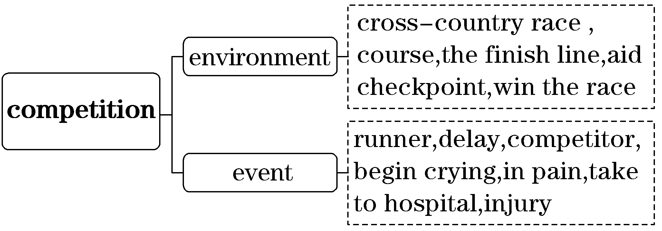

(二)基于深层主题“体育精神”建构表达词汇
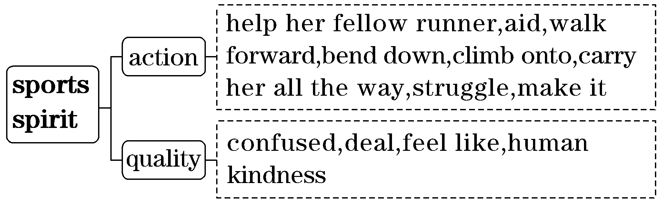

二、借助语境知识，实现深度学习
(一)把握一词多义，提高理解的准确性
1．compete v．竞争；对抗；参加比赛；争夺
[语境辨义] (写出黑体部分的含义)
①On Oct.11, hundreds of runners competed in a crosscountry race in Minnesota.____________
②Young children will usually compete for their mother's attention.____________
③Kangaroos compete with sheep and cattle for sparse supplies of food and water.____________
2．pain n．疼痛，痛苦；烦恼；努力；讨厌的/令人头痛的人(或事) vt.使痛苦；使苦恼；使疼痛
[语境辨义] (写出黑体部分的词性及含义)
①...a runner in front of her began crying in pain.
②I felt we both shared the same sense of loss, and felt the same pain.____________
③As the proverb says, “No pains, no gains.”
④The wound still pained him occasionally.
3．aid n．援助；帮助；助手；救援物资v.援助；帮助
[语境辨义] (写出黑体部分的词性及含义)
①Bailey took her arm to see if she could walk forward with aid.
②The government could do a lot of good by sending aid to the area.____________
③This feature is designed to aid inexperienced users.
(二)融通词形转换，提升表达的准确性
1．compete v．竞争；对抗；参加比赛→____________ n．竞赛→____________n．比赛者
2．pain n．痛苦→____________ adj.痛苦的；疼痛的
3．injury n．损伤→_____________vt.损害；使受伤→____________ adj.受伤的
4．extreme adj.极端的；极度的→____________ adv.极其；极端地
5．equal adj.平等的→____________ n．平等→____________ adv.平等地
6．assess v．评估；评价→____________ n．评估；评价
7．confused adj.感到困惑的→__________ v．使困惑→____________ adj.令人困惑的→__________ n．困惑
8．benefit v．使受益；得益于→______________ adj.有益的
(三)明辨熟词生义，强化思维的灵活性
1．attention n．[熟义]注意；关注；注意力；关心；[生义]特别照料
[语境辨义] (写出黑体部分的含义)
①Bailey then bent down to let Lenoue climb onto her back and carried her all the way to the finish line, then another 300 feet to where Lenoue could get medical attention.____________
②He turned his attention back to the road again.____________
③As the youngest child, she was always the centre of attention.____________
2．struggle [熟义] v．斗争；努力；奋斗；搏斗n.斗争；努力[生义]v.艰难地行进；吃力地进行
[语境辨义] (写出黑体部分的词性及含义)
①She would have struggled with extreme pain to make it to that aid checkpoint without Bailey's help.
②He struggled against cancer for two years.
③James was hit in the mouth as he struggled with the robbers.
④Several modern writers saw the process of education as a struggle against human nature.
3．meet[熟义]v.开会；会晤；遇见；见面
[生义]n.运动会，体育比赛 v．满足
[语境辨义] (写出黑体部分的词性及含义)
①Although the two young women were strangers before the meet, they've since become friends.
②Maybe we'll meet again some time.
③How can we best meet the needs of all the different groups？
三、发掘词块短语，实现类群拓展
1．由go away串记“v.＋away”的短语
go away 走开；离开；(岁月)流逝
put away 放在一边；收起来；储存
give away 捐赠；泄露
take away 带走；拿走
pass away 去世
[完成句子]
①Please ______________________， and we'll start the test.
请把你的书收起来，我们要开始考试了。
②When Miss Betsey saw me, she shouted：“________________！ Don't walk on my grass！”
贝齐小姐一看见我，就喊道：“走开！不要在我的草地上走！”
③He grieved to know that his mother ____________________.
得知母亲去世，他很悲痛。
2．由stand up串记“v.＋up”的短语
stand up 站起来；站立
set up 建立
give up 放弃
pick up 捡起，拾起；用车接；学会；恢复
break up 打碎；解散；放假
[完成句子]
①The society ________________ to preserve endangered species from extinction.
成立这个协会是为了保护濒危物种免遭灭绝。
②There were no seats left so I had to ____________________________________________.
没有座位留下，所以我只好站着。
③I stretched out a hand and __________________________________________________.
我伸出一只手，把书捡起来。

朗朗晨读(二)2023·新高考Ⅱ卷·完形填空·价值词汇发掘
三遍而熟·背出语感——(第一遍，做题；第二遍，代入答案诵读；第三遍，带空诵读，凭语感顺出答案)
In April last year, I saw a post on the PNP (Pilots N Paws) website from a family in Topeka.They had to move to Virginia but they were on a very tight __1__.They could not afford to pay for __2__ for their dog, Tiffy, and __3__ wanted to take her with them.
It just __4__ that I was planning another PNP flight with another pilot, Karen, who __5__ to take Tiffy from Kansas City to Virginia.What I was to do was fly to Topeka to __6__ Tiffy.
When I met Tiffy's owners, they seemed very __7__. George, the husband, was trying to be calm, but I could tell this was __8__ for him, having to leave his dog to a __9__ and trust that everything would __10__.
After some goodbyes, I asked George and his wife to help me __11__ Tiffy into the plane.I promised to take care of Tiffy and __12__ them as soon as we got to Kansas City.
The flight was __13__， and Tiffy was a great passenger.The next day, she __14__ with Karen and made it back to George in Virginia within a few days.He was so __15__ and sent me a nice email with pictures.It felt great to know that I had helped bring this family together again.
1.A.turn B．budget
C．schedule D．connection
2．A.food B．shelter
C．medicine D．transportation
3．A.desperately B．temporarily
C．secretly D．originally
4．A.appeared B．proved
C．happened D．showed
5．A.waited B．offered
C．hurried D．failed
6．A.see off B．look for
C．hand over D．pick up
7．A.confused B．nervous
C．annoyed D．curious
8．A.hard B．fine
C．common D．lucky
9．A.coworker B．passenger
C．stranger D．neighbor
10．A.speed up B．work out
C．come back D．take off
11．A.feed B．follow
C．change D．load
12．A.call B．join
C．leave D．serve
13．A.unnecessary B．unexpected
C．unavoidable D．uneventful
14．A.returned B．fought
C．flew D．agreed
15．A.thankful B．generous
C．proud D．sympathetic
[答案自查：1～5 BDACB 6～10 DBACB 11～15 DADCA]

一、立足主题语境，建构词汇网络
2023年新高考Ⅱ卷完形填空的主题语境是“人与社会”，其表层话题为“运送宠物”，深层主题为“助人为乐”。文章讲述了作者通过Pilots N Paws网站帮助一对夫妇将他们的狗接到另一个城市的过程。作者和另一位飞行员一起完成了这次任务，最终成功将这只狗带回到了它的主人身边，彰显了人与人之间的关爱与互助，倡导助人为乐。

(一)基于表层话题“运送宠物”建构阅读词汇
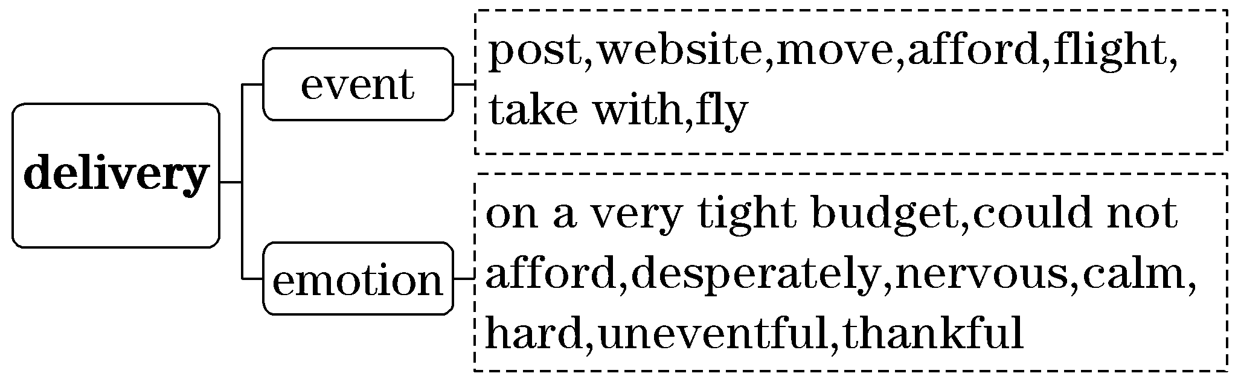

(二)基于深层主题“助人为乐”建构表达词汇
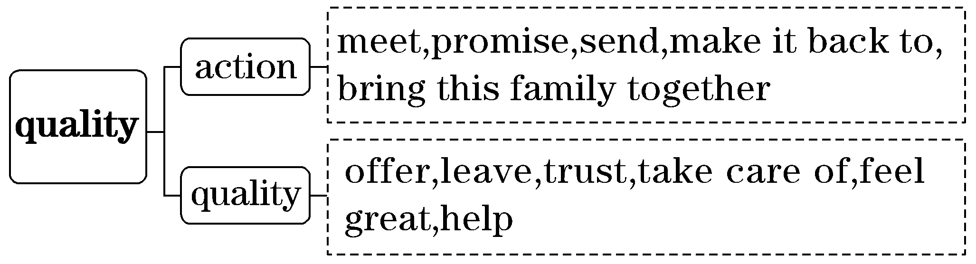
二、借助语境知识，实现深度学习
(一)把握一词多义，提高理解的准确性
1．desperately adv.绝望地，拼命地，不顾一切地；极度地；猛烈地
[语境辨义]
①They could not afford to pay for transportation for their dog, Tiffy, and desperately wanted to take her with them.____________
② The rabbit ran so desperately that it seemed not to have been hurt at all.____________
2．offer v．提供；供应；主动提出；出价
n．建议；报价；减价；出价
[语境辨义]
①It just happened that I was planning another PNP flight with another pilot, Karen, who offered to take Tiffy from Kansas City to Virginia.____________
②The hotel offers excellent facilities for families.
③He offered 23 pounds for the bike, but they refused.
④She just couldn't stop shopping and she loved special offers.
⑤In that event, we will have to reconsider our offer.
3．calm adj.平静的；镇静的；风平浪静的
v．使镇静 n．镇静；平静
[语境辨义]
①George, the husband, was trying to be calm ...
②He took a few deep breaths to calm himself down.
③Such a boat is fit only for a calm sea.
④Jin said literature gave him a sense of calm and freedom.

(二)融通词形转换，提升表达的准确性
1．tight adj.紧的→____________ adv.紧紧地
2．afford v．提供；买得起→____________ adj.买得起的；负担得起的
3．original adj.最初的→____________ n．起源→____________ adv.原来；起初
4．annoyed adj.恼怒的→____________ vt.使恼怒→______________ adj.烦人的→____________ n．烦恼；恼怒
5．curious adj.好奇的→____________ n．好奇心
6．generous adj.慷慨的→____________ n．慷慨
7．sympathetic adj.同情的→____________ n．同情

(三)明辨熟词生义，强化思维的灵活性
1．post[熟义] n．邮政；职位 v．邮寄
[生义] n．帖子 v．发帖子
[语境辨义]
①In April last year, I saw a post on the PNP (Pilots N Paws) website from a family in Topeka.
②I want to post this letter now so you can get it by the weekend.
③He has held the post for three years.
2．tell v．[熟义]告诉；讲述；说明；显示
[生义]看出，判断出
[语境辨义]
①George, the husband, was trying to be calm, but I could tell this was hard for him ...
②He told the news to everybody he saw.
③This gauge tells you how much fuel you have left.
3．trust v．[熟义]信任；相信；信赖[生义]期望，希望
[语境辨义]
①George, the husband, was trying to be calm, but I could tell this was hard for him, having to leave his dog to a stranger and trust that everything would work out.
②I know I can trust her in any circumstance.
③Don't trust what the newspapers say!
三、发掘词块短语，实现类群拓展
1．由see off串记“v.＋off”的短语
see off 送别；为……送行
turn off 关上；使失去兴趣
cut off 切断；中止；与世隔绝
put off 推迟；延期
take off 脱下；起飞；休假
set off 动身；出发；引起；使爆炸
show off 炫耀
[完成句子]
①His friends will ___________________at the airport next week.
他的朋友们下星期将到机场为他送行。
②To live a lowcarbon life, we must remember to_____________________ when we leave the room.
要想过上低碳生活，我们必须记得离开房间时要关灯。
③He __________________________ and squeezed the water out.
他脱下湿衣服，拧干了水。
2．由hand over串记“v.＋over”的短语
hand over 移交；交出
take over 接管；取代
get over 克服；恢复过来
go over 复习；仔细检查；走过去
turn over 翻转；翻身
[完成句子]
①Liz picked up the blue envelope and ________________________________.
莉兹拿起蓝色信封，好奇地翻过来看。
②My mother was happy to ____________________________________.
我的母亲很高兴把工作转交给了我的父亲。
③____________________________ for spelling mistakes before you hand it in.
交作业前仔细检查一下拼写错误。
朗朗晨读(三)2023·全国甲卷·完形填空·价值词汇发掘
三遍而熟·背出语感——(第一遍，做题；第二遍，代入答案诵读；第三遍，带空诵读，凭语感顺出答案)
Many years ago, I bought a house in the Garfagnana, where we still go every summer.The first time we__1__ there, we heard the chugchugchug of a motorbike__2__ its way down the hill toward us.It was a__3__ called Mario, coming to__4__ us a box containing some tomatoes and a bottle of wine.It was a very nice __5__ for him to make.But when we looked at the tomatoes, we were __6__ because they were so misshapen: not at all like the nice, round, __7__ things you get in a supermarket.And the wine was cloudy, in a funny old bottle with no label (标签) on it.These can't be any __8__ , we thought.But we were __9__ his kindness, so we __10__ them.
What we discovered is that it's __11__ to judge what you eat only by its __12__.Those tomatoes had a __13__ that reminded me of the ones my uncle used to grow when I was a child.Nowadays supermarket tomatoes __14__ perfect but taste of water.Nobody's going to have a __15__ memory of those.It's a surprise they haven't managed to grow square ones so that they can __16__ them easily.Mario's wine may have been cloudy and come out of an old bottle, but it was __17__ .
It's good to eat things at the correct time, when they're __18__ and as close as possible to where they were__19__ .What Mario had__20__ us was the taste of the Garfagnana.
1.A.waited B．met
C．camped D．stayed
2．A.making B．searching
C．squeezing D．feeling
3．A.customer B．neighbor
C．relative D．passenger
4．A.lend B．send
C．bring D．show
5．A.choice B．comment
C．promise D．gesture
6．A.worried B．moved
C．thrilled D．bored
7．A.simple B．real
C．shiny D．fun
8．A.more B．good
C．new D．easy
9．A.sympathetic to B．thankful for
C．cautious about D．interested in
10．A.tried B．sold
C．returned D．mixed
11．A.unnecessary B．uncertain
C．unwise D．unusual
12．A.appearance B．quality
C．origin D．price
13．A.size B．shape
C．color D．taste
14．A.smell B．look
C．become D．work
15．A.happy B．vivid
C．short D．vague
16．A.clean B．check
C．count D．pack
17．A.perfect B．useful
C．convenient D．familiar
18．A.on view B．on sale
C．in season D．in need
19．A.finished B．stored
C．found D．grown
20．A.cooked B．given
C．bought D．Told
[答案自查：1～5 DABCD 6～10 ACBBA 11～15 CADBA 16～20 DACDB]
一、立足主题语境，建构词汇网络
2023年全国甲卷完形填空的主题语境是“人与社会”，其表层话题为“邻里关系”，深层主题为“感受内在美”。本文是夹叙夹议文。作者回忆了第一次住在Garfagnana时，邻居Mario送来了时令的西红柿和自酿酒，虽然品相不好，但味道却很好。作者意识到仅仅以外表来判断食物是否好吃是不明智的。邻居的善意也让作者感受到了温暖。本文旨在培养学生正确的人生观和价值观——不以外表去评价人或事，倡导健康的人际关系。
(一)基于表层话题“邻里关系”建构阅读词汇
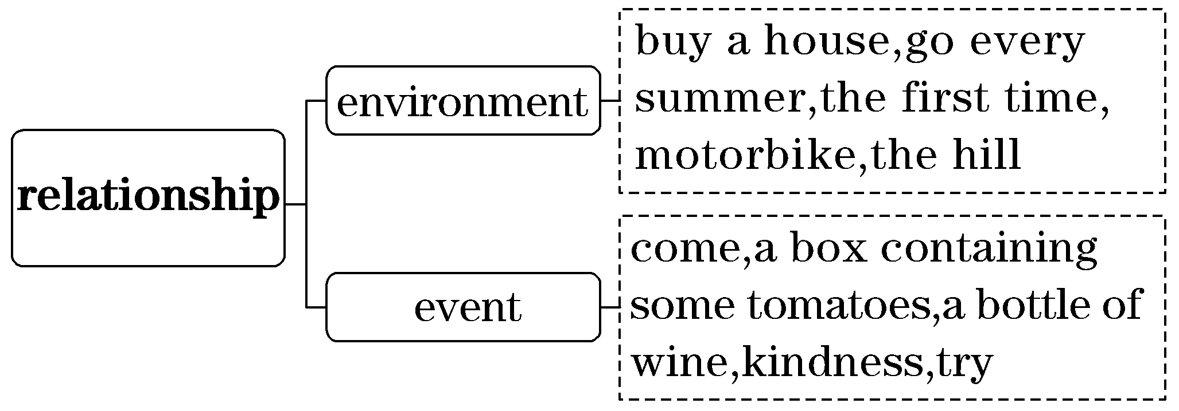
(二)基于深层主题“感受内在美”建构表达词汇
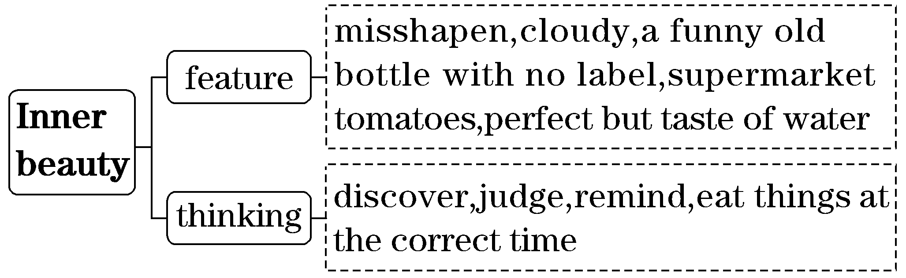
二、借助语境知识，实现深度学习
(一)把握一词多义，提高理解的准确性
1．contain vt.含有，包含；控制，抑制(感情)；容纳
[语境辨义]
①It was a neighbor called Mario, coming to bring us a box containing some tomatoes and a bottle of wine.____________
②This chapter contains the real meat of the writer's argument.____________
③She was unable to contain her excitement.____________
④More than a hundred firemen are still trying to contain the fire at the plant.____________
2．label n．标签；标记
vt.贴标签于；把……称为；用标签标明
[语境辨义]
①And the wine was cloudy, in a funny old bottle with no label on it.
②We carefully labelled each item with the contents and the date.
③It is unfair to label a small baby as naughty.
3．judge n．法官；审判员；裁判员
v．判断；审判；认为；估计
[语境辨义]
①What we discovered is that it's unwise to judge what you eat only by its appearance.
②The judge sentenced him to five years in prison.
③The tour was judged a great success.
4．perfect adj.完美的；完全的；合适的
vt.使完善；使完美
[语境辨义]
①Nowadays supermarket tomatoes look perfect but taste of water.
②I don't know him — he's a perfect stranger.
③As a musician, she has spent years perfecting her technique.
(二)融通词形转换，提升表达的准确性
1．choice n．选择→____________ vt.选择，挑选
2．shiny adj.发亮的；闪光的→_____________n．阳光
3．cautious adj.小心的；谨慎的→_________________n．小心；谨慎
4．mix vt.混合→_____________n．混合；混合物
5．appearance n．外貌；出现→____________ v．出现→____________ v．消失→____________ n．消失
6．vivid adj.生动的；逼真的→_______________adv.生动地；逼真地

(三)明辨熟词生义，强化思维的灵活性
1．gesture n．[熟义] 手势；姿势；示意动作
[生义](表明感情或意图的)姿态，表示
[语境辨义]
①It was a very nice gesture for him to make.____________
②He made a friendly gesture at the driver of the other car.____________
2．cloudy adj.[熟义]多云的；阴云密布的，阴天的
[生义](液体)不清澈的，浑浊的
[语境辨义]
①And the wine was cloudy, in a funny old bottle with no label on it.____________
②The sky is cloudy, and looks like rain.____________

三、发掘词块短语，实现类群拓展
1．由in need串记“in＋n.”的短语
in need 需要帮助的
in trouble 处于困境
in silence 安静地；沉默地
in advance 提前
in vain 徒劳的；白费力气
[完成句子]
①Her life is ____________________ and she is desperately depressed.
她的生活陷入困境，她非常郁闷。
②I'd advise buying your tickets _________________if you want to travel in August.
要是你想在八月份去旅行，我建议提前购票。
③The portable clinic will take doctors to children_______________.
移动诊所将为需要帮助的孩子们带去医生。
2．由on view串记“on＋n.”的短语
on view 展览中
on average 平均
on display 展览
on duty 值班
on board 在船上；在飞机上
on occasion 偶尔
[完成句子]
①400 people a year die of this disease _________________________________________.
平均每年有400人死于这种疾病。
②The latest models will be ____________________ at the motor show.
最新的车型将会在这次汽车展上展出。
③Don't swim unless there is a lifeguard ______________________________________.
除非有救生员值班，否则不要游泳。

朗朗晨读(四)2023·全国乙卷·完形填空·价值词汇发掘
三遍而熟·背出语感——(第一遍，做题；第二遍，代入答案诵读；第三遍，带空诵读，凭语感顺出答案)
To become the Olympic champion in the individual (个人) allaround event, Gabby Douglas had to leave everything she__1__ best.She had to __2__ her bedroom in Virginia.She had to say __3__ to her two dogs and to the beach, where she loved to __4__ waves on her board.But it was __5__ to take the leap (飞跃)，however __6__ it would be.Even at 14, Douglas knew that.So she __7__ about 1,200 miles away from home, to __8__ with a coach from China.She lived with a family she had never __9__ and everything was new to her.
As it turned out, Douglas did __10__ what she needed to do to become Olympic champion when she __11__ two Russians.The Chinese coach __12__ Douglas into one of the best gymnasts in the __13__， helping her skyrocket from an __14__ member of the national team to the top of the sport.By __15__ the Olympic allaround title, she became the first black woman to do so.She __16__ the competition from beginning to end.She said she had felt __17__ all along that she would win.
Not so long ago, Martha Karolyi, the coordinator (联络人) of the women's national team, did not think Douglas had what it __18__ to be an Olympian.As time went by, she thought __19__ that she could make the London Games — and win.
“I'm going to inspire so many people，” she said.“I'm ready to __20__.” And shine she did.
1.A.tried B．thought
C．judged D．knew
2．A.take up B．pack up
C．clean up D．do up
3．A.goodbye B．hello
C．thanks D．no
4．A.cause B．observe
C．ride D．strike
5．A.common B．time
C．fun D．tough
6.A.breathtaking B．heartbreaking
C．eyecatching D．headspinning
7．A.dropped out B．moved on
C．pulled over D．went off
8．A.reason B．talk
C．compete D．train
9．A.met B．helped
C．understood D．needed
10．A.approximately B．gradually
C．exactly D．possibly
11．A.defeated B．pleased
C．respected D．assisted
12．A.forced B．transformed
C．persuaded D．put
13．A.world B．city
C．team D．state
14.A.amateur B．elected
C．average D．enthusiastic
15．A.clarifying B．defending
C．winning D．demanding
16．A.followed B．organized
C．watched D．led
17．A.confident B．nervous
C．excited D．uneasy
18．A.viewed B．appeared
C．mattered D．took
19．A.now and then B．more and more
C．far and wide D．on and on
20．A.shine B．fly
C．dance D．score
[答案自查：1～5 DBACB 6～10 BDDAC 11～15 ABACC 16～20 DADBA]

一、立足主题语境，建构词汇网络
2023年全国乙卷完形填空的主题语境是“人与自我”，其表层话题为“著名人物”，深层主题为“勇敢追梦”。文章讲述了黑人奥运冠军Gabby Douglas的成长之路。为了训练，她离开了自己熟悉的一切，到千里外接受中国教练的训练。之后，她战胜了对手成为奥运冠军。通过自己的亲身经历，她想激励更多的人。本文旨在引导学生在学习和生活中锤炼意志，勇敢追梦。

(一)基于表层话题“著名人物”建构阅读词汇
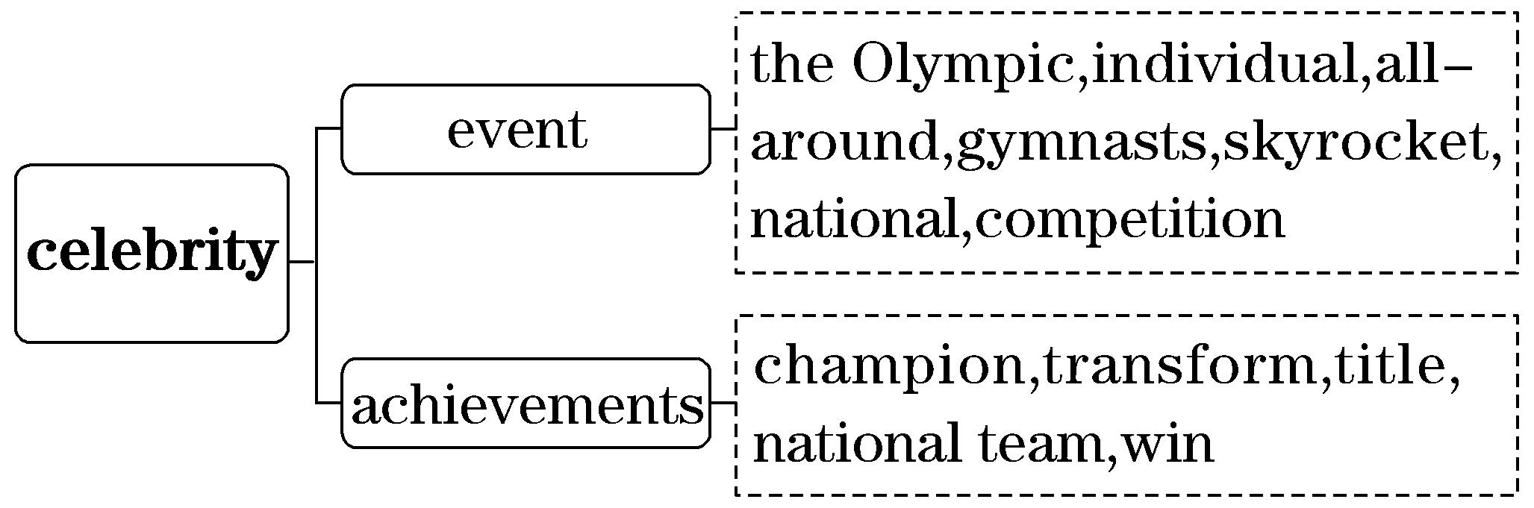
(二)基于深层主题“勇敢追梦”建构表达词汇
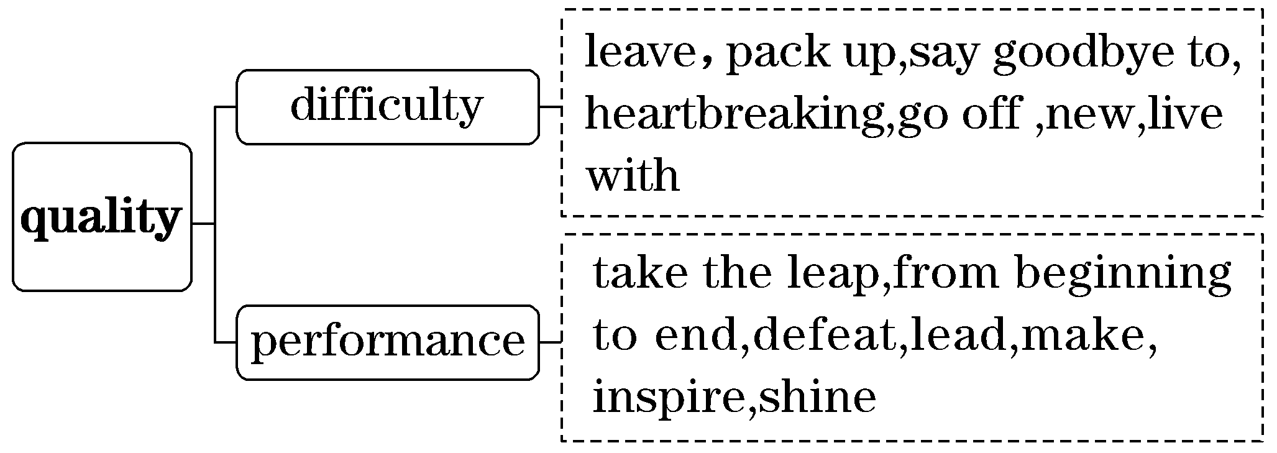

二、借助语境知识，实现深度学习
(一)把握一词多义，提高理解的准确性
1．individual adj.单独的；个别的；独特的
n．个人；有个性的人
[语境辨义]
①To become the Olympic champion in the individual allaround event ...
②We interviewed each individual member of the community.
③I encourage my child to be an individual.
④She has her own individual style of doing things.
2．ride v．骑；驾驶；穿越；搭乘；漂浮
n．短途旅行；乘坐；搭便车
[语境辨义]
① ... she loved to ride waves on her board.
②The boys were riding their bikes around the streets.
③She rode the bus to school every day.
④We managed to get a ride into town when we missed the bus.
⑤She took some friends for a ride in the family car.
3．defeat vt.打败，击败；阻挠；使困惑，难住
n．击败，战胜；失败
[语境辨义]
①As it turned out, Douglas did exactly what she needed to do to become Olympic champion when she defeated two Russians.
②The instruction manual completely defeated me.
③The world champion has only had two defeats in 20 fights.
4．average adj.平均的；一般的，普通的
n．平均数 v．平均为
[语境辨义]
①The Chinese coach transformed Douglas into one of the best gymnasts in the world, helping her skyrocket from an average member of the national team to the top of the sport.
②Average earnings are around ￡20,000 per annum.
③Parents spend an average of $220 a year on toys.
④Economic growth is expected to average 2% next year.
(二)融通词形转换，提升表达的准确性
1．inspire vt.激励；启发→____________ n．灵感→____________ adj.鼓舞人心的
2．pleased adj.高兴的；满意的→____________adj.令人愉快的→____________ n．快乐；愉快
3．assist v．帮助；援助→____________ n．帮助；援助→____________ n．助手
4．defend v．保卫；辩护→____________ n．保卫；防御
5．demand v．要求；需求→____________ adj.要求高的
6．confident adj.自信的→_____________n．自信
(三)明辨熟词生义，强化思维的灵活性
1．board [熟义] n．董事会，委员会，理事会v.寄宿；上船 [生义] n．冲浪板
[语境辨义]
①She had to say goodbye to her two dogs and to the beach, where she loved to ride waves on her board.
②She has a seat on the board of directors.
③The ship was boarded by customs officials.
2．shine v．[熟义]闪耀；闪光；[生义]出色；出类拔萃
[语境辨义]
①“I'm going to inspire so many people，”she said.“I'm ready to shine.”____________
②The sun shone brightly in a cloudless sky.____________
三、发掘词块短语，实现类群拓展
1．由turn out串记“v.＋out”的短语
turn out 结果是；生产；发生
come out 出来；出版
work out 解决；锻炼
carry out 执行；实施
put out 扑灭；生产
break out 爆发
[完成句子]
①No one could have foreseen that things would___________________.
谁都没有预料到事情的结果会这样。
②The book written by this famous novelist ________________ next month.
由这位著名小说家写的书将于下个月出版。
③The government should take strict measures__________________garbage sorting policy.
政府应采取严格措施实施垃圾分类政策。
2．由move on串记“v.＋on”的短语
move on 继续前进
carry on 继续开展
depend on 依靠；依赖
take on 承担；呈现；雇佣
turn on 打开
put on 穿上；增加(体重)
[完成句子]
①You'll wear yourself out if you ________________ so hard.
你要是继续这样拼命工作，身体会吃不消的。
②I don't think I should always __________________________________________________.
我认为我不应该总是依赖我的父母。
③They________________until at last; David saw some houses below.
他们继续前行，直到最后，大卫看到了下面的房子。

朗朗晨读(五)2023·浙江1月高考·完形填空·价值词汇发掘
三遍而熟·背出语感——(第一遍，做题；第二遍，代入答案诵读；第三遍，带空诵读，凭语感顺出答案)
The sun was beginning to sink as I set off into the Harenna Forest.I was on my way to __1__ a unique honey harvest.Here，in southeast Ethiopia，handcarved beehives (蜂箱) are placed in the __2__ .Reaching them to get the honey is difficult — and often __3__ .
I __4__ beekeeper Ziyad over a wide stretch of grassland before entering a thick jungle.Ziyad began preparations.He __5__ handfuls of damp tree leaves，wrapped them with string，and __6__ the bunch to create a torch (火把)．Then，with one end of a rope tied to his waist and the other end around the trunk of a tree，Ziyad began __7__ .He stopped every few minutes to move the __8__ higher up the tree trunk.
__9__ ，Ziyad got close to the hive which was around 20 metres above the ground.Sitting on a branch，he __10__ towards it and blew smoke from his torch into a tiny hole in the hive.Suddenly，Ziyad let out a sharp cry.Within seconds，he'd __11__ the trunk and was back on the ground.
It was too __12__ to collect the honey.A cool summer had delayed __13__ .Baby bees were still in the honeycombs (蜂巢)．The adult bees were __14__ and kept attacking as Ziyad escaped from the tree.He had to wait for the right __15__ to go back up.
1.A.share B．collect
C．celebrate D．witness
2．A.courtyards B．fields
C．treetops D．caves
3．A.urgent B．dangerous
C．expensive D．pointless
4．A.searched B．recognised
C．followed D．invited
5．A.gathered B．cleaned
C．dropped D．checked
6．A.shook B．lit
C．measured D．decorated
7．A.jumping B．talking
C．testing D．climbing
8．A.hives B．leaves
C．rope D．honey
9．A.Finally B．Surprisingly
C．Naturally D．Immediately
10．A.backed B．dived
C．shouted D．inched
11．A.cut off B．gone up
C．slid down D．held onto
12．A.high B．early
C．fast D．close
13．A.hatching B．training
C．sowing D．trading
14．A.curious B．hungry
C．bored D．angry
15．A.moment B．equipment
C．person D．order
[答案自查：1～5 DCBCA 6～10 BDCAD 11～15 CBADA]
一、立足主题语境，建构词汇网络
2023年浙江1月高考完形填空的主题语境是“人与自然”，其表层话题为“人与蜜蜂”，深层主题为“尊重劳动”。文章讲述了作者作为见证者，记录了一次养蜂人爬到树上徒手采集蜂蜜的独特场景。文章提倡理解劳动者的艰辛，尊重劳动者，同时也要尊重自然规律。

(一)基于表层话题“人与蜜蜂”建构阅读词汇
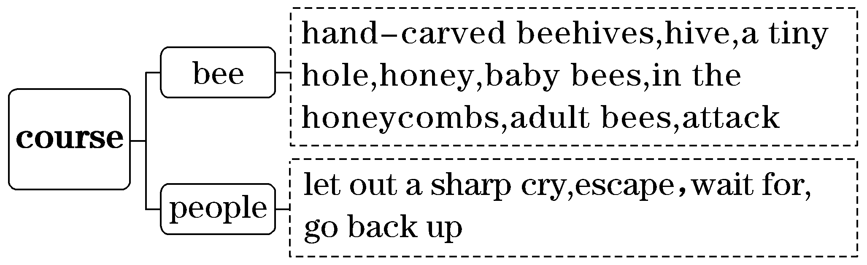

(二)基于深层主题“尊重劳动”建构表达词汇
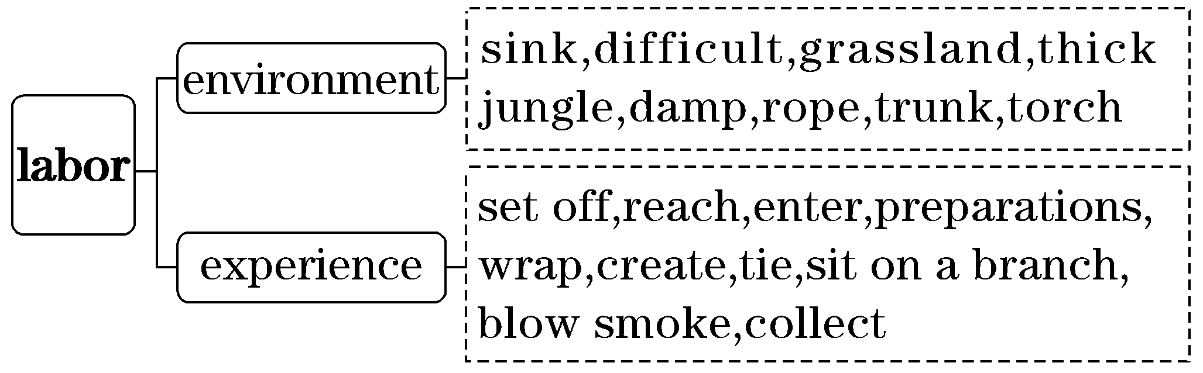
二、借助语境知识，实现深度学习
(一)把握一词多义，提高理解的准确性
1．sink v．下沉；沉没；倒下，坐下 n．洗涤池
[语境辨义]
①The sun was beginning to sink as I set off into the Harenna Forest.
②The ship sank to the bottom of the sea.
③She sank back into her seat, exhausted.
④Don't just leave your dirty plates in the sink!
2．place n．位置；场所，地方 v．放置
[语境辨义]
①Here, in southeast Ethiopia, handcarved beehives are placed in the treetops.
②I can't remember all the places we visited in Thailand.
3．branch n．树枝；分支；支流；分部 v．分叉
[语境辨义]
①Sitting on a branch, he inched towards it and blew smoke from his torch into a tiny hole in the hive.
②The bank has branches all over the country.
③The accident happened where the road branches.
4．delay v．延迟；使耽搁 n．延迟；延期
[语境辨义]
①A cool summer had delayed hatching.
②That way, you will avoid potential time delays in getting to your classes.
(二)融通词形转换，提升表达的准确性
1．urgent adj.紧急的→____________ v．督促；力劝 n．冲动；强烈的欲望
2．dangerous adj.危险的→____________ n．危险
3．recognise v．承认；认出→____________ n．承认；识别；赞扬
4．decorate v．装饰；装修→_____________n．装饰；装饰物
5．hungry adj.饥饿的；渴望的→______________ n．饥饿；渴望→____________ adv.饥饿地；渴望地
6．bored adj.厌烦的→____________ adj.令人厌烦的；无聊的→____________ n．无聊
7．equipment n．装备；设备→__________________v．配备；装备
(三)明辨熟词生义，强化思维的灵活性
1．stretch [熟义]v.伸展；延伸；伸出；拉紧；伸手 n．伸展[生义] n．一片
[语境辨义]
①I followed beekeeper Ziyad over a wide stretch of grassland before entering a thick jungle.
②He stretched and yawned lazily.
③She stretched across the table for the butter.
④The procession stretched for several miles.
2．inch [熟义] n．英寸[生义] v．谨慎移动
[语境辨义]
①Sitting on a branch, he inched towards it and blew smoke from his torch into a tiny hole in the hive.
②She's a few inches taller than me.
3．sharp adj.[熟义]敏锐的；尖的，锋利的
[生义]刺耳的
[语境辨义]
①Suddenly, Ziyad let out a sharp cry._____________
②I got a seat opposite a middleaged man with sharp eyes, who kept watching a kid in a window seat.____________
③Using sharp scissors, make a small cut in the material.____________
三、发掘词块短语，实现类群拓展
1．由slide down串记“v.＋down”的短语
slide down 向下滑动
break down 分解；抛锚
put down 放下
cut down 砍倒；砍伐；减少
die down 渐渐消失
[完成句子]
①A large ship_________________ in the river, leaving at least 100 big ships unable to pass.
一艘大船在河中抛锚，导致至少100艘大船无法通过。
②The windows_________________ at the touch of a button.
按一下开关，窗玻璃便落下来。
③The rain remained steady though the wind had ______________.
尽管风势已经减弱，但雨还是下个不停。
2．由get close to 串记“get＋adj.＋介词”的短语
get close to 接近
get angry at 对……生气
get accustomed to 习惯于
get involved in 参与，涉及，卷入
[完成句子]
①I kept trying at the song, no longer ____________________________.
我一直在努力唱这首歌，不再生自己的气。
②You'll soon ________________________ the job.
你很快就会习惯这项工作的。
③Day care enables women to __________________________________________________.
日托服务能够让妇女参与其他活动。
朗朗晨读(六)2022·新高考Ⅰ卷·完形填空·价值词汇发掘
三遍而熟·背出语感——(第一遍，做题；第二遍，代入答案诵读；第三遍，带空诵读，凭语感顺出答案)
My husband, our children and I have had wonderful camping experiences over the past ten years.
Some of our __1__ are funny, especially from the early years when our children were little. Once, we __2__ along Chalk Creek. I was __3__ that our 15monthold boy would fall into the creek (小溪). I tied a rope around his waist to keep him near to our spot. That lasted about ten minutes. He was __4__， and his crying let the whole campground know it. So __5__ tying him up, I just kept a close eye on him. It __6__ — he didn't end up in the creek. My threeyearold, however, did.
Another time, we rented a boat in Vallecito Lake. The sky was clear when we __7__， but storms move in fast in the mountains, and this one quickly __8__ our peaceful morning trip. The __9__ picked up and thunder rolled. My husband stopped fishing to __10__ the motor. Nothing. He tried again. No __11__. We were stuck in the middle of the lake with a dead motor. As we all sat there __12__， a fisherman pulled up, threw us a rope and towed (拖) us back. We were __13__ .
Now, every year when my husband pulls our camper out of the garage, we are filled with a sense of __14__， wondering what camping fun and __15__ we will experience next.
1.A.ideas B．jokes
C．memories D．discoveries
2．A.camped B．drove
C．walked D．cycled
3．A.annoyed B．surprised
C．disappointed D．worried
4．A.unhurt B．unfortunate
C．uncomfortable D．unafraid
5．A.due to B．instead of
C．apart from D．as for
6．A.worked B．happened
C．mattered D．changed
7．A.signed up B．calmed down
C．checked out D．headed off
8．A.arranged B．interrupted
C．completed D．recorded
9．A.wind B．noise
C．temperature D．speed
10．A.find B．hide
C．start D．fix
11．A.luck B．answer
C．wonder D．signal
12．A.patiently B．tirelessly
C．doubtfully D．helplessly
13．A.sorry B．brave
C．safe D．right
14．A.relief B．duty
C．pride D．excitement
15．A.failure B．adventure
C．performance D．conflict
[答案自查：1～5 CADCB 6～10 ADBAC 11～15 ADCDB]
一、立足主题语境，建构词汇网络
2022年新高考Ⅰ卷完形填空的主题语境是“人与自我”，其表层话题为“冒险趣事”，深层主题为“积极乐观”。文章讲述了作者和家人在野营旅行中经历过的趣事与冒险，以至于作者和家人都十分期待下一次野营。文章旨在引导我们要积极乐观地面对生活。
(一)基于表层话题“冒险趣事”建构阅读词汇
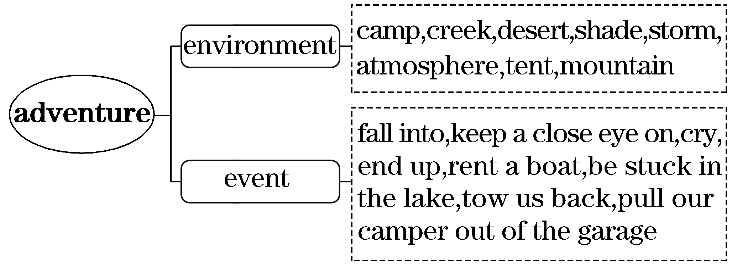
(二)基于深层主题“积极乐观”建构表达词汇
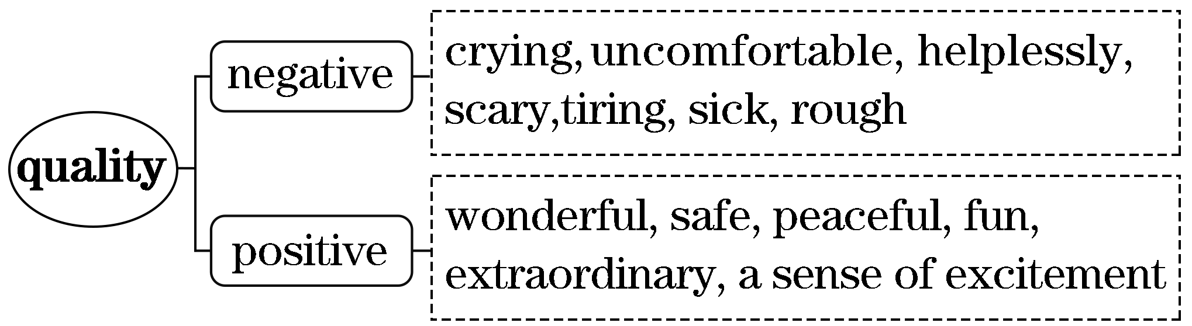
二、借助语境知识，实现深度学习
(一)把握一词多义，提高理解的准确性
1．tie v．将……系在……上；系，拴；打结；使相联系；束缚；打成平局
n．领带；带子，绳子；纽带，联系；束缚；平局
[语境辨义]
①I tied a rope around his waist to keep him near to our spot.
②He had tied the dog to one of the trees near the canal.
③I want a tie that will match with this suit.
④We have established trade ties with these regions.
2．spot n．地点，场所；点，斑点；污点，污渍；困境，窘境
v．发现，注意到；使有斑点；稀疏地点缀
[语境辨义]
①I tied a rope around his waist to keep him near to our spot.
②She was wearing a red dress with white spots.
③He tried cleaning the spot with alcohol.
④I was spotted by a ship and brought to London.
3．stick v．粘贴；刺，扎，戳；放置；卡住，困住
n．枝条；棍，条，签
[语境辨义]
①We were stuck in the middle of the lake with a dead motor.
②Pictures of some famous scientists were stuck on the wall of the classroom.
③He looked around and found a stick to defend himself against the dog.

(二)融通词形转换，提升表达的准确性
1．camp v．&n.露营；营地→____________ n．野营度假→____________ n．露营者；野营车
2．die v．死→____________ n．死亡→____________ adj.死亡的→____________ adj.临终的
3．move v．移动→____________ adj.感人的→______________ adj.感动的→____________ n．移动，运动
4．peace n．平静→____________ adj.平静的
5．help n．&v.帮助→____________ adj.有帮助的→____________ adj.无助的→____________ adv.无助地
6．excite v．使兴奋→____________ adj.兴奋的→____________ adj.令人激动的→____________ n．兴奋，激动

(三)明辨熟词生义，强化思维的灵活性
1．work v．[熟义]工作；[生义]奏效，起作用
[语境辨义]
①It worked — he didn't end up in the creek.____________
②I started working in a recording studio.____________
2．pick up [熟义] 拾起，捡起；[生义]变强，增大
[语境辨义]
①The wind picked up and thunder rolled.____________
②Mike knelt down and helped the boy pick up the scattered articles.____________

三、发掘词块短语，实现类群拓展
1．由fall into串记“v.＋into”的短语
fall into 跌入；陷入
break into 闯进，破门而入
burst into 突然……起来
get into 陷入，进入
run into 撞上，偶然碰见
look into 调查，考察
[完成句子]
①Hearing the news, she ____________________ deep sorrow.
听到这个消息，她陷入极度的悲伤之中。
②She ____________________________ and ran out of the room.
她突然哭了起来，跑出了房间。
③She ____________________ when she couldn't find the tickets.
当她找不到票时，她陷入了恐慌。
2．由pull up串记“动词＋up”的短语
pull up 拔起；停下来；阻止
pick up 拾起；学会；用车接；增强
use up 用完，耗尽
break up 分裂，打碎
bring up 抚养长大；呕吐
keep/catch up 赶上
take up 拿起，占用
[完成句子]
①The cab ______________ slowly and the driver jumped out.
出租车慢慢停了下来，司机跳下了车。
②By this time he had ________________________ all his savings.
到这时，他的存款已全部用完了。
③Though born in a big city, she ________________ in the countryside.
她虽然出生在大城市，但却是在农村被抚养长大的。
3．由be filled with串记“be＋过去分词＋with”的搭配
be filled with 充满……
be satisfied with 对……满意
be impressed with 对……印象深刻
be occupied with 忙于
be pleased with 对……满意/感到高兴
be concerned with 涉及；关心
[完成句子]
①Life ________________________.
生活充满了挑战。
②I ______________________________ the happiness and fun that I brought to others.
我很满意我给别人带来的快乐和乐趣。
③Grandma ________________________________ and encouraged me to continue.
奶奶对我的能力印象深刻，鼓励我继续。

朗朗晨读(七)2022·新高考Ⅱ卷·完形填空·价值词汇发掘
三遍而熟·背出语感——(第一遍，做题；第二遍，代入答案诵读；第三遍，带空诵读，凭语感顺出答案)
Like many young people, Jessica wants to travel the globe. Unlike most of them, this25yearold is doing it __1__. She and her husband have spent the last two years traveling the world, stopping everywhere from Paris to Singapore. It might sound like one long, expensive __2__， but the couple has an unusual way to make their travel __3__.
They're part of a new form of the __4__ economy: an online group of house sitters. Throughout their nocost stays in __5__ homes, they feed pets and water plants in the homeowner's __6__.
It's not all sightseeing. The two travelers carefully __7__ their trips, scheduling their days around the pets that are sometimes difficult to __8__. But house sitting also offers a level of __9__ they can't find in a hotel. “It's like __10__ at a friend's house，” Jessica says.
The couple has a high __11__ rate in getting accepted as house sitters and they always go beyond the homeowner's __12__. For Jessica, that means __13__ plenty of pictures of happy pets, keeping the house __14__ and leaving a nice small gift before heading to the next house. “You want to make the homeowner feel that they made the right ___15__ ，” she says.
1.A.indoors B．online
C．singlehanded D．fulltime
2．A.game B．service
C．vacation D．procedure
3．A.safe B．busy
C．helpful D．affordable
4．A.local B．private
C．sharing D．agricultural
5．A.strangers' B．parents'
C．coworkers' D．neighbors'
6．A.favor B．defense
C．honor D．absence
7．A.plan B．explain
C．compare D．complete
8．A.buy B．transport
C．choose D．please
9．A.support B．comfort
C．control D．attention
10．A.cooking B．staying
C．waiting D．studying
11．A.success B．survival
C．growth D．unemployment
12．A.budget B．abilities
C．expectations D．understanding
13．A.admiring B．donating
C．sending D．borrowing
14．A.clean B．open
C．simple D．empty
15．A.guess B．decision
C．response D．impression
[答案自查：1～5 DCDCA 6～10 DADBB 11～15 ACCAB]
一、立足主题语境，建构词汇网络
2022年新高考Ⅱ卷完形填空的主题语境是“人与社会”，其表层话题为“旅行”，深层主题为“真诚友善”。文章讲述了一对夫妇通过当看房人来环球旅行，热心照看房主的宠物和植物并受到好评的故事，告诉我们待人真诚友善才会成功。

(一)基于表层话题“旅行”建构阅读词汇
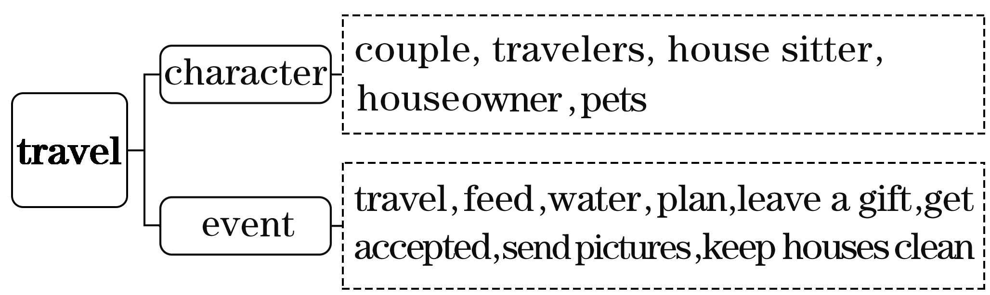
(二)基于深层主题“真诚友善”建构表达词汇
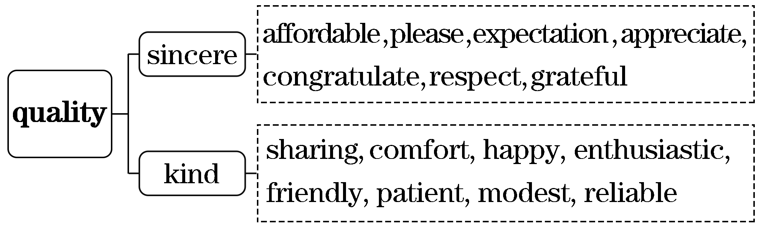
二、借助语境知识，实现深度学习
(一)把握一词多义，提高理解的准确性
1．sound n．声音，声响 v．发声；听起来好像
adj.健康的；合理的；可靠的；酣畅的
[语境辨义]
①It might sound like one long, expensive vacation ...
②Quickly she followed the sound to a stream.
③Without a sound body, one cannot achieve anything.
④I had a sound sleep last night and I got up rather early this morning.
2．form n．形式；种类；表格 v．形成，构成
[语境辨义]
①They're part of a new form of the sharing economy: an online group of house sitters.
②They formed a circle and sang Auld Lang Syne.
③The manager asked the job applicant to fill out the form first.
3．mean v．意味着；打算 n．中间，折中
adj.吝啬的；卑鄙的；残忍的，刻薄的；平均的
[语境辨义]
①For Jessica, that means sending plenty of pictures of happy pets ...
②I didn't mean to take a taxi but I had to, as I was late.
③It is mean to speak ill of others in the back of them.
④That man is very mean and tries every means to save money.
(二)融通词形转换，提升表达的准确性
1．afford v．负担得起→____________ adj.买得起的
2．economy n．经济→____________ adj.经济的→____________ n．经济学家
3．absent adj.不在的，缺席的→______________ n．不在，缺席
4．comfort v．&n.安慰→____________ adj.舒适的
5．succeed v．成功→____________ n．成功→__________________ adj.成功的
6．expect v．期待→____________ n．期待
(三)明辨熟词生义，强化思维的灵活性
please [熟义] int.请，请问[生义]v.使满意，使愉快
[语境辨义]
①The two travelers carefully plan their trips, scheduling their days around the pets that are sometimes difficult to please.____________
②Can we have the bill, please？____________
三、发掘词块短语，实现类群拓展
1．由spend ... doing sth.串记表示“花费……做某事”的搭配
sb. spend(s) ... doing sth.,it takes sb. ... to do sth.,it costs sb. ... to do sth.
[完成句子]
①It took my father thirty minutes ______________________________.
完成这项工作花费了我爸爸半小时的时间。
②It cost me 50 yuan _____________________________.
买这本书花了我50元。
③He spent some time ________________________， but I didn't learn much.
他花了一些时间教我如何滑冰，但我学得不多。
2．由head to串记“动词＋to (介词)”搭配
head to 引至，通向
add to 增添，增加
keep to 坚持，遵守
happen to 碰巧
contribute to 有助于，投稿，捐款
[完成句子]
①The driver pulled out the car and ______________ the nearest Police Station.
司机把车驶离路边，向最近的警察局开去。
②The howl of animals and the whistling wind in the distance __________________.
远处动物的嚎叫和呼啸的风声增添了她的恐惧。
③Riding bicycles __________________ people's physical fitness as well as easing traffic jams.
骑自行车不仅有助于人们的身体健康，也能缓解交通阻塞。
④Traffic regulations should always ________________________ at any time.
任何时候都要遵守交通规则。
3．由mean串记“动词＋to do/doing”的搭配
mean to do/doing sth. 打算做/意味着做某事
stop to do/doing sth. 停止去做/停止做某事
remember to do/doing sth. 记得去做/记得做过某事
forget to do/doing sth. 忘记去做/忘记做过某事
regret to do/doing sth. 后悔去做/后悔做过某事
try to do/doing sth. 努力去做/尝试做某事
[完成句子]
①Doing one thing well ________________________ exactly one thing.
做好一件事并不意味着仅仅做一件事。
②I ____________________________________ when I was little.
我记得小时候在那里玩耍过。
③Take the note as a reminder in case we might ________________ what we need while shopping.
拿上这张纸条作为一个提醒，以防我们在购物时忘记买我们需要的东西。
④I ________________________________ her about such a small question.
我后悔和她争论这么小的问题。

朗朗晨读(八)2022·全国甲卷·完形填空·价值词汇发掘
三遍而熟·背出语感——(第一遍，做题；第二遍，代入答案诵读；第三遍，带空诵读，凭语感顺出答案)
You can tell a lot about a man by how he treats his dogs.
For many years, I enjoyed living with my dogs, Tilly and Chance. Their __1__ was nearly enough to keep my loneliness at bay. Nearly. Last year, I started dating, but with __2__ . When I first dated Steve, I __3__ he had a dog, Molly, and a cat, Flora. While I was __4__ that he was an animal lover, I __5__ that three dogs were perhaps too many, and my dogs might attack __6__， the cat.
The next week we __7__ our dogs together. It was a hot day. When we paused to catch our __8__， Steve got down on one knee. Was he proposing (求婚)? I liked him too, but so __9__？ He poured water from a bottle into his hand and offered it to my dogs. __10__， I began to fall for him.
We __11__ to date, though neither of us brought up the future. And then in late November, Tilly had an operation on her __12__. I took the dogs out four times a day, and I worried that Tilly __13__ climbing the stairs could reopen the wound. Then Steve __14__ his house. All worked __15__ . The three dogs formed a pack that, with coaching, __16__ Flora's space; Steve and I formed a good team __17__ for Tilly. We made good housemates.
A year later, much to my __18__， this man produced a little box with a ring and proposed to me. He did not kneel (跪) down, nor did I __19__ him to. That's only for giving __20__ to the dogs that brought us together.
1.A.ownership B．membership
C．companionship D．leadership
2．A.reservations B．expectations
C．confidence D．prejudice
3．A.feared B．doubted
C．hoped D．learned
4．A.unsatisfied B．amused
C．terrified D．thrilled
5．A.predicted B．worried
C．regretted D．insisted
6．A.Flora B．Chance
C．Molly D．Tilly
7．A.tied B．walked
C．bathed D．fed
8．A.breath B．balance
C．attention D．imagination
9．A.calm B．sure
C．soon D．real
10．A.By the way B．In that case
C．By all means D．In that moment
11．A.continued B．decided
C．intended D．pretended
12．A.eye B．tail
C．ear D．leg
13．A.secretly B．constantly
C．eventually D．unwillingly
14．A.left B．sold
C．suggested D．searched
15．A.late B．hard
C．fine D．free
16．A.emptied B．respected
C．occupied D．discovered
17．A.looking B．caring
C．waiting D．calling
18．A.delight B．credit
C．interest D．disadvantage
19．A.beg B．trust
C．need D．aid
20．A.toys B．awards
C．food D．water
[答案自查：1～5 CADDB 6～10 ABACD 11～15 ADBCC 16～20 BBACD]

一、立足主题语境，建构词汇网络
2022年全国甲卷完形填空的主题语境是“人与社会”，其表层话题为“宠物情缘”，深层主题为“爱与幸福”。文章讲述了两个陌生人因为都喜欢狗而产生爱慕并最终成为伴侣的故事，告诉我们共同的兴趣爱好可以成就爱与幸福。

(一)基于表层话题“宠物情缘”建构阅读词汇
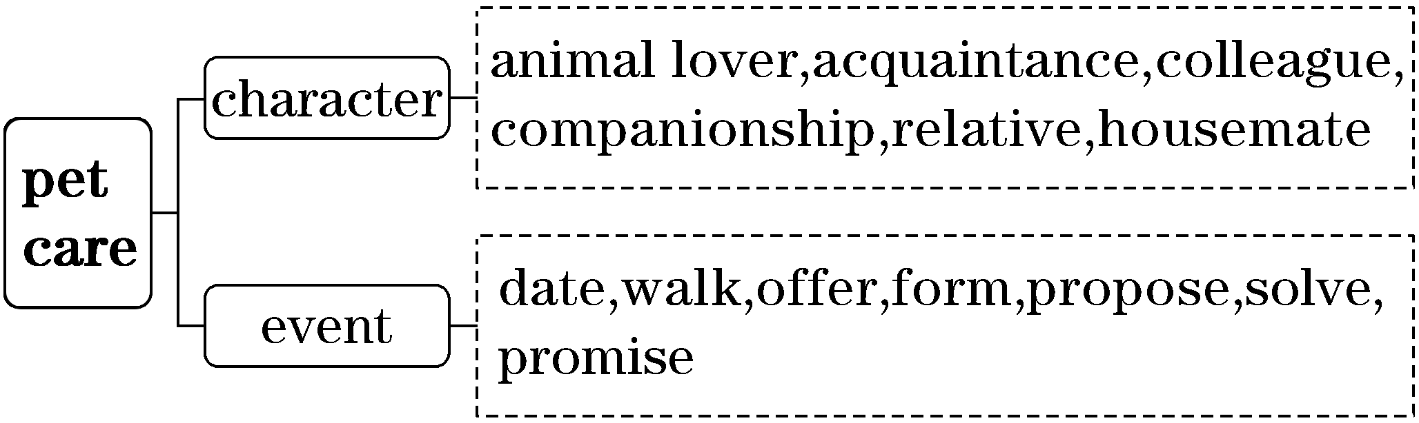
(二)基于深层主题“爱与幸福”建构表达词汇
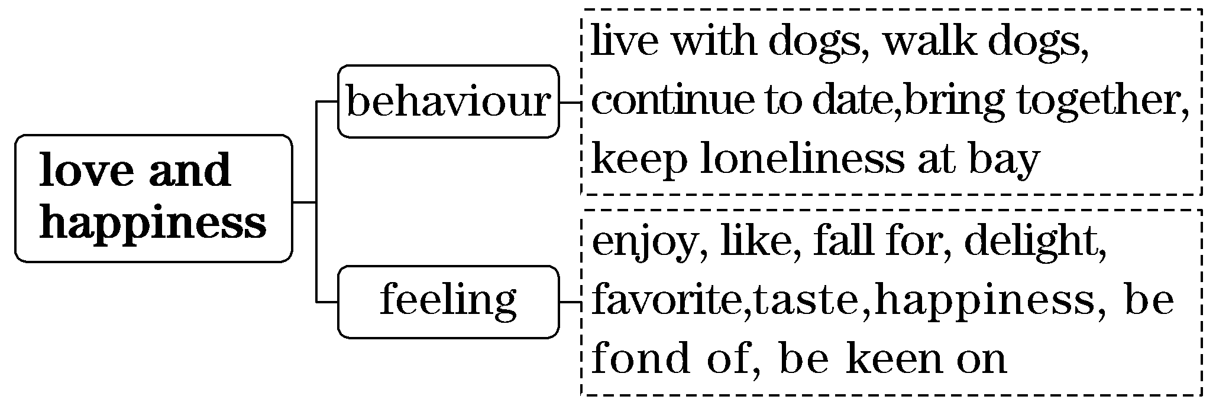
二、借助语境知识，实现深度学习
(一)把握一词多义，提高理解的准确性
1．bring up 提出；教育；养育，抚养；呕吐
[语境辨义]
①We continued to date, though neither of us brought up the future.____________
②I'm lucky to have been brought up in such a happy family.____________
③After the meal, they had stomachaches and brought up what they had eaten.____________
2．coach n．教练；私人教师；长途客车 v．辅导；训练
[语境辨义]
①The three dogs formed a pack that, with coaching, respected Flora's space ...
②It is at the hotel that the coach picks up tourists.
③The coach posted a list of this year's team members on his office door.
3．ring n．圆形；戒指；铃声；打电话
v．包围；给……打电话；响铃
[语境辨义]
①... this man produced a little box with a ring and proposed to me.
②I'll give you a ring this evening.
③The bell rang, announcing the end of the class.
④I'll ring you up as soon as they arrive.
(二)融通词形转换，提升表达的准确性
1．enjoy v．喜欢，享受→____________ adj.令人愉快的
2．lonely adj.孤单的，寂寞的，荒凉的→__________ n．孤单，寂寞
3．companion n．伴侣，同伴→____________ n．陪伴
4．amuse v．逗乐，使娱乐→____________ adj.觉得好笑的→____________ n．娱乐
5．breath n．呼吸，微量→____________ v．呼吸
6．propose v．提议，建议；求婚→______________ n．提议，建议；求婚
7．operate v．做手术；操作→______________ n．手术；操作→____________ n．接线员，操作员

(三)明辨熟词生义，强化思维的灵活性
1．date [熟义] n．日期[生义] n．约会 v．与……约会；起始于(某时期)
[语境辨义]
①When I first dated Steve, I learned he had a dog, Molly, and a cat, Flora.
②The brooch dates back to the fourth century BC.
③Since it is out of date, it is a waste of time to practice it.
2．walk[熟义] v．步行，散步
[生义] v．牵着动物走，遛 n．行业
[语境辨义]
①The next week we walked our dogs together.
②My father has friends from all walks of life.
③She missed the bus and had to walk home.
三、发掘词块短语，实现类群拓展
1．由fall for串记“动词＋for”的短语
fall for 迷恋；爱上；上……的当
call for 需要，提倡
care for 关心，照顾，喜欢
apply for 申请
long for 期望；渴望
pay for 为……付钱
[完成句子]
①Ted ________________ Alice and they decided to get married.
泰得对爱丽丝非常迷恋，并且他们决定结婚了。
②Today's society still ____________ the spirit of Lei Feng.
当今社会仍然需要雷锋精神。
③I am writing ________________ the job of tour guide that was advertised on your website.
我写信是为了应聘在你的网站上刊登的导游一职。
④I ______________ the day when my dream can come true.
我渴望有一天能够梦想成真。
2．由continue to do串记“动词＋to do”的搭配
continue to do sth. 继续做某事
afford to do sth. 负担得起做某事
arrange to do sth. 安排做某事
attempt to do sth. 尝试做某事
decide to do sth. 决定做某事
offer to do sth. 主动提出做某事
[完成句子]
①Tears of frustration and fear trickled down my face, but I __________________.
沮丧和恐惧的泪水从我脸上淌下，但我继续跑。
②So precious is time that we can't ____________________________.
时间是如此珍贵，以至于我们浪费不起。
③We ____________________ our way back but everything in our sight was strange.
我们试图找到回去的路，但我们看到的一切都是陌生的。
④Moved to tears, I ____________________ the piano by heart.
被感动得热泪盈眶，我决定用心学习钢琴。

朗朗晨读(九)2022·全国乙卷·完形填空·价值词汇发掘
三遍而熟·背出语感——(第一遍，做题；第二遍，代入答案诵读；第三遍，带空诵读，凭语感顺出答案)
Young children across the globe enjoy playing games of hide and seek. For them, there's something highly exciting about __1__ someone else's glance and making oneself unable to be seen.
However, we all witness that preschool children are remarkably __2__ at hiding. They often cover only their eyes with their hands, leaving the rest of their bodies __3__ .
For a long time, this ineffective hiding method was __4__ as evidence that children are hopelessly“egocentric” (自我中心的) creatures. But our __5__ research results in child developmental psychology __6__ that idea.
We brought young children aged 2－4 into our Minds in Development Lab at USC. Each __7__ sat down with an adult who covered her own eyes or __8__ . We then asked the child if she could __9__ or hear the adult. Surprisingly, children replied that they couldn't. The same __10__ happened when the adult covered her own mouth: __11__ children said that they couldn't __12__ to her.
A number of __13__ ruled out that the children misunderstood what they were being asked. The results were clear: Our young subjects __14__ the questions and knew __15__ what was asked of them. Their __16__ to the questions reflected their true __17__ that “I can see you only if you can see me, too.” They simply __18__ mutual (相互的) recognition and regard. Our __19__ suggest when a child “hides” by putting a blanket over her head, it is not a result of egocentrism. In fact, children consider this method __20__ when others use it.
1.A.following B．taking
C．escaping D．directing
2．A.clever B．bad
C．scared D．quick
3．A.exposed B．examined
C．untouched D．imbalanced
4．A.supported B．guaranteed
C．imagined D．interpreted
5．A.disappointing B．mixed
C．surprising D．desired
6．A.explained B．confirmed
C．contradicted D．tested
7．A.parent B．child
C．researcher D．doctor
8．A.feet B．nose
C．hands D．ears
9．A.see B．help
C．reach D．fool
10．A.event B．thing
C．action D．accident
11．A.Yet B．Now
C．Soon D．Once
12．A.speak B．listen
C．turn D．wave
13．A.instructions B．descriptions
C．experiments D．assumptions
14．A.comprehended B．predicted
C．explored D．ignored
15．A.partly B．honestly
C．vaguely D．exactly
16.A.responses B．approaches
C．contribution D．sensitivity
17．A.ability B．belief
C．identity D．purpose
18．A.hold back B．relate to
C．insist on D．make up
19．A.limitations B．requirements
C．theories D．findings
20．A.tentative B．impressive
C．creative D．effective
[答案自查：1～5 CBADC 6～10 CBDAB 11～15 BACAD 16～20 ABCDD]

一、立足主题语境，建构词汇网络
2022年全国乙卷完形填空的主题语境是“人与社会”，其表层话题为“儿童行为”，深层主题为“承认与尊重”。文章主要介绍了有研究发现孩子们捉迷藏时，只遮住自己的眼睛并不是自我中心主义的结果，而是孩子们坚持相互承认和尊重的结果。
(一)基于表层话题“儿童行为”建构阅读词汇
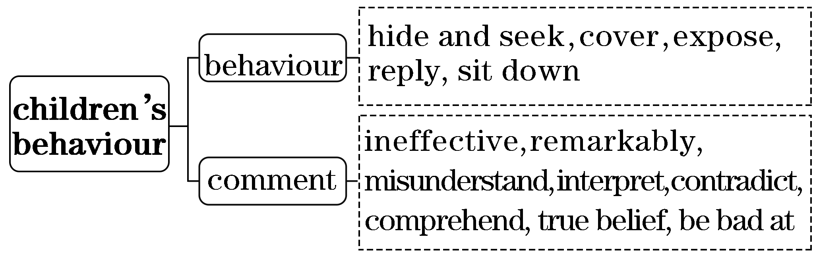
(二)基于深层主题“承认与尊重”建构表达词汇
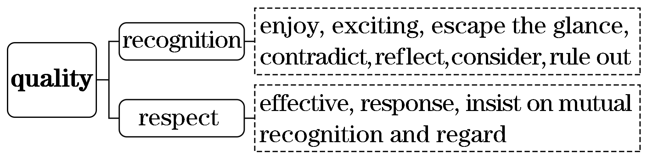
二、借助语境知识，实现深度学习
(一)把握一词多义，提高理解的准确性
1．eye n．眼睛；目光；眼力；针眼；观点，态度v.注视
[语境辨义]
①They often cover only their eyes with their hands ...
②Mother eyed Jim with an eager, expectant smile.
③In the eyes of the law, he was not yet guilty.
④The little child couldn't take his eyes off the new toys.
2．subject n．主题，话题；学科，科目；主语；对象v.使臣服
[语境辨义]
①Our young subjects comprehended the questions and knew exactly what was asked of them.
②My favorite subject is English.
③This is a book on the subject of love.____________
④Ancient Rome subjected most of Europe.
⑤Often, the subject of the sentence comes at the beginning of the sentence.
(二)融通词形转换，提升表达的准确性
1．globe n．球，球体，地球→________________ adj.全球的
2．high adj.高的→____________ adv.非常，极其→____________ n．高度
3．remark n．言论→____________ adj.引人注目的→____________ adv.不寻常地，惊人地
4．expose v．暴露，使显露→______________ n．暴露，曝光→____________ adj.暴露的，易受攻击的
5．effect n．效果，作用→____________ adj.有效的→____________ adj.无效的
6．develop v．发展；成长；养成→______________ n．发展，成长；养成→____________ adj.发展的
7．surprise n．惊讶→____________ adj.惊讶的→____________ adj.令人惊讶的→____________ adv.惊人地
8．reflect v．反映；反射；思考→________ n．反射；反映；思考→____________ adj.反思的；反光的
(三)明辨熟词生义，强化思维的灵活性
1．regard[熟义] v．把……视为；看待
[生义] n．尊重；尊敬
[语境辨义]
①They simply insist on mutual recognition and regard.____________
②People regard the sun as the chief source of heat and light.____________
2．suggest v．[熟义]建议；[生义]暗示，表明
[语境辨义]
①Our findings suggest when a child “hides” by putting a blanket over her head, it is not a result of egocentrism.____________
②I strongly suggest that students shouldn't carry mobile phones into school.____________
三、发掘词块短语，实现类群拓展
1．由result in串记“动词＋in”的短语
result in 导致
bring in 引进，生产
give in 屈服，让步
take in 吸收，理解，消化
hand in 上交
lie in 在于，位于
[完成句子]
①Three sessions in a week at the gym would ____________________ a healthier life.
一周在健身房锻炼三次会使生活更健康。
②Our club plans ________________ 20 new members.
我们俱乐部计划吸收20名新会员。
③Your problem ______________ lacking efficient methods.
你的问题在于缺少有效的方法。
2．由insist on串记“动词＋on”的短语
insist on 坚持；强调
work on 从事
depend/rely on 依靠，依赖
take on 承担；呈现
carry on 继续，进行
try on 试穿
pass on 传递；继续
turn/switch on 打开
[完成句子]
①The English teacher ____________________ of mastering a foreign language.
英语老师强调了掌握一门外语的重要性。
②He didn't accept helps from others and fully _____________________________.
他没有接受别人的帮助，全靠他自己的努力。
③Kindness is one thing that really deserves ________________________ from one to another.
善良是一件真正值得我们接力传递的东西。

朗朗晨读(十)2022·浙江1月高考·完形填空·价值词汇发掘
三遍而熟·背出语感——(第一遍，做题；第二遍，代入答案诵读；第三遍，带空诵读，凭语感顺出答案)

When Beverley Burdeyney turned seventyfour last year, she started having problems with her __1__， notably dryness and discomfort.
“I was simply __2__ a terrible experience，” Ms. Burdeyney said at her home in Toronto. “I felt so helpless and insecure because the quality of my __3__ was affected.”
Ms. Burdeyney talked to some friends who had __4__ problems and discovered that they were largely suffering in __5__ . “Nobody chooses to talk about it because it seems so __6__ ，” she said. “But more and more are suffering and lives are being __7__.”
Eventually, Ms. Burdeyney learned about plans for an eye research __8__ at Tel Aviv University in Israel. The research team __9__ Canadian doctor Allan Slomovic, who has done __10__ work on eye care using stem cells. Seeing a ray of hope, Ms. Burdeyney began raising __11__ for the project with a friend, Toronto businessman Meyer Zeifman. __12__， she has raised $110,000 with another $40,000 __13__.
“I'm trying to get more and more people to __14__ that there are solutions (解决办法)，” said Ms. Burdeyney, a trained nurse who is still working as a personal trainer after __15__ . “I say there is no old __16__ , there's only neglect (忽视). Don't stand __17__ ; do something about it.”
Ms. Burdeyney __18__ that she is hoping to do more for the research project. “I just want to bring __19__ into people's eyes and this is just the __20__. There is still a long way to go.”
1.A.throat B．skin
C．lungs D．eyes
2．A.getting over B．going through
C．holding on D．passing down
3．A.story B．treatment
C．life D．relationship
4．A.similar B．various
C．personal D．special
5．A.turn B．peace
C．vain D．silence
6．A.unbearable B．abnormal
C．insignificant D．disturbing
7．A.compromised B．forgotten
C．substituted D．separated
8．A.course B．program
C．paper D．conference
9．A.informed B．doubted
C．included D．dismissed
10．A.parttime B．controversial
C．voluntary D．groundbreaking
11．A.money B．standards
C．awareness D．questions
12．A.As ever B．So far
C．In return D．Once again
13．A.wasted B．donated
C．expected D．earned
14．A.imagine B．confirm
C．remember D．understand
15．A.retirement B．childbirth
C．graduation D．marriage
16．A.time B．rule
C．age D．tale
17．A.straight B．still
C．firm D．alone
18．A.commented B．learned
C．reminded D．added
19．A.light B．joy
C．color D．beauty
20．A.future B．beginning
C．truth D．meaning
[答案自查：1～5 DBCAD 6～10 CABCD 11～15 ABCDA 16～20 CBDAB]

一、立足主题语境，建构词汇网络
2022年浙江1月高考完形填空的主题语境是“人与自我”，其表层话题为“健康生活”，深层主题为“无私奉献”。文章讲述了一个遭受眼睛问题之苦的女士积极为眼睛研究项目募集资金以寻求解决方法的故事，反映了公民的“无私奉献”精神。
(一)基于表层话题“健康生活”建构阅读词汇
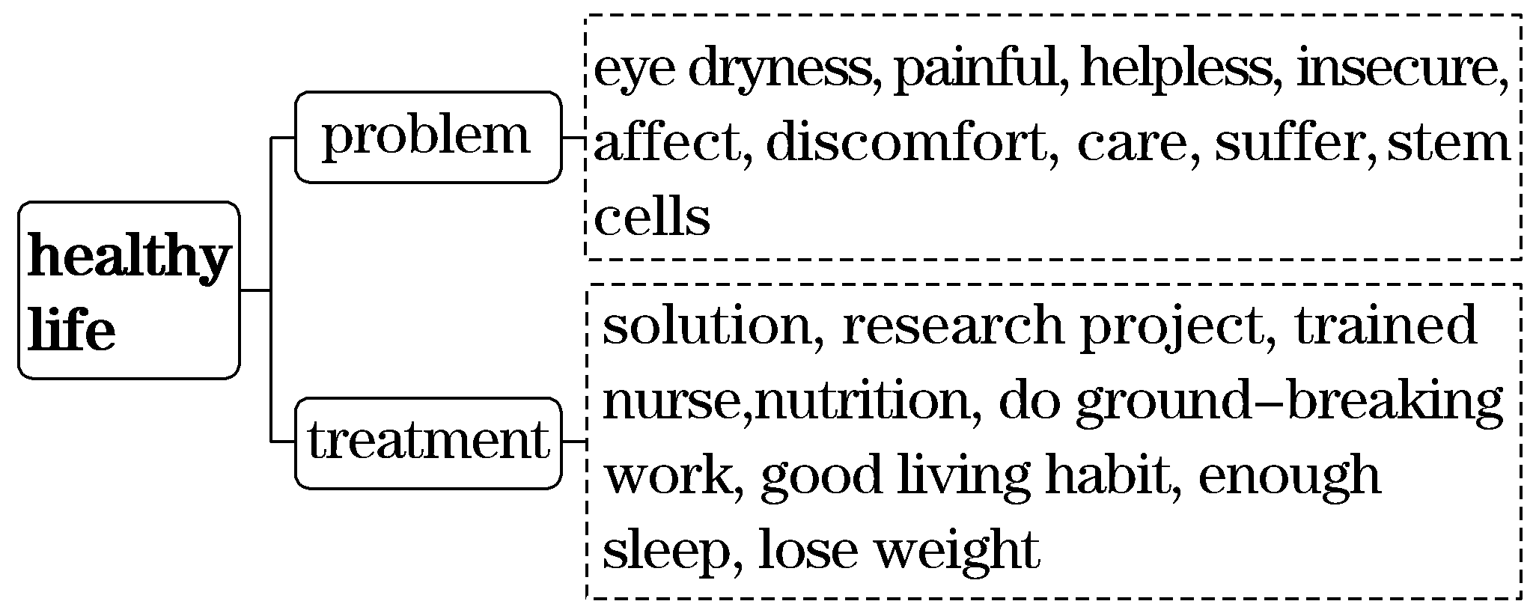
(二)基于深层主题“无私奉献”建构表达词汇
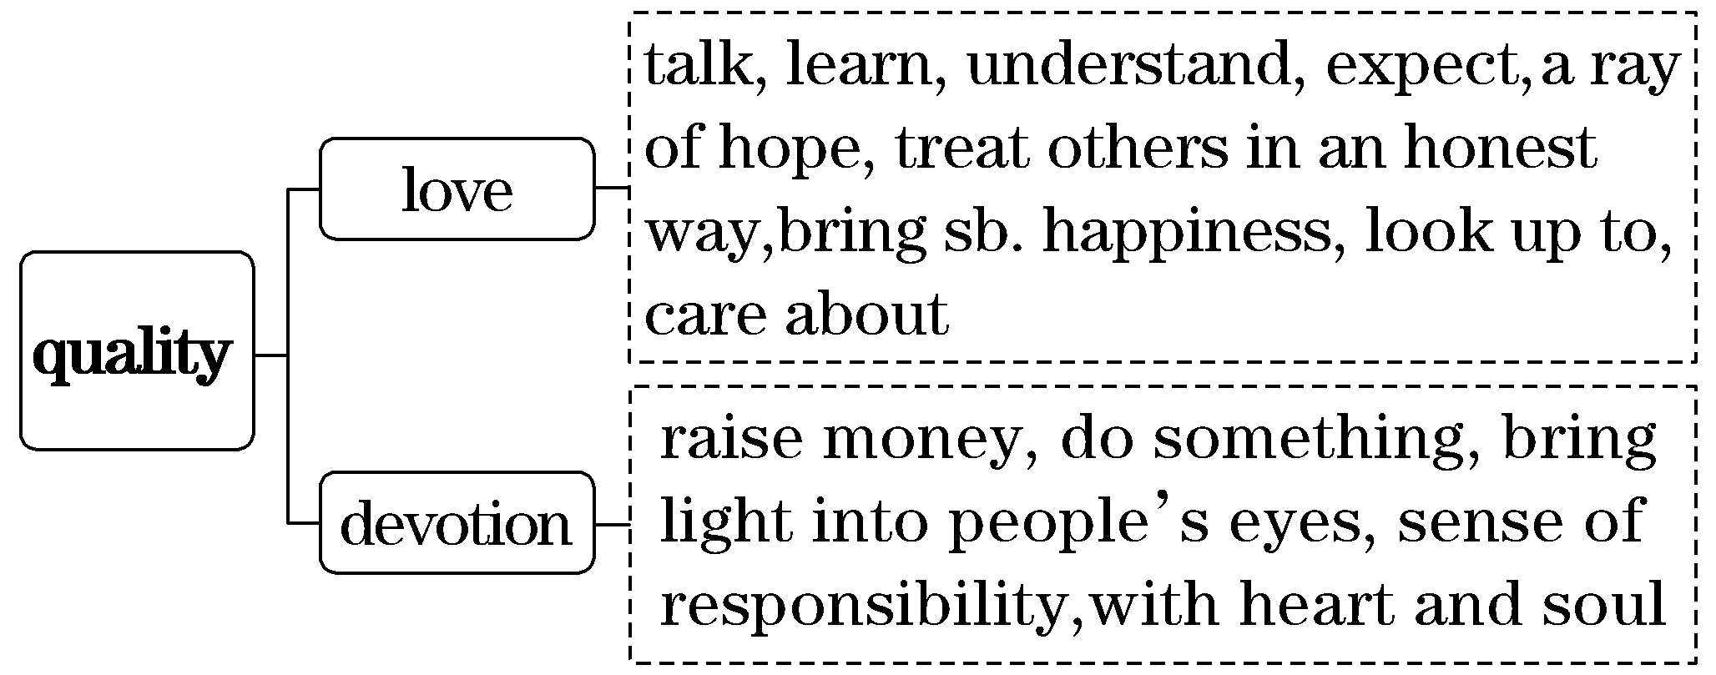
二、借助语境知识，实现深度学习
(一)把握一词多义，提高理解的准确性
1．go through 穿过，通过；经历，经受；仔细检查；被批准
[语境辨义]
①I was simply going through a terrible experience.____________
②My application for visa has gone through.____________
③The train is going through the tunnel.____________
④I always start the day by going through my emails.____________
2．age n．年龄；寿命；时代 v．变老，使变老
[语境辨义]
①I say there is no old age, there's only neglect.
②We live in an age of rapid technological advance.
③For example, the population in China is aging drastically.

(二)融通词形转换，提升表达的准确性
1．notable adj.显著的，值得注意的→____________ adv.显著地
2．dry adj.干的，干燥的→____________ n．干燥
3．donate v．捐赠→____________ n．贡献，奉献
4．retire v．退休→____________ n．退休
5．person n．人→____________ adj.个人的
6．train v．训练→____________ adj.受过培训的→____________ n．教练员→____________ n．学员
7．expect v．期待，盼望→____________ n．期待→____________ adj.预料的，预期的
8．understand v．理解→____________ n．理解→____________ v．误解
(三)明辨熟词生义，强化思维的灵活性
1．raise v．[熟义]举起；提起；[生义]筹集，筹募
[语境辨义]
①So far, she has raised $110,000 with another $40,000 expected.____________
②She raised the gun and fired.____________
2．stand [熟义] v．站立 [生义] v．保持，维持 n．摊位
[语境辨义]
①Don't stand still; do something about it.
②There's an icecream stand around the corner.
③So shocked was he that he stood there, openmouthed.
三、发掘词块短语，实现类群拓展
1．由go through串记“动词＋through”的短语
go through 穿过；经历；仔细检查
get through 完成，熬过；接通电话
break through 冲破，突破
see through 看穿，识破
look through 浏览，看穿
[完成句子]
①Let's ________________ the numbers together and see if a workable deal is possible.
让我们一起仔细检查一下这些数字，看能否找出一个可行的方案。
②They ________________ all kinds of hardships.
他们克服了各种困难。
③A smile can ____________________ difficult situations and find friends in a world of strangers.
一个微笑可以帮助我们渡过难关并在陌生人世界里找到朋友。
2．由in silence串记“in＋名词”的短语
in silence 沉默地
in vain 白费力气，枉然
in need 需要帮助的
in trouble 处于困境
in turn 反过来；依次，轮流
in return 作为回报
in advance 提前，预先
in particular 尤其，特别
in addition 另外
[完成句子]
①____________________ is a friend indeed.
患难见真情。
②We ____________________ until I broke the ice.
我们静静地站着，直到我打破沉默。
③Theory begins with practice and ________________________.
理论来源于实践又反过来为实践服务。
④Anne decided _____________________________________________________________.
安妮决定做些事情作为回报。
3．由work as串记“动词＋as”的短语
work as 担任
act as 充当，起……作用；扮演
serve as 担任，充当，起……作用
function as 充当，起……作用
[完成句子]
①A trained dog can __________________________ to a blind person.
经过训练的狗可以担任盲人的向导。
②He can't afford to pay the rent, so for now, his car will also ______________________ his home.
他付不起租金，所以目前他的车也将充当他的家。

朗朗晨读(十一)2021·新高考Ⅰ卷·完形填空·价值词汇发掘
三遍而熟·背出语感——(第一遍，做题；第二遍，代入答案诵读；第三遍，带空诵读，凭语感顺出答案)
My life as a taxpaying employed person began in middle school, when, for three whole days, I worked in a baking factory.
My best friend Betsy's father was a manager at Hough Bakeries, which, at Easter time, __1__ little bunny (兔子) cakes for all its __2__ throughout Cleveland. It happened that the plant downtown needed eight kids for__3__ help during our spring break, for which I had no __4__ beyond listening to my favorite records. I'd __5__ minimum wage. I'd see how a factory __6___. My parents thought all of this was a grand idea and called Betsy's dad with their __7__ .
Our__8__ in the factory were simple: Place cakes on a moving belt. Attach icing (糖霜) ears. Apply icing eyes and nose.__9__ bunny from the belt. This was __10__ than it sounds. __11__ a bit and the cakes pile up. As I told my parents at dinner that first night, it was all a little more highpressure than I'd__12__.
Dad__13__ . The son of a grocer, he'd spent the summers of his childhood__14__ food in Bernardsville, New Jersey. This was the sort of work that made you __15__ the dollars you earned and respect those who did the work, he told me.
1.A.sold B．ordered
C．made D．reserved
2．A.stores B．families
C．schools D．citizens
3．A.generous B．financial
C．technical D．temporary
4．A.plans B．problems
C．excuses D．hobbies
5．A.offer B．earn
C．set D．suggest
6．A.worked B．closed
C．developed D．survived
7．A.ambition B．permission
C．experience D．invitation
8．A.joys B．ideas
C．roles D．choices
9．A.Save B．Keep
C．Stop D．Remove
10．A.harder B．better
C．longer D．cheaper
11．A.Calm down B．Slow down
C．Stay on D．Move on
12．A.indicated B．witnessed
C．expected D．remembered
13．A.cried B．smiled
C．hesitated D．refused
14．A.tasting B．finding
C．sharing D．delivering
15．A.withdraw B．donate
C．receive D．Appreciate
[答案自查：1～5 CADAB 6～10 ABCDA 11～15 BCBDD]

一、立足主题语境，建构词汇网络
2021年新高考Ⅰ卷完形填空的主题语境是“人与自我”，其表层话题为“个人生活”，深层主题为“尊重与感恩”。文章讲述了身为学生的作者在春假期间在一家烘焙厂打工的经历。它让作者感悟到了要感恩劳动所得并尊重劳动者这一公民美德。
(一)基于表层话题“个人生活”建构阅读词汇
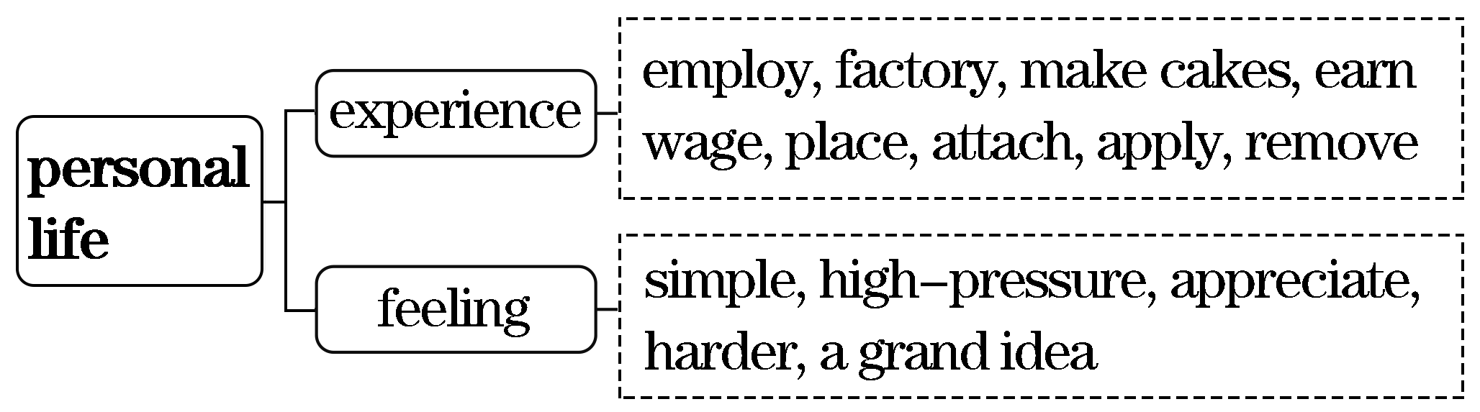
(二)基于深层主题“尊重与感恩”建构表达词汇
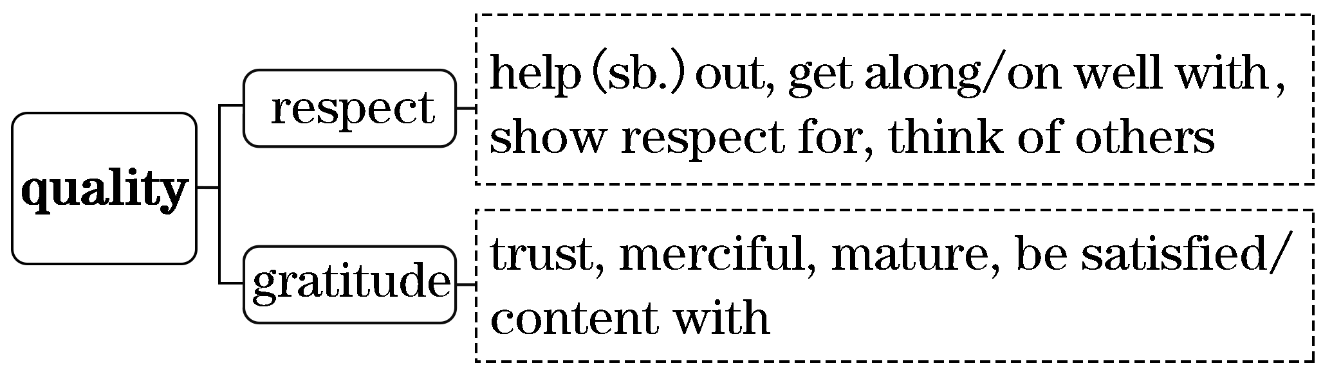
二、借助语境知识，实现深度学习
(一)把握一词多义，提高理解的准确性
1．store n．商店；储藏 v．储藏，储存
[语境辨义]
①...Hough Bakeries ...made little bunny cakes for all its stores throughout Cleveland.
②The gas is stored under pressure in the tank.
③This animal makes a store of nuts for the winter.
2．break n．裂缝；停顿；黎明；休息；短假
v．打破，破碎；破坏；折断
[语境辨义]
①...the plant downtown needed eight kids for temporary help during our spring break.
②There is a break in the water pipe.
③Jane rose at the break of day, hungry and thirsty.
④He slipped and broke his feet on the day when the camp started.
3．sort n．种类，品种 v．分类，整理；妥善处理
[语境辨义]
①This was the sort of work that made you appreciate the dollars you earned.
②Please help me sort these dishes, and put the glass here and the plastic there.
③It's our problem. We'll get it sorted.

(二)融通词形转换，提升表达的准确性
1．employ v．雇用→____________ n．雇用→____________ n．雇主，老板→____________ n．雇员，员工
2．manage v．管理，处理→______________ n．经理，经纪人→____________ n．管理
3．permit v．允许，许可→____________ n．准许
4．deliver v．递送；发表；接生→________________ n．递送；递送物；分娩
5．appreciate v．感谢，感激；欣赏→____________ n．感谢，感激；欣赏
6．respect v．尊重，尊敬 n．尊重，方面→____________ adj.尊敬的→____________ adj.受人尊敬的

(三)明辨熟词生义，强化思维的灵活性
1．plant [熟义] n．植物 v．种植 [生义] n．工厂
[语境辨义]
①It happened that the plant downtown needed eight kids for temporary help during our spring break.
②Don't judge each day by the harvest you reap but by the seeds that you plant.
③Carol also developed love for plants, animals and beautiful nature.
2．apply v．[熟义] 申请，请求；[生义] 涂，抹；敷
[语境辨义]
①Apply icing eyes and nose.
②A large number of people have applied for the job.
3．beyond prep.[熟义] 超过；超出
[生义] 除……之外
[语境辨义]
①...I had no plans beyond listening to my favorite records.
②Our success was far beyond what we thought possible.
三、发掘词块短语，实现类群拓展
1．由listen to串记“动词＋to”的短语
listen to 听
lead to 导致
adjust to 适应
stick to 坚持
belong to 属于
contribute to 有助于
refer to 参考，查阅
[完成句子]
①They __________________________ whistling through the trees.
他们听到风在树林中呼啸。
②Your eyes automatically ______________ changing light.
你的眼睛会自动适应光线的变化。
③But one problem is that few people can ____________________ for long.
但一个问题是很少有人能长期坚持节食。
④I believe that each of us can __________________ the future of the world.
我相信我们每一个人都能够对世界的未来有所贡献。
2．由at dinner串记“at＋名词”的短语
at dinner 在吃晚饭
at ease 安逸，自在
at random 任意地，胡乱地；随便地
at risk 有危险
[完成句子]
①He was so friendly to me ____________ last week.
上周吃晚饭时他对我很友好。
②He didn't feel completely ____________ in the strange surroundings.
他在陌生的环境中感到不那么自在。
③The librarian took a book ____________________ from the shelf.
图书管理员从书架上随便拿了一本书。
④The disease is spreading, and all children under five ______________.
这种疾病正在蔓延，所有五岁以下的儿童都有危险。

朗朗晨读(十二)2021·新高考Ⅱ卷·完形填空·价值词汇发掘
三遍而熟·背出语感——(第一遍，做题；第二遍，代入答案诵读；第三遍，带空诵读，凭语感顺出答案)
Over the past 38 years, Mr. Wang has pretended to be someone else many times, and has even learned to __1__ different dialects (方言), leading to him being described as an “Oscarwinning actor”．
The 60yearold is not an actor, but a __2__ . However, he is more devoted to his “__3__ ” than any real actor.
In the 1990s, a group of thieves often sold stolen goods with the help of some beggars. To look into the ___4__ , Wang disguised (伪装) himself and __5__ the beggars. Dirty shorts and old shoes gave him the __6__ of a real beggar and his convincing dialect soon won him the __7__ of the beggars.
“I often __8__ them to drink alcohol. Once they were __9__ , they began to talk a lot，” Wang said.“I'd then __10__ myself to use the toilet, __11__ what the beggars said, and send the __12__ to my teammates.”
Wang, who is often in __13__ situations, is also a judo (柔道) master. “As long as I get close enough, no criminal can __14__ from me，” he said.
Wang's __15__ won him several honors, including a National May Day Labor Medal and 11 Citations of Merit.
1.A.teach B．compare
C．assess D．speak
2．A.lawyer B．doctor
C．policeman D．businessman
3．A.role B．study
C．family D．audience
4．A.mirror B．case
C．future D．question
5．A.interviewed B．joined
C．arrested D．assisted
6．A.challenge B．experience
C．appearance D．freedom
7．A.vote B．sympathy
C．permission D．trust
8．A.invited B．forced
C．helped D．expected
9．A.drunk B．deserted
C．bored D．lost
10．A.guide B．persuade
C．excuse D．allow
11．A.refer to B．note down
C．ask about D．miss out
12．A.plan B．agreement
C．direction D．information
13．A.awkward B．dangerous
C．unfortunate D．strange
14．A.separate B．recover
C．escape D．hear
15．A.courage B．honesty
C．kindness D．optimism
[答案自查：1～5 DCABB 6～10 CDAAC 11～15 BDBCA]

一、立足主题语境，建构词汇网络
2021年新高考Ⅱ卷完形填空的主题语境是“人与社会”，其表层话题为“警界人物”，深层主题为“智勇忠诚”。文章讲述了王警官伪装成乞丐成功破案的故事。文章赞扬了王警官为维护社会稳定所做出的辛苦付出以及他的智勇忠诚。
(一)基于表层话题“警界人物”建构阅读词汇
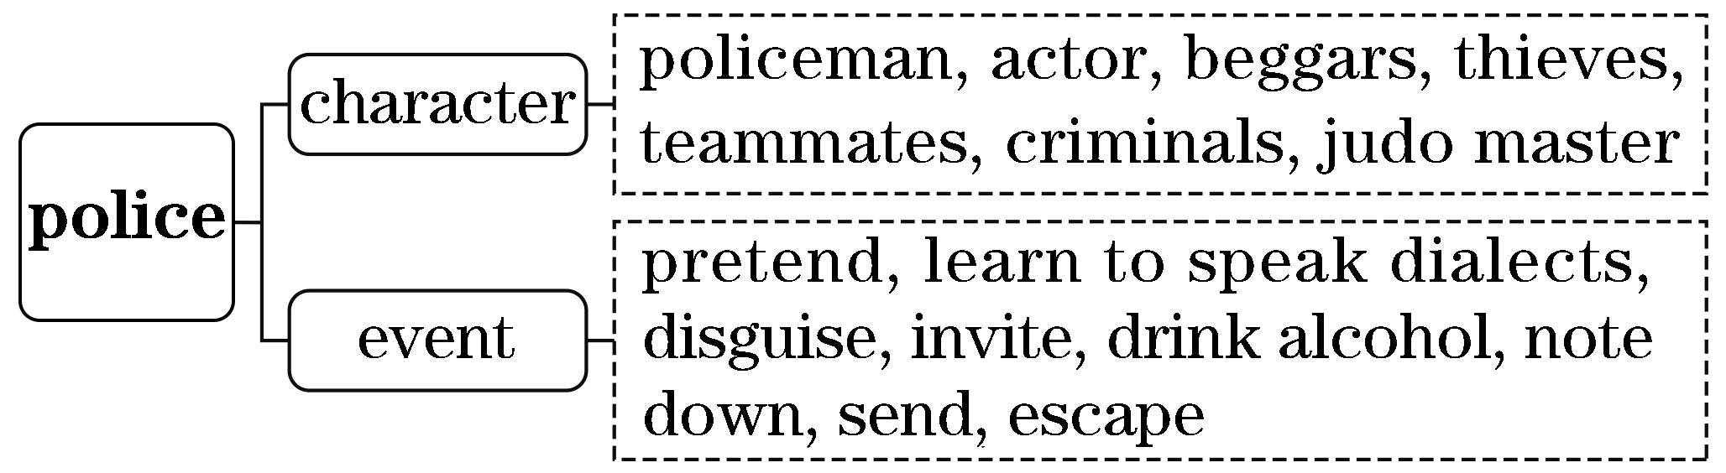
(二)基于深层主题“智勇忠诚”建构表达词汇
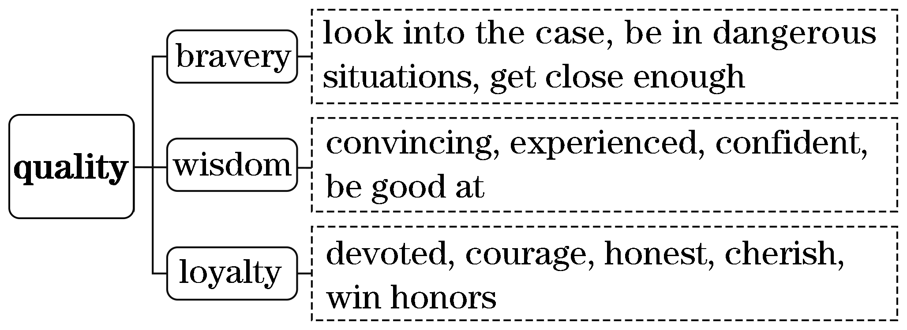
二、借助语境知识，实现深度学习
(一)把握一词多义，提高理解的准确性
1．role n．角色；职责；作用
[语境辨义]
①However, he is more devoted to his “role” than any real actor.____________
②Computers play an increasingly important role in our studies.____________
③The role of the police is to ensure that the law is obeyed.____________
2．good adj.好的；有益的；擅长的
n．善行；益处；货物(常用复数)
[语境辨义]
①In the 1990s, a group of thieves often sold stolen goods with the help of some beggars.
②It is hard to do good all one's life and never do anything bad.
③He was just one of those people who were good at everything.
④Her wish for the river had come true, and now she had a very good friend named Run.
3．escape v．逃跑；逃避；泄漏；被遗忘
n．逃离；泄漏
[语境辨义]
①“As long as I get close enough, no criminal can escape from me，” he said.
②Can you smell an escape of gas？
③The thief jumped into a car and made his escape.
④Her face was so familiar but her name escaped me.
⑤If you commit a crime, you can never escape being punished.
(二)融通词形转换，提升表达的准确性
1．describe v．描述，描绘→____________ n．描述，描绘
2．act v．表演；行动；担任→__________ n．行动，行为→______________ n．男演员→____________ n．女演员
3．devote v．奉献，献身→____________ n．奉献，献身→____________ adj.忠诚的
4．thief n．小偷，贼→____________ n．偷盗行为
5．appear v．出现；显得→____________ n．外观；出现
6．beg v．乞求，请求→____________ n．乞丐
7．convince v．使信服，说服→______________ adj.令人信服的→____________ adj.相信的
8．invite v．邀请→____________ n．邀请
9．danger n．危险→____________ adj.危险的→____________ v．使有危险
10．crime n．犯罪→____________ n．罪犯
11．honor n．荣誉，尊敬→____________ adj.光荣的，可敬的→____________ adj.光荣的，荣幸的
(三)明辨熟词生义，强化思维的灵活性
1．case n．[熟义] 情况；[生义] 案件；病例
[语境辨义]
①To look into the case，Wang disguised himself and joined the beggars.____________
②Some cases of blindness can be prevented with the help of medical treatment. ____________
③Please remember that in no case will you give up especially in trouble.____________
2．excuse v．[熟义] 原谅；宽恕
[生义] 准许……离开
[语境辨义]
①I'd then excuse myself to use the toilet, note down what the beggars said, and send the information to my teammates.____________
②I hope you'll excuse me for being so late.____________
三、发掘词块短语，实现类群拓展
1．由note down串记“动词＋down”的短语
note down 作记录，记笔记
break down 出故障；垮掉；分解
cut down 砍倒；削减(on sth.)
put down 放下；记下
take down 拆卸；写下，记下
turn down 关小；拒绝
write down 记下，写下
[完成句子]
①He ____________________ her address and telephone number in the back of his diary.
他在日记本的后面记下了她的地址和电话号码。
②The computer system ________________ suddenly while he was searching for information on the Internet.
当他在互联网上搜索信息时，计算机系统突然出故障了。
③He tried to ______________________ but failed.
他试图少抽烟，但没成功。
④She could not bear the relentless music and __________________________.
她受不了没完没了的音乐，就把音量调小了。
2．由escape from串记“动词＋from”的短语
escape from 从……逃脱
hear from 收到……的来信
die from 死于(外因)
result from 起因于
suffer from 忍受，遭受
[完成句子]
①She managed _________________________________________________________.
她设法从燃烧的汽车里逃了出来。
②I am expecting ______________________ as soon as possible.
我希望尽快收到你的来信。
③His blindness of both eyes ___________________ a traffic accident.
他的双眼失明是由于一次交通事故。
④Facing the crowd, I ______________________________________ stage fright.
面对人群，我发现自己患上了怯场症。
朗朗晨读(十三)2021·全国甲卷·完形填空·价值词汇发掘
三遍而熟·背出语感——(第一遍，做题；第二遍，代入答案诵读；第三遍，带空诵读，凭语感顺出答案)
It's the seaside birds that deserve at least part of the blame for getting Nick Burchill blacklisted at the Fairmont Empress Hotel in Victoria, Canada.
Burchill was__1__ at the hotel on business and planning to __2__ some friends in the area.They had asked him to__3__ some pepperoni (辣香肠) from back east.So he__4__ a suitcase full of pepperoni.As he was__5__ that it would be too warm, he __6__ it out on the table near an open window.He thought his pepperoni was__7__ and well chilled (冷却) and he__8__ .
That's when things went__9__ .“I remember walking down the long__10__ and opening the door to my room to find an entire flock of seagulls，” Burchill said in a recent letter of__11__ to the 4star hotel. “The seagulls immediately went __12__ . They rushed to the window, 30 or 40 birds all trying to __13__ at the same time, and pepperoni — everywhere.The curtains were falling down; the lamps were falling down.It was a real__14__ .”
Older and wiser now, Burchill chalked up the incident to youthful indiscretion (莽撞)．
“I have__15__ and I admit responsibility for my__16__ ，” he said in the letter.“I come to you, __17__ , to apologize for the damage I had__18__ caused and to ask you to__19__ my lifetime ban from the hotel.”
His letter__20__ .Banned from the hotel since 2001，Burchill is now welcome to come back, the Fairmont said.
1.A.studying B．staying
C．looking D．packing
2．A.visit B．help
C．follow D．make
3．A.sell B．have
C．bring D．taste
4．A.filled B．locked
C．abandoned D．lost
5．A.surprised B．pleased
C．excited D．worried
6．A.dug B．cleared
C．cut D．laid
7．A.delicious B．safe
C．soft D．ready
8．A.left B．nodded
C．waited D．regretted
9．A.far B．funny
C．wrong D．blind
10．A.beach B．driveway
C．hall D．table
11．A.application B．apology
C．request D．invitation
12．A.hungry B．dead
C．missing D．wild
13．A.wake up B．get out
C．take off D．break in
14．A.mess B．puzzle
C．fight D．challenge
15．A.recovered B．retired
C．escaped D．matured
16．A.suffering B．plans
C．madness D．actions
17．A.hands in pockets B．nose in the air
C．hat in hand D．feet on the ground
18．A.indirectly B．deliberately
C．cautiously D．secretly
19．A.replace B．remember
C．reconsider D．renew
20．A.arrived B．worked
C．ended D．Disappeared
[答案自查：1～5 BACAD 6～10 DBACC 11～15 BDBAD 16～20 DCACB]
一、立足主题语境，建构词汇网络
2021年全国甲卷完形填空的主题语境是“人与自我”，其表层话题为“失信风波”，深层主题为“诚实守信”。文章讲述了Burchill入住酒店后因把给朋友捎带的香肠放在靠窗的桌子上而引来海鸥，给酒店造成损失，他因此被该酒店列入黑名单。但在向酒店真诚道歉后他又赢得酒店的信任。故事告诉我们：敢为自己的行为负责的人才能赢得社会信任。
(一)基于表层话题“失信风波”建构阅读词汇
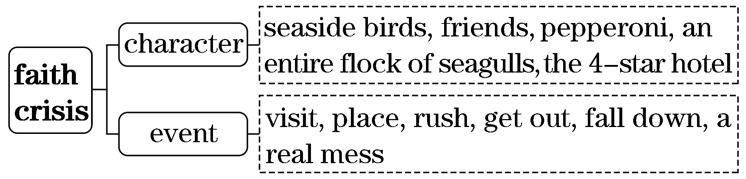
(二)基于深层主题“诚实守信”建构表达词汇
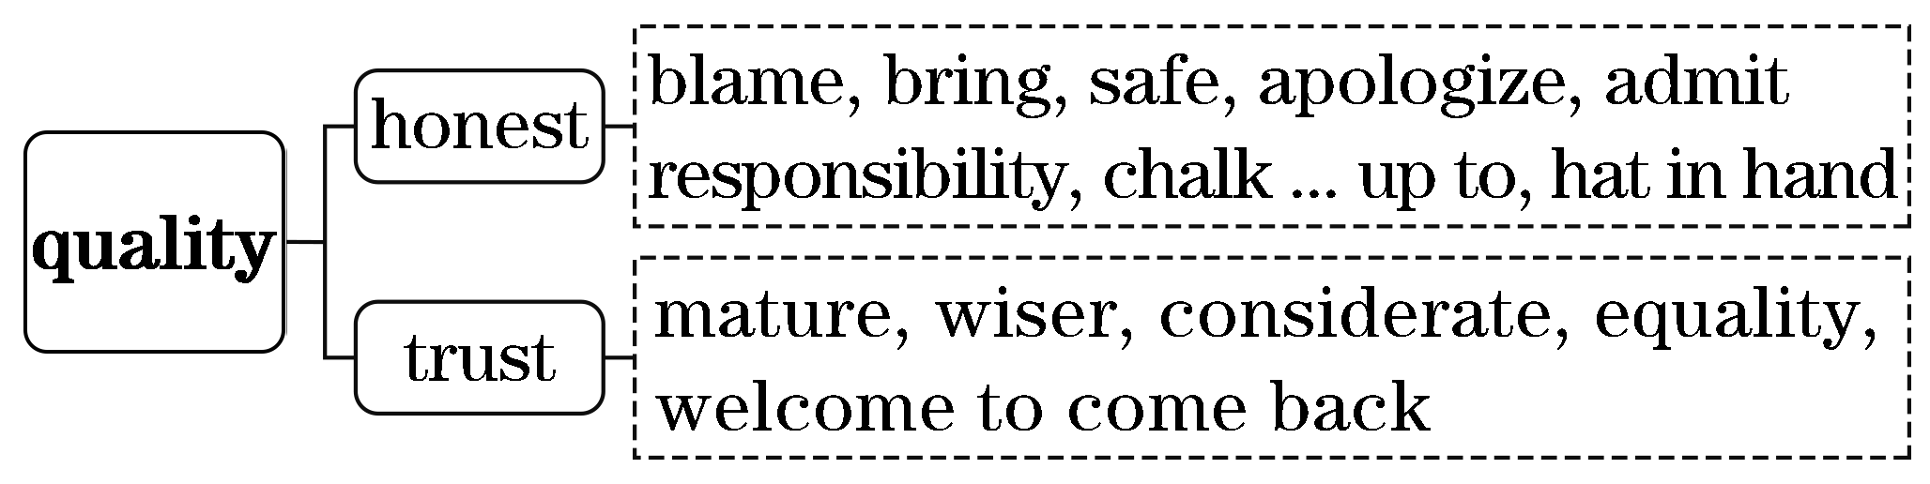
二、借助语境知识，实现深度学习
(一)把握一词多义，提高理解的准确性
1．lay v．放置；下(蛋)；产(卵)；躺下(lie的过去式)
[语境辨义]
①As he was worried that it would be too warm, he laid it out on the table near an open window.____________
②The big hen laid eggs on the grass.____________
③He lay on his back and looked up at the sky.____________
2．cause n．起因，原因；事业 v．引起，造成；迫使
[语境辨义]
①I come to you, hat in hand, to apologize for the damage I had indirectly caused ...
②The heavy rain was the cause of the flood.
③I determined to devote myself to the cause of our education.
(二)融通词形转换，提升表达的准确性
1．long adj.长的→____________ n．长度
2．apologize v．道歉→____________ n．道歉
3．immediate adj.立即的，立刻的→____________ adv.立即，立刻
4．mess n．杂乱→____________ adj.乱七八糟的
5．wise adj.充满智慧的，英明的→____________ n．智慧，才智
6．youth n．青春；青年→____________ adj.年轻的，青春的
7．admit v．承认；接收→____________ n．承认；接收；入场费
8．responsible adj.负责任的→____________ n．责任
9．indirect adj.间接的→____________ adv.间接地
10．lay v．放置；产(卵)→____________(过去式)→__________(过去分词)→__________(现在分词)

(三)明辨熟词生义，强化思维的灵活性
chalk [熟义] n．粉笔 [生义] v．把某事归因于
[语境辨义]
①Older and wiser now, Burchill chalked up the incident to youthful indiscretion.
②The teacher wrote on the blackboard with a piece of chalk.

三、发掘词块短语，实现类群拓展
1．由get out串记“动词＋out”的短语
get out 逃离；外出；泄露
come out 出来；出版；结果是
go out 出去；熄灭
look out 留神，当心
set out 出发；开始
put out 扑灭
pick out 挑选；辨认出
[完成句子]
①When I stopped the car, she ________________ and walked wordlessly away.
我停下车后，她下了车，一言不发地走了。
②The couple appreciated the old man's kindness and ______________ on the journey.
这对夫妇很感激老人的好意，然后出发了。
③Although his arm burned several times as he __________________， he managed to free his sisters.
尽管他的手臂在灭火时被烧伤了好几次，他还是设法救出了他的姐妹。
④He quickly ________________ the biggest, roundest, and reddest apple and gave it to Kitty.
他很快就挑出了最大、最圆、最红的苹果给了基蒂。
2．由hat in hand串记“名词＋介词短语”式的俚语
hat in hand 恭敬地，毕恭毕敬地
nose in the air 目中无人，高傲地
feet on the ground 脚踏实地
hands in pocket 慷慨解囊
ants in one's pants 坐立不安
the apple of one's eye 掌上明珠
butterflies in one's stomach 七上八下

[完成句子]
①He was standing ________________ before his teacher.
他毕恭毕敬地站在老师面前。
②She walked past me with her _______________________________________________.
她高傲地从我身边走过。
③He has __________________ for tomorrow's final exam.
他为明天的期末考试坐立难安。
④His youngest daughter is _________________________________________________.
他的小女儿是他的掌上明珠。
朗朗晨读(十四)2021·全国乙卷·完形填空·价值词汇发掘
三遍而熟·背出语感——(第一遍，做题；第二遍，代入答案诵读；第三遍，带空诵读，凭语感顺出答案)
Simply saying thank you doesn't seem enough in certain situations. I was considering this while working as a __1__ just a few weeks ago. And it came to me then how much easier it would be if we had a range of words that express different __2__ of gratitude (感谢)．
My thoughts were soon __3__. We had a woman patient who was __4__ from a knee replacement operation. One afternoon, while __5__ to get into bed she collapsed (倒下) from what was __6__ discovered to be a heart attack. The collapse was disastrous, __7__ the emergency medical team and good teamwork. But she recovered, though __8__ , and was ready for discharge (出院) after four weeks.
She was __9__ for everything that the medical and nursing team had done for her. On her day of discharge, we shared in her __10__ at her recovery. As she was __11__ she was eager to say __12__ to each of us in the nursing team. When she __13__ one nurse, she tried to press a fivepound note into her hand. My colleague __14__ to accept it, saying that we were all just __15__ our job. The patient looked puzzled, and then __16__ : “Oh this isn't for the __17__ I had. I take that as a __18__ . No, this is for setting my hair yesterday.”
And there you have it. To many people, __19__ lives is part of the job but styling hair is an __20__ and should be rewarded.
1.A.cleaner B．chemist
C．nurse D．doctor
2．A.grades B．meanings
C．needs D．expectations
3．A.brushed aside B．put to the test
C．brought under discussion D．taken into account
4．A.departing B．escaping
C．retiring D．recovering
5．A.attempting B．choosing
C．pausing D．promising
6．A.eventually B．fortunately
C．casually D．secretly
7．A.assessing B．requiring
C．forming D．proving
8．A.slightly B．accidentally
C．slowly D．happily
9．A.grateful B．thoughtful
C．sorrowful D．fearful
10．A.surprise B．delight
C．curiosity D．disappointment
11．A.operating B．thinking
C．hesitating D．leaving
12．A.sorry B．hello
C．goodbye D．yes
13．A.reached B．consulted
C．introduced D．persuaded
14．A.wished B．pretended
C．failed D．refused
15．A.enjoying B．doing
C．securing D．starting
16．A.repeated B．recited
C．replied D．reported
17．A.courage B．patience
C．duty D．care
18．A.goal B．given
C．push D．greeting
19．A.risking B．changing
C．saving D．building
20．A.honour B．ability
C．opening D．extra
[答案自查：1～5 CABDA 6～10 ABCAB 11～15 DCADB 16～20 CDBCD]
一、立足主题语境，建构词汇网络
2021年全国乙卷完形填空的主题语境是“人与社会”，其表层话题为“医疗救助”，深层主题为“懂得感恩”。文章讲述了作者做护士期间自己的一位同事为一位病人做头发而收到病人感谢的故事。故事告诉我们，即使有人只是做了自己分内的事，我们也应该对他们的付出表示真诚的感谢。
(一)基于表层话题“医疗救助”建构阅读词汇
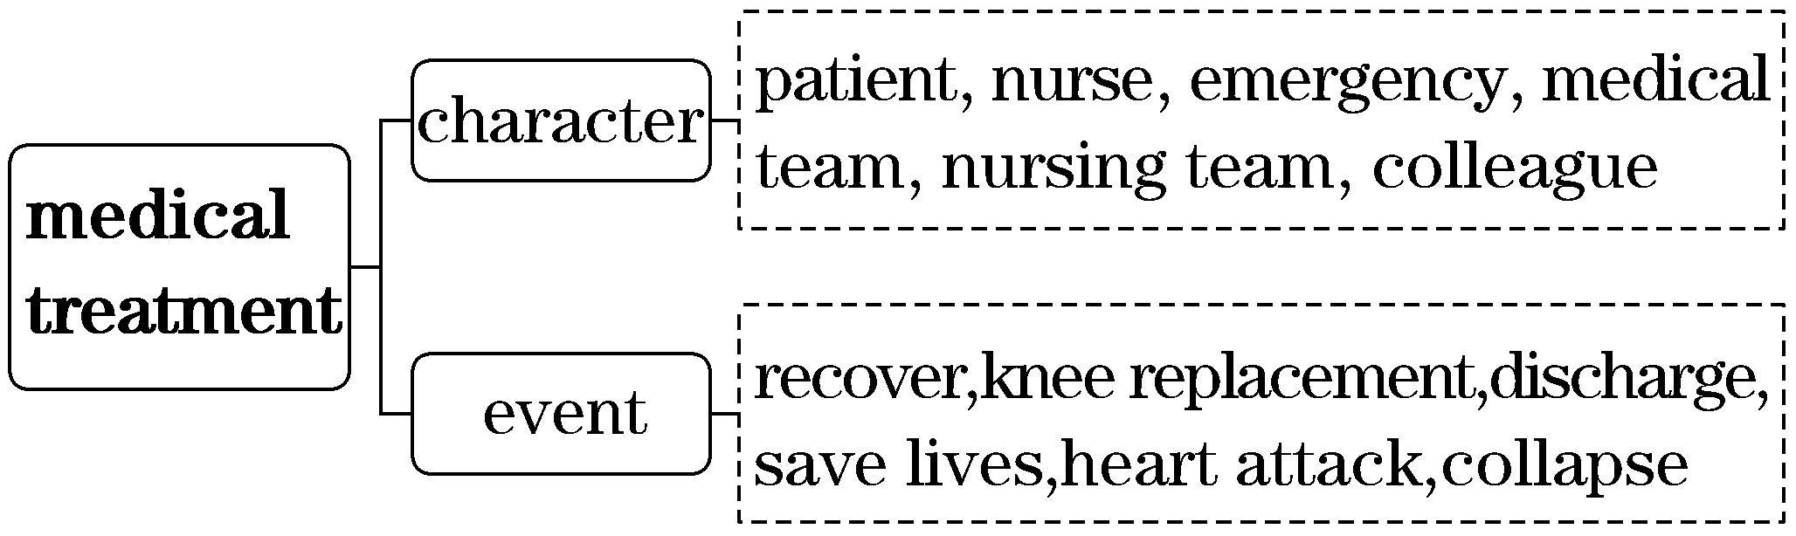
(二)基于深层主题“懂得感恩”建构表达词汇
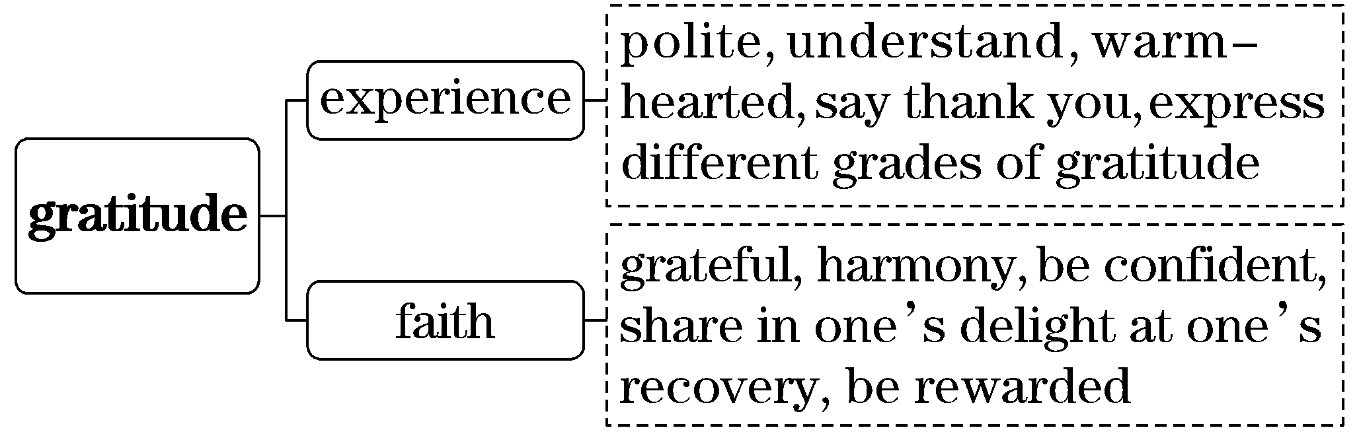
二、借助语境知识，实现深度学习
(一)把握一词多义，提高理解的准确性
1．while conj.当……时；而，然而；尽管，虽然
n．一段时间
[语境辨义]
①I was considering this while working as a nurse just a few weeks ago.
②While I admit his good points, I can see his bad ones.
③The three days of his absence seemed a long while to us all.
④When I worked as a nurse, I was on day duty while my friends were on night duty.
2．express v．表达，表示 n．快车；快递 adj.特快的；明确的
[语境辨义]
①And it came to me then how much easier it would be if we had a range of words that express different grades of gratitude.
②I received the package from New York by express.
③The quickest way to get here is to take the express.
④The doctor gave express orders that the patient was to have no visitors.
3．press n．新闻界；出版社；按，压
v．按，压；把……塞进；催促
[语境辨义]
①When she reached one nurse, she tried to press a fivepound note into her hand.
②It is not wise to press them to leave here so early.
③The minister issued a statement to the press.
④When you're ready to get off, remember to press the button near your seat.
(二)融通词形转换，提升表达的准确性
1．consider v．考虑，认为→____________ n．考虑，思考→____________ adj.体贴的
2．differ v．不同→____________ adj.不同的→________________ n．不同，差异，分歧
3．express v．表示，表达→____________ n．表达，表情→____________ adj.富于表现力的
4．patient n．病人 adj.有耐心的→____________ n．耐心
5．replace v．取代，替换→____________ n．取代，替换
6．disaster n．灾难→____________ adj.灾难性的
7．emergency n．紧急情况→________ adj.紧急的
8．recover v．康复，恢复→____________ n．康复，恢复

(三)明辨熟词生义，强化思维的灵活性
1．grade n．[熟义] 年级；[生义] 等级
[语境辨义]
①And it came to me then how much easier it would be if we had a range of words that express different grades of gratitude.____________
②My dad, George, only had an eighth grade education.____________
2．given [熟义] v．给予 [生义] n．已知(或既定)的事实；必然的事物(情况)
[语境辨义]
①Oh this isn't for the care I had.I take that as a given.
②He based his conclusions on the evidence given by the animals.
三、发掘词块短语，实现类群拓展
1．由put to the test串记“动词＋介词＋名词”的短语
put to the test 经受考验，得到验证
take ... into account 把……考虑在内
bring ... under discussion 对……进行讨论
keep/bear in mind 牢记
put ... into effect 把……付诸实施
[完成句子]
①His theories have never really been ______________________.他的理论从未真正经受过检验。
②These are factors we __________________________________________________.
这些是我们不得不考虑的因素。
③That's something we should always ____________________________.
那是我们应该总是牢记的事情。
④The new traffic law ____________________________ on the first of January.
新交通法将于1月1日生效。
2．由be eager to do串记“be＋adj.＋to do”的搭配
be eager/anxious to do sth. 渴望做某事
be bound to do sth. 一定会做某事
be ready to do sth. 乐意做/准备好做某事
[完成句子]
①Guilin is such a beautiful place that people all over the world _______________________.
桂林是一个如此美丽的地方，全世界的人都渴望参观它。
②One's education ________________ shape his/her world view.
一个人接受的教育必定会决定其世界观的形成。
③He is always ______________________________.
他总是乐意帮助他的朋友。

朗朗晨读(十五)2021·浙江6月高考·完形填空·价值词汇发掘
三遍而熟·背出语感——(第一遍，做题；第二遍，代入答案诵读；第三遍，带空诵读，凭语感顺出答案)
My mother is 92.Unless I have to be out of town, each week I take my mother to do her__1__ and visit the doctor, providing__2__ and transportation.During the week, however, she likes to go to a nearby store to__3__ some small things she needs.
Last week she walked up to the store, but when she went to pay for her groceries, she was__4__ about three dollars. The only__5__ to pay for the groceries was to take off the__6__ she could do without：a bottle of rubbing alcohol (医用酒精) and a bar of soap.By taking off these, she was able to__7__ the new total to the amount of cash she had with her.
At this store, people__8__ and then go off to the side to__9__ their own groceries.My mother was putting her groceries into shopping bags when a__10__ came up to her and said, “Here are the things that you__11__ ，” handing her the rubbing alcohol and the __12__ .My mother, who is never speechless, was speechless.She__13__ for the woman's name and address so that she could__14__ her.The woman told her it was her__15__ .
My mother was so__16__ by her gesture that she decided to go back to the store and give the cashier (收银员) a fivedollar bill to keep on hand__17__ the same happened to someone else if they didn't have enough__18__ for all of their groceries.
So, whoever you are, thank you for the random act of__19__ that not only helped my mother out, but__20__ too.
1.A.exercise B．housework
C．cooking D．shopping
2．A.reward B．medicine
C．company D．shelter
3．A.return B．collect
C．order D．buy
4．A.short B．cautious
C．wrong D．concerned
5．A.aim B．way
C．advice D．reason
6．A.weight B．things
C．mask D．glasses
7．A.raise B．add
C．bring D．switch
8．A.show up B．call in
C．check out D．sit down
9. A．store B．select
C．deliver D．bag
10．A.stranger B．cashier
C．friend D．doctor
11．A.looked for B．talked about
C．threw away D．put back
12．A.receipt B．soap
C．cash D．bottle
13．A.asked B．waited
C．cared D．searched
14．A.repay B．trust
C．recognize D．help
15．A.luck B．chance
C．gift D．turn
16．A.surprised B．amused
C．touched D．convinced
17．A.in case B．even if
C．as though D．so that
18．A.energy B．money
C．space D．time
19．A.faith B．courage
C．kindness D．honor
20．A.made her day B．changed her mind
C．caught her eye D．met her demand
[答案自查：1～5 DCDAB 6～10 BCCDA 11～15 DBAAC 16～20 CABCA]

一、立足主题语境，建构词汇网络
2021年浙江6月高考完形填空的主题语境是“人与社会”，其表层话题为“人际关系”，深层主题为“真诚善良”。文章讲述了作者的母亲在超市购物时因钱不够而受到陌生人的帮助，事后，她又把钱放在超市以帮助他人的故事。故事告诉我们：善意的行为不仅能使人开心，而且能继续撒播真诚与善良的种子。

(一)基于表层话题“人际关系”建构阅读词汇
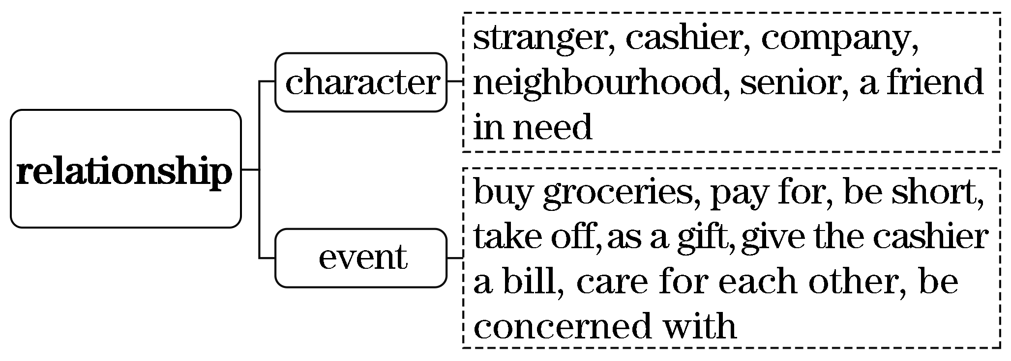
(二)基于深层主题“真诚善良”建构表达词汇
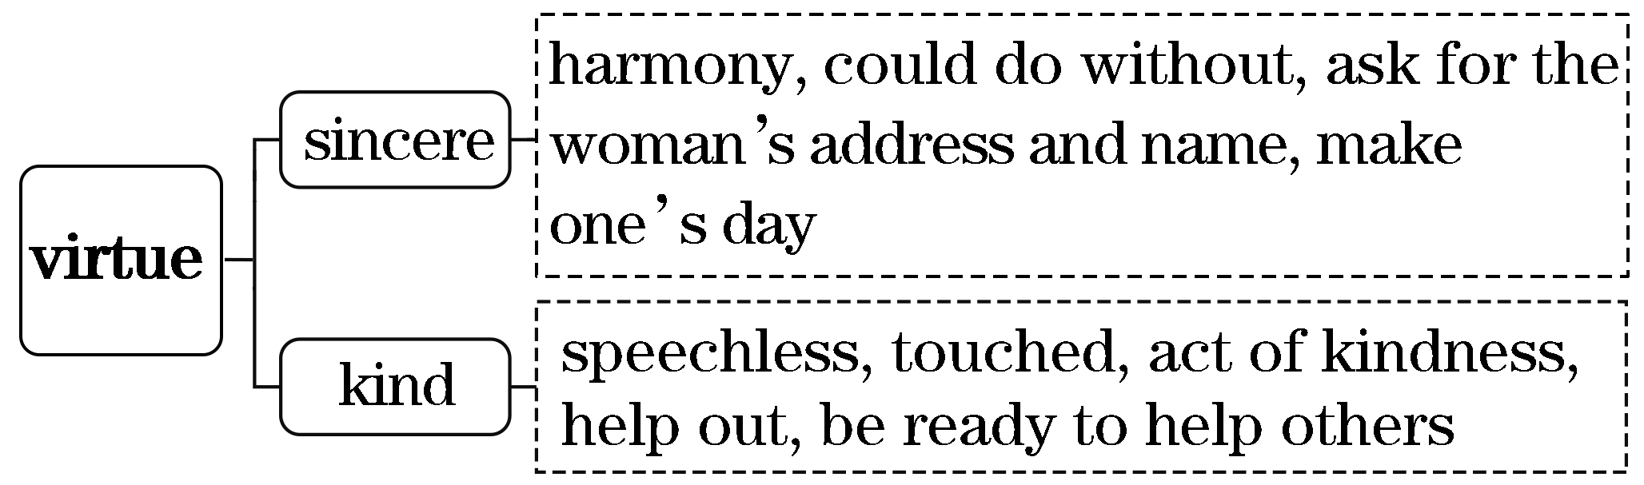
二、借助语境知识，实现深度学习
(一)把握一词多义，提高理解的准确性
1．take off起飞；拿掉，脱下；离开；突然成功，腾飞
[语境辨义]
①The only way to pay for the groceries was to take off the things she could do without ...____________
②The flight takes off at 12：00.____________
③He took off at once and headed back to the motel.____________
④This was the moment when Spielberg's career really took off.____________
2．address n．地址；演讲，演说
v．写地址；对……发表演说
[语境辨义]
①She asked for the woman's name and address so that she could repay her.
②This letter is addressed to a newspaper editor.
③The mayor gave a television address yesterday evening.
④It's said that the president will address a speech at the graduation ceremony.
(二)融通词形转换，提升表达的准确性
1．company n．公司；陪伴→____________ v．陪伴
2．transport v．运输→____________ n．运输
3．kind adj.善良的→____________ n．善良
4．speech n．言语；演说；说话的能力→____________ adj.无语的；说不出话的
5．touch v．触摸，碰 n．触摸；触觉→____________ adj.被感动的→____________ adj.感人的

6．able adj.能，能够→____________ n．能力→__________ adj.不能的，无能力的→__________ v．使丧失能力

(三)明辨熟词生义，强化思维的灵活性
1．company n．[熟义] 公司；[生义] 陪伴，同伴
[语境辨义]
①...I take my mother to do her shopping and visit the doctor, providing company and transportation.____________
②A few years ago I worked in an international company that sold computer devices.____________
2．touch v．[熟义] 触摸；[生义] 感动
[语境辨义]
①My mother was so touched by her gesture that she decided to go back to the store ...____________
②I reached out to touch her face, which was as cold as the ice.____________
三、发掘词块短语，实现类群拓展
1．由go off串记“动词＋off”的短语
go off 出发前往；熄灭；爆炸
pay off 还清；取得成功；得到回报
cut off 中断
give off 发出，放出
put off 延期；脱去
[完成句子]
①As the water came in the windows, ______________________________.
随着水从窗子漫进来，灯全部熄灭了。
②With the electricity ____________， all the machines stopped.
由于停电，所有的机器都停了。
③“All of the hard work and sacrifice __________，” she said.
“所有的努力和牺牲都得到了回报，”她说。
④Most of the things you see are not ____________________ of their own.
你所看到的大多数物体本身并不发光。
2．由make one's day串记“make”的搭配
make one's day 使某人开心
make one's way 前进
make ends meet 使收支相抵，量入为出
make a long story short 长话短说
make oneself at home 别拘束，别客气
make a mountain out of a molehill 小题大做
[完成句子]
①You are the sunshine _______________________________________________________.
你就是让我快乐的阳光。
②When his name was called, he ________________________ the stage.
当叫到他的名字时，他走向舞台。
③You're among our friends, so _________________________________________________.
你是我们的朋友，所以不要拘束。
④Things are so expensive nowadays that ____________________________________.
现在东西太贵了，以至于很难实现收支平衡。
⑤I'm very busy now. Please ______________________________.
我现在很忙，请长话短说。

朗朗晨读(十六)2021·浙江1月高考·完形填空·价值词汇发掘
三遍而熟·背出语感——(第一遍，做题；第二遍，代入答案诵读；第三遍，带空诵读，凭语感顺出答案)
Last year I decided to do some volunteer work. I began to __1__ on the Internet and discovered Volunteer USA. Three months later I __2__ myself on a plane to Phoenix, Arizona. I was __3__ at the thought of living with loads of new people for three months. However, within fifteen minutes of __4__ , my worries had gone. Everyone was so __5__ and likeminded that it was very __6__ to feel at home.
I was sent to the Coronado National Forest for my first 8day __7__ . We had to __8__ everything we needed and walk three miles to where we worked. It may not seem like a __9__ way but in 35℃ heat and with a heavy pack, my legs were on fire.
My job was to __10__ a stairway out of rock. This __11__ climbing up and down the side of a mountain inhabited (栖息) by mountain lions, although I should say they were only heard, never __12__ .
Three days later, a beautiful stairway came into being. The __13__ of knowing that my __14__ will be on that mountainside for years to come is massive.
But on the last night we were __15__ in a thunderstorm. I woke up at midnight to find a swimming pool in my tent. The temperature was close to __16__ . I had to spend the rest of the night trembling in the only __17__ part of my tent.
__18__ , I suffered a lot. But I know whatever I have to face in my life I was there and I __19__ . I think I am much __20__ for having taken part in the project.
1.A.calculate B．negotiate
C．advertise D．research
2．A.imagined B．introduced
C．enjoyed D．found
3．A.annoyed B．surprised
C．scared D．excited
4．A.arriving B．sleeping
C．thinking D．walking
5．A.confident B．friendly
C．energetic D．curious
6．A.funny B．good
C．lucky D．easy
7．A.tour B．project
C．campaign D．course
8．A.drop B．make
C．carry D．buy
9．A.nice B．safe
C．long D．quick
10．A.build B．test
C．clean D．guard
11．A.helped B．ended
C．allowed D．meant
12．A.hunted B．trained
C．seen D．fed
13．A.satisfaction B．ambition
C．expectation D．intention
14．A.work B．memory
C．record D．story
15．A.left B．caught
C．attacked D．separated
16．A.boiling B．average
C．normal D．freezing
17．A.tidy B．dry
C．new D．soft
18．A.By the way B．Regardless of that
C．Needless to say D．In either case
19．A.survived B．resisted
C．escaped D．recovered
20．A.smarter B．stronger
C．happier D．busier
[答案自查：1～5 DDCAB 6～10 DBCCA 11～15 DCAAB 16～20 DBCAB]

一、立足主题语境，建构词汇网络
2021年浙江1月高考完形填空的主题语境是“人与自我”，其表层话题为“志愿服务”，深层主题为“坚强与感恩”。文章讲述了作者在科罗拉多国家森林当志愿者的经历。作者虽然经历了种种磨难，但是也因此变得更加坚强。故事告诉我们要感谢生活中的磨难。
(一)基于表层话题“志愿服务”建构阅读词汇
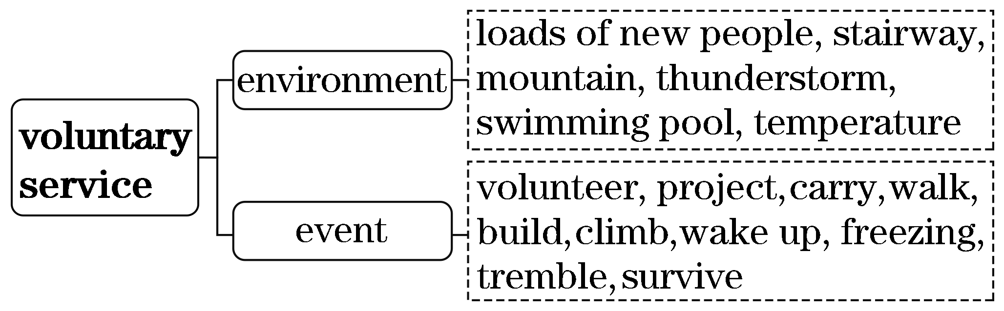
(二)基于深层主题“坚强与感恩”建构表达词汇
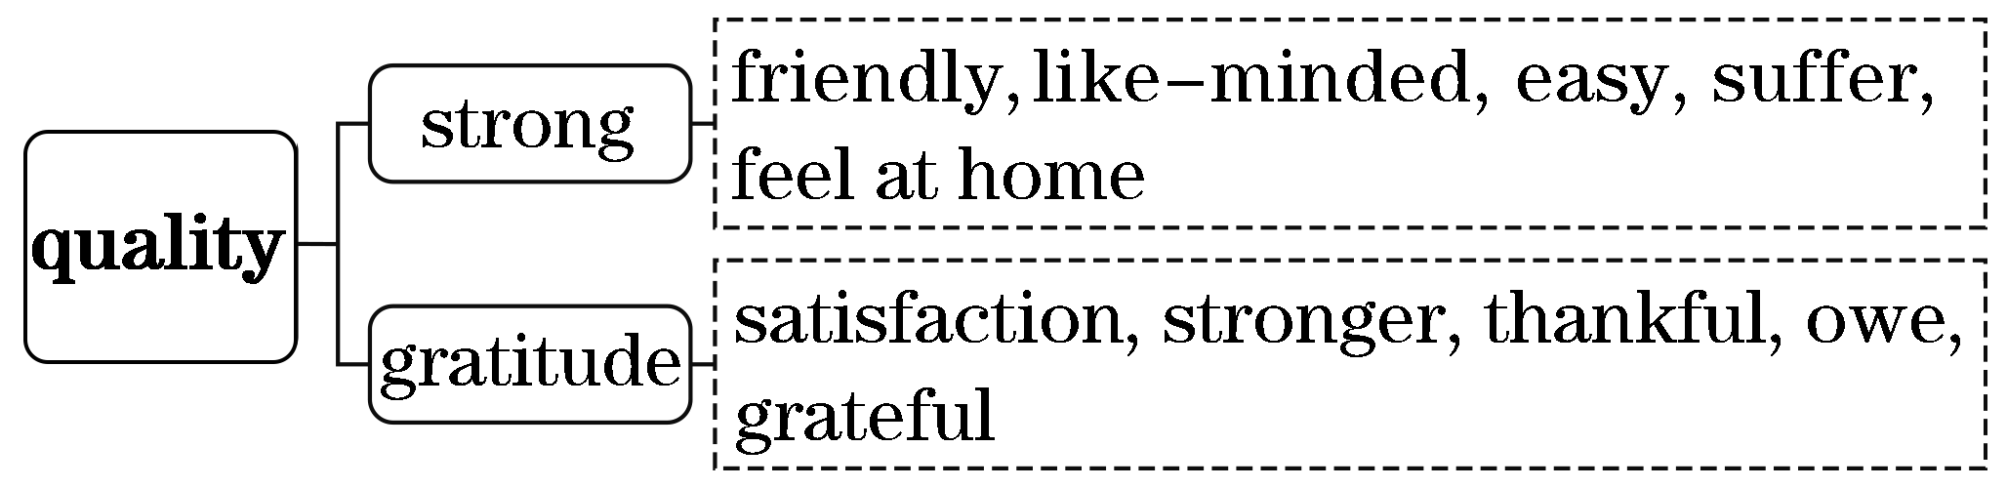
二、借助语境知识，实现深度学习
(一)把握一词多义，提高理解的准确性
1．load n．负荷，负载；负担，压力；大量 v．装上；载入
[语境辨义]
①I was scared at the thought of living with loads of new people for three months.
②With food, necessities and cookers loaded onto the car, the family squeezed into the car.
③Supporting such a large family is really a heavy load for him.
④An efficient bulb may lighten the load of power stations.
2．heat n．热量，热能；炎热；暖气 v．加热，变热
[语境辨义]
①It may not seem like a long way but in 35℃ heat and with a heavy pack, my legs were on fire.
②Metals expand when they are heated.
③He felt the heat in his body rising, and his cheeks blushing.
3．pack n．包；捆；群；盒；副 v．装(箱)；塞满，装满
[语境辨义]
①It may not seem like a long way but in 35℃ heat and with a heavy pack, my legs were on fire.
②He packed a bag with a few things and was off.
③They went hunting with a pack of hounds.
④The car park was absolutely packed solid with people.
(二)融通词形转换，提升表达的准确性
1．friend n．朋友→____________ adj.友好的
2．volunteer n．志愿者 v．自愿做→____________ adj.志愿的，自愿的
3．arrive v．到达，出现→____________ n．到达，到来
4．survive v．幸存，活下来→____________ n．幸存
5．mountain n．山，山脉→____________ adj.多山的
6．strong adj.强大的，结实的→______________ n．力量，体力
7．scare v．吓唬，使害怕→____________ adj.害怕的→____________ adj.恐怖的，吓人的，令人害怕的
8．mean v．意思是；意味着 adj.吝啬的，卑鄙的→____________ n．意思，意义→______________ adj.无意义的→____________ adj.有意义的，重大的
(三)明辨熟词生义，强化思维的灵活性
1．catch v．[熟义]抓住；接住
[生义] 赶上；突然遭受
[语境辨义]
①But on the last night we were caught in a thunderstorm.____________
②She managed to catch the keys as they fell.____________
2．face [熟义] n．脸 [生义] v．面临；面对
[语境辨义]
①But I know whatever I have to face in my life I was there and I survived.
②With tears streaming down her face, she was unsure of what to do next.
三、发掘词块短语，实现类群拓展
1．由at the thought of串记“at the＋名词＋of”的短语
at the thought of 一想到……就
at the sight of 一看到……就
at the mention of 一提到……就
at the risk of 冒着……的危险
at the age of 在……岁时
at the beginning of 在……开始时
[完成句子]
①________________________ a book there is often a table of contents.
在一本书的开头通常有个目录。
②He was terrified ____________________________ in the woods.
他一想到在树林里迷路就吓坏了。
③____________________ the helicopter, Jane jumped with wild joy.
一看到直升机，简很高兴地跳了起来。
④He saved my life ____________________ his own.
他冒着生命危险救了我的命。
2．由needless to say串记常用“插入语”
needless to say 不用说；不必说
strange to say 说来也奇怪
worse still/what's worse 更糟糕的是
generally speaking 一般来说
[完成句子]
①____________________， he hasn't got my letter up to now.
说来也奇怪，他到现在还没有收到我的信。
②Air as well as sunlight is, ________________， essential to our daily life.
不必说，空气和阳光是我们日常生活中不可缺少的。
③________________________， the weather there is neither too cold in winter nor too hot in summer.
一般来说，那儿的天气冬天既不太冷，夏天也不太热。
朗朗晨读(十七)2020·新高考全国卷Ⅰ·完形填空·价值词汇发掘
三遍而熟·背出语感——(第一遍，做题；第二遍，代入答案诵读；第三遍，带空诵读，凭语感顺出答案)
Molai grew up in a tiny village in India. The village lay near some wetlands which became his second __1__ . He learned the value and beauty of __2__ there from a very young age.
When he was 16, Molai began to notice something __3__ happening around his home. A flood had hit the area earlier that year and the __4__ it caused had driven away a number of birds. __5__ , the number of snakes had declined as well. He __6__ that it was because there weren't enough trees to protect them from the __7__ . The solution, of course, was to plant trees so the animals could seek __8__ during the daytime. He turned to the __9__ department for help but was told that nothing would grow there. However, Molai went looking on his own and __10__ a nearby island where he began to plant trees.
__11__ young plants in the dry season was __12__ for a lone boy. Molai built at the __13__ of each sapling (幼树) a bamboo platform, where he placed earthen pots with small holes to __14__ rainwater. The water would then drip (滴落) on the plants below.
Molai __15__ to plant trees for the next 37 years. His efforts have resulted in 1,360 acres of naturallygrown land that has become home to many plants and animals.
1.A.dream B．job
C．home D．choice
2．A.nature B．youth
C．culture D．knowledge
3．A.precious B．interesting
C．disturbing D．awkward
4．A.waste B．tension
C．pain D．damage
5．A.Besides B．However
C．Therefore D．Otherwise
6．A.agreed B．realized
C．remembered D．predicted
7．A.noise B．heat
C．disease D．dust
8．A.directions B．partners
C．help D．shelter
9．A.labor B．police
C．forest D．finance
10．A.rebuilt B．discovered
C．left D．managed
11．A.Decorating B．Observing
C．Watering D．Guarding
12．A.tough B．illegal
C．fantastic D．beneficial
13．A.back B．top
C．foot D．side
14．A.cool down B．keep off
C．purify D．collect
15．A.returned B．learned
C．failed D．continued
[答案自查：1～5 CACDA 6～10 BBDCB 11～15 CABDD]

一、立足主题语境，建构词汇网络
2020年新高考全国卷Ⅰ完形填空的主题语境是“人与自然”，其表层话题为“环境保护”，深层主题为“责任与爱护”。文章讲述了一个名叫Molai的印度人用30多年的时间在自己家乡的小岛上植树，保护动物的故事。故事告诉我们，当周围环境遭到破坏时，我们应当献出自己的爱，对自然承担起一份责任。
(一)基于表层话题“环境保护”建构阅读词汇
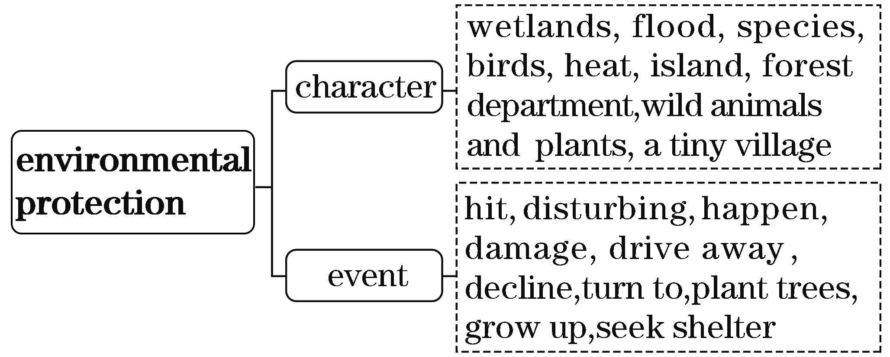
(二)基于深层主题“责任与爱护”建构表达词汇
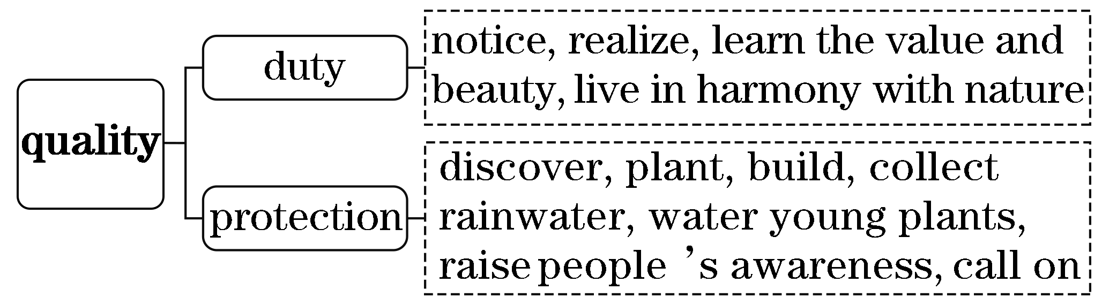
二、借助语境知识，实现深度学习
(一)把握一词多义，提高理解的准确性
1．notice n．通知，布告；注意v.注意到
[语境辨义]
①When he was 16, Molai began to notice something disturbing happening around his home.
②It may be necessary to put up a notice saying “Keep off”．
③His special talent has attracted many people's notice.
2．hit v．打，撞击；命中；袭击；碰，接触；使突然想起
n．打；命中；(演出等的)成功/热门
[语境辨义]
①A flood had hit the area earlier that year ...
②The song can't fail to be a big hit.
③I fell asleep as soon as my head hit the pillow.
④It hit me that I forgot to return the books to the library.
⑤A snowflake hit the window and melted away, gone forever.
3．season n．季节；(体育)赛季 v．给……调味，加调料
[语境辨义]
①Watering young plants in the dry season was tough for a lone boy.
②We need to season dishes with salt in the end of cooking.
③When the football season ended, these warrior bands literally vanished.
4．tough adj.坚韧的；坚强的；健壮的；艰难的；棘手的；(食物)老的，硬的；严厉的
[语境辨义]
①Watering young plants in the dry season was tough for a lone boy.____________
②The steak was so tough that I couldn't eat it.____________
③Don't be too tough on him — he was only trying to help.____________
④Great pains have been taken to solve the tough problem.____________
(二)融通词形转换，提升表达的准确性
1．value n．价值→____________ adj.宝贵的，重要的
2．beautiful adj.美的，漂亮的→____________ n．美；美人
3．nature n．自然→____________ adj.自然的
4．protect v．保护→____________ n．保护
5．collect v．收集→____________ n．收集；收藏品
6．solve vt.解决；处理→____________ n．解决方案；溶解

(三)明辨熟词生义，强化思维的灵活性
1．water[熟义] n．水
[生义] v．给……浇水；灌溉；充满眼泪

[语境辨义]
①Watering young plants in the dry season was tough for a lone boy.
②The smoke made my eyes water.
③The water is boiling.
2．home n．[熟义] 家；[生义] 生息地；栖息地；产地
[语境辨义]
①His efforts have resulted in 1,360 acres of naturallygrown land that has become home to many plants and animals.____________
②Old people prefer to stay in their own homes.____________

三、发掘词块短语，实现类群拓展
1．由notice sb./sth. doing串记“动词＋sb./sth.＋doing”的搭配
notice sb./sth. doing 注意到某人或某物正在做……
see sb./sth. doing 看到某人或某物正在做……
watch/observe sb./sth. doing 观察到某人或某物正在做……
hear sb./sth. doing 听到某人或某物正在做……
feel sb./sth. doing 感到某人或某物正在做……
[完成句子]
①He felt his heart ________________.
他觉得他的心在狂跳。
②I ________________________________ in the forest just now.
我刚才听到鸟儿在森林里唱歌。
③He ________________________________________________ on the square.
他注意到广场上有一群人在喊叫欢呼。
2．由drive away串记“动词＋away”的短语
drive away 驶离；驱走；使不愿久留；使想离去
throw away 扔掉；丢掉(废弃物)；错过，浪费
blow away 吹走
clear away 清除掉，消散
die away 逐渐消失，减弱
pass away 去世
wash away 冲走
[完成句子]
①I should know by now ____________________ the directions until we've finished cooking.
我现在应该明白，饭没做完之前，不要把食谱扔掉。
②When I finally tried to ________________， my wheels began to spin.
当我终于想开车离开时，我的车轮开始打转了。
③The waitress ____________________________ and brought coffee.
女服务员清除了盘子，端来了咖啡。
④Heavy rain will ______________________ from desolate hills.
大雨将把泥土从荒凉的山丘上冲走。

朗朗晨读(十八)2020·新高考全国卷Ⅱ·完形填空·价值词汇发掘
三遍而熟·背出语感——(第一遍，做题；第二遍，代入答案诵读；第三遍，带空诵读，凭语感顺出答案)
When Jim Grant spotted black smoke coming out of a building on his way to work, he __1__ his car to call 911. Then he __2__ a Uturn, circling back to take another look.
Pulling up to the building, Grant saw flames (火焰) shooting out of a secondfloor window. Not seeing or hearing any fire engines __3__ , Grant rushed to a side __4__ and ran up the stairs.
On the second floor, he __5__ every apartment door. “Get out！” Grant shouted. No one __6__ and he assumed that people had already __7__ . Reaching the end of the hallway, though, Grant __8__ a halfopen door. He kicked it wide open, finding a __9__ woman in a wheelchair with a little boy and a tiny baby. “Let's __10__ ！” he screamed. The woman looked at him in confusion and said something about changing her clothes. Grant didn't wait. Clutching (抓牢) the baby to his chest and __11__ the boy alongside, Grant ran down the hallway. When he was __12__ outside, the only __13__ in sight was a policeman. Grant told him about the __14__ and they rushed into the smoky building.
Thanks to them, a family was saved from the fire. Grant and the policeman were honored for their __15__ .
1.A.drove B．stopped
C．reached D．abandoned
2．A.saw B．made
C．missed D．crossed
3．A.burning B．leaving
C．approaching D．waiting
4．A.entrance B．road
C．building D．window
5．A.locked B．kicked
C．counted D．repaired
6．A.agreed B．cared
C．responded D．understood
7．A.arrived B．returned
C．hidden D．escaped
8．A.skipped B．closed
C．noticed D．remembered
9．A.frightened B．curious
C．patient D．grateful
10．A.turn back B．go up
C．get out D．lie down
11．A.following B．dragging
C．examining D．passing
12．A.safely B．secretly
C．suddenly D．previously
13．A.witness B．guide
C．service D．help
14．A.woman B．door
C．car D．baby
15．A.wisdom B．generosity
C．honesty D．Courage
[答案自查：1～5 BBCAB 6～10 CDCAC 11～15 BADAD]
一、立足主题语境，建构词汇网络
2020年新高考全国卷Ⅱ完形填空的主题语境是“人与社会”，其表层话题为“冒险救人”，深层主题为“勇敢大爱”。文章讲述了格兰特在上班途中偶遇有人被困在着火的大楼里并出手相救的故事，彰显了公民大爱无私的高尚品德。故事告诉我们：遇到别人有生命危险时，应勇敢出手相救。
(一)基于表层话题“冒险救人”建构阅读词汇
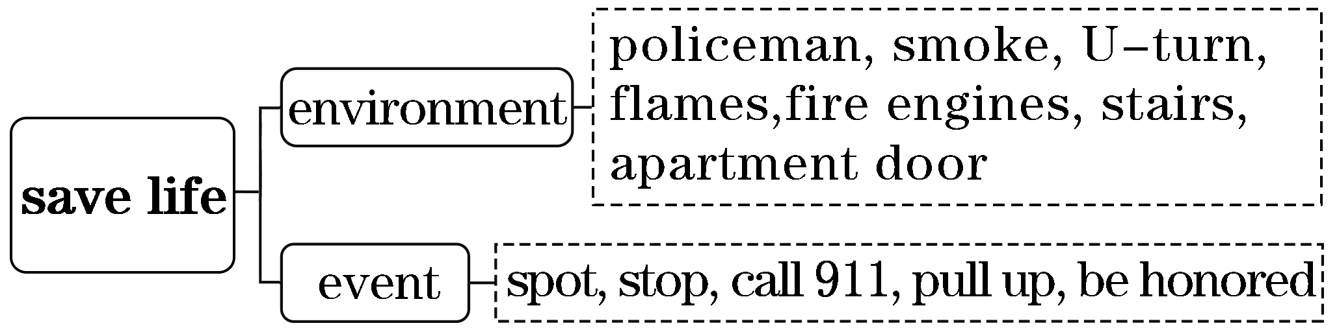

(二)基于深层主题“勇敢大爱”建构表达词汇
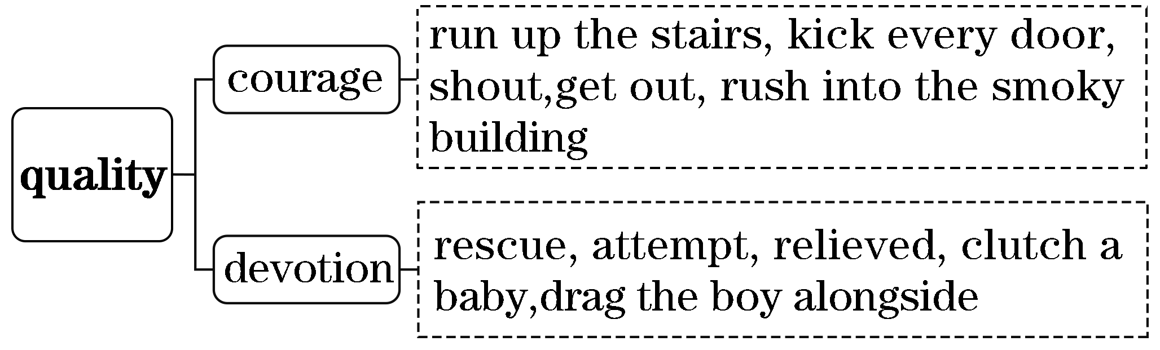
二、借助语境知识，实现深度学习
(一)把握一词多义，提高理解的准确性
1．approach n．方法；方式；接近；接洽；建议；要求；通路v.靠近；接洽；建议；要求；着手处理
[语境辨义]
①Not seeing or hearing any fire engines approaching, Grant rushed to a side entrance and ran up the stairs.
②What's the best way of approaching this problem？
③The school has decided to adopt a different approach to discipline.
④All the approaches to the palace were guarded by troops.
2．get out离开，出来；泄露，透露；出版
[语境辨义]
①Let's get out！____________
②Don't get out the secret to others.____________
③Her new book on how to get along with others is to get out next month.____________
3．family n．家，家庭；家人，家属；家族；(动植物)科
[语境辨义]
①Thanks to them, a family was saved from the fire.____________
②The cat family includes lions and tigers.____________
③She was too frightened to tell her family what had happened.____________
④The old poor peasant has a family history written in blood and tears.____________
(二)融通词形转换，提升表达的准确性
1．shoot v．射击，发射→____________ n．射击；打猎
2．respond v．反应，应答→____________ n．反应，回应
3．assume v．认为，假设→____________ n．认为，假设
4．fright n．害怕→____________ v．使害怕→________________ adj.害怕的
5．confuse v．使迷惑/困惑→__________ adj.迷惑/困惑的，混乱的→____________ n．迷惑，困惑，混乱
6．smoke n．烟雾 v．吸烟→__________ adj.多烟的→____________ n．吸烟者
7．honor n．荣耀，荣誉 v．给予表扬→____________ adj.光荣的，尊敬的
8．courage n．勇气，勇敢→__________ v．鼓励，鼓舞→____________ v．使沮丧

(三)明辨熟词生义，强化思维的灵活性
1．circle [熟义] n．圆；圈 [生义] v．环行，转圈
[语境辨义]
①Then he made a Uturn, circling back to take another look.
②The kids were sitting in a circle on the floor listening to the teacher.
2．shoot v．[熟义] 射中，射击
[生义](使朝某方向)冲，奔，扑，射，飞驰
[语境辨义]
①Pulling up to the building, Grant saw flames shooting out of a secondfloor window.____________
②The soldier only aimed his gun but did not shoot.____________
③They had almost reached the boat when a figure shot past them.____________
三、发掘词块短语，实现类群拓展
1．由look at串记“动词＋at”的短语
look at 看；考虑
laugh at 嘲笑
point at 指着
yell at 对……吼叫
call at 拜访；停靠
stare at 盯着看；凝视
[完成句子]
①“That's the man who did it，” she said, __________________.
“那就是做那事的人，”她指着我说。
②They ________________________， wondering what to do with this little girl.
他们面面相觑，不知道该拿这个小女孩怎么办。
③We ________________________， hit pots hard, and fired blank shotgun shells into the air.
我们朝熊大喊大叫，使劲敲罐子，并向空中发射了空弹。
④You can ______________ the issue from many different angles.
你可以从很多不同的角度看这个问题。
2．由in sight串记“in＋名词”的短语
in sight 看得见
in confusion 乱七八糟；处于混乱状态
in detail 详细地
in relief 如释重负地；欣慰地
in practice 实际上，在实践中
[完成句子]
①I glanced around me quickly. There ______________________.
我快速地扫视四周，看不到一个人影。
②The room ____________ after the birthday party.
生日晚会之后，房间里一片混乱。
③The new method ________________________.
新方法在实践中行之有效。
④I __________________， as I hoped that he was heading back towards his family.
我如释重负地笑了，因为我希望他是回到他的家人那里去了。
⑤In order to deliver a clear presentation, I explained the traditional procedure of making tea ________________.
为了发表一个清晰的演讲，我详细讲解了泡茶的传统步骤。

朗朗晨读(十九)2020·全国卷Ⅰ·完形填空·价值词汇发掘
三遍而熟·背出语感——(第一遍，做题；第二遍，代入答案诵读；第三遍，带空诵读，凭语感顺出答案)
Since our twins began learning to walk, my wife and I have kept telling them that our sliding glass door is just a window. The __1__ is obvious. If we __2__ it is a door, they'll want to go outside __3__. It will drive us crazy. The kids apparently know the __4__ . But our insisting it's __5__ a window has kept them from __6__ millions of requests to open the door.
I hate lying to the kids. One day they'll __7__ and discover that everything they've always known about windows is a __8__.
I wonder if __9__ should always tell the truth no matter the __10__ . I have a very strong __11__ that the lie we're telling is doing __12__ damage to our children. Windows and doors have __13__ metaphorical (比喻) meanings. I'm telling them they can't open what they absolutely know is a door. What if later in __14__ they come to a metaphorical door, like an opportunity (机会) of some sort, and __15__ opening the door and taking the opportunity, they just __16__ it and wonder, “What if it isn't a door？” That is, “What if it isn't a __17__ opportunity？”
Maybe it's an unreasonable fear. But the __18__ is that I shouldn't lie to my kids. I should just __19__ repeatedly having to say, “No. We can't go outside now.” Then when they come to other doors in life, be they real or metaphorical, they won't __20__ to open them and walk through.
1.A.relief B．target
C．reason D．case
2．A.admit B．believe
C．mean D．realize
3．A.gradually B．constantly
C．temporarily D．casually
4．A.result B．danger
C．method D．truth
5．A.merely B．slightly
C．hardly D．partly
6．A.reviewing B．approving
C．receiving D．attempting
7．A.win out B．give up
C．wake up D．stand out
8．A.dream B．lie
C．fantasy D．fact
9．A.parents B．twins
C．colleagues D．teachers
10．A.restrictions B．explanations
C．differences D．consequences
11．A.demand B．fear
C．desire D．doubt
12．A.physical B．biological
C．spiritual D．behavioral
13．A.traditional B．important
C．double D．original
14．A.life B．time
C．reply D．history
15．A.by comparison with B．in addition to
C．regardless of D．instead of
16．A.get hold of B．stare at
C．knock on D．make use of
17．A.real B．typical
C．similar D．limited
18．A.safety rule B．comfort zone
C．bottom line D．top secret
19．A.delay B．regret
C．enjoy D．accept
20．A.hurry B．decide
C．hesitate D．intend
[答案自查：1～5 CABDA 6～10 DCBAD 11～15 BCBAD 16～20 BACDC]
一、立足主题语境，建构词汇网络
2020年全国卷Ⅰ完形填空的主题语境是“人与自我”，其表层话题为“育儿理念”，深层主题为“真诚与诚实”。作者把现实中的门比喻成生活中的“机遇”，探讨了不要害怕告诉孩子们真相，让他们不被各种“进退两难”所困扰，抓住机遇，勇往直前的教育理念。文章告诉我们：教育孩子最好要做到真诚与诚实。
(一)基于表层话题“育儿理念”建构阅读词汇
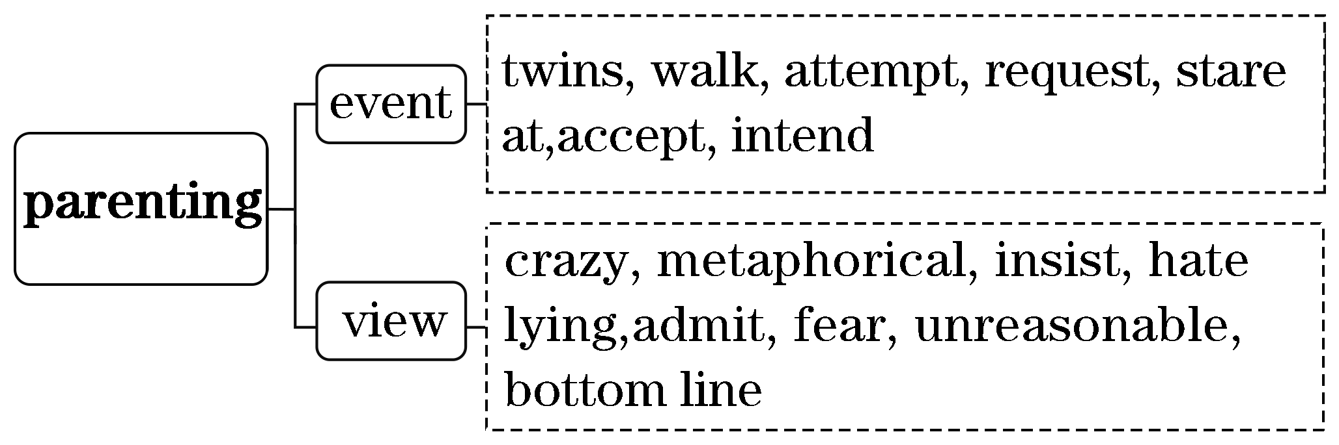
(二)基于深层主题“真诚与诚实”建构表达词汇
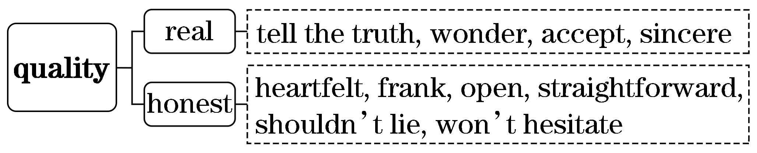
二、借助语境知识，实现深度学习
(一)把握一词多义，提高理解的准确性
1．admit v．承认；接纳，录取；准许进入；容纳
[语境辨义]
①If we admit it is a door, they'll want to go outside constantly.__________
②No one but ticketholders was admitted.__________
③I am glad to know that you have been admitted to your dream university.__________
2.lie v．撒谎；躺；位于；在于n.谎言
[语境辨义]
①I have a very strong fear that the lie we're telling is doing spiritual damage to our children.
②But the bottom line is that I shouldn't lie to my kids.
③Suzhou lies 50 miles to the west of Shanghai.
④The roots of this feeling may lie in our childhood.
⑤Sometimes, he likes lying on the grass to think some things and problems.
3．line n．线；边界；(思想或行为等的)界限；排，行；台词 v．排成行
[语境辨义]
①But the bottom line is that I shouldn't lie to my kids.____________
②Many people were lined along the streets, flags in hands.
③Seeing the lines of trees, we all had a sense of achievement.
④The actress often forgot her lines but was very good at acting.
(二)融通词形转换，提升表达的准确性
1．insist v．坚持→____________ n．坚持
2．lie v．撒谎；躺；位于；在于n.谎言→____________ adj.说谎的
3．true adj.真实的→____________ n．真相→________________ adv.真正地；如实地
4．reason n．原因 v．推理；劝告→____________ adj.合理的，公平的→____________ adj.不合理的
5．repeat v．重复；复述→____________ adj.重复的→____________ adv.反复地
6．hesitate v．犹豫，迟疑→____________ n．犹豫，迟疑→____________ adj.犹豫的

(三)明辨熟词生义，强化思维的灵活性
1．drive v．[熟义]驾驶；开车；[生义]迫使(某人生气、发疯或做出极端事情)
[语境辨义]
①It will drive us crazy.________________
②We watched him get into the car and drive away.________________
2．wake up[熟义]醒来，叫醒，唤醒
[生义]醒悟，开始了解真相
[语境辨义]
①One day they'll wake up and discover that everything they've always known about windows is a lie.____________
②What time do you usually wake up in the morning？____________

三、发掘词块短语，实现类群拓展
1．由what if串记“含if”的搭配
what if 如果……将会怎样
if only 要是……就好了
only if 只要
as if 好像
even if 即使
[完成句子]
①______________ I let him down?
如果我让他失望了将会怎样呢？
②He always wore a coat, ________________________________________.
他总是穿着一件外套，即使是在一个美丽的春日。
③________________________________ enough money to go to school.
我只有找到了工作才有足够的钱去上学。
④Feeling ______________________ hundreds of eyes peeping at me, my face blushed.
感觉好像有几百只眼睛在窥视我，我的脸涨红了。
⑤Mom said delightedly, ____________________________ such a delicious breakfast every day!
妈妈开心地说，要是她每天都可以吃到这么美味的早餐就好了！
2．由bottom line串记可以“望文生义”的习语
bottom line 底线
sour grapes 酸葡萄
blind alley 死胡同
hot potato 烫手山芋
flea market 跳蚤市场
crocodile tears 鳄鱼的眼泪
[完成句子]
①The ________________ is that we have to make a decision today.
底线是，我们今天必须做出决定。
②I got it __________________. It was just 5 dollars.
我在跳蚤市场买的它，才花了5美元。
③Teaching listening is always __________________ in English teaching.
听力教学一直是英语教学中的难点。

朗朗晨读(二十)2020·全国卷Ⅱ·完形填空·价值词汇发掘
三遍而熟·背出语感——(第一遍，做题；第二遍，代入答案诵读；第三遍，带空诵读，凭语感顺出答案)
It was just after sunrise on a June morning. “Nicolo，” whose real name cannot be __1__ to the public because of Italy's privacy laws, __2__ working the whole night at a factory in Turin. As he often did, he stopped by the “after work auction (拍卖)” __3__ by the Italian police where things __4__ on the trains were sold to the highest bidder. There, among many other things, Nicolo spotted two paintings he thought would look __5__ above his dining room table. Nicolo and another bidder __6__ until Nicolo finally won the paintings for $32.
When Nicolo retired and went to live in Sicily, he __7__ the paintings with him. He hung them above the same table he had __8__ from Turin. His son, age 15, who had __9__ an art appreciation class, thought that there was something __10__ about the one with a young girl sitting on a garden chair. It was signed (签名) “Bonnato” or so he thought, but when he __11__ it, he only found “Bonnard，” a French __12__ he had never heard of. He bought a book and was __13__ to find a picture of the artist Pierre Bonnard sitting on the same chair in the same __14__ as his father's painting.
“That's the garden in our picture，” Nicolo's son told his father. They __15__ learned that the painting they __16__ was called “The Girl with Two Chairs.” They __17__ the other painting and learned that it was __18__ Paul Gauguin's “Still Life of Fruit on a Table with a Small Dog.” The __19__ called the Italian Culture Ministry; the official confirmed that the paintings were __20__ and worth as much as $50 million.
1.A.attached B．allocated
C．exposed D．submitted
2．A.finished B．delayed
C．considered D．tried
3．A.attended B．reserved
C．cancelled D．run
4．A.shown B．found
C．kept D．hidden
5．A.nice B．familiar
C．useful D．real
6．A.battled B．debated
C．discussed D．bargained
7．A.held B．left
C．registered D．brought
8．A.chosen B．received
C．ordered D．moved
9．A.missed B．failed
C．taken D．led
10．A.concrete B．unusual
C．unappealing D．natural
11．A.appreciated B．touched
C．researched D．witnessed
12．A.painter B．designer
C．author D．actor
13．A.expected B．surprised
C．anxious D．ready
14．A.room B．kitchen
C．hall D．garden
15．A.apparently B．confidently
C．eventually D．temporarily
16．A.owned B．borrowed
C．sold D．stole
17．A.collected B．cleaned
C．framed D．studied
18．A.suitably B．actually
C．rightly D．specifically
19．A.girl B．artist
C．family D．police
20．A.copies B．originals
C．models D．Presents
[答案自查：1～5 CADBA 6～10 ADDCB 11～15 CABDC 16～20 ADBCB]
一、立足主题语境，建构词汇网络
2020年全国卷Ⅱ完形填空的主题语境是“人与社会”，其表层话题为“艺术价值”，深层主题为“审美能力”。文章讲述了一个名叫Nicolo的人在拍卖会上以低价购得两幅油画，他学艺术的儿子研究后疑为名画，后经国家文化部官员证实为真迹的故事。故事告诉我们：对艺术的热爱和有艺术审美能力也会得到回报。

(一)基于表层话题“艺术价值”建构阅读词汇
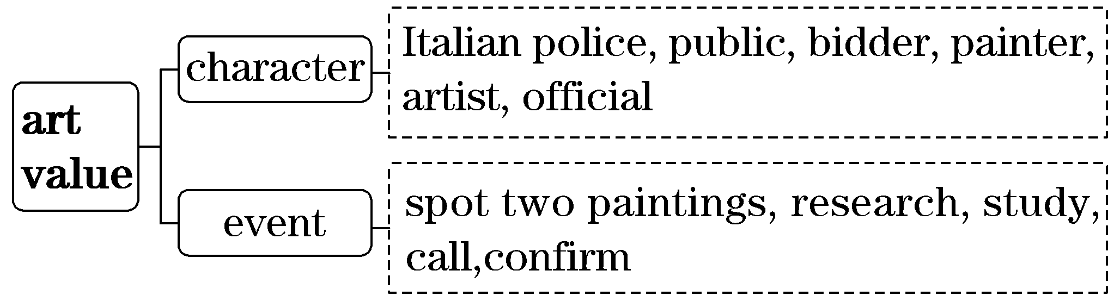
(二)基于深层主题“审美能力”建构表达词汇
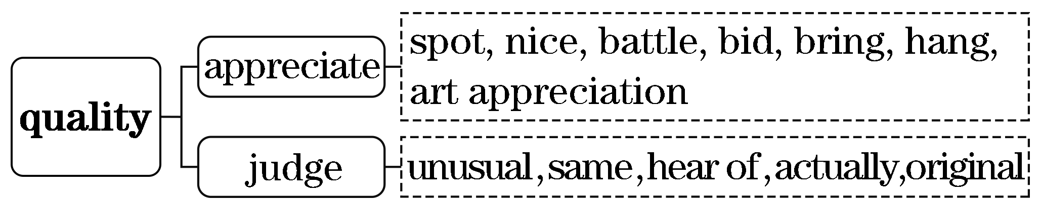
二、借助语境知识，实现深度学习
(一)把握一词多义，提高理解的准确性
1．expose v．揭露；使暴露；(胶卷)曝光；使接触
[语境辨义]
①“Nicolo，” whose real name cannot be exposed to the public because of Italy's privacy laws ...____________
②I found the boy had exposed the film to light.____________
③We want to expose the kids to as much art and culture as possible.____________
2．run v．跑；管理，经营；(使)运转，操作；竞选 n．跑步
[语境辨义]
①As he often did, he stopped by the “after work auction” run by the Italian police ...
②He was so frightened and ran away.
③The old machine is still running all right.__________
④I went for a run there, keeping an eye on the children the whole time.
3．hang v．悬挂；垂下，低下；绞死；闲逛
[语境辨义]
①He hung them above the same table he had moved from Turin.____________
②You may hang about here when I send down these vegetables.____________
③The boy did something wrong and hung his head in shame.____________
4．sign n．符号；迹象；广告牌；签名 v．签名，签署；示意
[语境辨义]
①It was signed “Bonnato” or so he thought ...
②There are no signs of life on Mars.
③The buyer and seller have signed the contract.
④On one of her trips, Lill saw a sign, reading: “Secretary Wanted”．

(二)融通词形转换，提升表达的准确性
1．private adj.私人的，私自的→____________ n．隐私
2．Italy n．意大利→______________ adj.意大利的 n．意大利人
3．bid v．出价，竞拍→____________ n．投标人
4．paint v．用颜料画→____________ n．画家→____________ n．绘画
5．origin n．起源，起因，出身→______________ adj.原先的，最初的，真迹的n.原作
(三)明辨熟词生义，强化思维的灵活性
1．battle[熟义] n．战斗，斗争
[生义] v．与……斗争，奋斗；竞争，争夺
[语境辨义]
①Nicolo and another bidder battled until Nicolo finally won the paintings for $32.
②The firemen battled against the flames for nine days and nights before getting them under control.
③She finally won the legal battle for compensation.
2．original[熟义] adj.原先的，起初的
[生义] n．原作，原件
[语境辨义]
①... the official confirmed that the paintings were originals and worth as much as $50 million.
②The room still has many of its original features.
三、发掘词块短语，实现类群拓展
1．由stop by串记“动词＋by”的短语
stop by 顺便访问
go by 经过；(时光)流逝
pass by 从……旁边经过
stand by 袖手旁观
[完成句子]
①Perhaps I'll ____________ the hospital.
也许我会顺路去一下医院。
②I see them __________________ every day.
我每天都看到他们从我家经过。
③His guilt deepened ____________________.
随着时间的推移，他的内疚加深了。
④__________________！ Can't you lend a hand?
别只是袖手旁观！你不能帮一下忙吗？
2．由hear of串记“动词＋of”的短语
hear of 听说
think of 想起，记起
speak of 说起，谈到
consist of 由……组成
approve of 赞成，支持
dream of 梦想
[完成句子]
①I was shocked to ____________ your wife's illness.
听说你妻子病了，我很震惊。
②I __________________ his name at the moment.
我一时不能想起他的名字。
③The team ______________ 25 football players.
这个队由25名足球运动员组成。
④I'm afraid your parents won't ______________________________.
我担心你父母不会赞成你到那儿去。

晨读“完形”参考答案
朗朗晨读(一)
二、借助语境知识，实现深度学习
(一)1.①参加比赛 ②竞争 ③争夺 2.①n.疼痛 ②n.痛苦
③n.努力 ④ v．使疼痛 3.①n.帮助 ②n.救援物资
③v.帮助
(二)1.competition; competitor 2.painful 3.injure; injured
4．extremely 5.equality; equally 6.assessment
7．confuse; confusing; confusion 8.beneficial
(三)1.①特别照料 ②注意力 ③关注
2．①v.吃力地进行 ②v.斗争 ③v.搏斗 ④n.斗争
3．①n.体育比赛 ②v.见面 ③v.满足
三、发掘词块短语，实现类群拓展
1．①put away your books ②Go away ③had passed away
2．①was set up ②stand up ③picked up the book

朗朗晨读(二)
二、借助语境知识，实现深度学习
(一)1.①极度地 ②拼命地 2.①v.主动提出 ②v.提供 ③v.出价 ④n.减价 ⑤n.建议 3.①adj.镇静的
②v.使镇静 ③adj.风平浪静的 ④n.平静
(二)1.tightly 2.affordable 3.origin; originally
4．annoy; annoying; annoyance 5.curiosity 6.generosity
7．sympathy
(三)1.①n.帖子 ②v.邮寄 ③ n．职位 2.①看出，判断出
②告诉 ③显示 3.①期望，希望 ②信任 ③相信
三、发掘词块短语，实现类群拓展
1．①see him off ②turn off the lights
③took off his wet clothes
2．①turned it over curiously ②hand over the job to my father
③Go over your homework

朗朗晨读(三)
二、借助语境知识，实现深度学习
(一)1.①含有 ②包含 ③抑制 ④控制
2．①n.标签 ②vt.用标签标明 ③v.把……称为
3．①v.判断 ②n.法官 ③v.认为
4．①adj.完美的 ②adj.完全的 ③vt.使完善
(二)1.choose 2.shine 3.caution 4.mixture
5．appear; disappear; disappearance 6.vividly
(三)1.①表示，姿态 ②手势 2.①浑浊的 ②阴云密布的
三、发掘词块短语，实现类群拓展
1．①in trouble ②in advance ③in need
2．①on average ②on view/display ③on duty

朗朗晨读(四)
二、借助语境知识，实现深度学习
(一)1.①n.个人 ②adj.单独的 ③n.有个性的人
④adj.独特的 2.①v.漂浮 ②v.骑 ③v.搭乘
④n.搭便车 ⑤n.短途旅行
3．①vt.击败 ②vt.使困惑 ③n.失败
4．①adj.普通的 ②adj.平均的 ③n.平均数 ④v.平均为
(二)1.inspiration; inspiring 2.pleasant; pleasure
3．assistance; assistant 4.defense 5.demanding 6.confidence
(三)1.①n.冲浪板 ②n.董事会 ③v.上船
2．①出类拔萃 ②闪耀
三、发掘词块短语，实现类群拓展
1．①turn out this way ②will come out ③to carry out
2．①carry on working ②depend on my parents ③moved on

朗朗晨读(五)
二、借助语境知识，实现深度学习
(一)1.①v.下沉 ②v.沉没 ③v.坐下 ④n.洗涤池
2．①v.放置 ②n.地方
3．①n.树枝 ②n.分部 ③v.分叉
4．①v.使耽搁 ②n.延迟
(二)1.urge 2.danger 3.recognition 4.decoration
5．hunger; hungrily 6.boring; boredom 7.equip
(三)1.①n.一片 ②v.伸展 ③v.伸手 ④v.延伸
2．①v.谨慎移动 ②n.英寸
3．①刺耳的 ②敏锐的 ③锋利的
三、发掘词块短语，实现类群拓展
1．①broke down ②slide down ③died down
2．①getting angry at myself ②get accustomed to
③get involved in other activities

朗朗晨读(六)
二、借助语境知识，实现深度学习
(一)1.①v.系 ②v.将……系在……上 ③n.领带
④n.联系 2.①n.地点 ②n.点，斑点 ③n.污渍 ④v.发现
3．①v.困住 ②v.粘贴 ③n.棍
(二)1.camping; camper 2.death; dead; dying 3.moving; moved; movement 4.peaceful 5.helpful; helpless; helplessly 6.excited; exciting; excitement
(三)1.①起作用 ②工作 2.①变强，增大 ②拾起
三、发掘词块短语，实现类群拓展
1．①fell into ②burst into tears ③got into a panic
2．①pulled up ②used up ③was brought up
3．①is filled with challenges ②was satisfied/pleased with ③was impressed with my ability

朗朗晨读(七)
二、借助语境知识，实现深度学习
(一)1.①v.听起来好像 ②n.声音 ③adj.健康的
④adj.酣畅的 2.①n.形式 ②v.形成 ③n.表格
3．①v.意味着 ②v.打算 ③adj.卑鄙的 ④adj.吝啬的
(二)1.affordable 2.economic; economist 3.absence
4．comfortable 5.success; successful 6.expectation
(三)①v.使愉快 ②int.请问
三、发掘词块短语，实现类群拓展
1．①to finish the work ②to buy the book
③teaching me how to skate
2．①headed to ②added to her fear ③contributes to
④be kept to
3．①doesn't mean doing ②remember playing there
③forget to buy ④regretted arguing with

朗朗晨读(八)
二、借助语境知识，实现深度学习
(一)1.①提出 ②养育，抚养 ③呕吐
2．①v.训练 ②n.长途客车 ③n.教练
3．①n.戒指 ②n.打电话 ③v.响铃 ④v.给……打电话
(二)1.enjoyable 2.loneliness 3.companionship
4．amused; amusement 5.breathe 6.proposal
7．operation; operator
(三)1.①v.与……约会 ②v.起始于 ③n.日期
2．①v.遛 ②n.行业 ③v.步行
三、发掘词块短语，实现类群拓展
1．①fell for ②calls for ③to apply for ④long for
2．①continued to run ②afford to waste it
③attempted to find ④decided to learn

朗朗晨读(九)
二、借助语境知识，实现深度学习
(一)1.①n.眼睛 ②v.注视 ③n.观点 ④n.目光
2．①n.对象 ②n.学科，科目 ③n.主题 ④v.使臣服
⑤n.主语
(二)1.global 2.highly; height 3.remarkable; remarkably
4．exposure; exposed 5.effective; ineffective
6．development; developmental 7.surprised; surprising; surprisingly 8.reflection; reflective
(三)1.①n.尊重 ②v.把……视为 2.①表明 ②建议
三、发掘词块短语，实现类群拓展
1．①result in ②to take in ③lies in
2．①insisted on the importance ②depended/relied on his own efforts
③to be passed on

朗朗晨读(十)
二、借助语境知识，实现深度学习
(一)1.①经历 ②被批准 ③穿过，通过 ④仔细检查
2．①n.年龄 ②n.时代 ③v.变老
(二)1.notably 2.dryness 3.donation 4.retirement
5．personal 6.trained; trainer; trainee
7．expectation; expected 8.understanding; misunderstand
(三)1.①筹集，筹募 ②举起
2．①v.保持 ②n.摊位 ③v.站立
三、发掘词块短语，实现类群拓展
1．①go through ②broke through ③help us get through
2．①A friend in need ②stood in silence
③in turn serves practice ④to do something in return
3．①act/serve/work as a guide ②function/work/act/serve as

朗朗晨读(十一)
二、借助语境知识，实现深度学习
(一)1.①n.商店 ②v.储存 ③n.储藏
2．①n.短假 ②n.裂缝 ③n.黎明 ④v.折断
3．①n.种类 ②v.分类，整理 ③v.妥善处理
(二)1.employment; employer; employee
2．manager; management 3.permission
4．delivery 5.appreciation 6.respectful; respected
(三)1.①n.工厂 ②v.种植 ③n.植物 2.①涂，抹 ②申请
3．①除……之外 ②超过；超出
三、发掘词块短语，实现类群拓展
1．①listened to the wind ②adjust to ③stick to a diet
④contribute to
2．①at dinner ②at ease ③at random ④are at risk

朗朗晨读(十二)
二、借助语境知识，实现深度学习
(一)1.①角色 ②作用 ③职责
2．①n.货物 ②n.善行 ③adj.擅长的 ④adj.好的
3．①v.逃跑 ②n.泄漏 ③n.逃离 ④v.被遗忘 ⑤v.逃避
(二)1.description 2.action; actor; actress
3．devotion; devoted 4.theft 5.appearance 6.beggar
7．convincing; convinced 8.invitation
9．dangerous; endanger 10.criminal 11.honorable; honored
(三)1.①案件 ②病例 ③情况
2．①准许……离开 ②原谅；宽恕
三、发掘词块短语，实现类群拓展
1．①noted/put/took/wrote down ②broke down
③cut down on smoking ④turned down the volume
2．①to escape from the burning car ②to hear from you
③resulted from ④found myself suffering from

朗朗晨读(十三)
二、借助语境知识，实现深度学习
(一)1.①放置 ②下(蛋) ③躺下
2．①v.造成 ②n.起因 ③n.事业
(二)1.length 2.apology 3.immediately 4.messy
5．wisdom 6.youthful 7.admission 8.responsibility
9．indirectly 10.laid; laid; laying
(三)①v.把……归因于 ②n.粉笔
三、发掘词块短语，实现类群拓展
1．①got/came out ②set out ③put out the fire
④picked out
2．①hat in hand ②nose in the air ③ants in his pants
④the apple of his eye

朗朗晨读(十四)
二、借助语境知识，实现深度学习
(一)1.①conj.当……时 ②conj.尽管 ③n.一段时间
④conj.而 2.①v.表达 ②n.快递 ③n.快车
④adj.明确的
3．①v.把……塞进 ②v.催促 ③n.新闻界 ④v.按，压
(二)1.consideration; considerate 2.different; difference
3．expression; expressive 4.patience 5.replacement
6．disastrous 7.emergent 8.recovery
(三)1.①等级 ②年级 2.①n.已知的事实 ②v.给予
三、发掘词块短语，实现类群拓展
1．①put to the test ②have to take into account
③keep in mind ④will be put into effect
2．①are eager/anxious to visit it ②is bound to
③ready to help his friends

朗朗晨读(十五)
二、借助语境知识，实现深度学习
(一)1.①拿掉 ②起飞 ③离开 ④腾飞 2.①n.地址
②v.写地址 ③n.演讲，演说 ④v.对……发表演说
(二)1.accompany 2.transportation 3.kindness
4．speechless 5.touched; touching 6.ability; unable; disable
(三)1.①陪伴 ②公司 2.①感动 ②触摸
三、发掘词块短语，实现类群拓展
1．①all the lights went off ②cut off ③paid off
④giving off light
2．①that makes my day ②made his way to
③make yourself at home ④it's very difficult to make ends meet ⑤make a long story short

朗朗晨读(十六)
二、借助语境知识，实现深度学习
(一)1.①n.大量 ②v.装上 ③n.负担 ④n.负荷
2．①n.炎热 ②v.加热 ③n.热量
3．①n.包 ②v.装(箱) ③n.群 ④v.塞满
(二)1.friendly 2.voluntary 3.arrival 4.survival
5．mountainous 6.strength 7.scared; scary
8．meaning; meaningless; meaningful
(三)1.①突然遭受 ②接住 2.①v.面对 ②n.脸
三、发掘词块短语，实现类群拓展
1．①At the beginning of ②at the thought of being lost
③At the sight of ④at the risk of
2．①Strange to say ②needless to say ③Generally speaking

朗朗晨读(十七)
二、借助语境知识，实现深度学习
(一)1.①v.注意到 ②n.通知 ③n.注意 2.①v.袭击
②n.成功/热门 ③v.碰，接触 ④v.使想起 ⑤v.打，撞击
3．①n.季节 ②v.给……调味 ③n.(体育)赛季
4．①艰难的 ②(食物)老的，硬的 ③严厉的 ④棘手的
(二)1.valuable 2.beauty 3.natural 4.protection
5．collection 6.solution
(三)1.①v.给……浇水 ②v.充满眼泪 ③n.水
2．①生息地；栖息地 ②家
三、发掘词块短语，实现类群拓展
1．①beating wildly ②heard the birds singing
③noticed a crowd of people shouting and cheering
2．①not to throw away ②drive away
③cleared away the plates ④wash away the soil

朗朗晨读(十八)
二、借助语境知识，实现深度学习
(一)1.①v.靠近 ②v.着手处理 ③n.方法；方式 ④n.通路
2．①离开 ②泄露，透露 ③出版
3．①家庭 ②科 ③家人 ④家族
(二)1.shooting 2.response 3.assumption
4．frighten; frightened 5.confused; confusion
6．smoky; smoker 7.honorable 8.encourage; discourage
(三)1.①v.环行，转圈 ②n.圆；圈
2．①冲 ②射击 ③飞驰
三、发掘词块短语，实现类群拓展
1．①pointing at me ②stared at each other
③yelled at the bear ④look at
2．①was no one in sight ②was in confusion
③works well in practice ④smiled in relief ⑤in detail

朗朗晨读(十九)
二、借助语境知识，实现深度学习
(一)1.①承认 ②准许进入 ③接纳，录取
2．①n.谎言 ②v.撒谎 ③v.位于 ④v.在于 ⑤v.躺
3．①n.(思想或行为等的)界限 ②v.排成行 ③n.排，行
④n.台词
(二)1.insistence 2.lying 3.truth; truly
4．reasonable; unreasonable 5.repeated; repeatedly
6．hesitation; hesitant
(三)1.①迫使(某人发疯) ②开车 2.①醒悟 ②醒来
三、发掘词块短语，实现类群拓展
1．①What if ②even if it was a beautiful spring day
③Only if I get a job will I have ④as if there were
⑤if only she could have
2．①bottom line ②at the flea market ③a hot potato

朗朗晨读(二十)
二、借助语境知识，实现深度学习
(一)1.①使暴露 ②曝光 ③使接触
2．①v.管理 ②v.跑 ③v.运转 ④n.跑步
3．①悬挂 ②闲逛 ③垂下，低下
4．①v.签名 ②n.迹象 ③v.签署 ④n.广告牌
(二)1.privacy 2.Italian 3.bidder 4.painter; painting 5.original
(三)1.①v.竞争，争夺 ②v.与……斗争 ③n.斗争
2．①n.原作 ②adj.原先的
三、发掘词块短语，实现类群拓展
1．①stop by ②pass by my house ③as time went by
④Don't just stand by
2．①hear of ②can't think of ③consists of
④approve of your going there

